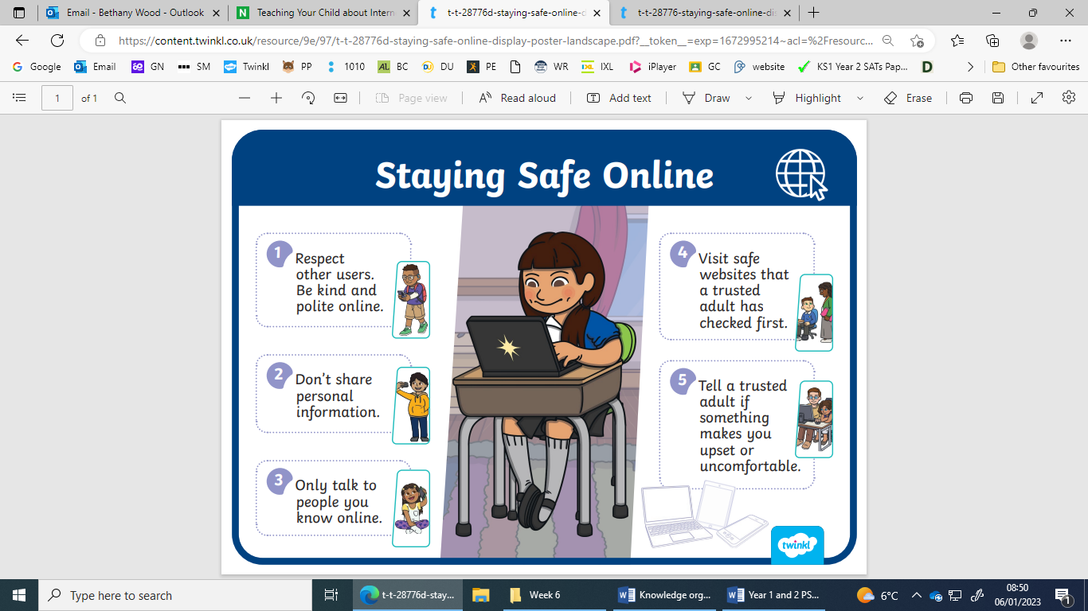

|  |  |
| --- | --- |
| To find out things we use: |  |
| To communicate we may use: |  |

|  |
| --- |
| I know how the internet can be used / is used in everyday life |

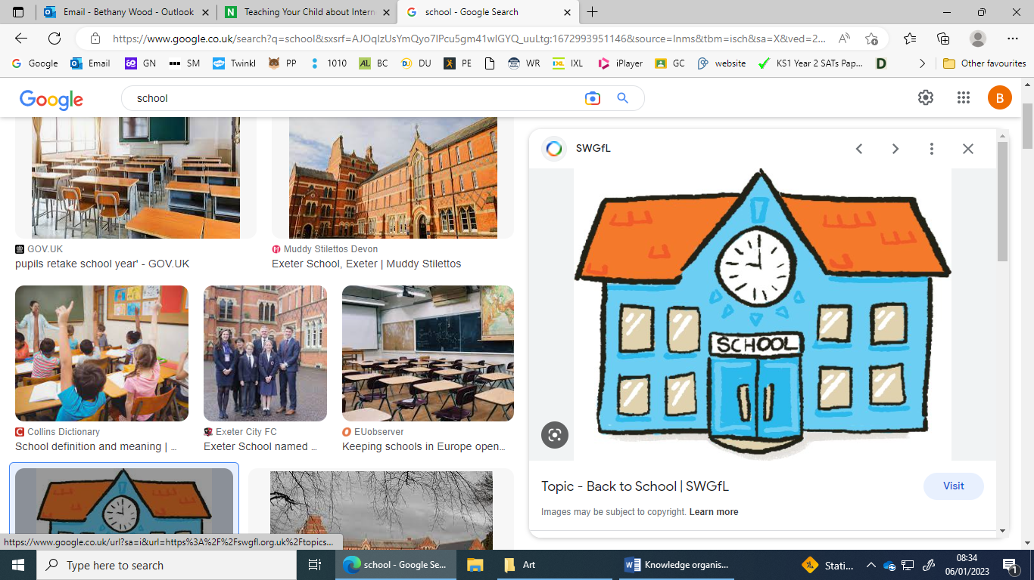 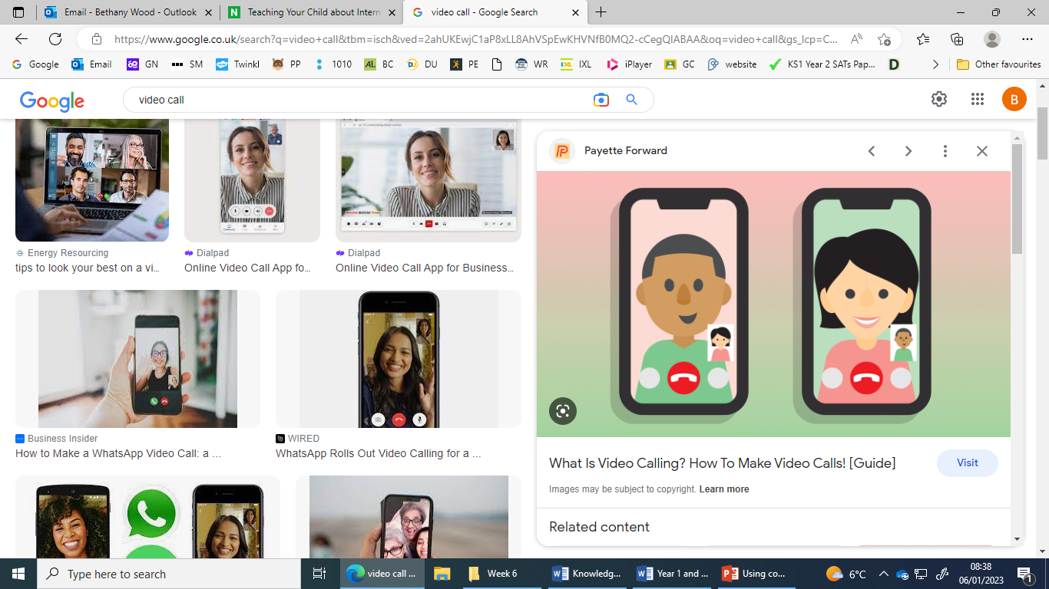 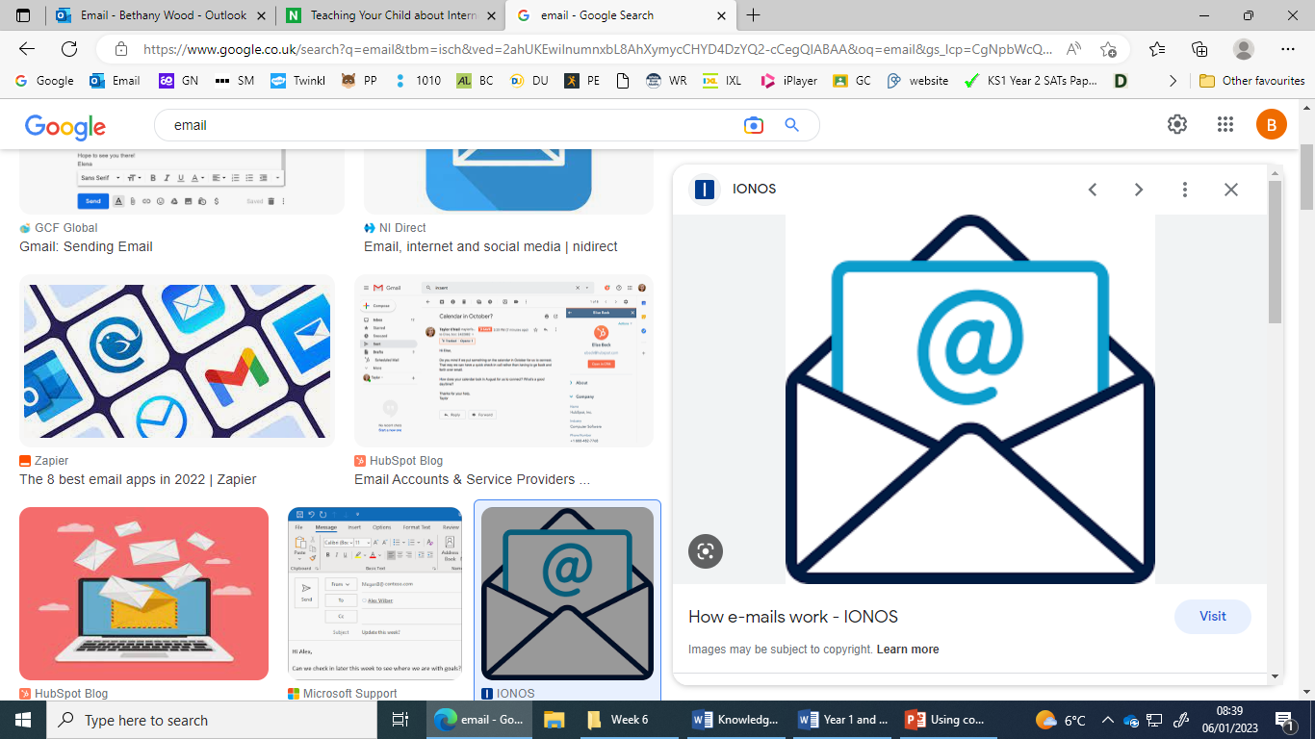   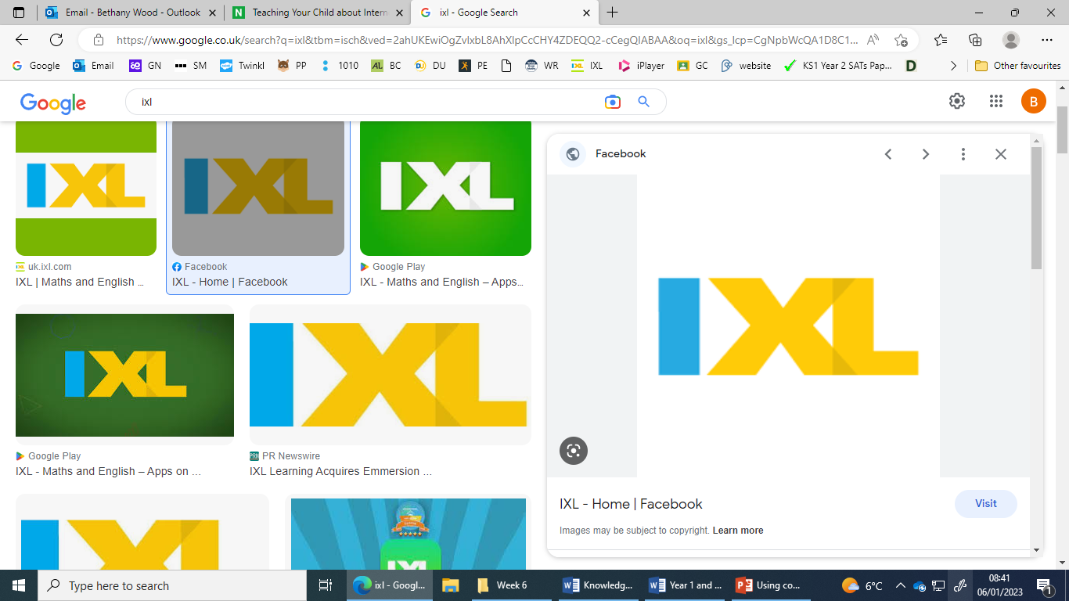

|  |
| --- |
| I know that not all information seen online is true |

* Anyone can add information online, that means that not everything that we find on line is true
* It is not always checked to make sure that it is true
* We cannot trust that new people who we talk to online are who they say they are
* We cannot trust websites that they will not give our computers viruses

|  |  |
| --- | --- |
| **Key Vocabulary** | |
| Internet | Is a worldwide system of computer networks. |
| Digital devices | An electronic device that can create, generate, send, share, communicate, receive, store, display, or process information. |
| Safe | To be protected from harm. |
| Safely | To lower the risk of harming yourself. |
| Safety | To ensure that things are put in place to lower the risk of harm. |
| Communicate | To share or exchange information. |
| Information | Facts. |
| Misleading | Giving someone the wrong idea. |
| True | Something that is correct. |
| False | Something that is not correct. |
| Online | Using the internet. |
| World wide web | A connected system of web pages. |

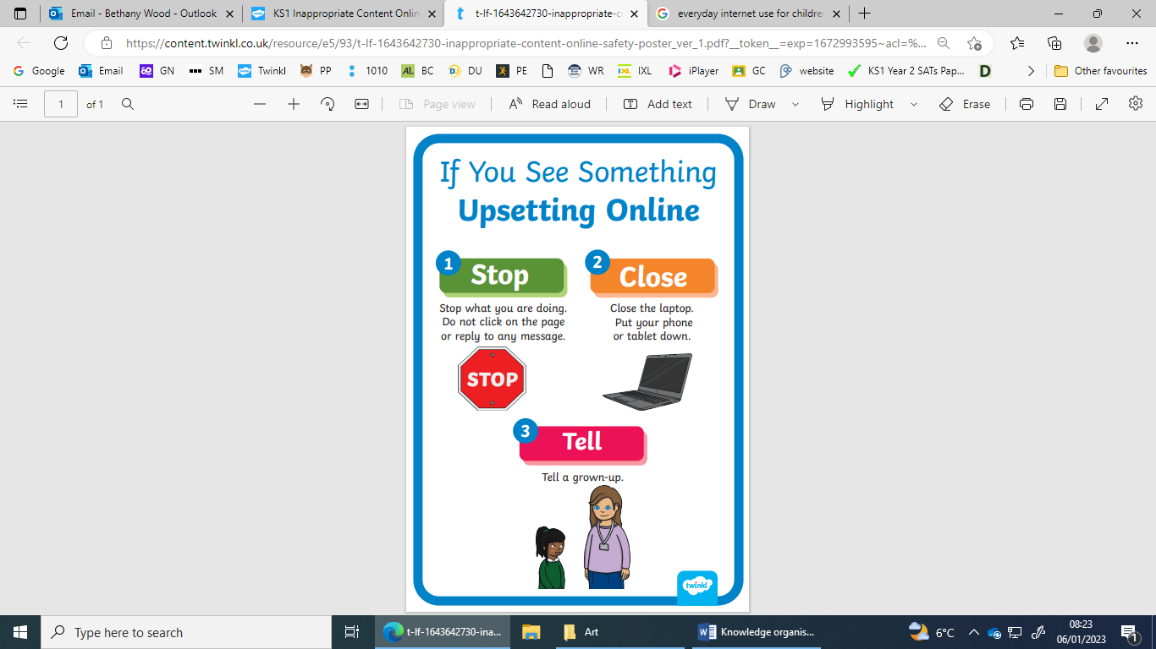

I know how the internet and digital devices can be used safely to find things out and to communicate with others

**Media Literacy and Digital Resilience**