To save your work:

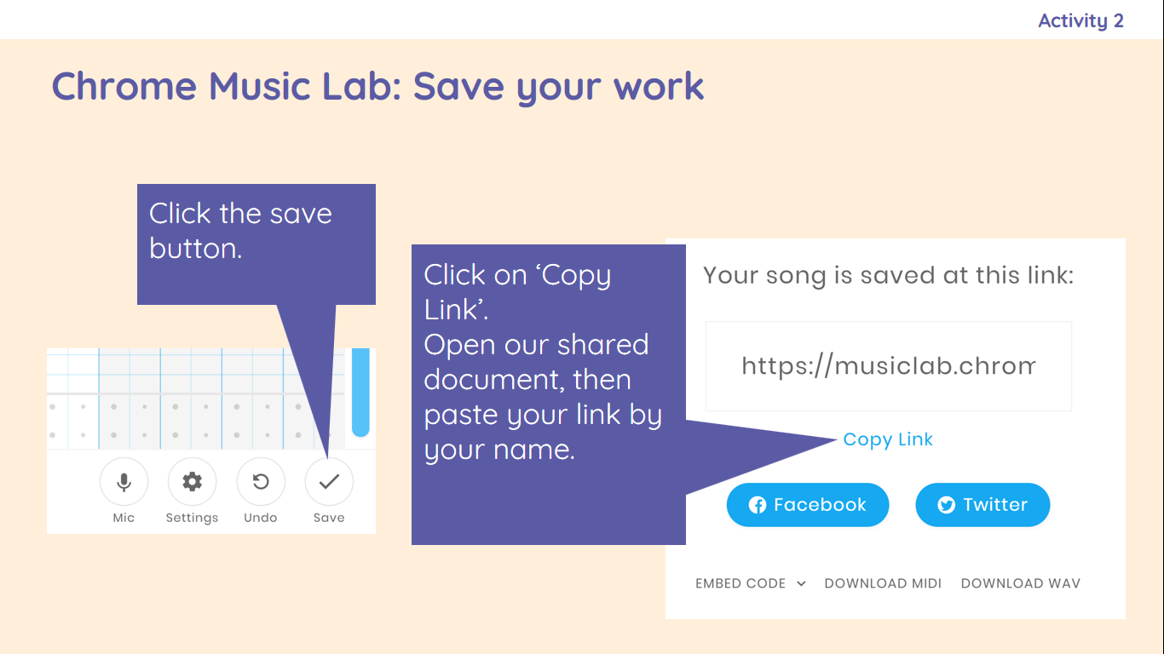

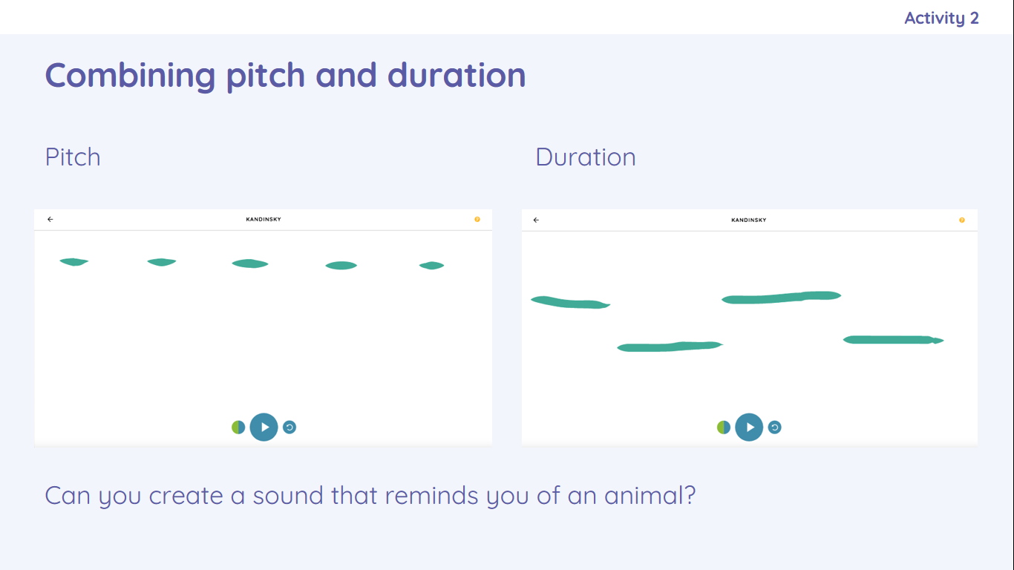

Duration is changed by how long or short the lines are.

Pitch is changed by how high or low the lines are.

|  |
| --- |
| I can describe an animal using sounds  I can explain my choices |

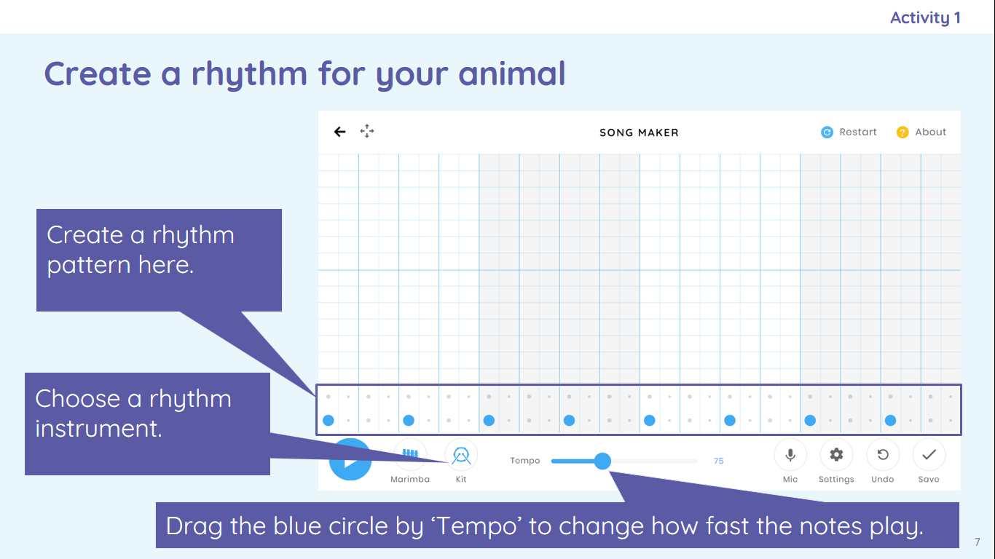

I can explain how I made my work better

I can listen to music and describe how it makes me feel

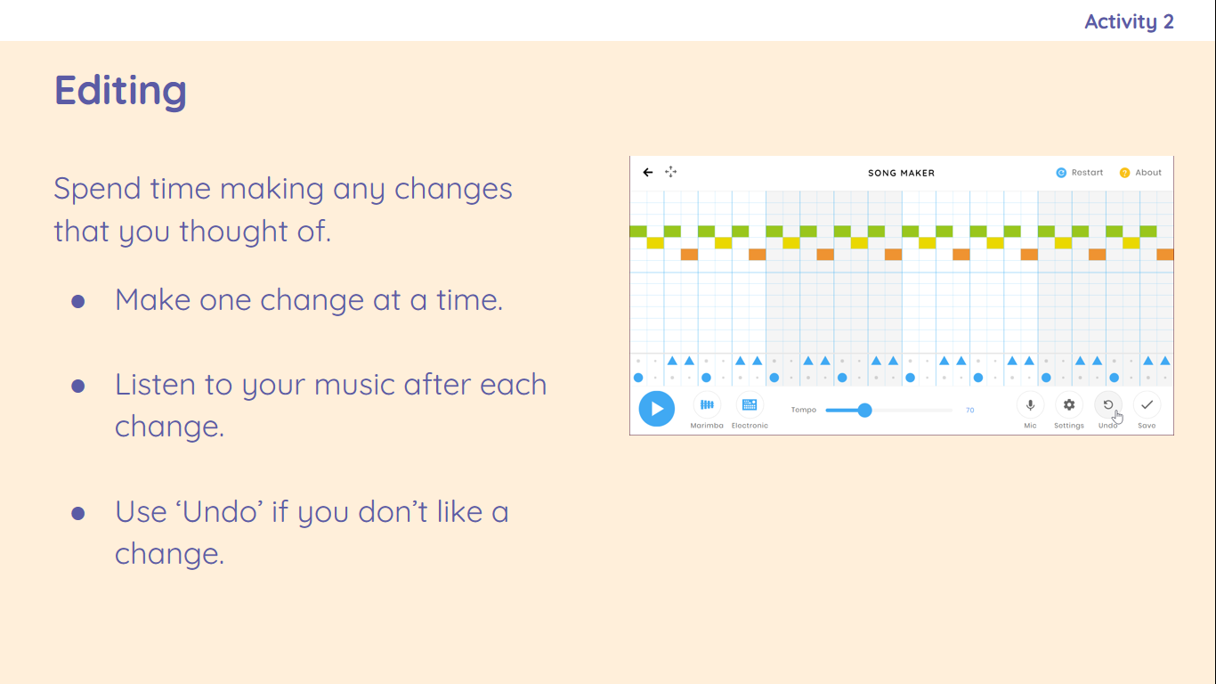

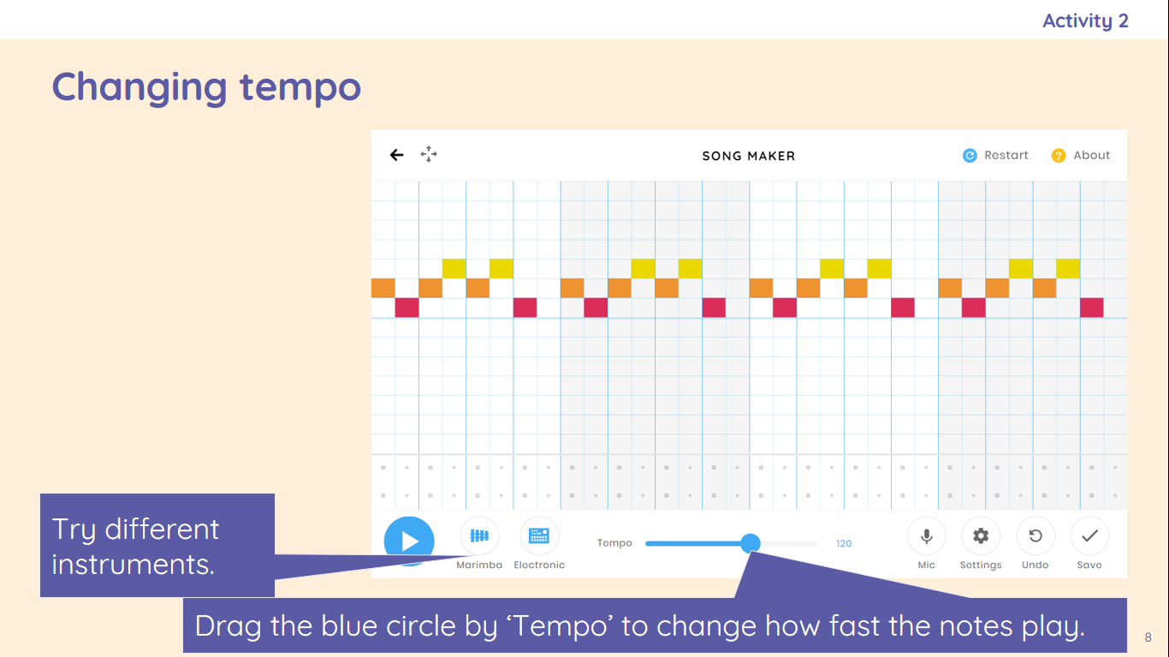

|  |  |
| --- | --- |
| **Key Vocabulary** | |
| Music | Sounds that may have rhythm, harmony, and melody. |
| Quiet | Soft sounds. |
| Loud | Big sounds. |
| Feelings | How you feel about situations. |
| Emotions | How you show your feelings. |
| Pattern | Something that is repeated. |
| Rhythm | In a song it follows the pattern of the words. |
| Pulse | The beat in the music. |
| Pitch | How high or low the music is. |
| Tempo | How fast or slow the music is. |
| Notes | The sound the music makes. |
| Instrument | Something that can be used to make music. |
| Create | To make something. |
| Open | To access something that has been closed. |
| Edit | To change something to improve it. |

I can identify that music is a sequence of notes

I can use a computer to create a musical pattern using three notes

I can connect images with sounds

I can use a computer to experiment with pitch and duration

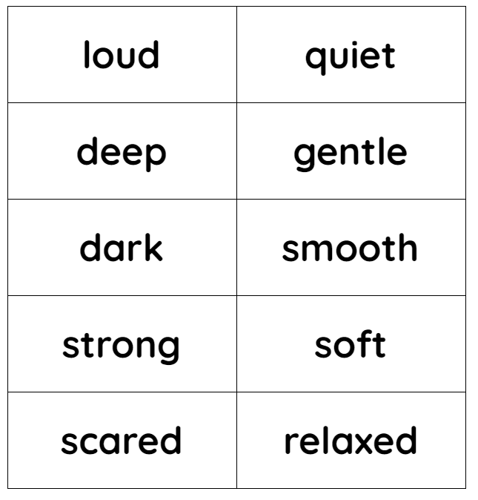

|  |
| --- |
| I can create a rhythm pattern  I can play an instrument following a rhythm pattern |

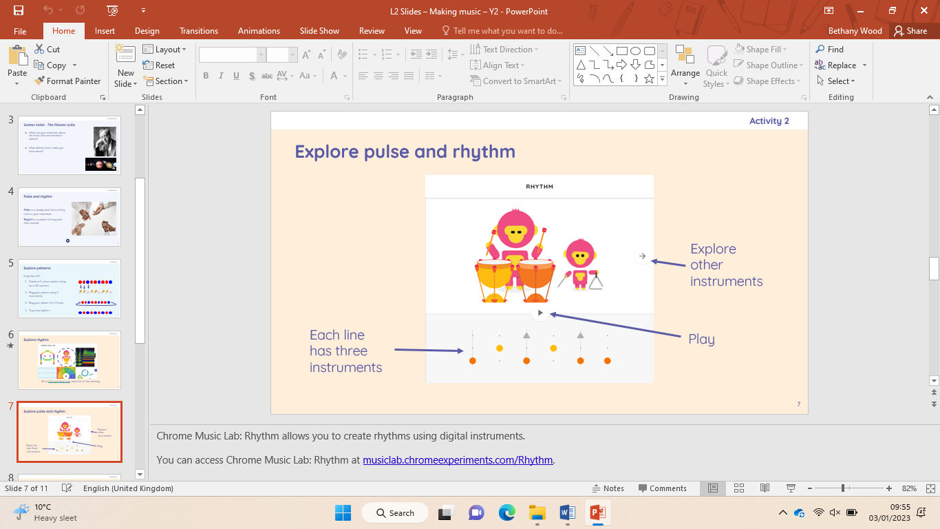

I can identify simple differences in pieces of music

I can describe how music makes me feel, e.g. happy or sad

Creating media- making music