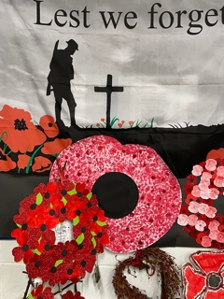

Thursday 11th November 2021
All children have been making poppies and reflecting on why we stop on 11th November as well as the actions we can take going forwards to show that we value the sacrifices that were made for us. This has been done in a very hopeful and respectful manner.
Year 6 have been developing their understanding of the steps that lead to World War I and 11 and how we now have an annual Remembrance Day Assembly. This morning Year 6 lead two Remembrance Services in school; the first for Owl and Woodpecker Class and the second for Eagle and Kestrel Class. Robin Class had their own class based reflection.
The powerpoint that Year used in the service is attached.
Year 6 lead this beautifully and all pupils showed their understanding of the relevance of the day by taking part in a one minute silence.
Following our school services Year 6 then took part in the Axminster Town Service. Each child placed a wooden cross in the memorial garden. Each of the crosses represented a named person from Axminster who fought and died in World War I.
During the service our school wreath was placed with other wreaths on the base of the memorial where it will stay for the next week.
Year 6 were a credit to the school and have shown great leadership skills by stepping up to lead in our services.

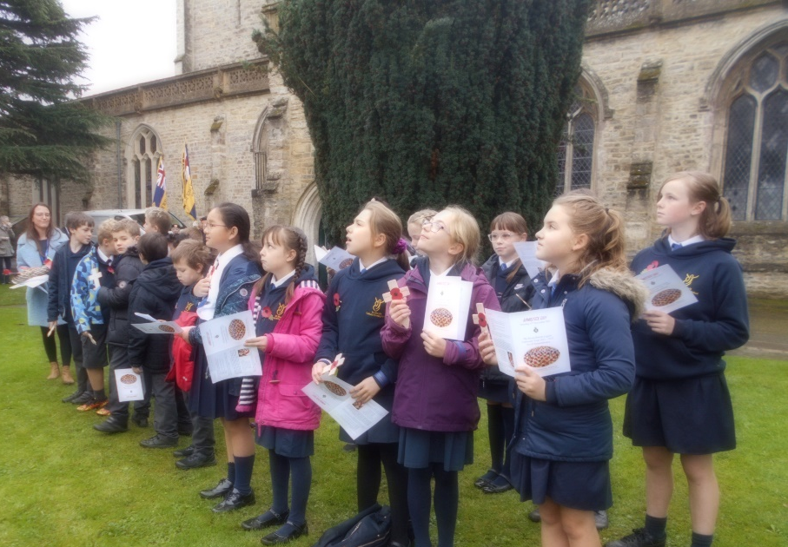

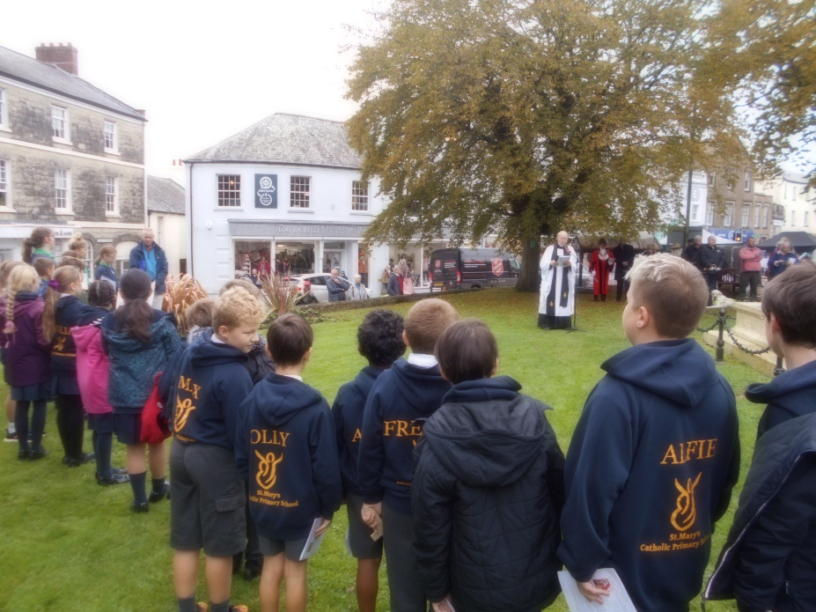

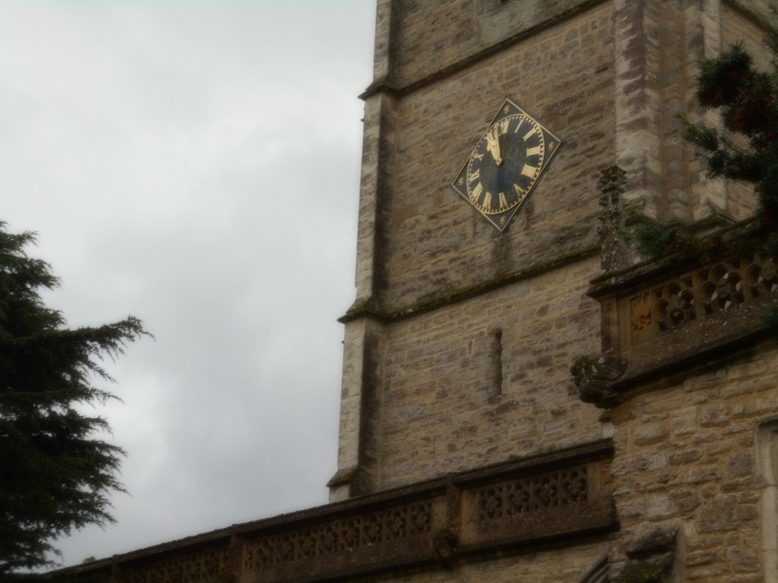
The children faced the church clock to wait for the eleven o clock chimes. They then turned to face the memorial as The Last Post was played on the trumpet to mark the start of the two minutes silence.
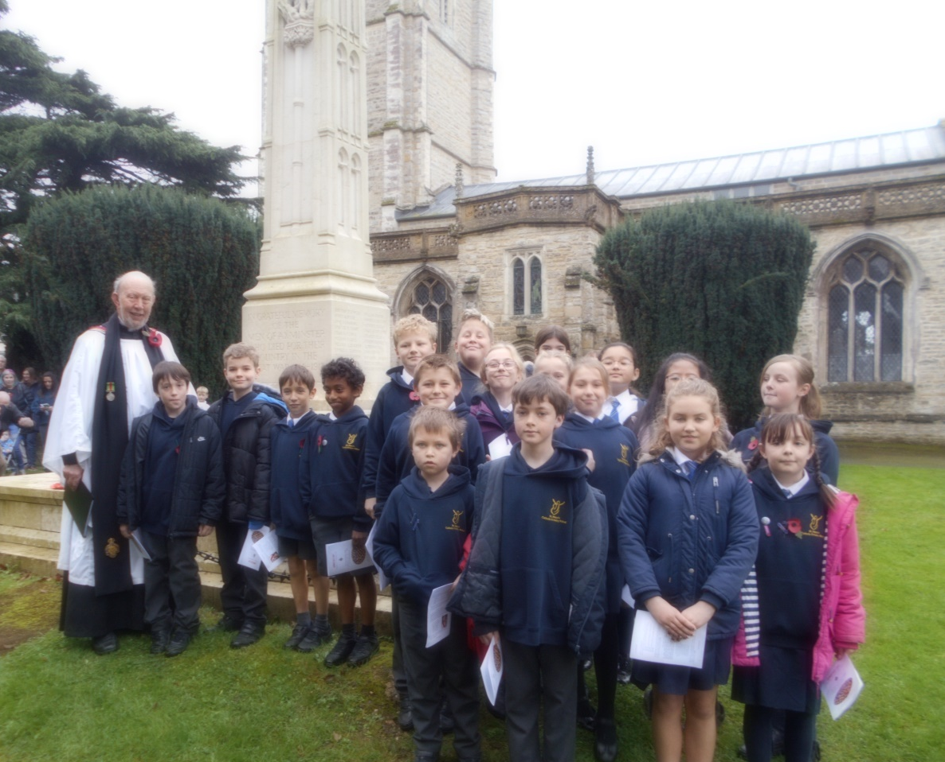

The Kohima Epitaph
When you go home, tell them of us and say,
For your tomorrow, we gave our today.

Peacemakers at St Mary’s
We have been encouraging the children to feel hopeful and grateful that they live in a country that does not have war. We have been asking them to take actions to be peacemakers as a way to thank those who gave their lives for us.

