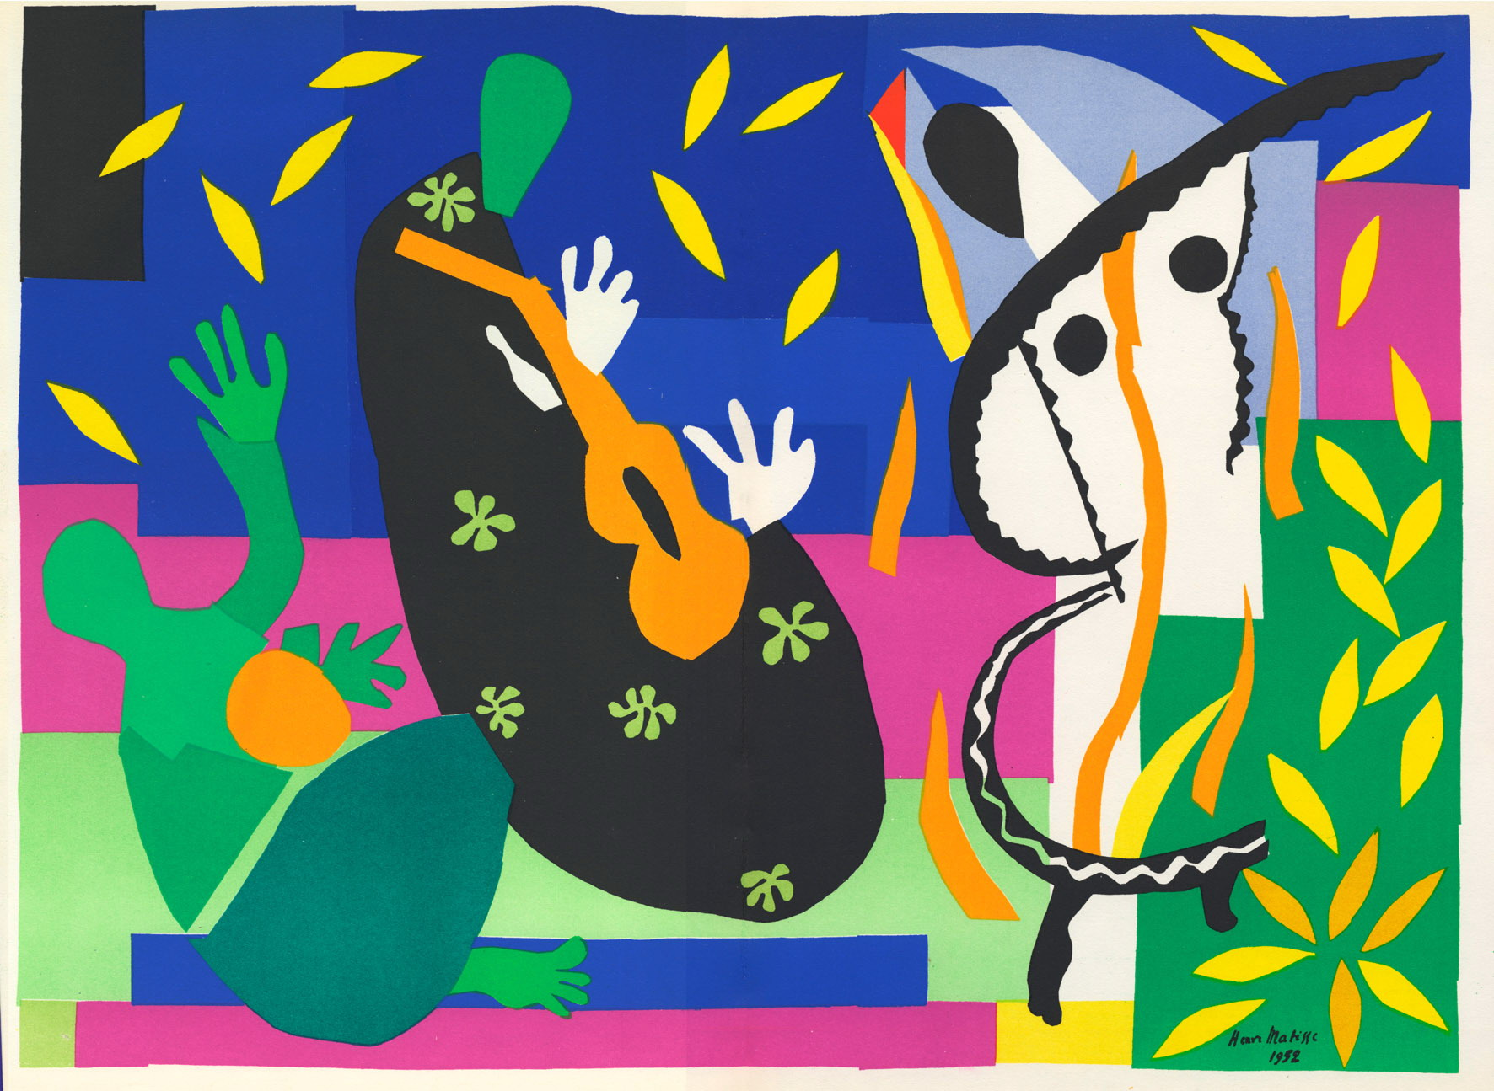

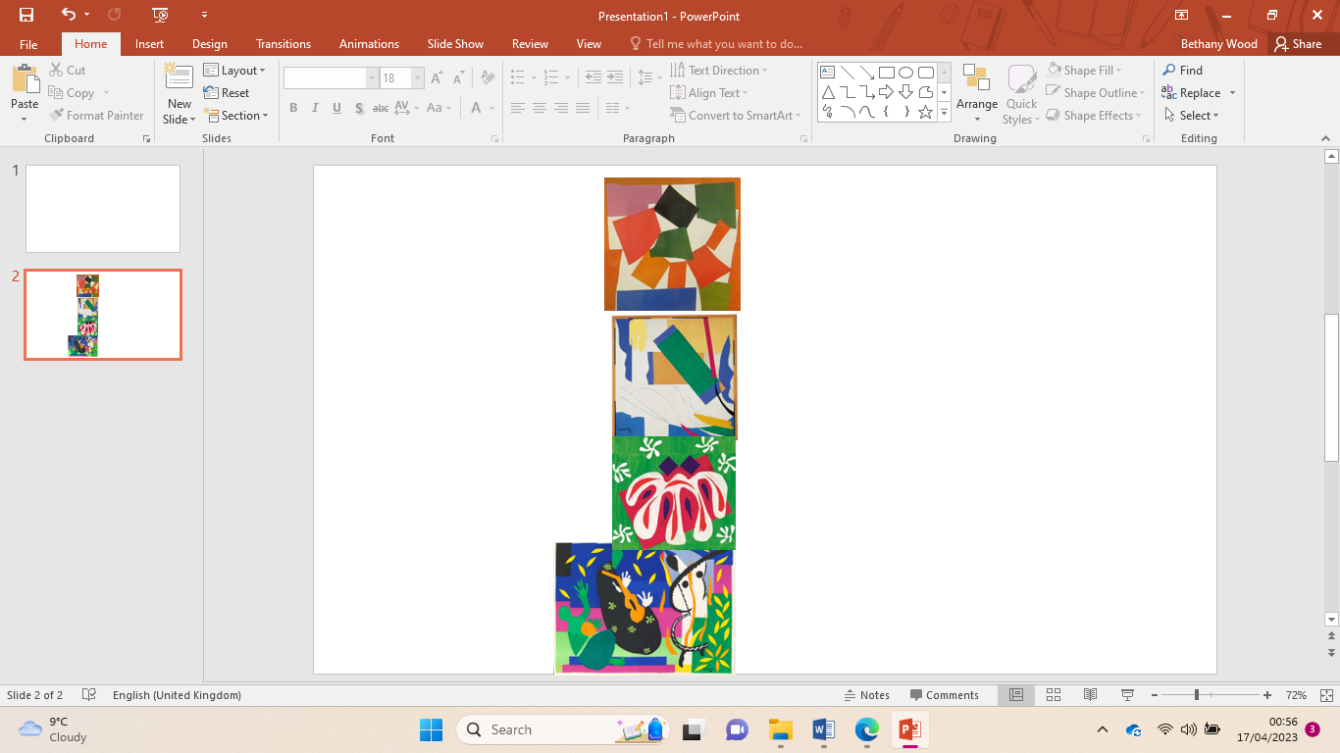

To understand how to print using a range of objects

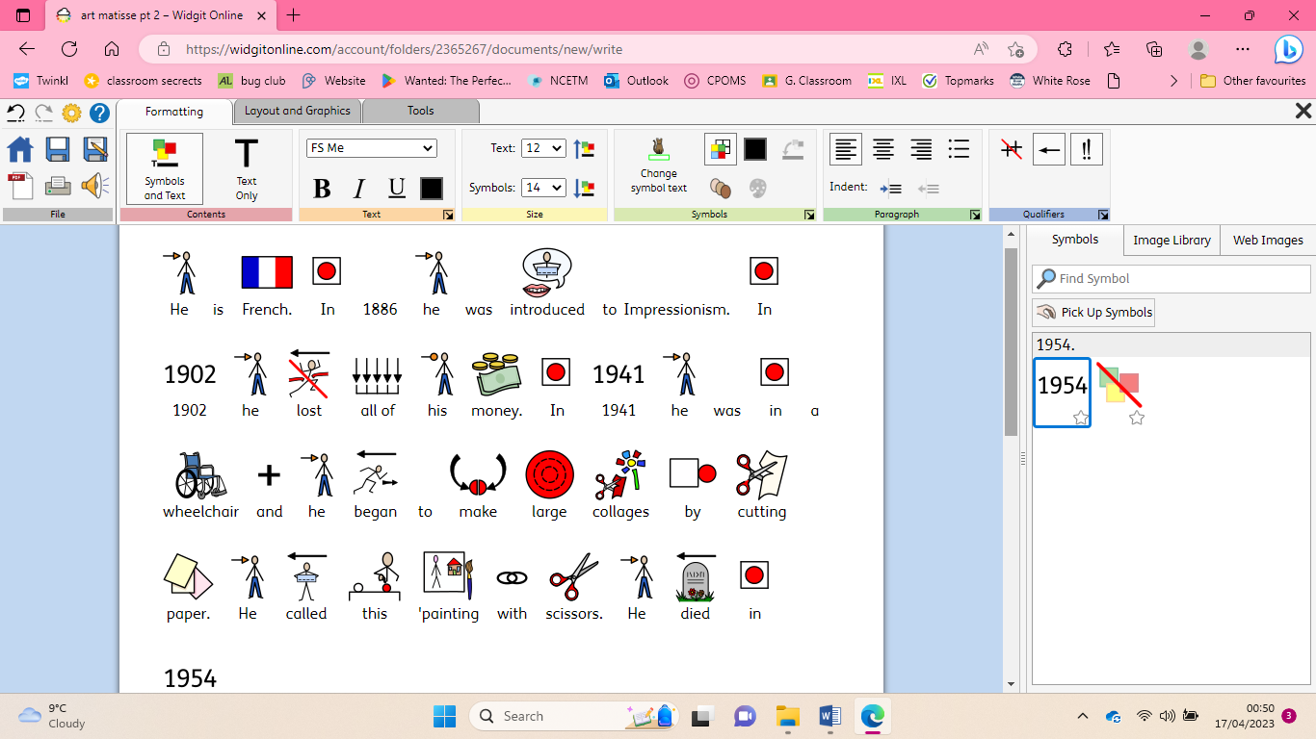

|  |
| --- |
| To understand simple repeating patterns |

To understand irregular patterns and symmetry

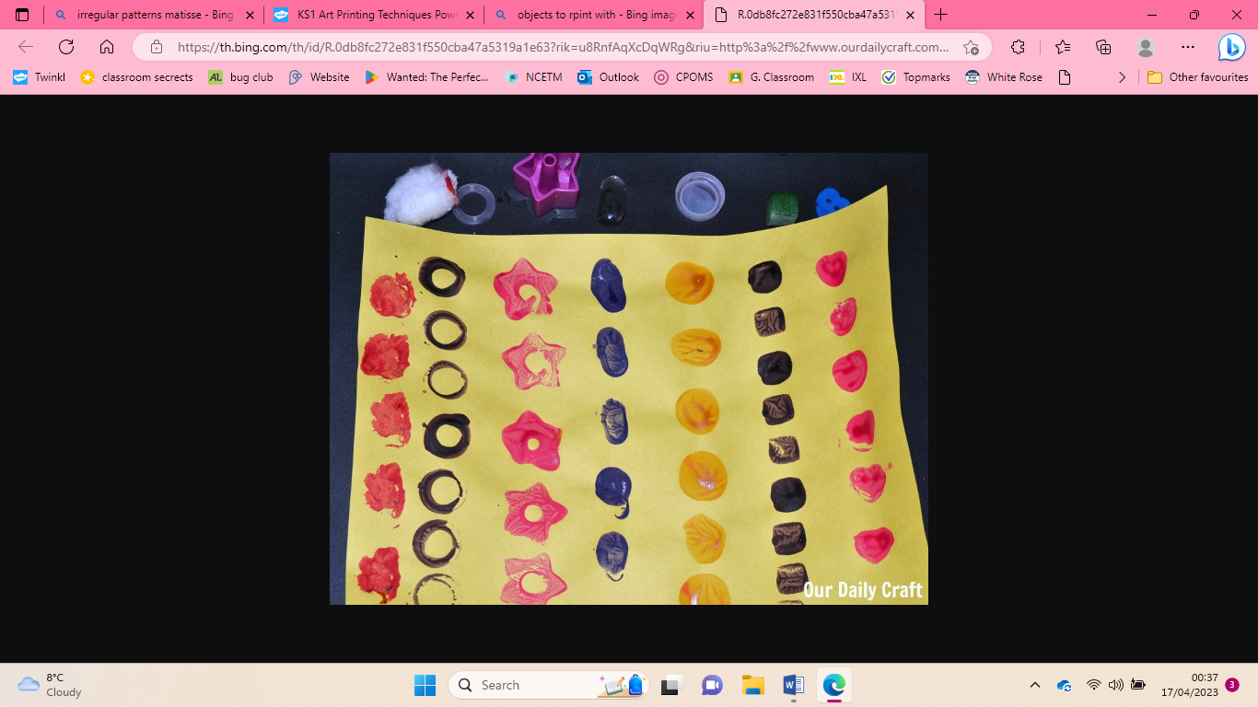

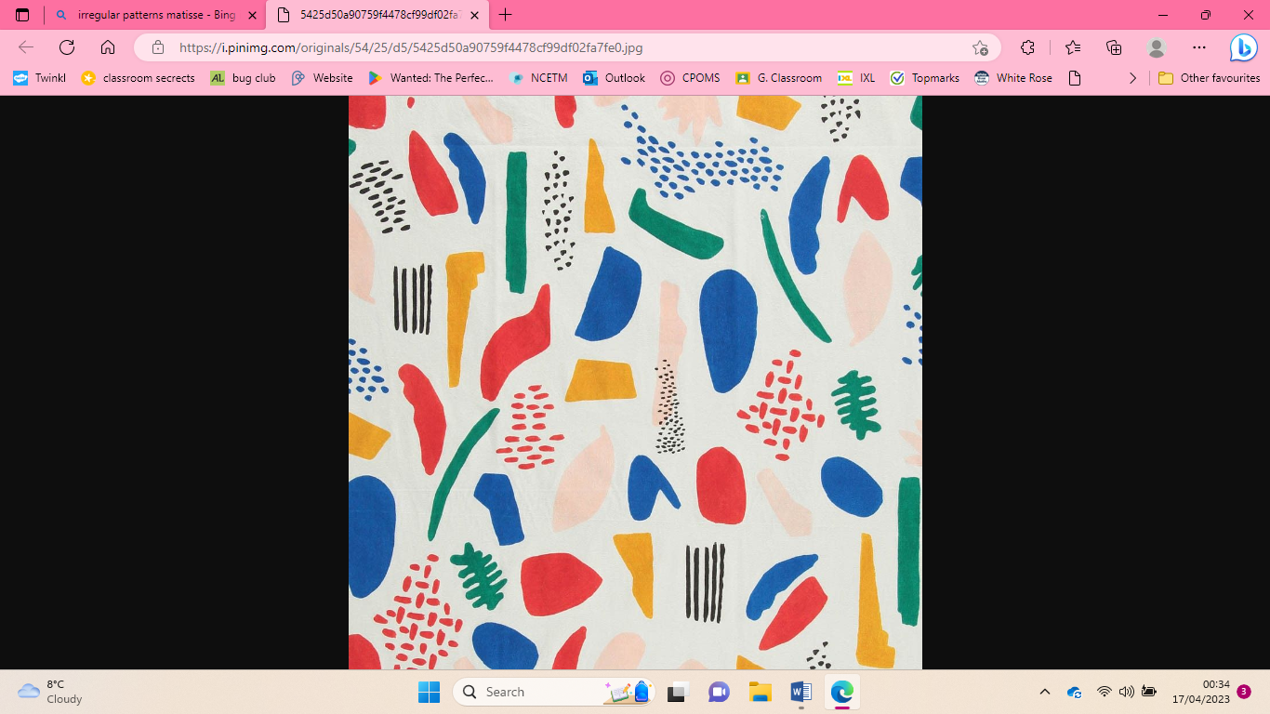

|  |
| --- |
| To choose different textures to create a simple collage |

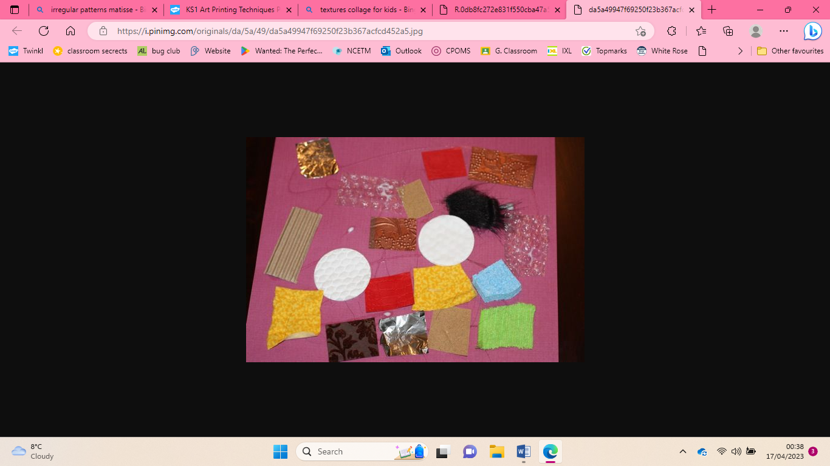

|  |
| --- |
| **Key Vocabulary** |

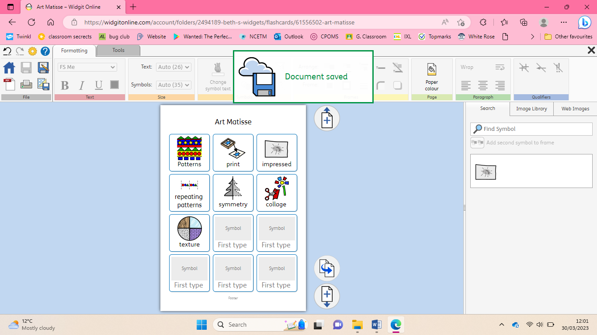

To know who Matisse was

Henri Matisse