St Mary’s Catholic Primary School
Living, loving and learning with God

Newsletter
5th November 2020

Dear Parents and Carers of St Mary’s
We sincerely hope that all had a restful half term.
For many it was a surprise to find Devon included in a second national lockdown. If you did watch the Government announcement on Saturday, South West data stood out as being significantly better than the rest of the country. The Government did explain that whilst Devon and South West data is significantly better than the rest of the country it is rising and the national picture and the direction it is heading is of serious concern.
Following this initial Government announcements there have been new Government guidelines to schools as well as some decisions that have been made for us by the central trust.
This is generally to maintain the strict controls we have had at St Mary’s since September with children remaining in individual hubs and will bring very little change for us. One change is that staff will wear face masks at all times. As a result of this staff are experimenting with a range of visors and cloth masks so you will see these changes over the next few days as each staff member finds the best face mask for their situation.
We had already expected that this half term we would not be loosening restrictions but we are sad that this is now confirmed. We are working very hard to maintain meaningful learning and to think of activities that will support the wider curriculum. All children seem happy to be in school and all are making progress. We hope that it is a source of comfort to you that schools are this time staying open for all pupils whilst so many other aspects of life are being taken away.
We are grateful to you for your on going support. Parents have been very thoughtful in notifying us of absence and the reasons why as well as working closely with Government guidelines in relation to self isolating protocols.
Blended learning
We continue to work to ensure that if any child, group of children, hub or the whole school has to remain at home then learning can be maintained.
Thank you to everyone for your on going work to support this transition. We have been using the different systems in school and setting homework to build up the children’s experience of these. These can be used additionally to encourage children to practice skills. IXL offers unlimited practice opportunities in all subjects.
We should be working with you directly if you have not yet logged on to the learning platforms. If this is not yet the case please let me know by emailing admin@stmarysaxminster.devon.sch.uk or telephoning the school.
We are so grateful to all families who are working to consider their out of school actions and interactions which are helping to keep us all safe. To date we have not had a positive Covid case amongst the school community: either staff or pupils. Within school we are working to clean all central area touch points and surfaces within the classrooms throughout the day as well as continuing with increased hand washing and limited the use of resources and no across hub contact.
For us as a whole school community, as we begin the next phase of lockdown from 5th November to 2nd December, whilst it will limit life outside of school the positive of that is that it may reduce the likelihood of a positive case being brought into school. We are hoping that by the 2nd December Devon will still be in a position to return to Tier 2.
Poppy Mae
Whilst we were pleased to hear that Poppy Mae did have her operation on Monday she is still in ICU following a very long surgery. We are keeping her and her family very much in our thoughts and wish her a speedy recovery.
Mrs Gill has been able to return to school this week. we have all been pleased to see her back complete with purple cast on her left arm.
Harvest Food Bank Collection
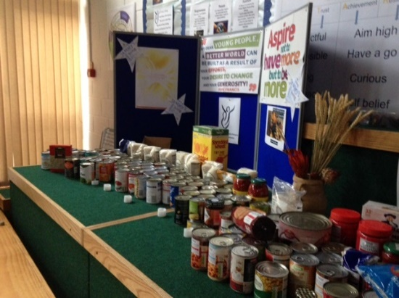
Thank you to everyone who contributed to our collection.
At this time with more business being closed again and many families returning to furloughed jobs then the Food bank will be an important support.
During half term your harvest contributions have been transferred to the empty shop window in Trinity House to give families an opportunity to see the harvest collection. If you are able to pass by with your child(ren ) please do so. It is great to see just how many items were collected.
It will be moved to The Axminster Foodbank once this can be negotiated.
Remembrance Event.
This week we are focussing on our value of respect. Classes will be thinking about what this looks and sounds like and how we gain the respect of others and show respect.
At the same time we will be making poppies for our in school display. Next week we plan to have a moment of reflection for all pupils on the field ( weather permitting ) or in individual classes to mark the end of the war on Wednesday 11th for 11.00am.
Each child will be given a poppy on Wednesday 11th November. We will put the poppy appeal collection box on a table in the playground from tomorrow. If you can make a donation, it would be greatly appreciated.
This is some of the thoughtful work from Kestrel Class. Other art work will be shared by the school website.
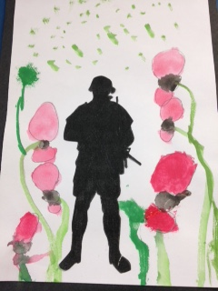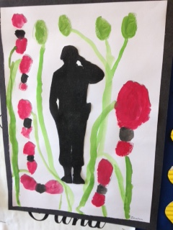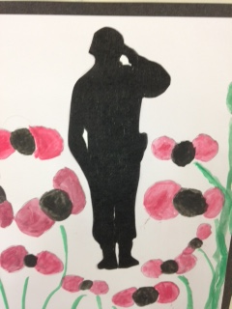

Children in Need
On Friday 13th November children can come in to school out of uniform for Children in Need. We are asking parents to make a £1 minimum contribution for this charity which is so valued for its impact on so many families and young people in the UK. Please give your child the £1 donation and we will collect it from them in school.
We will not have a fixed theme as at this time we do not think we should be asking you to buy additional items so please encourage your child to wear something that makes them feel happy but will be safe and appropriate for a school day: No high heels and suitable for these cold changeable days.
Music is still alive at St Mary’s
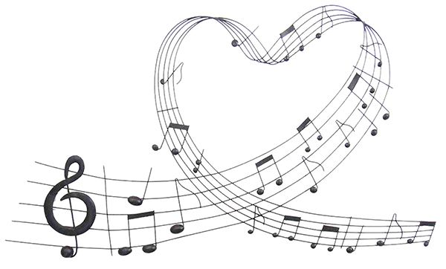
Since our return to school the singing voices of our children have been muted by Covid regulations. We all miss hearing the children singing together in our assemblies and services. Choir practice and Orchestra are adding to the gaps in our music life which is so much a part of who we are.
Despite this during lockdown and this term our musicians are still accessing one to one lessons on line and working to complete pieces and even sit exams.
In school we are now allowed soft singing and all are working creatively to keep music in the lives of the children.
Recently we purchased two second hand high quality key boards to give us the capacity to take music around the school once we can be allowed to do this again.
Quietly music is moving in the school with soft singing and signing of songs as well as clapping. We look forward to singing returning with its full joy later this year.
Musicianship is both beautiful and an important learning skill that we will not lose. Normally new recruits would have been enjoying access to music lessons, choir and orchestra but we will pick this up again as soon as we are allowed. If your child is interested in accessing music lessons then reassure them that this can happen when the Covid rules allow.
Flu vaccinations-Virgin Care
The immunisation team were in school today giving the flu vaccinations to children whose parents had given prior consent. If you did not complete the consent form and you would like your child to have the vaccine, please contact the Virgin Care Immunisation Team directly on 0300 247 0082. They will then direct you to the nearest availableclinic.

Advent and Christmas Services
Our talented music teachers, Mr Jacobs and Mrs Gibbs will be working with each class teacher to ensure that each class group uses the Christmas story as a focus using words and song. Lost of conversations and ideas have already taken place and resources are beginning to be selected. We plan to combine photos and video clips to share via the school website. We appreciate this will not be the same as our traditional advent and Christmas performance but again we will be working to give the children positive and memorable experiences despite the Covid restrictions.
Communication.
Teachers are on the playground at the end of every day and can make time then if you wish to speak to them about your child. If you do not wish to speak in front of other parents or whilst on the playground then you are welcome to phone or email. Whilst we are working to minimise in school meetings due to covid restrictions we can arrange these where necessary by maintaining 2m distance and wearing face masks.
If you do have any concerns or information to share about an aspect of your child's learning then please share these as early as possible so that we can work to resolve these with and for you.
Lunches
Thank you to all parents for your continued support in ordering lunches in advance. Our meals are provided by Devon Norse who commission Axminster Academy to prepare and deliver these. We work closely with this team and Mel, their lunch server , is very well known to our children. During lockdown and since we returned to school the team have been very flexible and work hard to deliver an effective service. They have informed us that whilst they do plan to continue to offer the stated menu there may be times when they may have to make suitable substitutions due to changes in deliveries or other factors all influenced by the current uncertain times. They apologise in advance if this is the case.
I shared a respect assembly with Woodpeckers this morning and they first shared with me their thoughts about Covid 19 and what was happening in the world. It melted my heart to hear one of them explaining that they because they were little then they were lucky because it is hard for them to get poorly so it is their job to help older people not catch it because it can make them very poorly. The whole class were filled with ways that they help from washing their hands more, not complaining about not being allowed sleep overs, and being smiley to help others feel happy.
As my mum would have said, ‘from the mouths of babes comes wisdom’.
Wishing you safe and happy times in this next phase of lockdown.
Mrs Mannix

