Character Education at St Mary’s
At St. Mary’s, we have a rich and diverse Catholic Life programme; faith permeates all we do for and with our children.
A key focus of our mission is to work with children so that they know themselves as individuals and are clear about who they are and how they fit into the world. We use Gospel Values ( the teachings of Jesus ) to shape the expectations for our shared community.

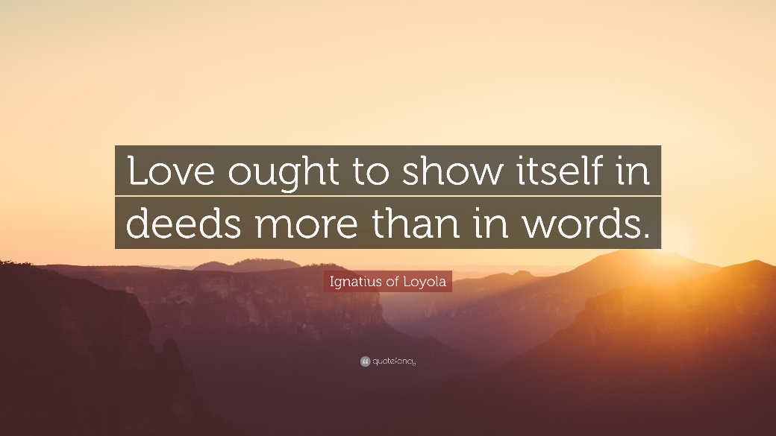

Our school values are expectations. We show who we are and how we understand the world through our actions. At St Mary’s we know that good character develops. It is a choice and we can learn it. We work together with children to celebrate good character or virtues. We work to see these values in action in our lives and in the lives of others and how we can work to encapsulate these values in our lives.
Our values and virtues are linked to our school house point system so that children can be reminded of ways that they are displaying these and how they are working to make themselves and each other more successful.
Our values and virtues also drive us to look outside of our school community top identify ways that we can spread God’s light to others.
The children experience intrinsic spiritual development as they mature and learn who God is calling them to be through the understanding of the virtues.

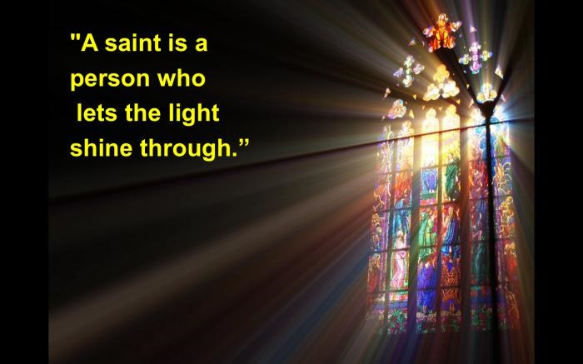
We say and we live that we want each of our children to be called to their greatness. We want them to feel proud and strong in who they are. We want them to know their areas of skill and their areas of development and work to challenge themselves to be the best they can be. Our values and virtues help us to achieve this together.
Values are what we state we want to be. Virtues are the positive expression of those in our lives.
St Mary’s Values and Virtues
Achievement
Aim high
Have a go
Curious
Self belief

Forgiveness
Respectful
Caring
Value each other
Caring
Resilience

Foundation values
Humility
Forgiveness
Integrity
Peace
Courage
Compassion
Kindness
Justice

