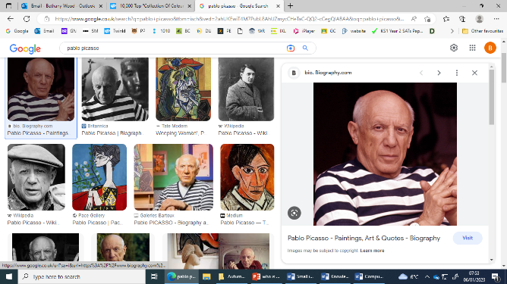

To understand what Cubism is





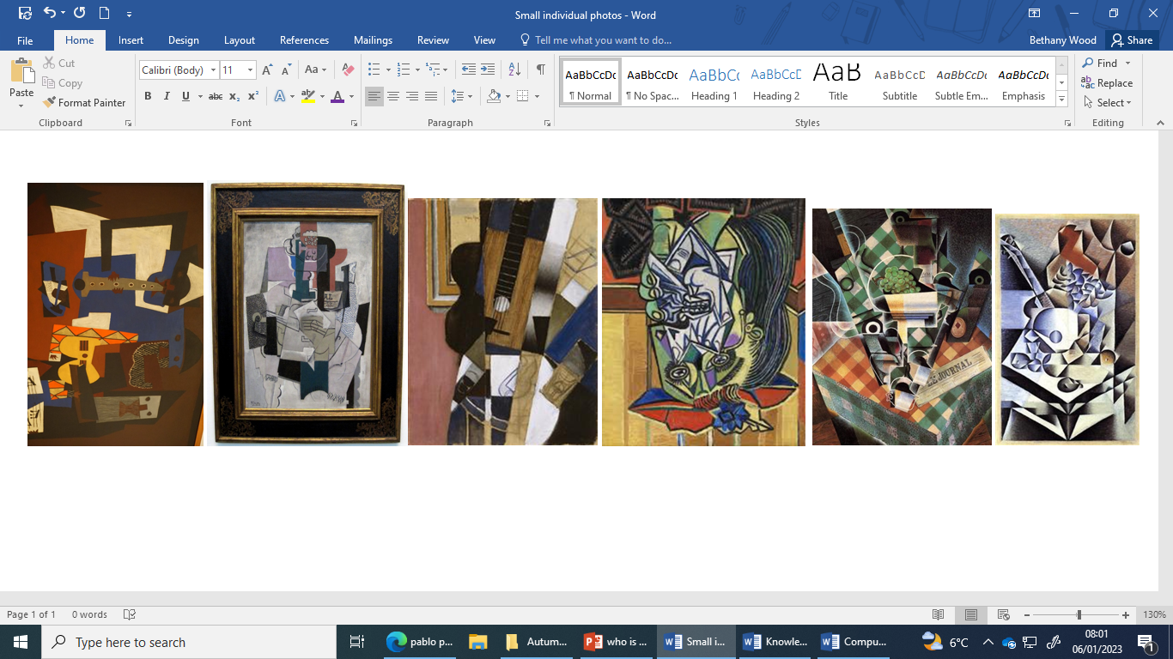

He wanted to paint things that he felt, remembered and saw all in one painting.

He was born in Spain but he lived in France.

To know who Picasso was

He was one of the first artists to explore Cubism!

To use paintz to create this on the computer

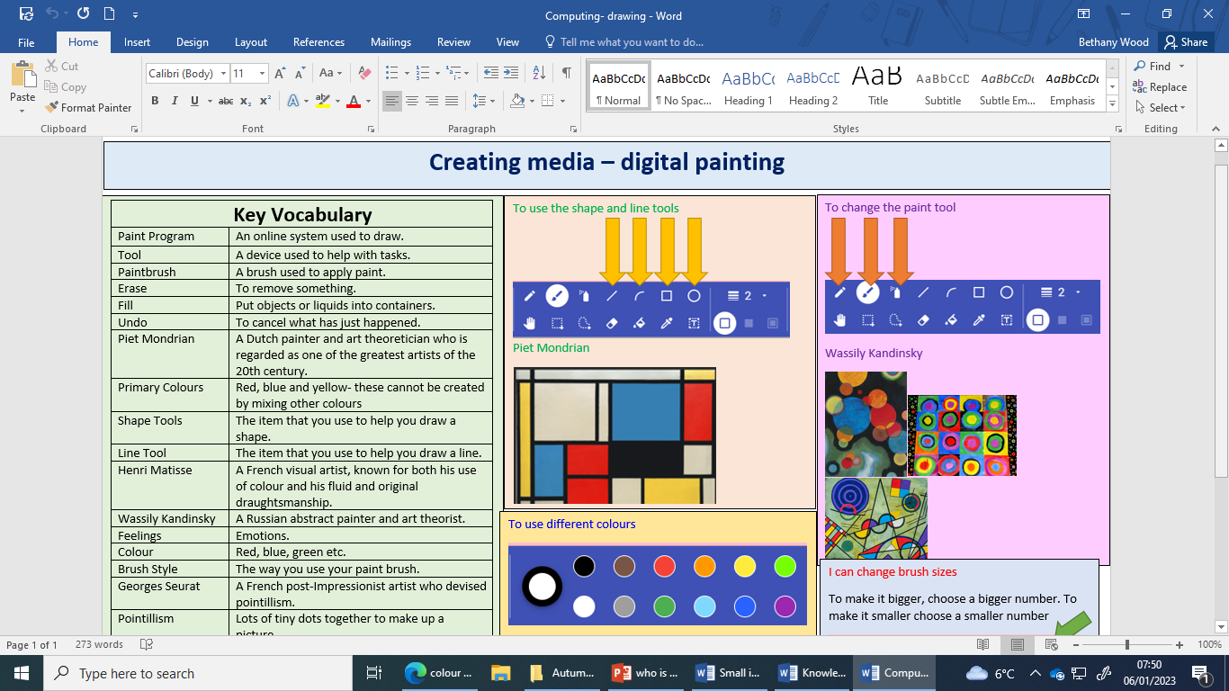

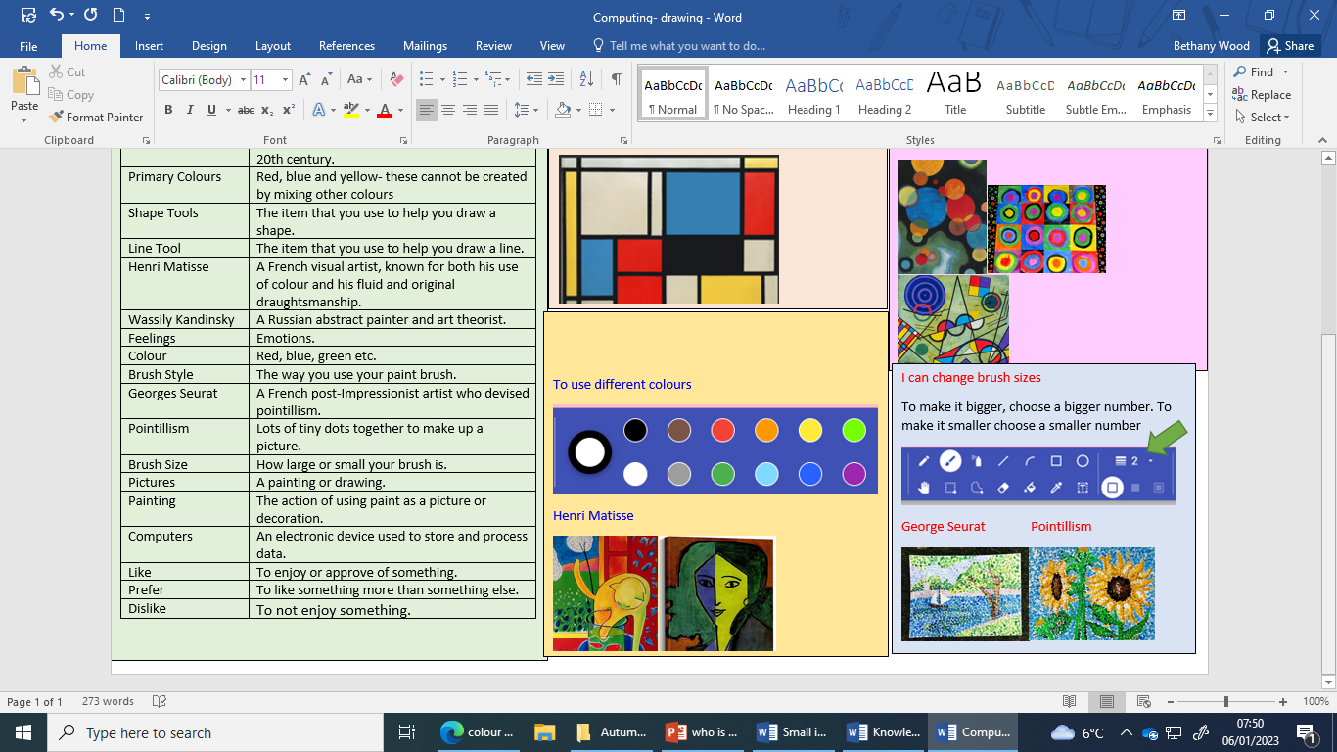

|  |
| --- |
| To know how to create secondary colours |

Secondary colours are made by mixing primary colours together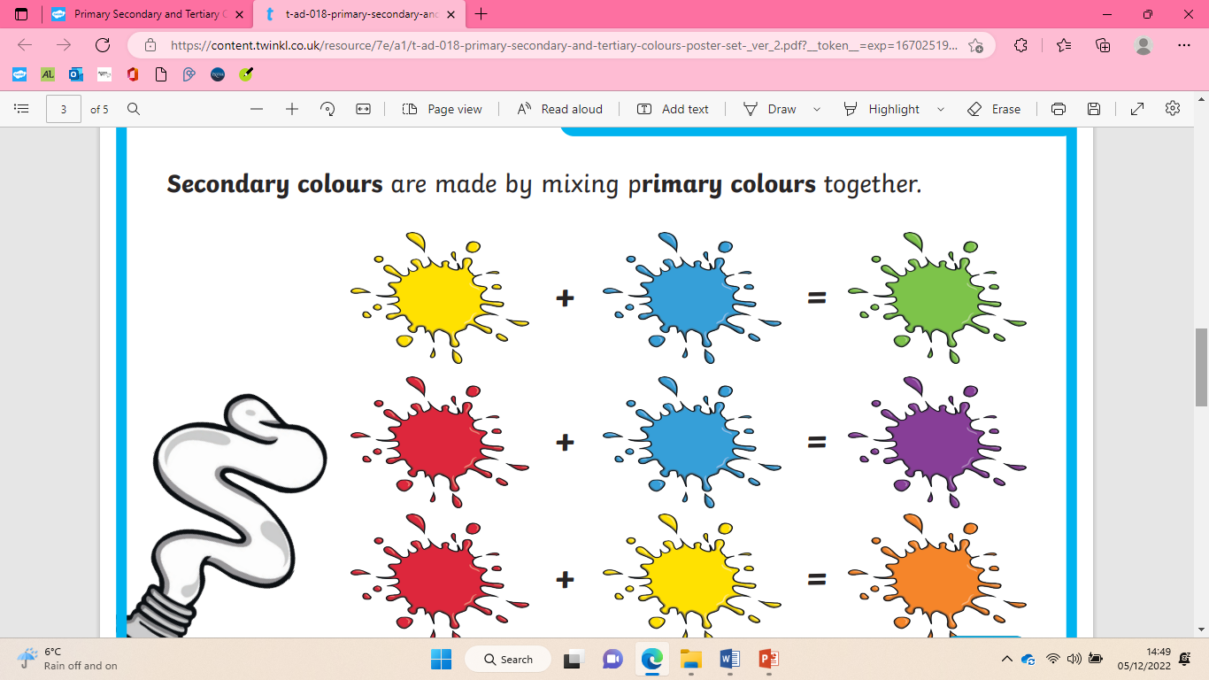

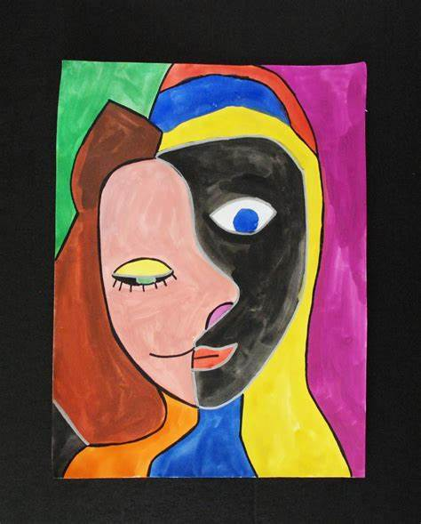 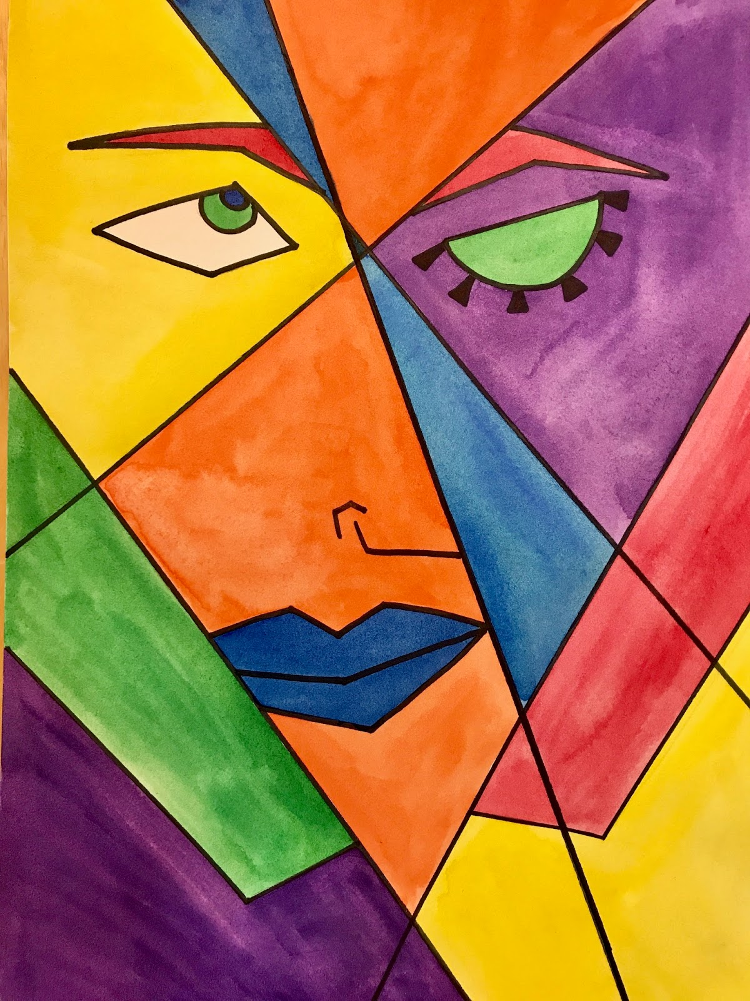 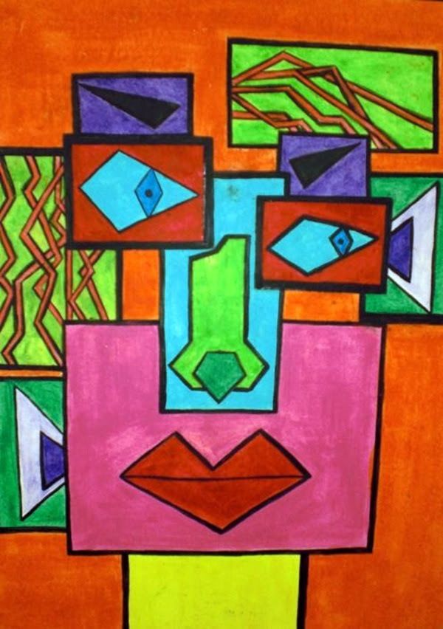

To draw a cubist style piece

|  |  |
| --- | --- |
| **Key Vocabulary** | |
| Pablo Picasso | Was an artist who helped invent cubism |
| cubism | A style of art made by breaking an image into different parts |
| Secondary colours | Made by mixing primary colours together- green, orange and purple |
| Colour | Different shades that we can see. For example red, blue, green |
| Paint | Liquid that can be used to colour a surface. |
| Collection | A collection that has been gathered together. |
| Apply | To put on something. |

Cubism