29th March 2019
Newsletter
Cafod – making a difference together
Children took their ‘give it up/ take it up’ envelopes home last week and should be working on something at home to raise a little pot of money for our Lenten cause CAFOD. We have been thinking about what is important and what we sometimes take for granted: fresh water, food each day, a home that keeps us safe from the weather, access to medical care…..and that we can all do something to make a difference to the lives of children and families around the world who have very little to keep them safe and healthy.
These envelopes can be returned next week and collected for our Friday Celebration Assembly. If you have misplaced the envelope any envelope is fine.
Thanking you in advance for your support and encouragement

School Council Eco Warriors
Our school council has been taken part in some research around school to look at how tidy some areas of the school are : cloakrooms and the library were areas they wanted to work on to improve. This lead them to think about the rubbish we generate at St Mary’s . On Tuesday they spent the morning with Sally ….. a member of the Devon Recycle Team thinking about the 3 RS : Reduce , Reuse, Recycle. We collected one days worth of school waste and they had the pleasure of auditing it …all of it. From this they will have an action plan which will include selecting new combinations of bins and education us on ways to improve on our 3 RS here at St Mary’s.
Sports at St Mary’s
Gymnastics with Axminster Gym Centre and Colyton Grammar school
Eagle and owl class started a gymnastic unit by visiting Colyton Grammar School where they took part in learning a gymnastics sequence. Back in school over the last six weeks they have been developing and refining their own sequences with the guidance and expertise of Emma from Axminster Gymnastics Centre. They will return to Colyton next week to perform their completed sequences.

Congratulations to all of our Woodpecker pupils who have enjoyed much success in their swimming this half term.

Balancability
Robin Class have been enjoying much success on balance bikes this term. It has been a great confidence builder as well as a great listening and focussing experience for our youngest pupils. What an adventure they have been having.
Colyton Science Workshops
Year 5 have been taking part in a series of science workshops with Mr Lynch from Colyton Grammar School, who has been supported by sixth formers from Colyton. Year 5’s have enjoyed much success exploring the scientific ideas of friction and sound. They then had to design and carry out a science investigation of their choice, write it up and present it to Mr Lynch. The investigations were judged by Mr Lynch and the Colyton Grammar School Sixth formers. Congratulations to Grace and Baraj who were crowned winners in the final workshop this week and will now take part in a summer science workshop at Colyton.
PTFA Easter Garden Competition
Easter Gardens can be celebrations of spring or of the Easter season. Last year we had so many lovely entries. Please bring finished gardens into school for Wednesday next week. Below are some examples. See our website for more of the entries last year.
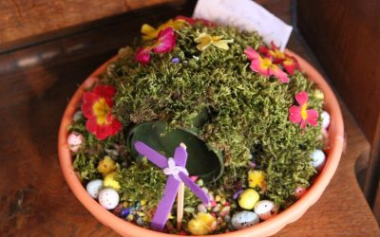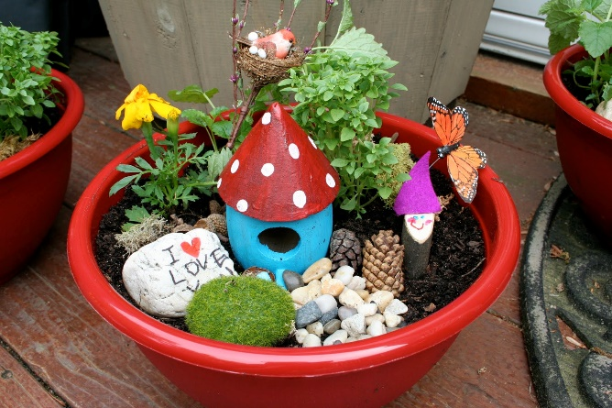
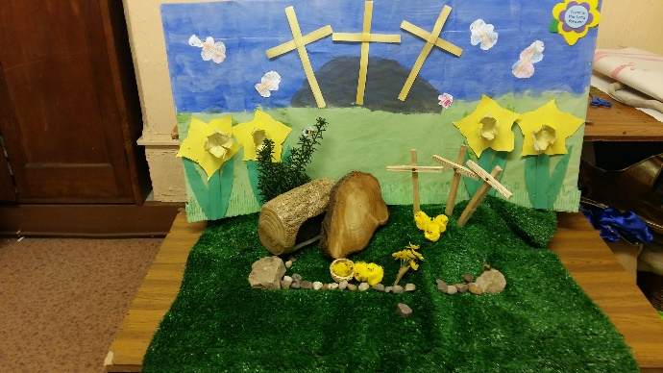

Holy Week Reflections
Next week each day in our morning assemblies we will journey through the main events in the week before Easter. Kestrel class have been preparing the art work for the stations of the cross and will be leading our assembly on Thursday morning. The art work will be in the hall next week. When you call in for parents information evenings next week do take the time to look out for this beautiful work.
Summer Uniform
After such rainy and wintery weather for so long it seems odd to be talking about summer but we will be in the summer term as soon as we return after Easter. This includes our navy polo tops and blue and white striped dresses. Children can remain in shirts and ties if desired.
Polo tops are available from Honiton Sports and are for boys and girls. Our official summer dress is a navy blue and white vertical striped dress.
Improvements around school
In the last year there have been a series of upgrades at school, including a new roof in the admin area at school. This has been part of on going reviews of the environment. The roof was leaking badly and caused much disruption to admin functions.
You may have noticed further small improvements: a desk and chairs in the reception area and a new front door. Over the holidays the reception area will have new carpeting.
At a time when across the country many are protesting about the lack of money in education you may be concerned that we are not prioritising well. Please be reassured that improvements to the school environment are funded from a different source to the every day money available for teaching and learning, We have a series of works that are making the school safer as well as more functional, alongside detailed action plans to continue to improve learning opportunities for all of our pupils.

Forest School Holiday Event
On Wednesday 10th April pupils can access a half day of forest school with Cara, our forest school leader. Woodpecker Class pupils currently work with Cara each week. She is extremely knowledgeable and experienced in working with children to explore the natural world. Any questions about these events please do contact Cara directly via email at cara_jenkins@btinternet.com. Booking forms are available from the school office.

School meals next week
In the run up to Easter, next week the puddings will have an Easter theme. There will be chocolate Easter mini egg nests and Easter biscuits.
Bags to school
You will have received a plastic bag in your child’s book bag for the collection of any old clothes. Last year we raised £100 for the school from bags to school. They will be coming again on Wednesday 1st May. If you do have any unwanted clothes please do collect them for us and bring them in on the morning of 1st May.

Gymnastics display
Parents of Robins, Owls and Eagles parents and carers are invited to watch their children's class gymnastics display on Wednesday 3rd April. Please see below for times for each class:

Robin Class: 11:15am
Owl Class: 1:45pm
Eagle Class: 2:45pm

Please come along if you can.

