

Who can we talk to about any of this?

|  |
| --- |
| Stranger danger |

* We know that if we meet an adult who we do not know we only approach them or talk to them if we have a trusted adult with us. we do not talk to strangers unless if we are with a safe adult.

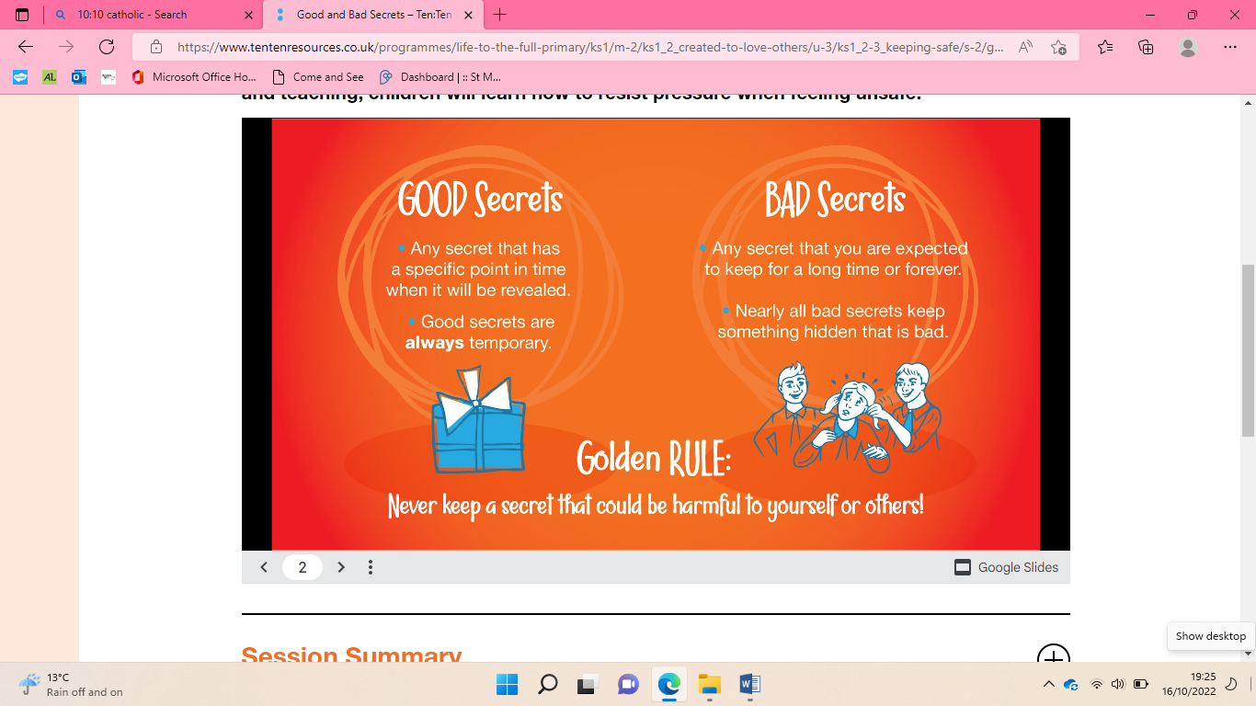

We have the right to say NO! and STOP!

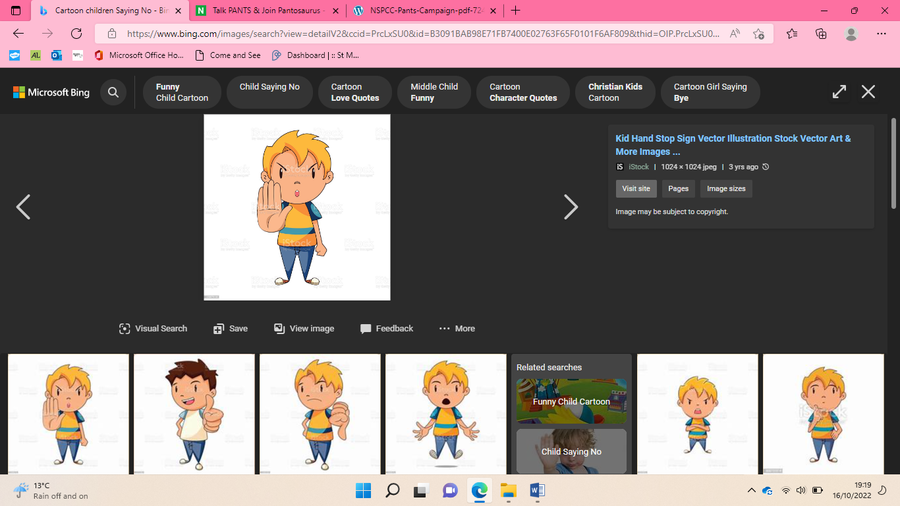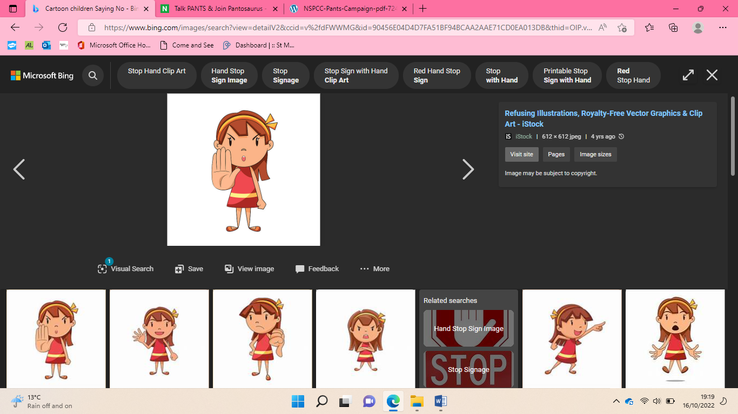

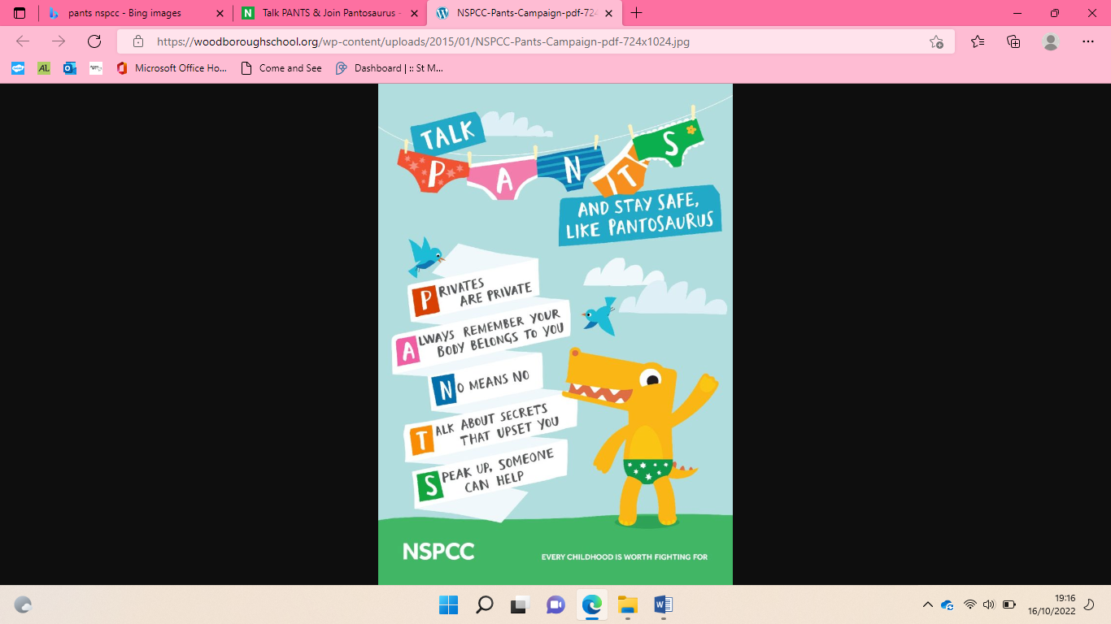

|  |  |
| --- | --- |
| **Key Vocabulary** | |
| Secrets | Something that is not known to certain people, it is kept from them |
| Good | When something nice or acceptable is happening |
| Bad | The opposite of good, when something not nice is happening |
| Safe | Protected from harm |
| Unsafe | When you are not protected from harm |
| Worrying | When something concerns you |
| Uneasy | When something does not feel right |
| Help | Make situations easier for people |
| Trusted adults | People in our lives who we know are there who will help to keep us safe |
| PANTS rule | How to stay safe (see to the right) |
| Childline | People young people can call if they do not feel safe |
| Safe hand people | Trusted adults in our lives |

Safe relationships