St Mary’s News April 2022

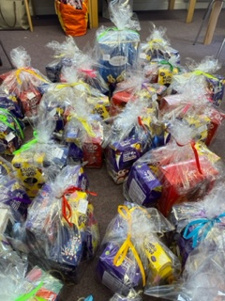
Thank you again to everyone involved in making the Easter Raffle a success. We were able to give 30 lovely prizes out and we raised £326.00 in total for the PTFA.

Our Easter Journey
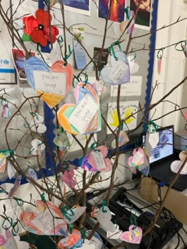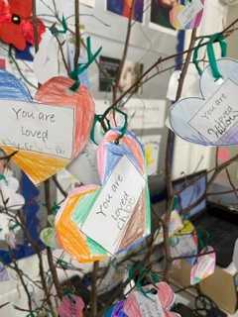
An individual heart for each of our unique and special children
We started Lent with everyone in our school making a heart to remind us that we are special and loved. Amazingly once each heart was put on our tree each heart was totally unique.
Each time we have gathered together we have started with a reminder that we are loved. Children have really enjoyed turning to each other to remind us; ‘You’re a special person.’
Throughout Lent we have been reflecting on our values and working to help children shine and be the best that they can be. It has been a gentle journey in reminding children of all that we have in our lives – we have not been reflecting on Ukraine at this time but we have mentioned that around the world not everyone is able to be as safe as we are.
Children have brought home an Easter activity booklet which we are kindly given by our parish.
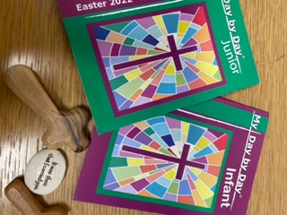

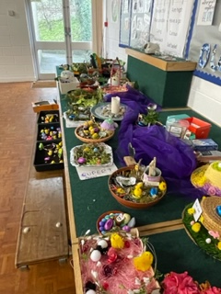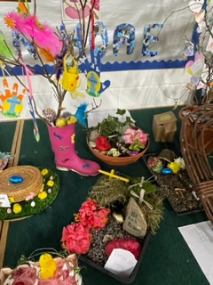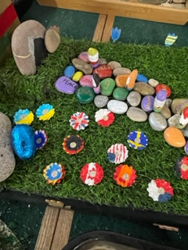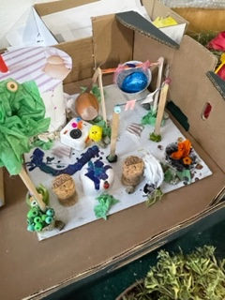
Easter Gardens and Hats
Thank you to all of the families who took time to make a garden or hat. Our celebration assembly today was brightened by the wonderful display of thoughtful and creative work.
We did not have winners but each of them has been given a chocolate treat as a thank you.

End of term
This term has brought lots of challenges with so many children and staff being absent due to Covid. There has been much juggling and staff working hard to keep teaching and learning at the centre.
At the same time, we have been working to move forward with lots of staff accessing training and developing skills to further support the progress of our school.
You will be aware that we have been able to grow our activities, trips and visitors and we look forward to continuing that journey after Easter.
We are extremely grateful for your continued support.

Easter Camp
A reminder that Mr Murnane will be running an Easter Camp at St Mary’s during the holiday. He is still taking bookings if you want a place.

Easter Learning
Of course we do want children to take a break and to enjoy being able to get out into the world but if you are able to give time to encouraging your child to do some reading, spelling and number work practice that will help to continue to close gaps in learning. This can be done via IXL or other on line learning platforms as well as with resources we have given the children.

Covid going forwards
You may be aware of Government changes to try to give Covid the same status as other illness. One of the most visible signs of this is the lack of tests. These are now only available to a small number of reserved professions.
After Easter children should only be away from school if they are too ill to be in school as we take the final steps in learning to live alongside Covid.

Easter a season of hope
Easter is the most important celebration in the church year. It is a time when we celebrate hope. We all need to breath in this sense of hope as we step forwards.
Thank you again for your continued supported
Wishing you a very happy Easter from all at St Mary’s
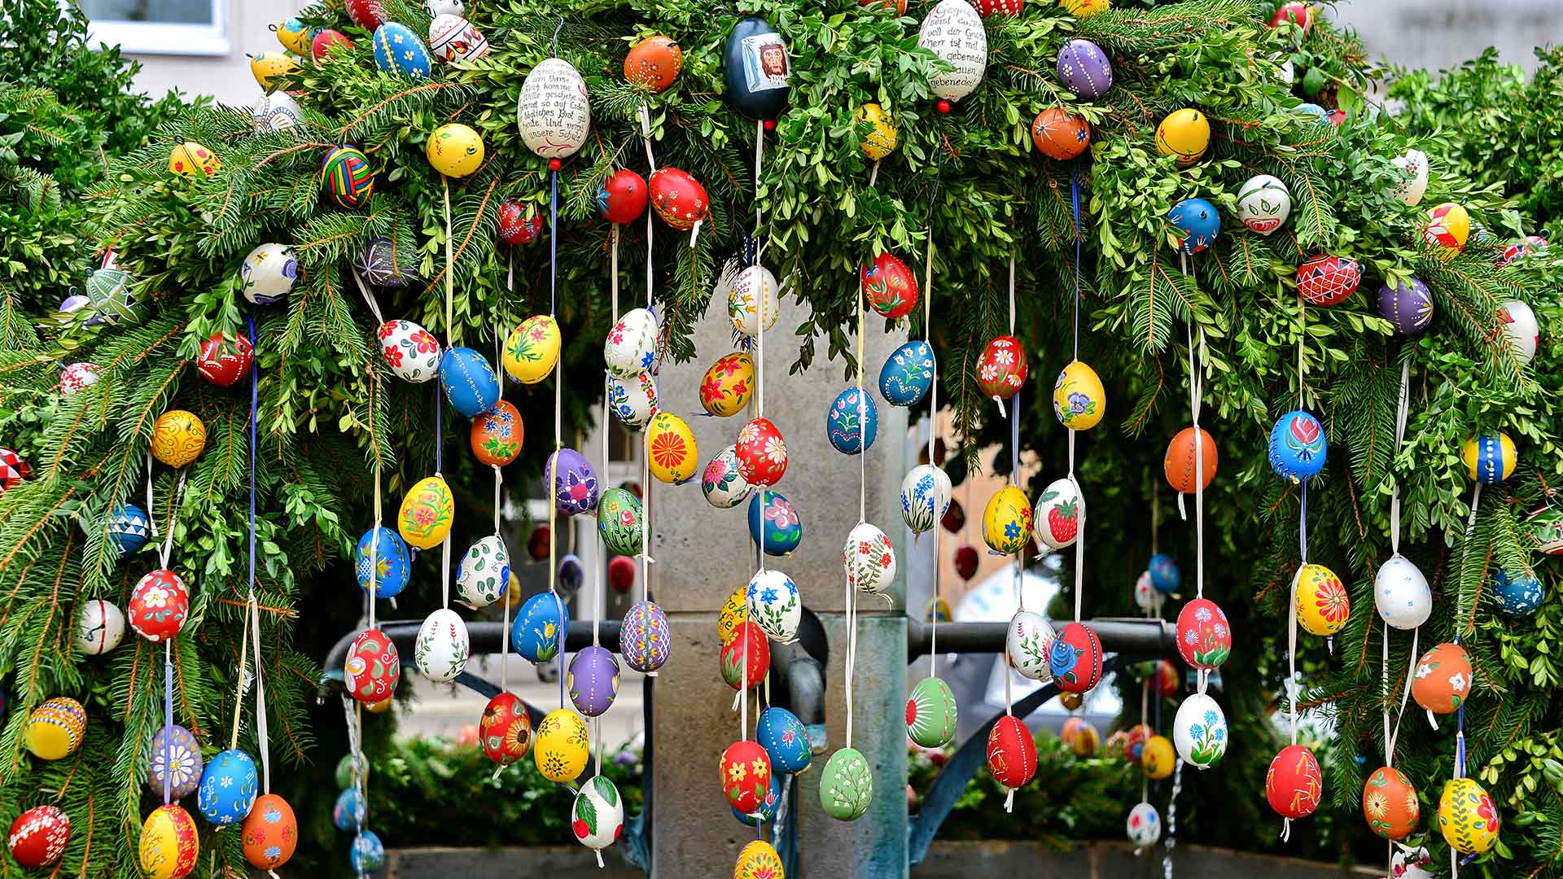

We return to school on
Monday 25th April 2022

Have a safe and happy Easter

