To describe the structure of birds and mammals

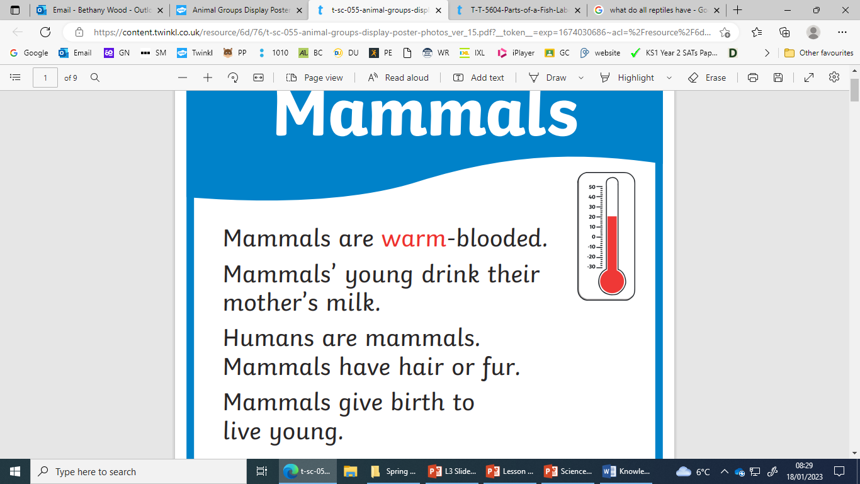

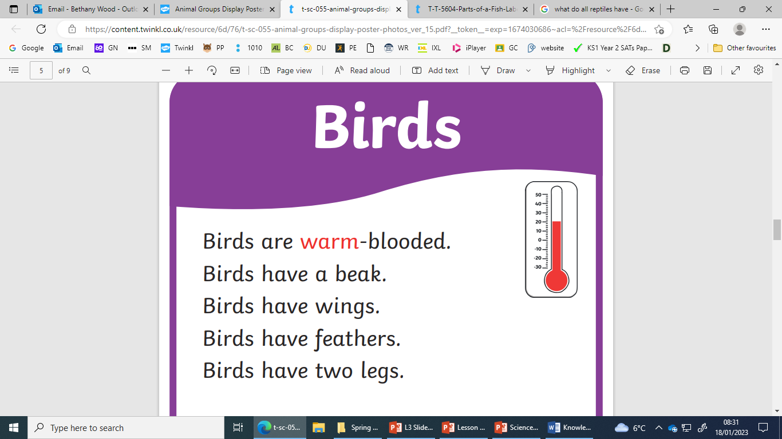

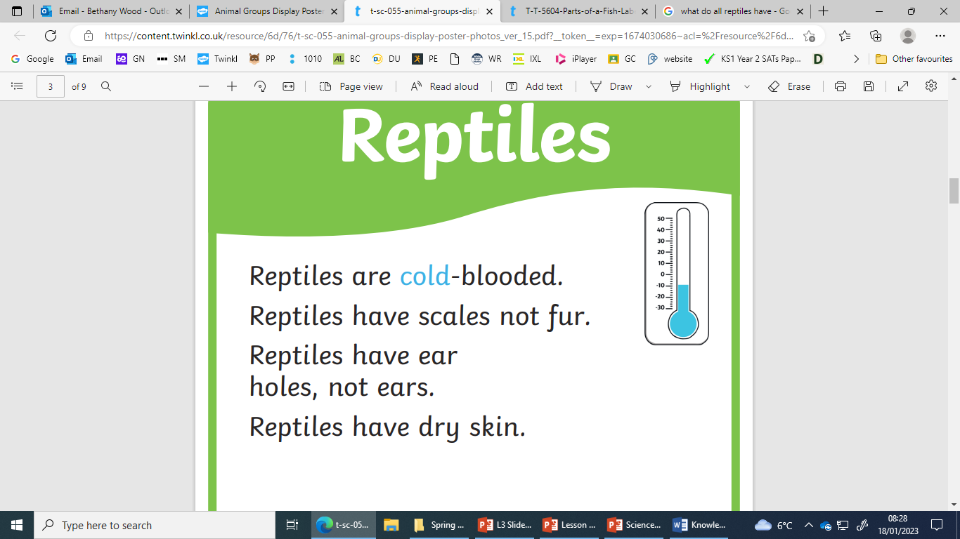

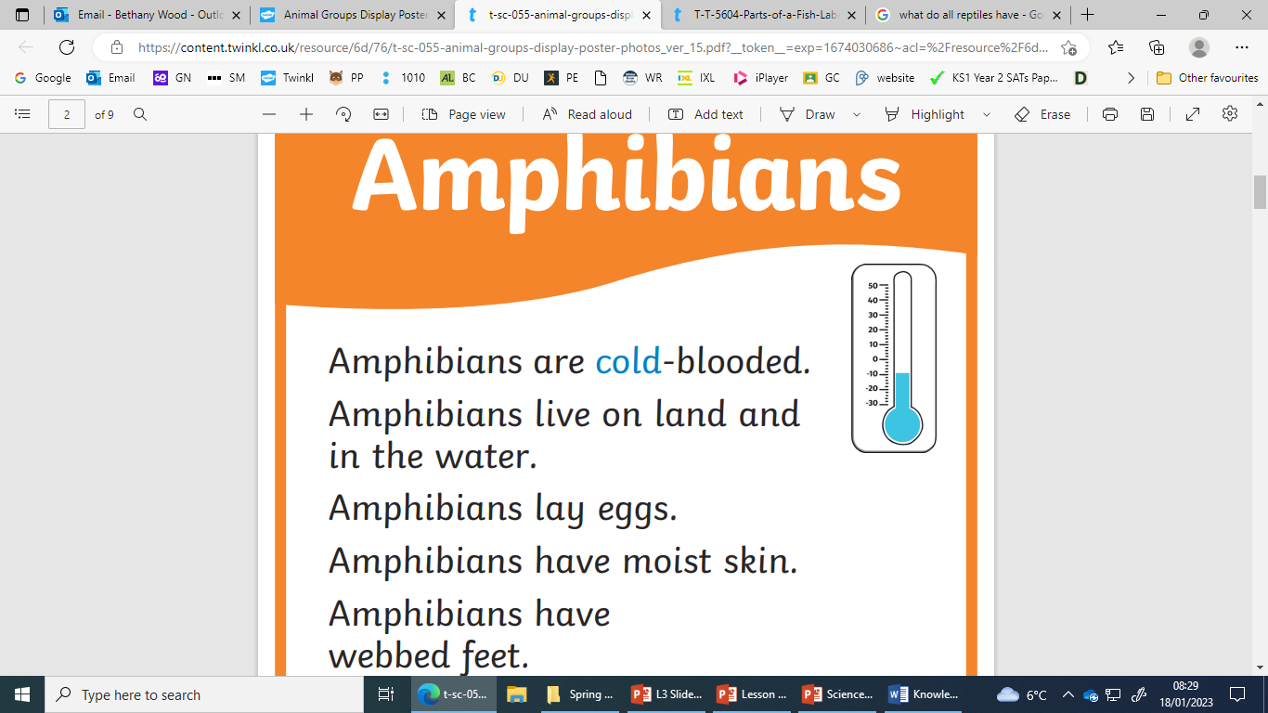

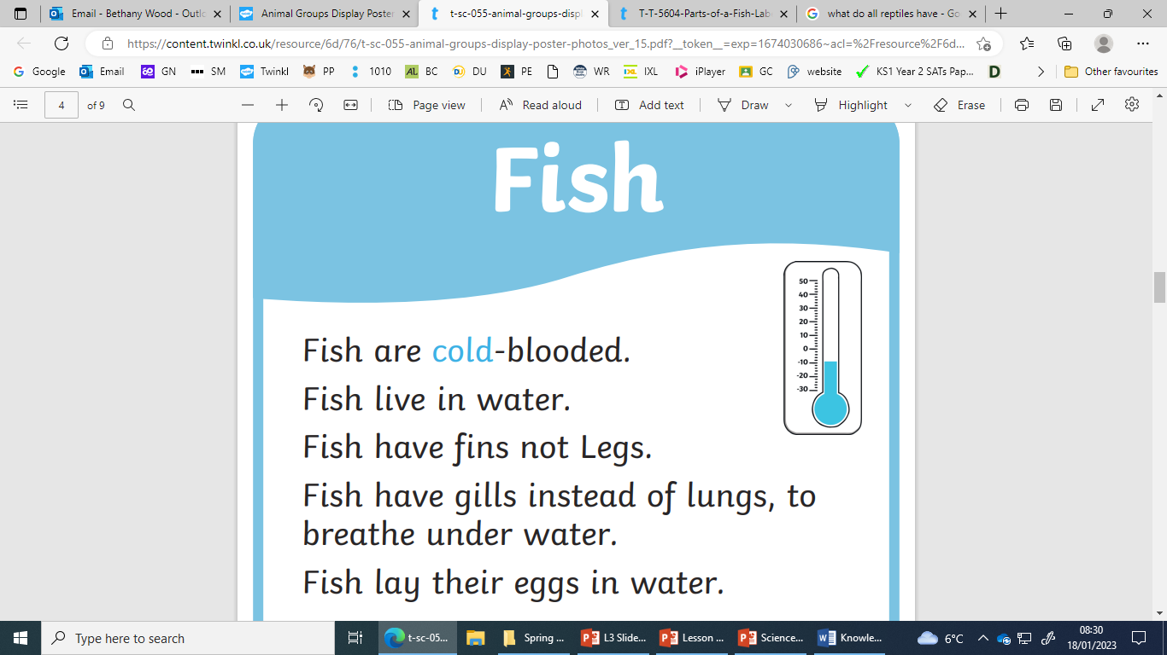



To describe the structure of fish, amphibians and reptiles

To identify and name a variety of common animals including fish, amphibians, reptiles



|  |
| --- |
| To identify and name a variety of common animals including birds and mammals |



|  |
| --- |
| To identify the parts of the human body |



To identify the parts of the human body associated with each sense

