Giant Jaffa cake recipe

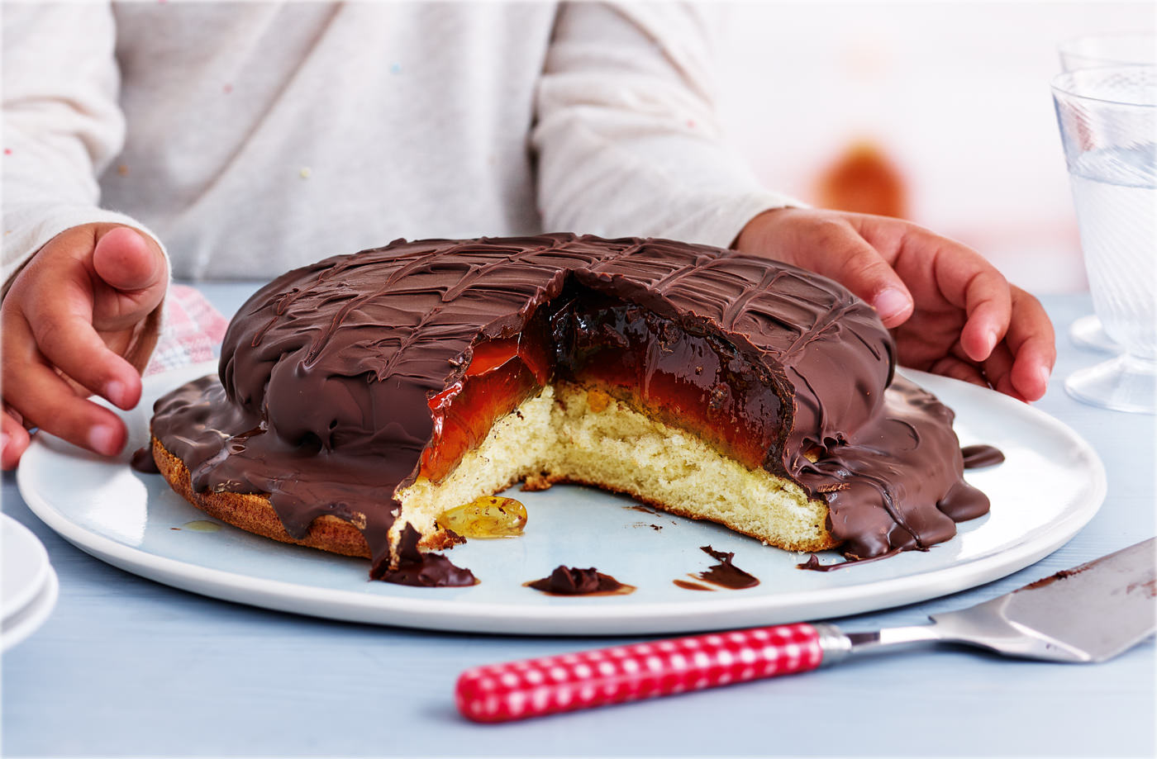

Ingredients

For the jelly
  - 135g pack orange jelly
  - 2 tbsp. shred less orange or golden marmalade

For the sponge
  - 2 eggs
  - 75g caster sugar
  - 75g self-raising flour
  - 275g gluten free dark chocolate

Method
- Break the jelly into cubes and put in a heatproof jug with the marmalade. Pour over 350ml boiling water and stir until the jelly has dissolved and the mixture is completely smooth (see tip). Pour into the 15cm lined tin, set aside to cool completely, then transfer to the fridge to set for 4 hrs.
- Preheat the oven to gas 4, 180°C, fan 160°C. To make the sponge, whisk the eggs and sugar, using an electric hand whisk, until pale and fluffy. Fold through the flour, taking care not to knock out the air. Pour into the 23cm lined tin and bake for 12 mins, or until firm to the touch but still springy. Leave to cool in the tin for 10 mins, then turn out onto a wire rack to cool completely.
- Put the sponge on a plate. Remove the jelly from the tin, using the Clingfilm to help, and put on top of the sponge.
- In a non-metallic bowl, microwave the chocolate for 30 secs at a time, stirring in between. (All appliances vary. Adjust times according to your particular microwave oven.) Continue until nearly all the chocolate has melted, then remove and stir until completely melted.
- Spoon the chocolate over the cake, spreading with a palette knife to ensure an even layer over the top and allowing the excess to drip over the sides. Let children gently drag a teaspoon handle across the top to make a crisscross pattern in the chocolate. Chill in the fridge for 15 mins to set. Serve at room temperature. Warm a knife by dipping in hot water; dry, then cut and serve.
Tip: If the jelly cubes aren't melting, microwave in 30-sec bursts, stirring in between.

