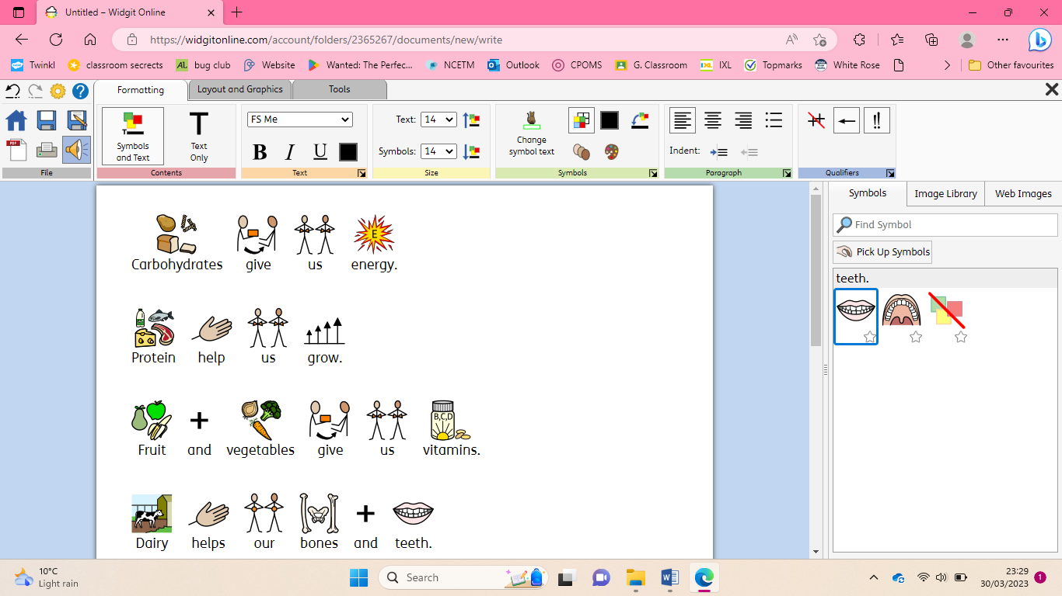

I can name foods that support good health and I know why too much sugar is not good for me

I can talk about ways to keep safe in the sun

I know why too much sun is unhealthy

I can talk about ways in which the sun can damage our skin

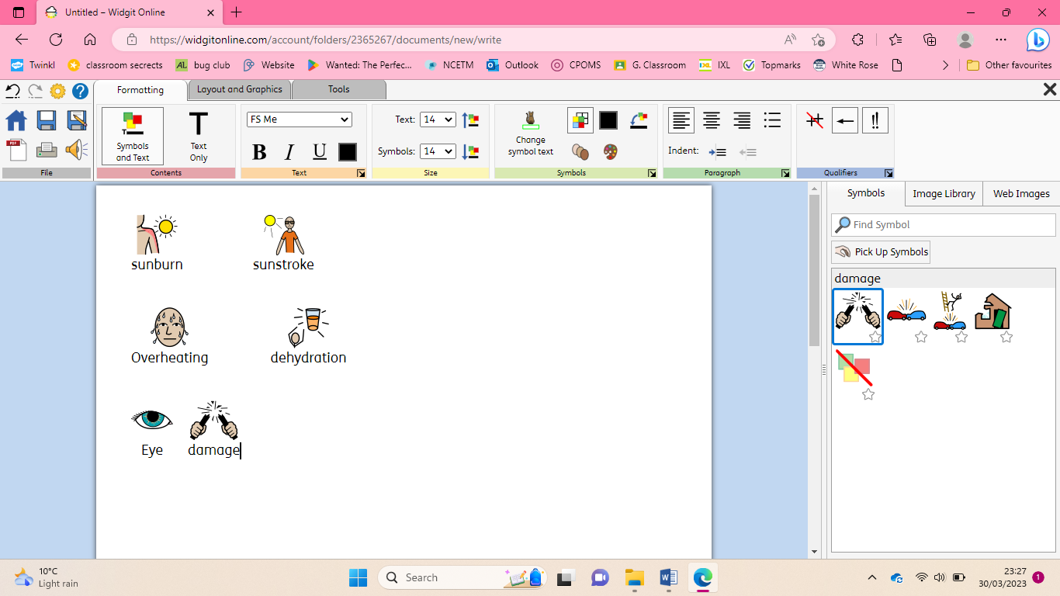

|  |
| --- |
| I know that physical activity helps to keep me healthy and I can talk about physical activity I enjoy |

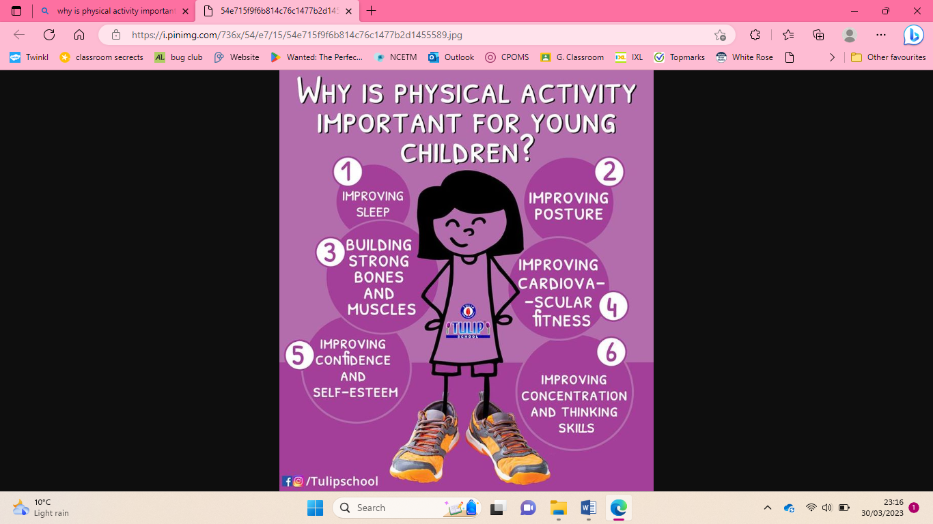

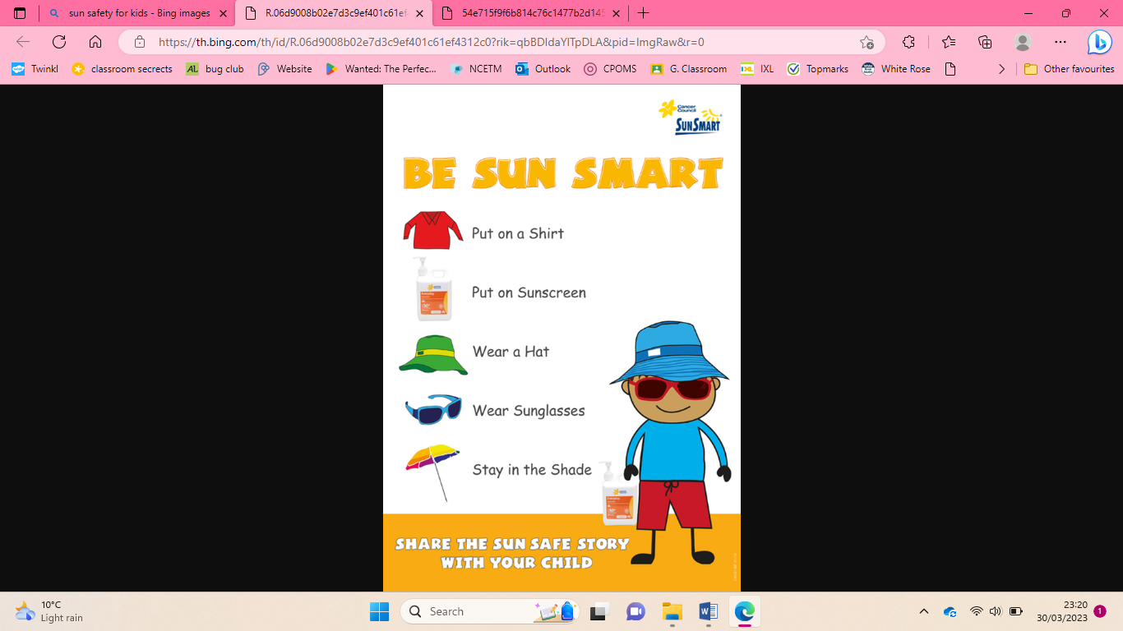

|  |
| --- |
| **Key Vocabulary** |

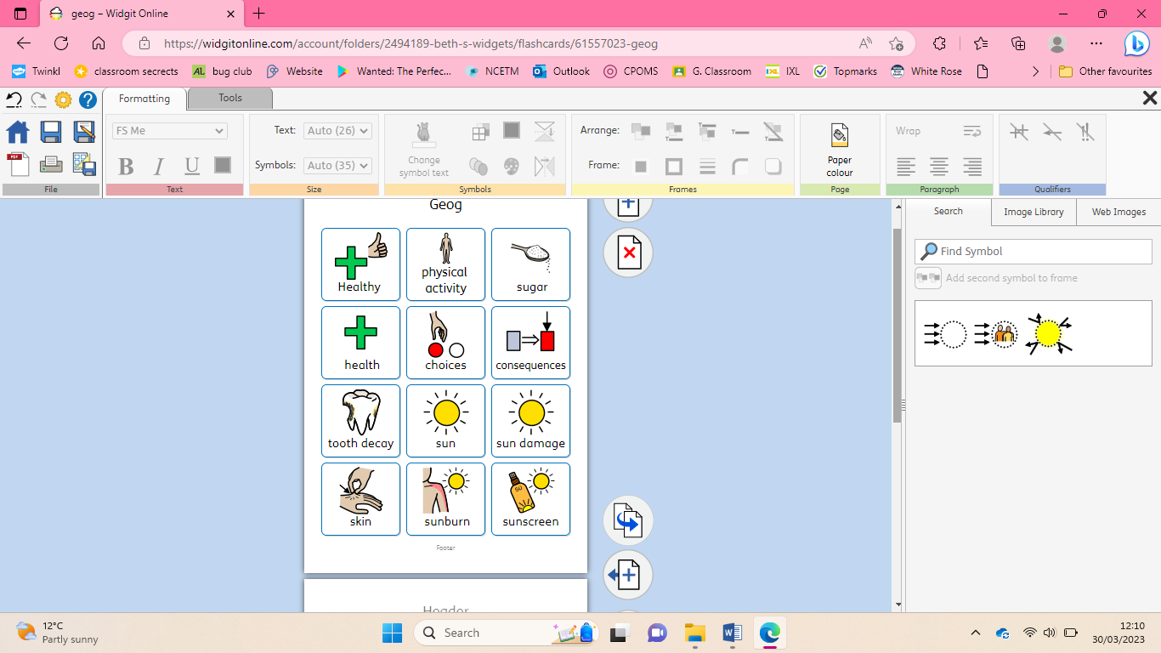 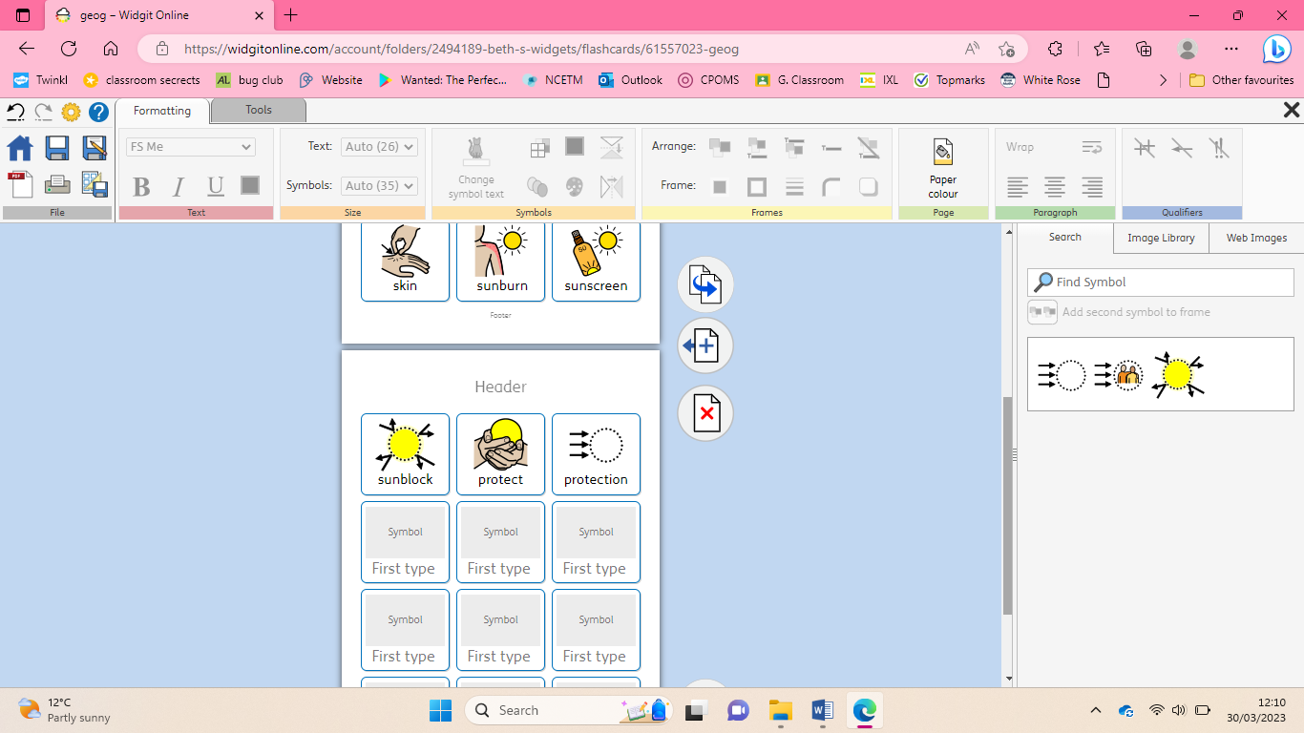

**Physical health and mental well-being**