|  |  |
| --- | --- |
| **Key Vocabulary** | |
| **Respect** | Appreciation for someone or something. |
| **Respectfully** | Talking (or behaving) with appreciation of someone or something else. Being respectful is the opposite of being rude / disrespectful. |
| **Calm** | Not feeling or showing any strong emotion. |
| **Disagree** | To not agree with someone or something. |
| **Debate** | To discuss calmly, using evidence to support your ideas. |

I know how to speak respectfully and politely to others, even when I disagree.

Respecting ourselves and others – Year 5 / 6

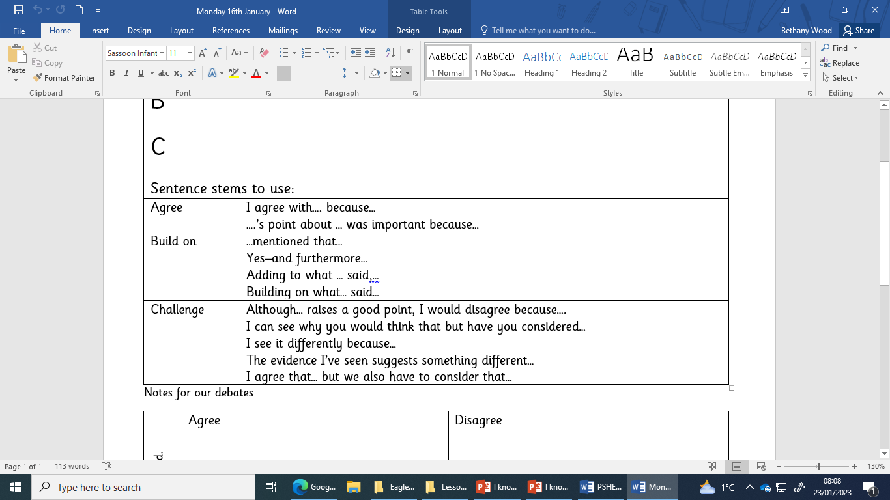

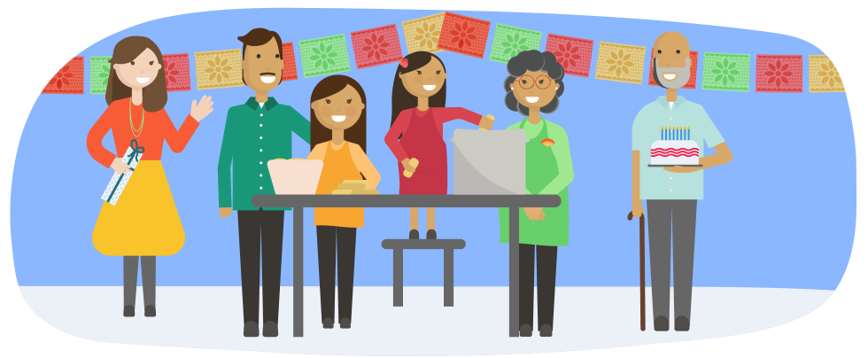

I know how to speak respectfully and politely to others.



* Saying please may I and thank you
* Respect for yourself and respect for others
* Tell the truth but not to be unkind about it
* Treat other how you would like to be treated

I can explain my views calmly.

