How many of these can you use at home and school every day?

|  |
| --- |
| I can demonstrate polite behaviour. |

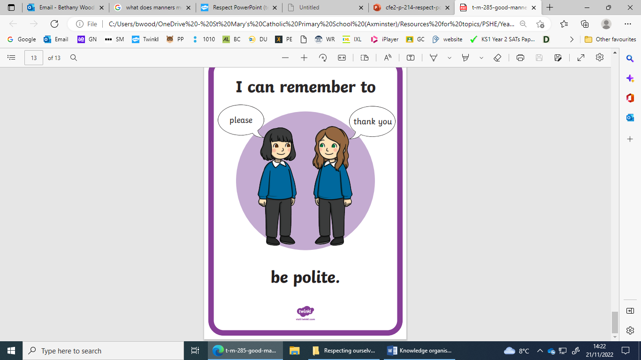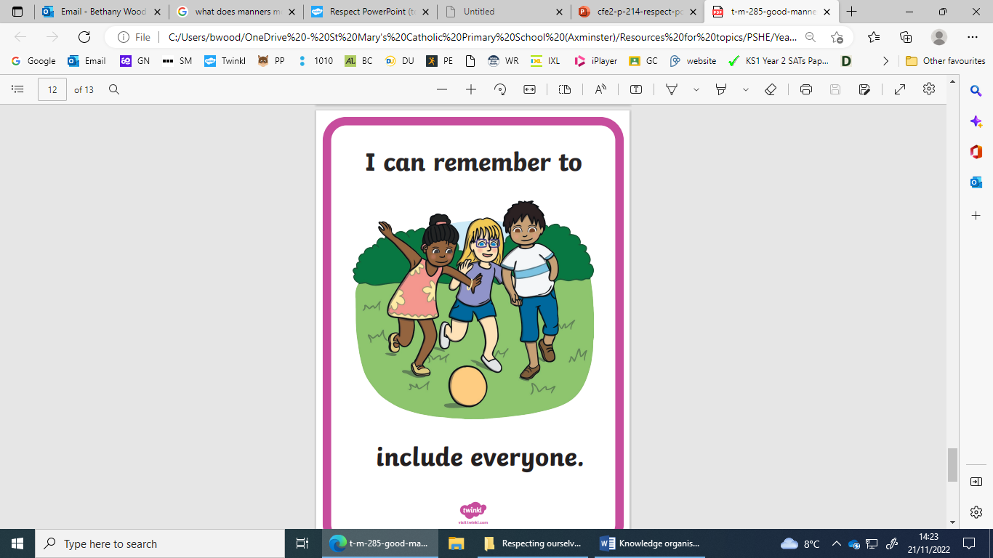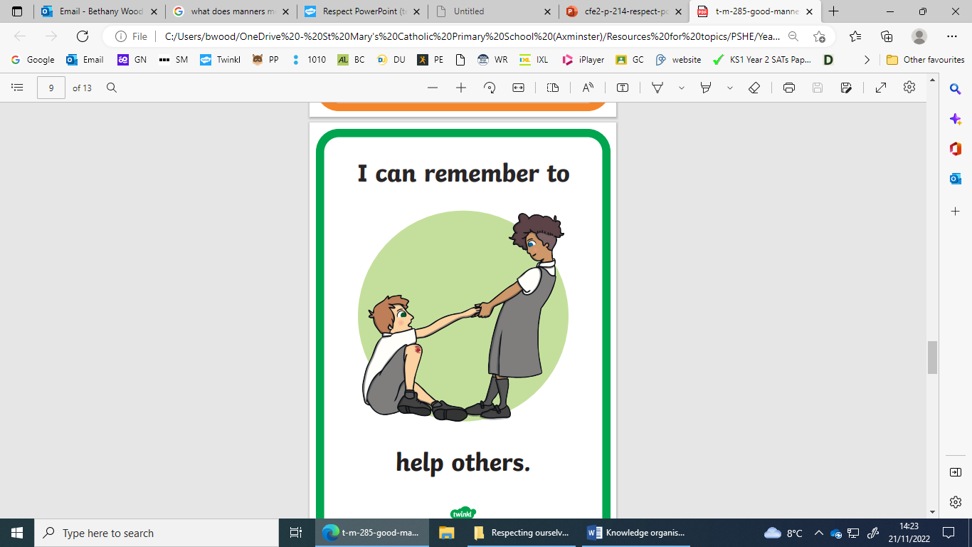

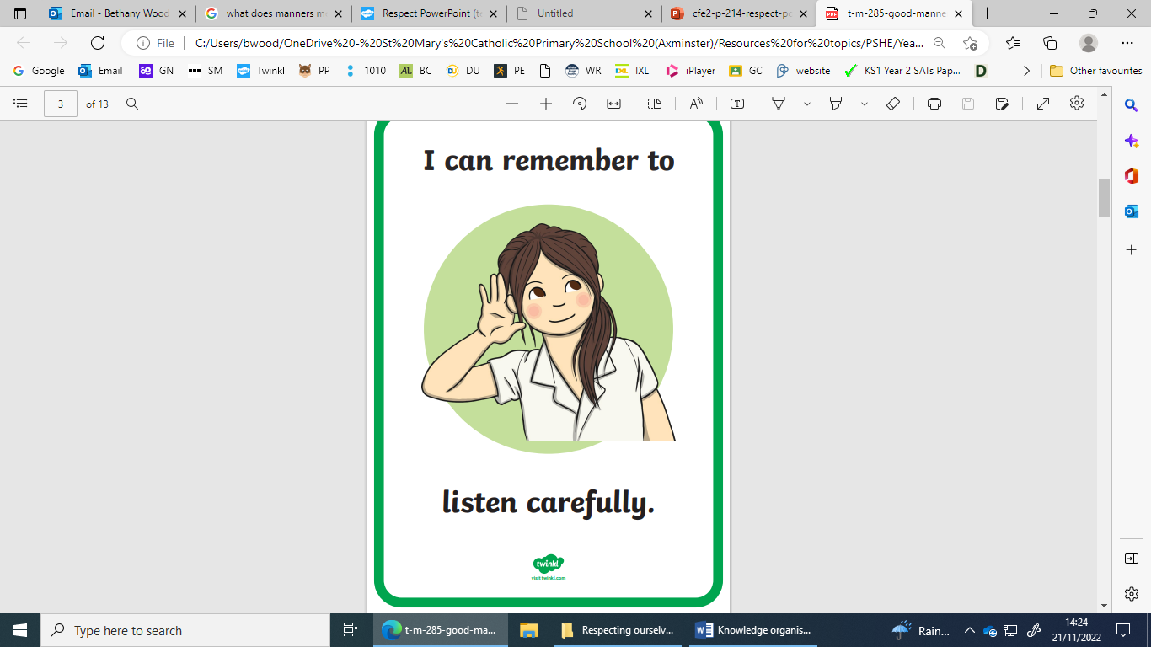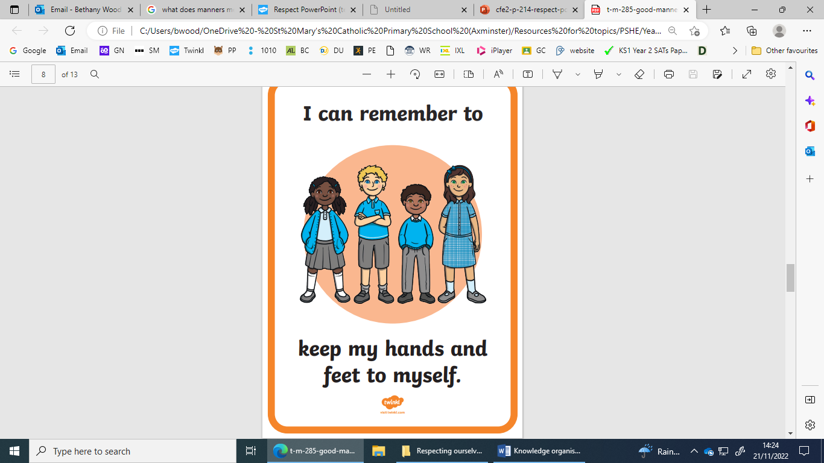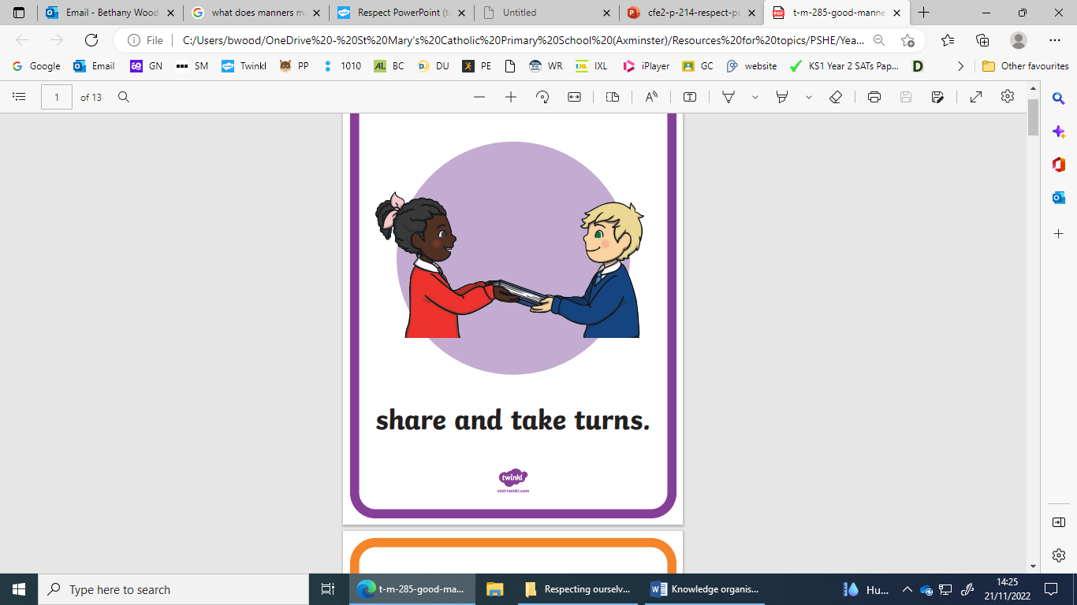

I can talk about how respect and polite behaviour are linked.

Being polite is a way in which we show respect to others!

|  |  |
| --- | --- |
|  |  |
| Listen to others | Think about others feelings |

I can identify respectful and disrespectful behaviours.

I can explain why a behaviour is respectful or disrespectful.

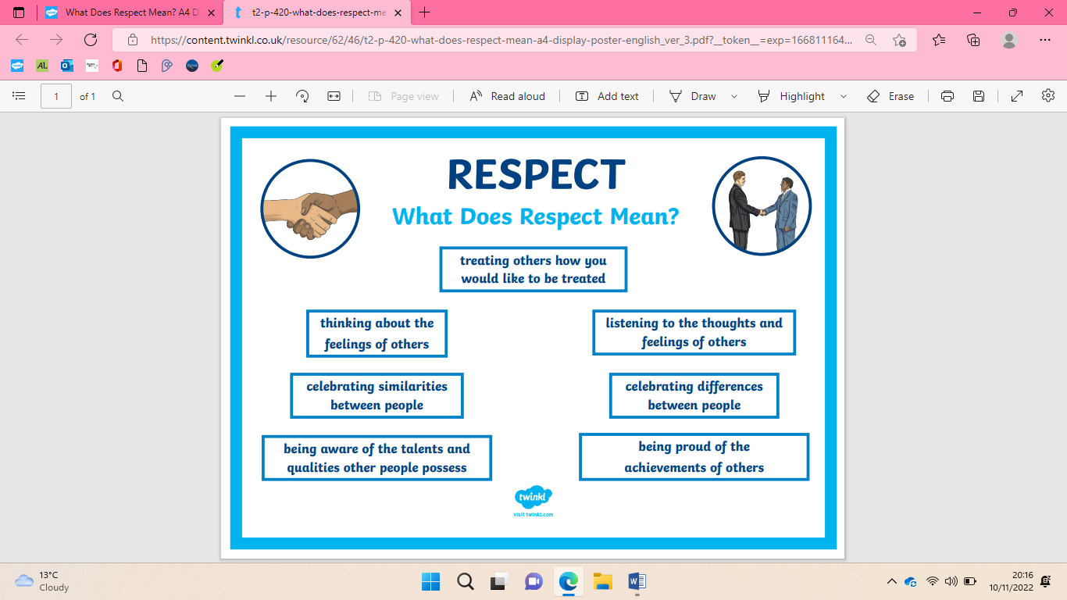

|  |  |
| --- | --- |
| **Key Vocabulary** | |
| Kind | To be caring and considerate |
| Unkind | To be mean and not nice |
| Behaviour | How someone acts |
| Friendly | To be kind and caring to people |
| Unfriendly | To be unkind to people |
| Helpful | To help others |
| Unhelpful | To not help others |
| Respect | Thinking of others and their feelings |
| Polite | Showing good manners and being respectful |
| Courteous | Being polite and respectful |
| Manners | Behaviour which is polite |

Respecting Ourselves and Others