|  |
| --- |
| To make your alien using the skills that you have developed |

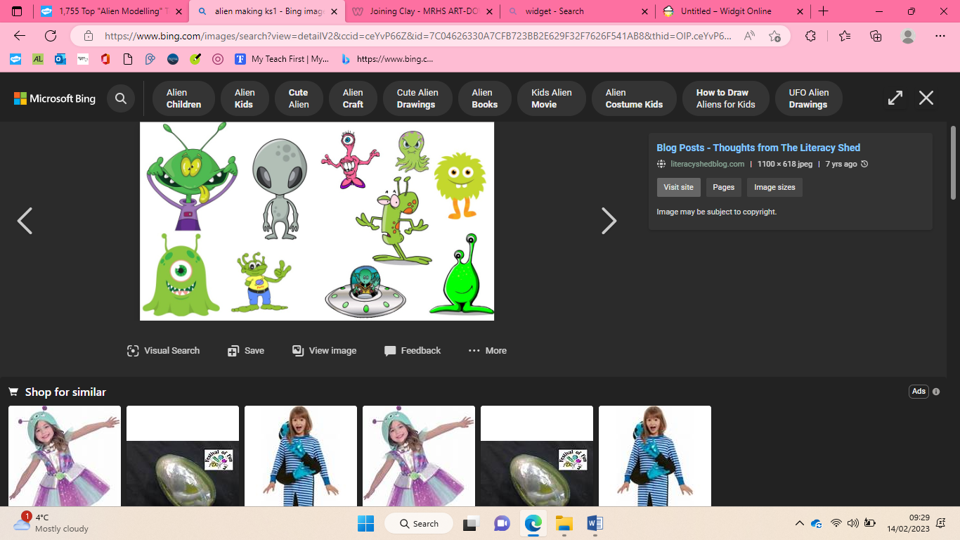

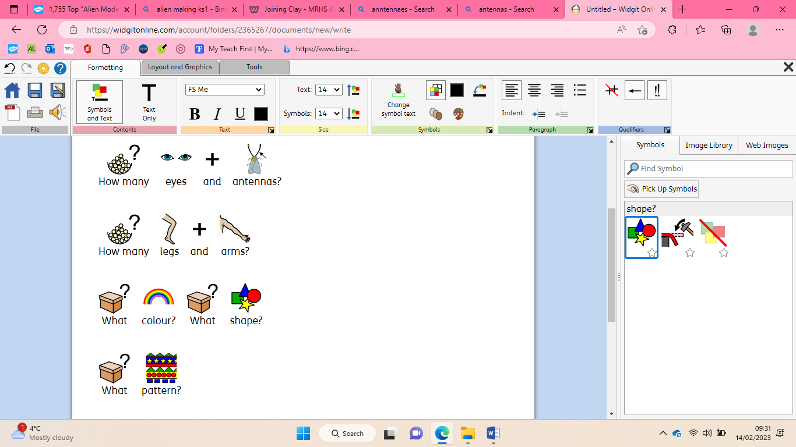

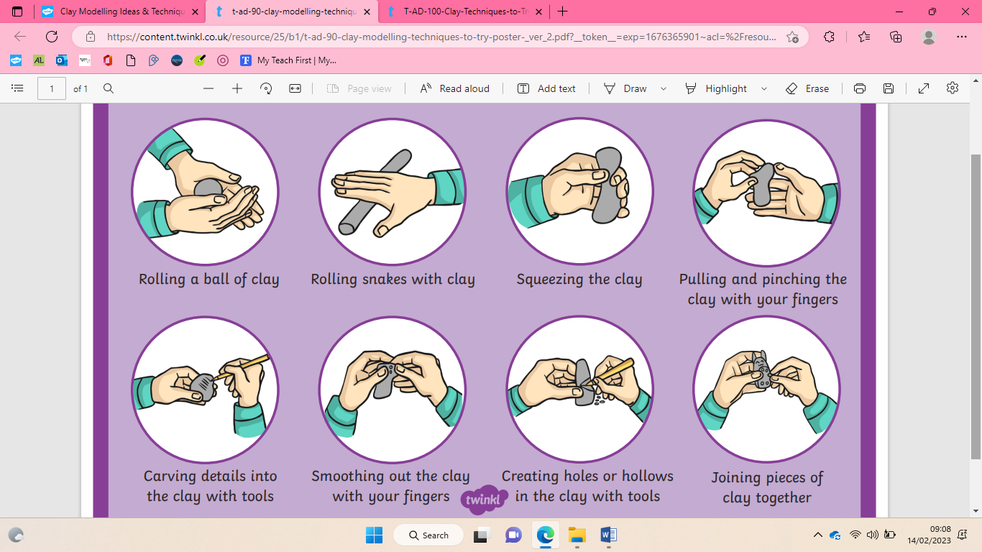



To replicate patterns and textures in 3D form

I like… because…

It is like my plan… because…

Next time I would change… because…

To evaluate your alien independently

It will look like…

I will need…

I want it to look like this because…

|  |
| --- |
| To roll and carve materials |



To join materials

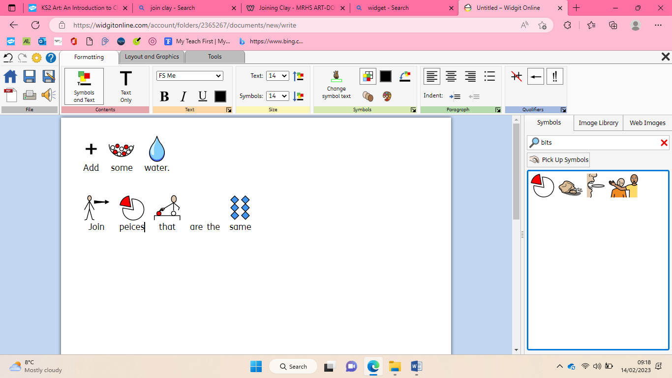

To plan

|  |
| --- |
| **Key Vocabulary** |

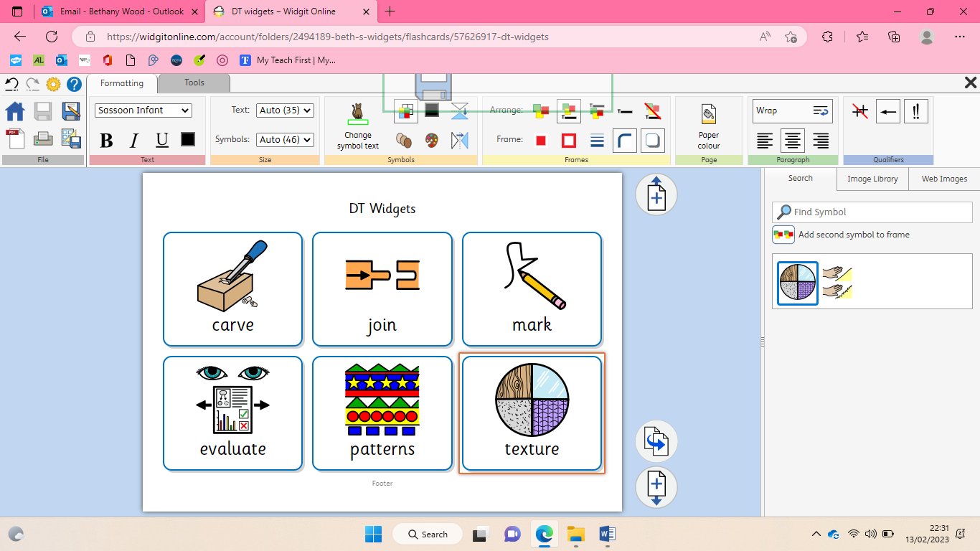 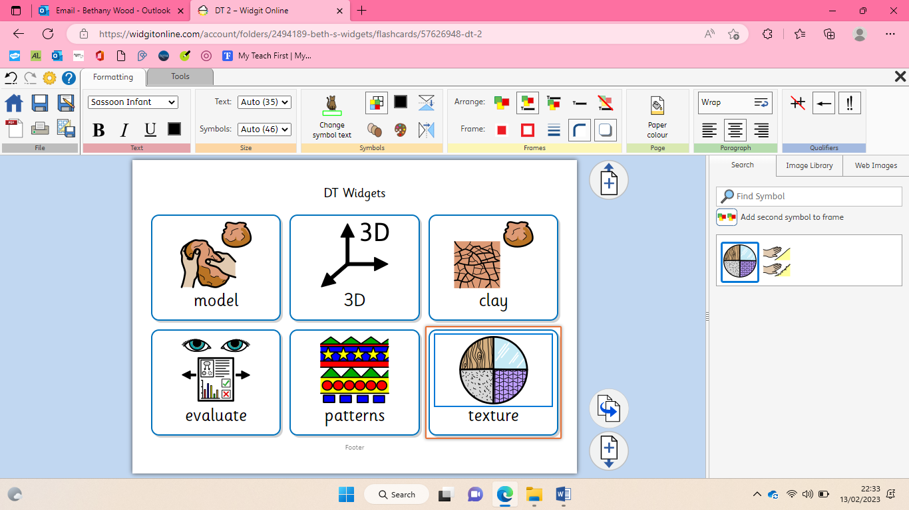

Construction- clay alien