Portrait artists

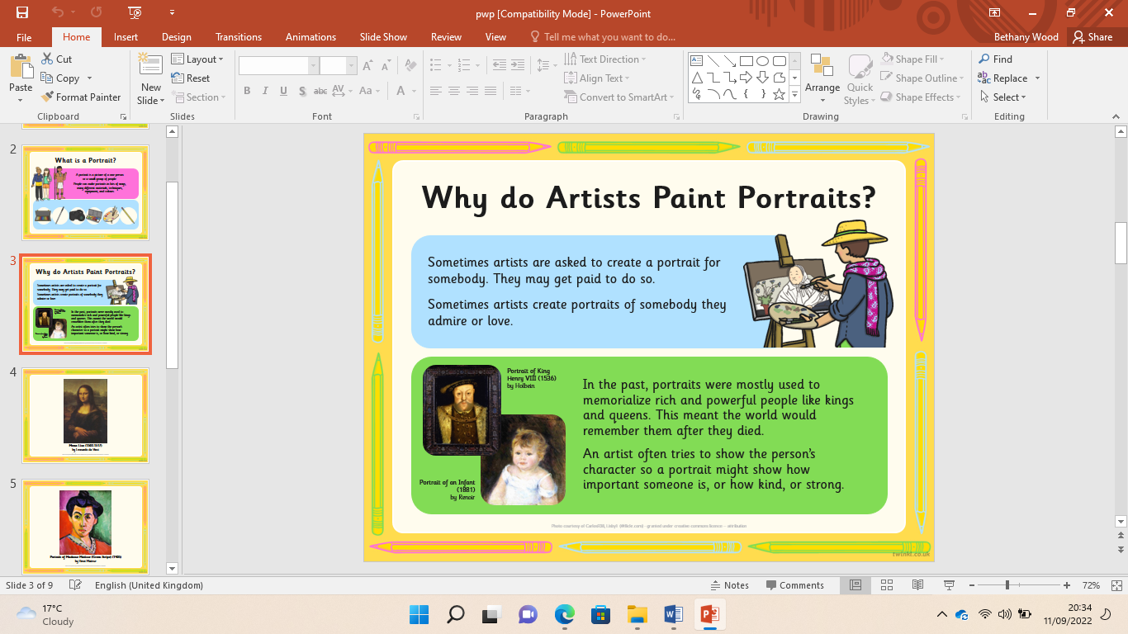

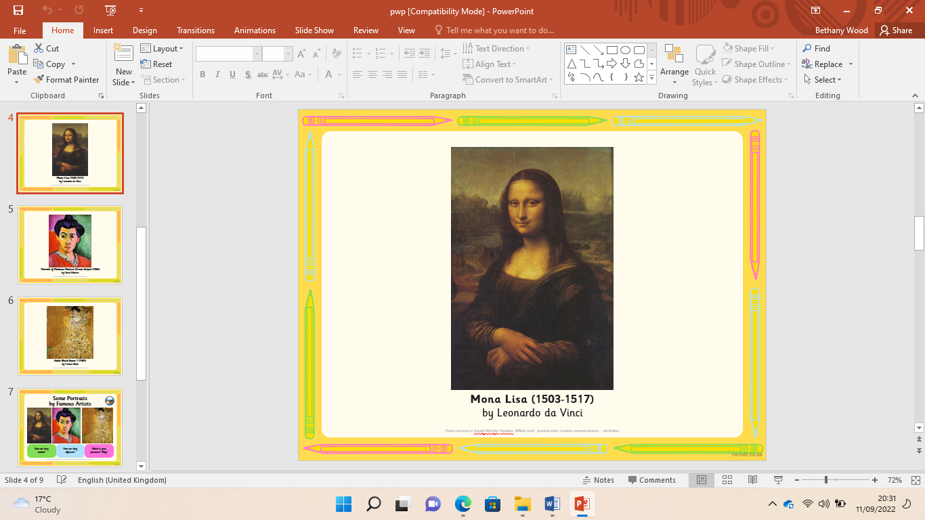 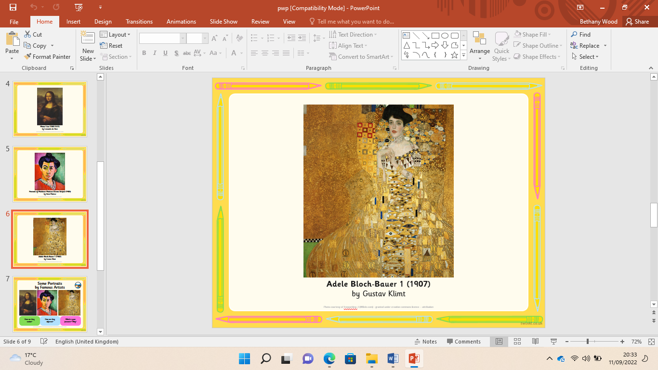 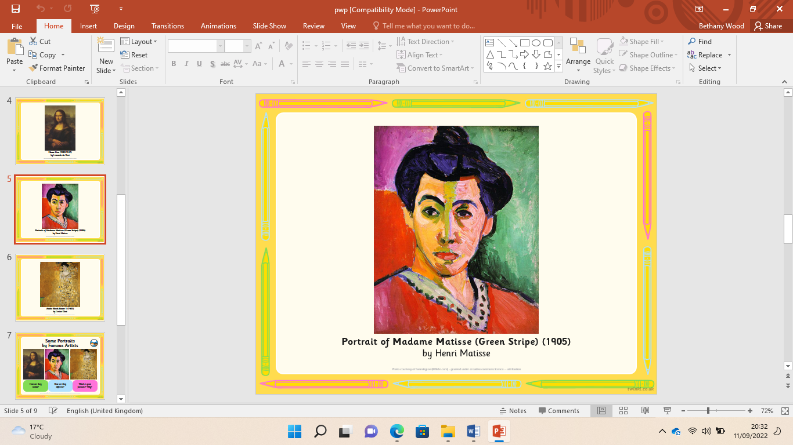

How to draw face shapes.

How to draw ears.

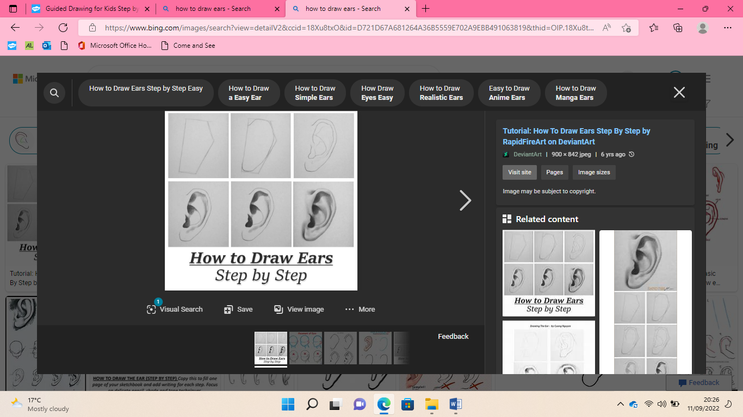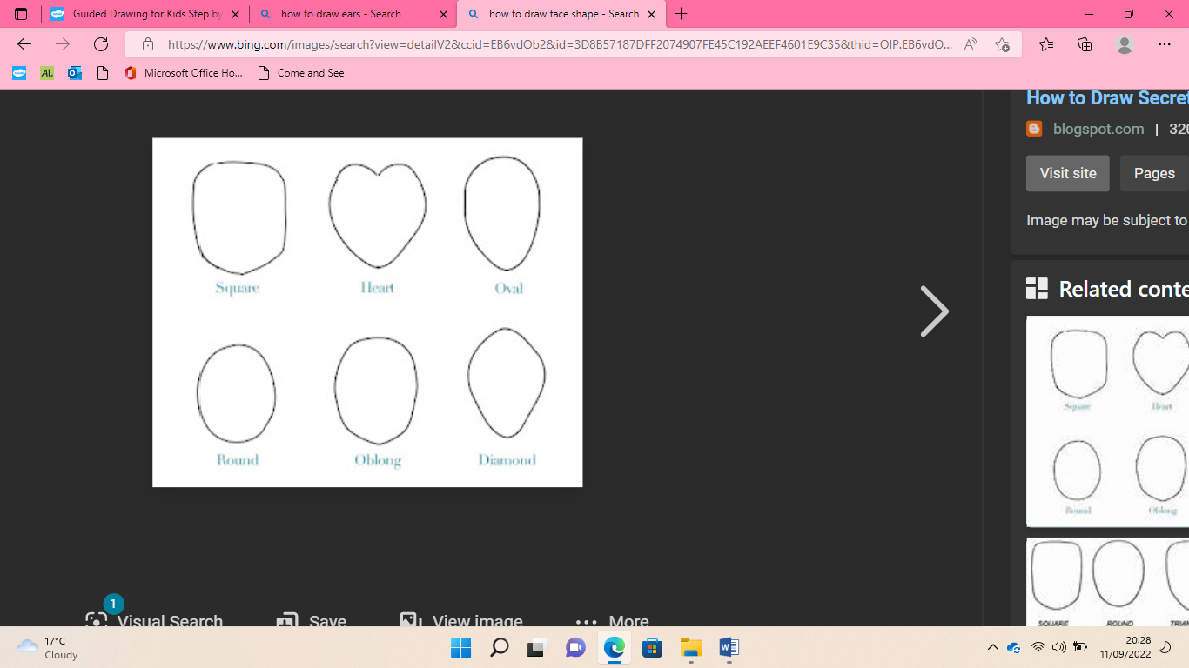

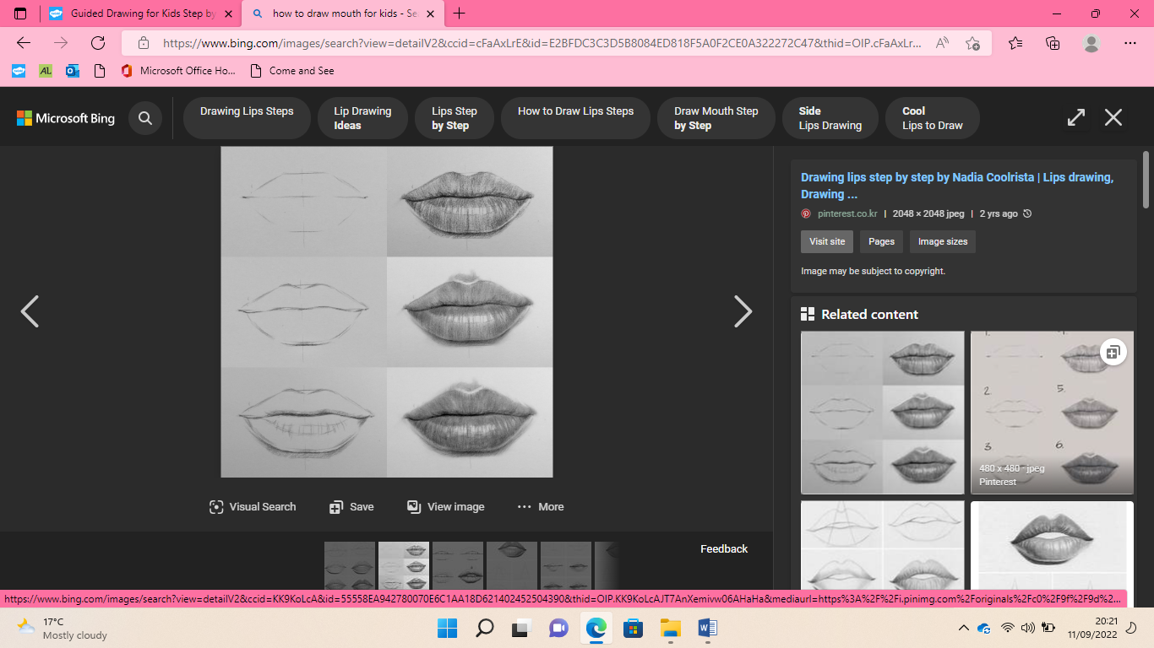

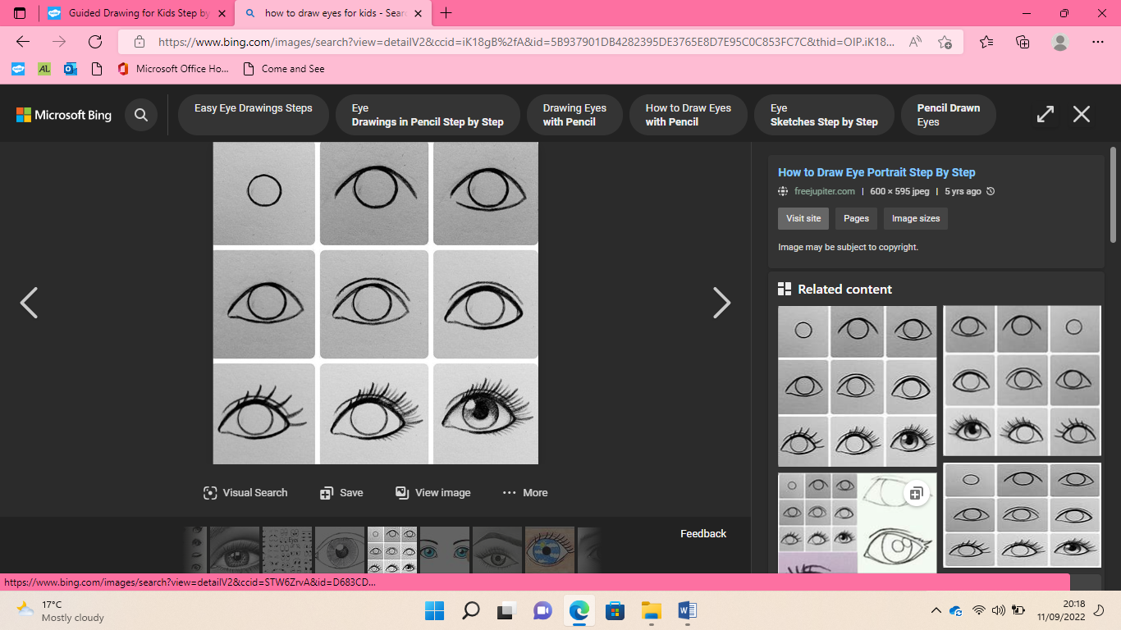

How to draw a mouth.

How to draw eyes.

How to draw a nose.

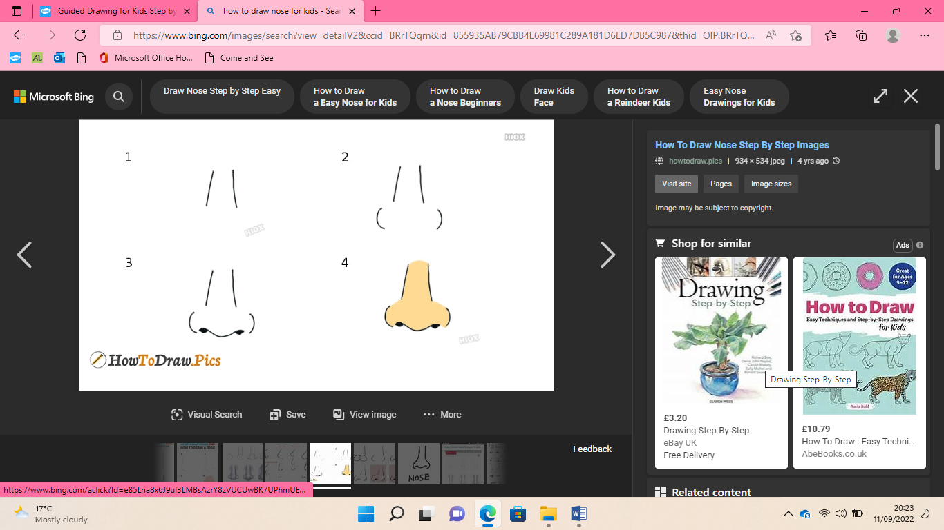

|  |  |
| --- | --- |
| **Key Vocabulary** | |
| Portrait | A picture of a one person or a small group of people. |
| Self portrait | When an artist makes a picture of himself or herself |
| Observation | When you notice small things and what you can see. |
| Sketch | A rough drawing or painting. |
| Feature | A distinctive part of something. |
| Drawing | A picture or diagram made with a pencil, pen, or crayon. |
| Artist | A person who creates paintings or drawings. |

Observational portraits