Map of the United Kingdom

Globe



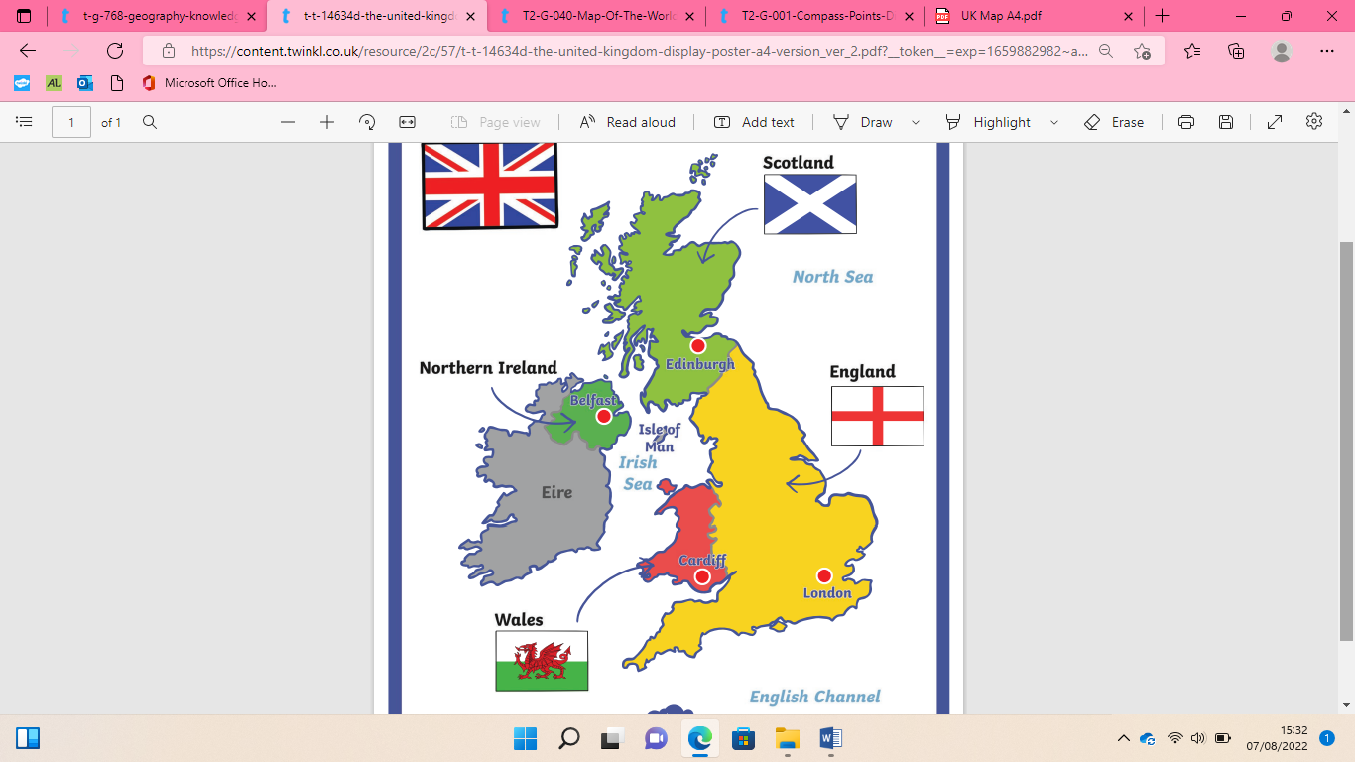

Countries along the equator

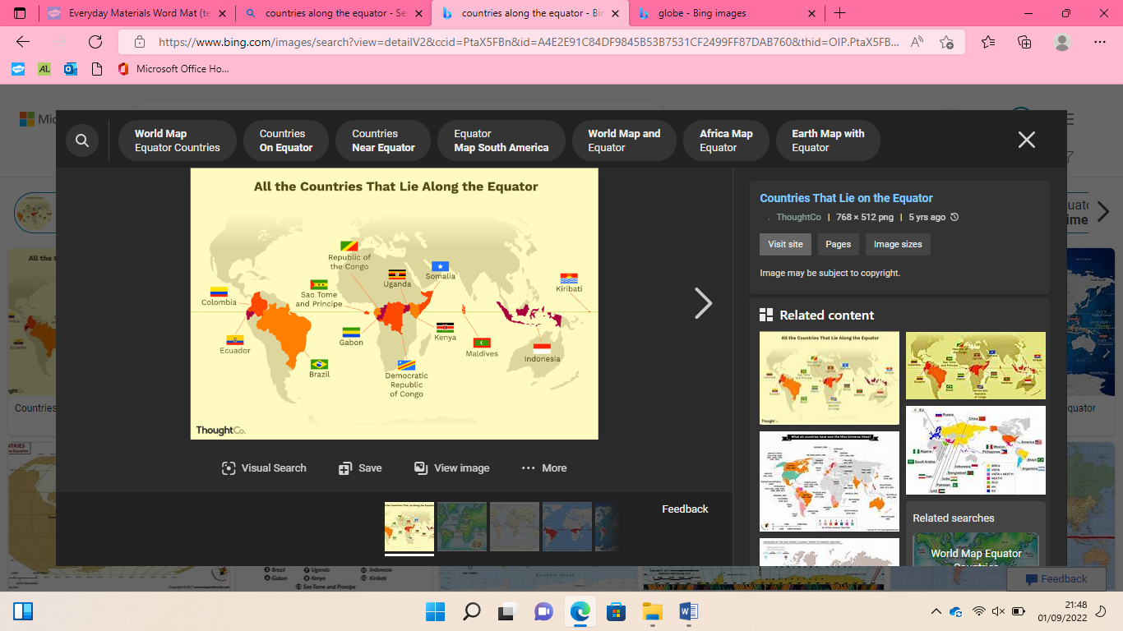

Compass points

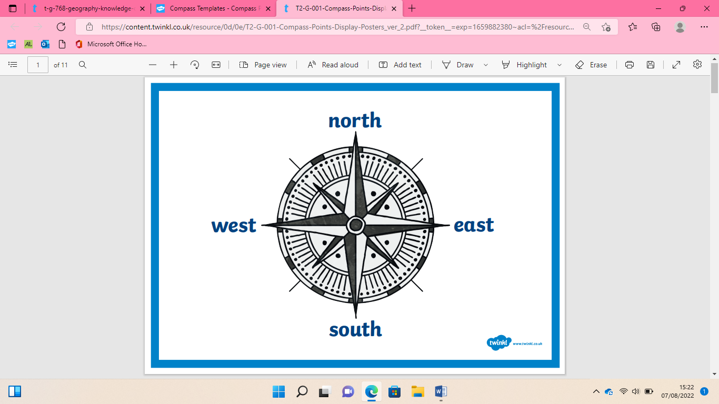

Equator

South Pole

North Pole

Map of the world

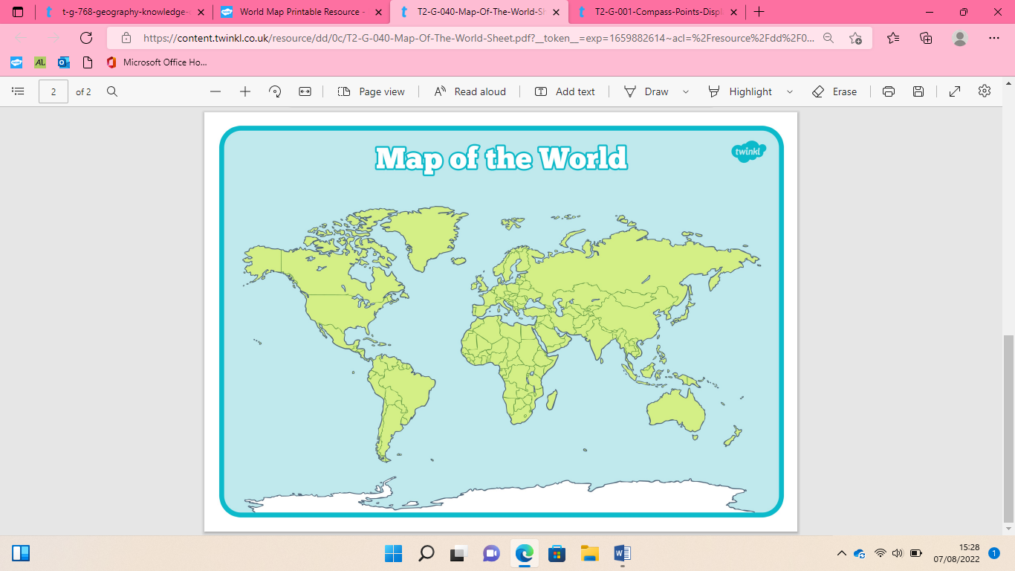

|  |  |
| --- | --- |
| **Key Vocabulary** | |
| Equator | An imaginary line drawn around the middle of Earth. |
| North pole | The most Northern part of the earth. |
| South pole | The most southern part of the earth. |
| Compass | A piece of equipment that tells you what direction you are travelling in. The main compass points are north, south, east and west. |
| Capital cities | An important city, often where the government works. |

Identify 4 countries, capital cities of UK. North, south pole and equator. 4 points of the compass.