Dear Parents and Carers

I am hoping that this communication finds you, your family and friends all well. We have not heard of any illness within our community so I am sincerely hoping that it remains so.

I recognise that this should be the Easter holiday but in the current worldwide crisis ‘holiday’ does seem to have lost its significance.
We have not had anything official from the government but we are working on the basis that we will continue to remain closed to all pupils except the children from the keyworker and vulnerable groups. We have continued to communicate with these groups. If you think you should be in the keyworker group and have not had any communication please do email school immediately via admin@stmarysaxminster.devon.sch.uk

As in previous communications I hope that your family is adjusting to the new lock down situation and you have been able to establish some routines that are helping to create some balance in this new world.

School Moving Forward
It does look as though this will continue for much longer than we hoped in a national state of lockdown. Given the daily news none of us can question that by each doing are part we are saving lives. It is vital that the priority is in keeping each person safe. Within your home, working to get through this positively is a challenge. It is important that you work to be realistic about what can be achieved for your whole family.
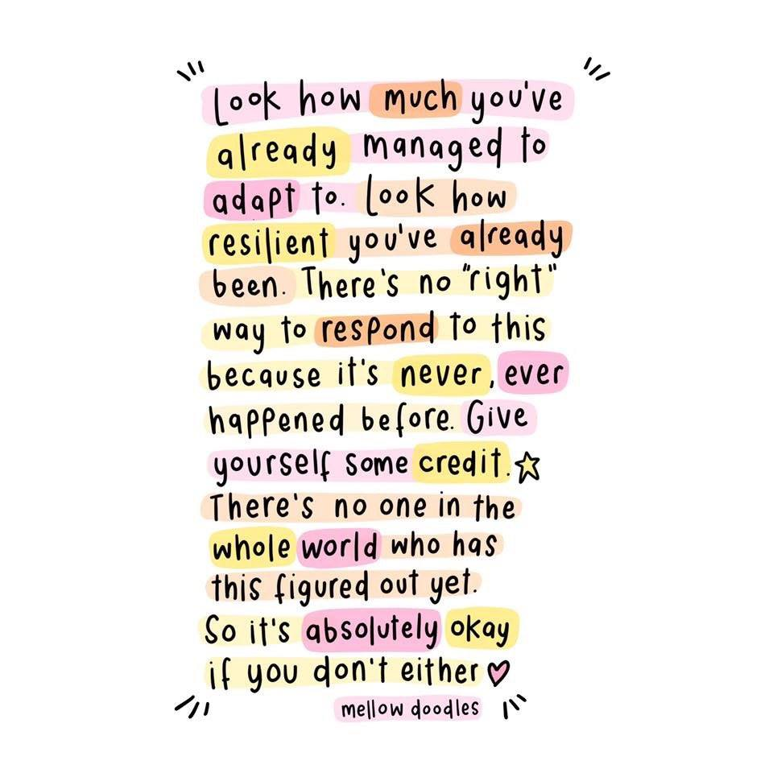
Summer term would have started for the children on Wednesday 15th April we would ask that you spend the week using the resources we gave you as school closed. Also please check out the resources on our school website if you haven’t already. There are lots of links that can encourage all kinds of learning. Importantly, if you haven’t already, establish some routines that allow you to make sense of your day.

From feedback it does seem that parents are finding a range of resources useful. Teachers can see which children have been accessing Bug Club Reading resources and the times table Rock Stars. Well done to those who are keeping up with these.

Setting priorities. Making it work.
If you can focus on the basics of reading and try to find ways to enjoy this by reading together or listening to stories on line – share successes – ask each other questions about what your child is reading or hearing…retell favourite parts of stories – if your child would like to, then encourage them to write parts of the stories or draw parts of it and add captions.

Bug Club is a very valuable resource. Do make use of it if you haven’t already. If you find your child has lost the log in then you can email school for a replacement.

Times tables skills are also worth working on. In school we encourage children to learn times tables in order and out of order then, for older children, (Owl Class and above ) to link them to division facts.
Games are a great way to learn.

The children do have access to lots of resources which can develop so many aspects of learning and we are putting together new resources which we will share ready for Monday 20th April.

Please don’t forget to encourage children to be active and if you are fortunate to have a garden or outside space to make use of that.

St Mary’s Values in Action at school and now at home.
At St Mary’s we don’t want our children to complete a task because a teacher tells them to. We want our children to be keen to have a go at all learning and to aim high, knowing that it is good for them to self challenge, to build their skills for their good and the good of all. Resilience is a key word. Children can show this in so many ways… how many skips/ how many bounces of the ball/ how many juggles/ how many times tables/ how many countries can you name…..

We have worked very hard with your lovely children to encourage kindness and to think of others. They are so good at that. So many of them want to make a difference. Encourage them to help in the house, to spend time making a card for an elderly or isolated neighbour.

You are not trying to be your child’s teachers and replicate school. You are doing your best to make this work and to maintain learning so that your child will step back into school successfully when the time comes.
We are all doing our part in this fight to respond to this challenge. We all know that never before has the world faced anything like this.
If you have any questions about any aspect of learning then please don’t hesitate to e mail admin and all questions will be answered.

A sense of community and hope

There has never been a better time to look after each other and despite the challenge to work to create positive memories.
In the midst of this there is light. The sense of community and the support available continues to grow. Thursday at 8pm when people all across the country stand outside their homes to celebrate the NHS workers is a positive act to show our children that we are united.
The image of the rainbow has become symbolic of our shared desire to make a positive difference. To remind us that after a storm there is a rainbow.

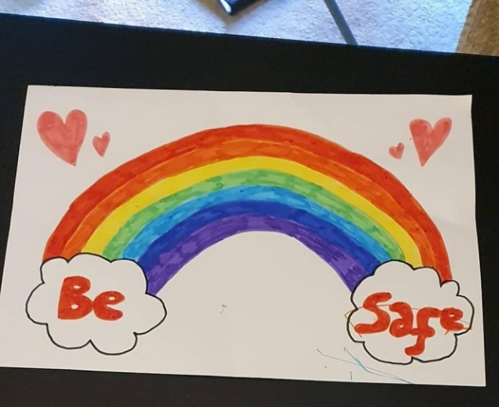
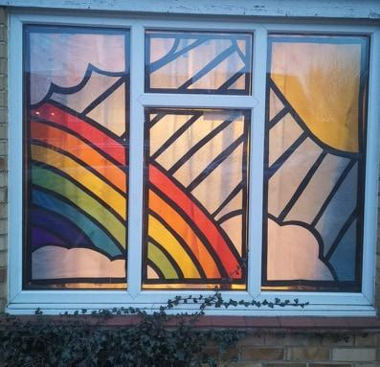

Please stay safe. Please let us know if there are any ways that we can make a difference.
Easter is time when eggs are broken as a symbol of the new life of Christ. ‘Easter people’ is a term that describes those who see hope in any situation. This can strengthen us and help us to deal with the darkest of times.

I wish you and yours a safe Easter Time.

Very best wishes,

Mrs Mannix on behalf of all at St Mary’s.

