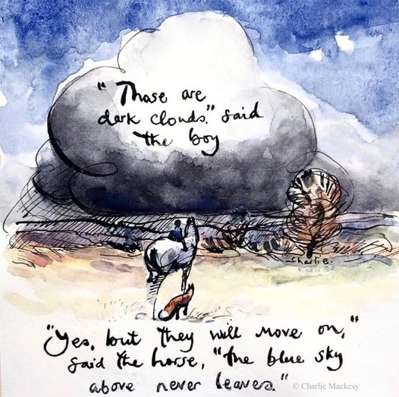
Monday 16th November 2020

As well as lockdown 2, with more reminders of the Covid restrictions and the uncertainty of what will happen after 2nd December, we have also had some serious rain over the last week. This weekend in Exmouth the skies were dark and the rain was heavy. When I saw this picture it did make me smile. This won’t be for ever.
Last week in school I saw and heard some Christmas nativity planning work happening and the tingle of xylophones in Eagle and Kestrel Class to a Christmas tune. Advent is almost upon us. Hold tight. Notice the kindness that is around us.

I am so glad to be the person that greets the children every morning, It is a joy to see the way the little ones hop and skip into and through the playground, rushing in to see their teachers and class mates. There is a lot of learning happening across the school with children working to live our value to aim high. I have been listening to Kestrel and Eagle Class this week working to make links in their learning. They are working to ask themselves constantly where and how they can draw on past learning in all areas of the curriculum to help their learning now.
Respect
We continue to work to achieve the Silver Unicef Rights Respecting Schools Award. Children are become more confident about the rights and why all children should be able to access them. Many of our children are appreciating the values that we very often take for granted and that having them does make them feel more valued and safe as well as developing their desire to make a difference for others.
We extended the word respect into our Remembrance activities. Please see school website News/ November for more information.
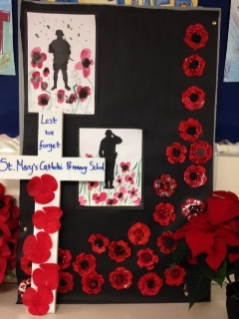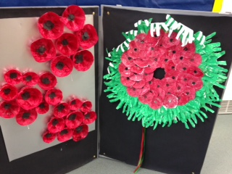

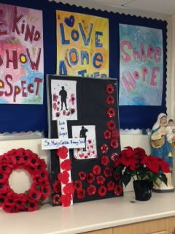

When every child walked into the playground in their class lines, each wearing a poppy and standing absolutely still, there was a tangible tingle of something special.
As we took a minute to thank all those we fought and continue to fight for our freedoms every child acted with humility. It was a very different service to previous years but still poignant.
The cross that was a part of our service was made so that it could be placed at the town square memorial as a visible sign that we took the time to remember and that we will work to be peacemakers.
Our school cross made for the service is now in Axminster town centre at the memorial statue

Thank you to everyone who contributed on Friday for this very well known charity that makes such a difference across the UK to so many children, young people and their families. Every child came in their home clothes and we raised a total of £157.98 Thank you.

Mrs Newcombe Jury Service
From Monday 25th November for two weeks Mrs Newcombe has been called to do jury service. I have to say we did appeal. Not that we don’t value the role that jury service plays but more because we thought that as more people are in lockdown, with many being furloughed again, that these would be prioritised over others.
To cover her we have employed a full time experienced temp for the two weeks who knows many of the systems we use. However, they will not know any of our children and families. If you need to call school about your child please could you give their full name and class so that the administrator will be able to pass on any information.
Mrs Newcombe has prepared us as well as she can for her absence but we know that she is very knowledgeable about aspects of school life ...please be patience with us….I might be a little bit pale for the first day or two !
Mrs Newcombe will be ordering the school meals for the two week period while she is away in advance on Friday 20th November. As such, if your child would like a school meal over the next two weeks please make sure you book it by Thursday 19th November so final numbers can be given to Axe Valley Canteen who make our meals.
Teacher Placement
From Monday 30th November we will have a trainee teacher in Owl Class and another in Kestrel Class. We have worked closely with the placement team and the director of studies to feel satisfied that we will be able to accept the trainee teachers. These post graduate students are part of a national programme. They study one day a week on the St Luke’s Campus in Exeter ( which is a small campus on Heavitree Road ) and they live in independent housing. Having met them last week we are satisfied that they will support all aspects our professional practice and look forward to welcoming them fully to our team.
Vocabulary Building – why we are focussing on this and how you can support it
Mrs Fudger and I attended a course before lockdown last year to receive a whole school training package on vocabulary building. Mrs Fudger began this work with staff in September and their hard work to find ways to fold this into class learning is already really benefitting children across the school.
Last week Owl Class took part in an A to Z review of words they have been using this term and their teachers were amazed by the number of quality words they had recalled. I asked Woodpecker Class to explain the meaning of some words and their explanations were very accurate. Zac explained ‘respect is when you look after others and things by caring for them and making the right choice for them’ Robin Class shared their poem with me packed full of beautiful describing words they have been using.
Vocabulary building has been shown to raise children’s confidence and skills. . Over the next year we will be continuing to grow this work.
What can you do at home
Spending time building children’s vocabulary will, like supporting their reading, have life long benefits. Children who enjoy reading are at the same time building their vocabulary. Continuing to grow your child into someone who loves books will really help.
If when you are sharing books and reading with your child, you spend a few minutes on the vocabulary used, to help your child make links, they are more likely to remember the words being used. Vocabulary building can happen at all times during the day. If you have a vocabulary jar children will enjoy putting the words in and building it up.
Another way to build both reading skills and vocabulary is to give your child access to story CDs. If they listen to stories ( rather than watch DVDs ) they will gain that opportunity to have quality words repeated.
Don’t stop hearing your child read out loud once they can read independently
As we have said before never stop reading with your child. If they are beginning to read in their heads rather than out loud try to make time to still read with them. It is very important that they don’t get into the habit of skim reading and skipping over the more difficult words. If this becomes how they read it will affect their reading skills and their understanding.

