Newsletter Update 29th November 2021

Wild weather
We seem to have had the best of this wild weekend weather when compared with some parts of the country. We hope that all is well with you and yours following the storms. We have had some damage to our forest school shelter so will be adapting our outside forest school provision until this is resolved.
A reminder that the days are getting colder and wherever possible we have outdoor breaks and PE lessons. We are also continuing to have additional ventilation to support Covid safety. Please ensure that your child has the correct layers to ensure that they stay warm in and out of school and can be outside.

Covid Climate
Even before the weekend announcement of the new variant we have all been aware that Covid is not disappearing.
In school we are making decision by decision to keep the situation as safe as possible whilst trying to keep everything as normal as possible.
Staff will continue to wear masks when they are outside on the playground and you may wish to wear them when on the playground.
This is constantly under review in school in light of local and national guidance which is emailed directly to us. We also have a trust wide network of support.
In school we continue to experience single positive Covid cases this term, either a parent or family member of a pupil in school or a pupil in school. We are asked by the Government to report positive cases and those who are suspected of Covid and need to isolate so this data is being collected at a national level.
We are pleased that so far we have not had any flair ups of Covid so we continue to keep children in their lunch and play hubs for now. There are no whole school events at the moment. Assemblies and singing are being kept to these hubs as well. We hope to not have to step back any further before the end of term.
The nativity this year will be Owl and Woodpecker Class. Robin Class are working on their own sharing of the Christmas story. Kestrel and Eagle classes are working together on their Advent Service. We plan to film and to share these events with you.
Thank you for your continued support.
We feel it is important to work with the children to ensure that they do not become anxious about the new variant or the Covid situation. When talking to the children about Covid we work to be positive and to remind them of the actions they are taking to support this.
Advent 2021

We are in now in week one of the Advent season. A time when we stop and reflect on the real meaning of the birth of Jesus.
This is a powerful story which is full of hope; Mary did not understand why she was being asked to be the mother of Jesus but she showed courage and said yes.
Joseph took on Jesus as his adoptive son. He looked after him and nurtured him.
Jesus, a king, was born as a homeless refugee with people of power determined to stop him and his family.
It is a story that is over 2,000 years old and yet it is powerful for modern times.
Advent gives us the time before Christmas to seek peace, hope and joy and to act with love and kindness.
Children will be taking part in a range of activities and reflections over the next three weeks with an Advent focus. In the last week we will have a focus on Christmas and its sparkle and joy.

Sports Events - Thank you – this term we have had a challenge to book coaches for the after school sports events – this is due to the bus companies not being fully back to their pre-Covid capacity. We are very grateful to parents for continuing to support these events by being prepared to drop off and collect children at these events. Children have had access to netball, cross country and athletic events this term giving them additional experiences to develop skills and to compete against others. It adds a lot to the life of our school.
We have dates for next term so have been working to get as many of these booked into the diary and where needed to have buses booked to transport the children.

School Council have been busy this term thinking about ways to add more to our school life. They are revitalising our recycling as part of our ‘Common Home’ focus.
Recycling took a hit during Covid so the school council are looking to get it back on track. They will be leading assemblies this week to talk to classes about how they can support this.

Waffle House Uniform – Recycle – Re use
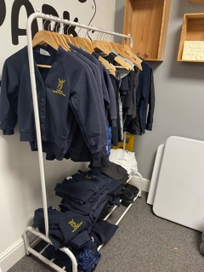

The Waffle House are hosting this rack of clothing for re- sale.
There are lots of good quality items. Please consider buying these to raise funds for the Waffle House as well as to make a small step towards helping the world.
Items are a £1.
If there is a parent who is willing to drop in weekly for 5 mins to ensure that the clothes are folded and presentable Waffle House would be grateful.

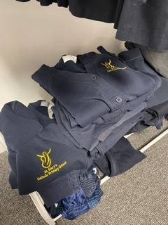

Parking
Thank you to those parents and families who continue to park away from school. We have noticed a small number of parents pulling in to the car park. A Reminder there is no parking facility on the school site and parents should not pull into the car park. Too many families now use the parking space to walk through to prevent congestion and crossing along the footpath. This area should be a very safe area for families.
We have many parents with young children who navigate this extra morning challenge with a smile despite the problems they have to overcome to achieve getting here on time. Please do not be a parent who tramples all over this hard work by assuming it is ok for you to park. Yes you are only one person and yes you will only be quick but so many other families do not do it.
Thank you again for your thought and understanding.

Friday 10th December Non Uniform day
This is Christmas Jumper day nationally. Your child is welcome to wear a jumper if they have one but do not feel you need to buy one especially - get them to wear something bright/ fun or comfortable and make a donation.
This year we are going to make our donation to Bristol Children’s Hospital as we continue to have families who access excellent medical and welfare support that makes a huge difference to them. Christmas is a time when it is especially hard for a child to be in hospital so we hope you will encourage your child to support this.
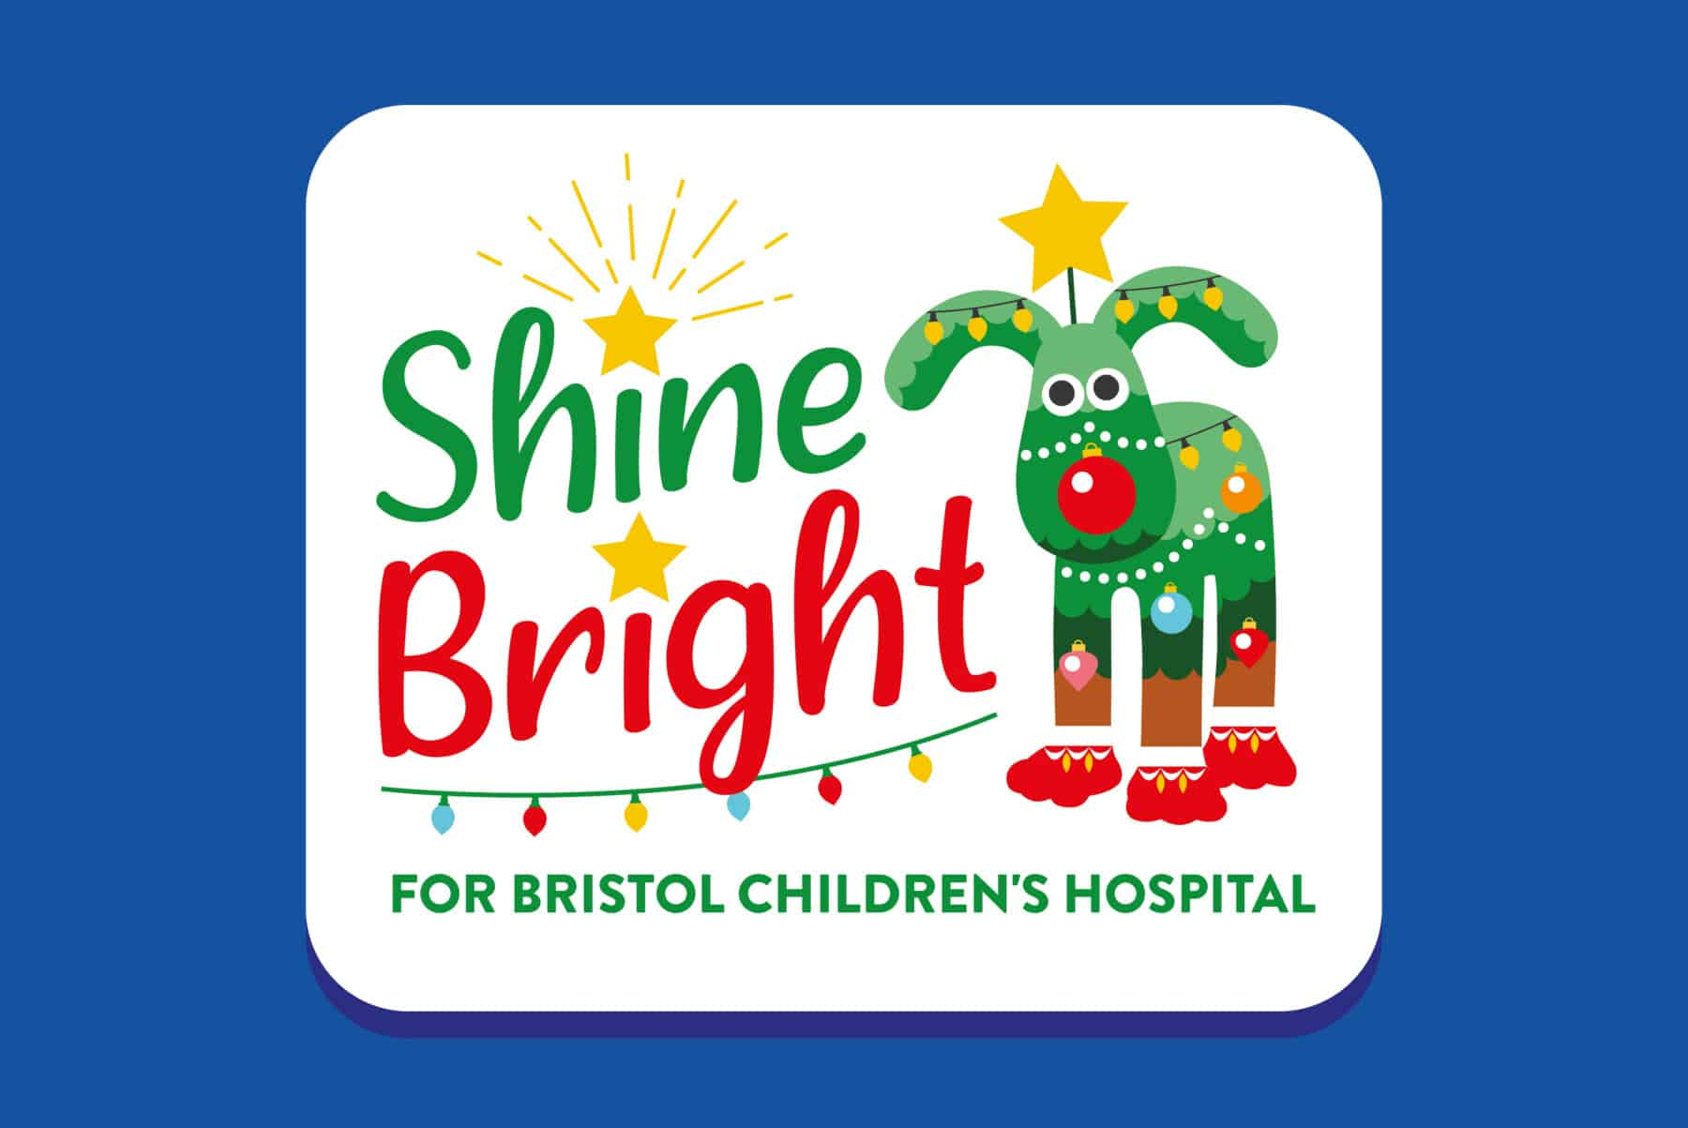

PTFA - St Mary’s Needs You – Please consider giving your support
Before Covid PTFA agreed to fund a large wooden shed outside so that children could have access to a wider range of play resources. It was also envisaged that this shed could be the focus for PTFA stay and play events. The shed would also provide a storage base for resources for forest school.
We have just had a quote for the ground work and shed. It was £10,000. Much more than the PTFA can currently give us. We do need to get PTFA back off the ground and to find ways to have Covid safe events that add to our community and raise much needed funds. We have had two parents who have expressed an interest to support this important school group. If you think you could lend a hand or you feel you could lead and get us back on track we really want to hear from you. Let the office or Mrs Mannix know.

Waffle House Advent Calendars
The Waffle house have donated some of their Advent Kindness calendars to school. We have decided to ask for a voluntary donation of minimum £2 per calendar and we will ensure that the proceeds go back to The Waffle House.
The Kindness calendars are full of daily tasks that give a lift, a smile or a gentle challenge to bring kindness into December. These will be on sale on Tuesday afternoon in the playground and each afternoon this week.

After school Club last week
After school clubs will run to Friday 10th December inclusive. There are no clubs in the last week of term. We will be sending out next terms clubs list this week. Clubs will start again in the week beginning Monday 10th January.

End of term
The last day of school is Friday 17th December 2021
Children will return to school on Wednesday 5th January 2022

Kindness Matters
