|  |
| --- |
| I can count objects and group objects |

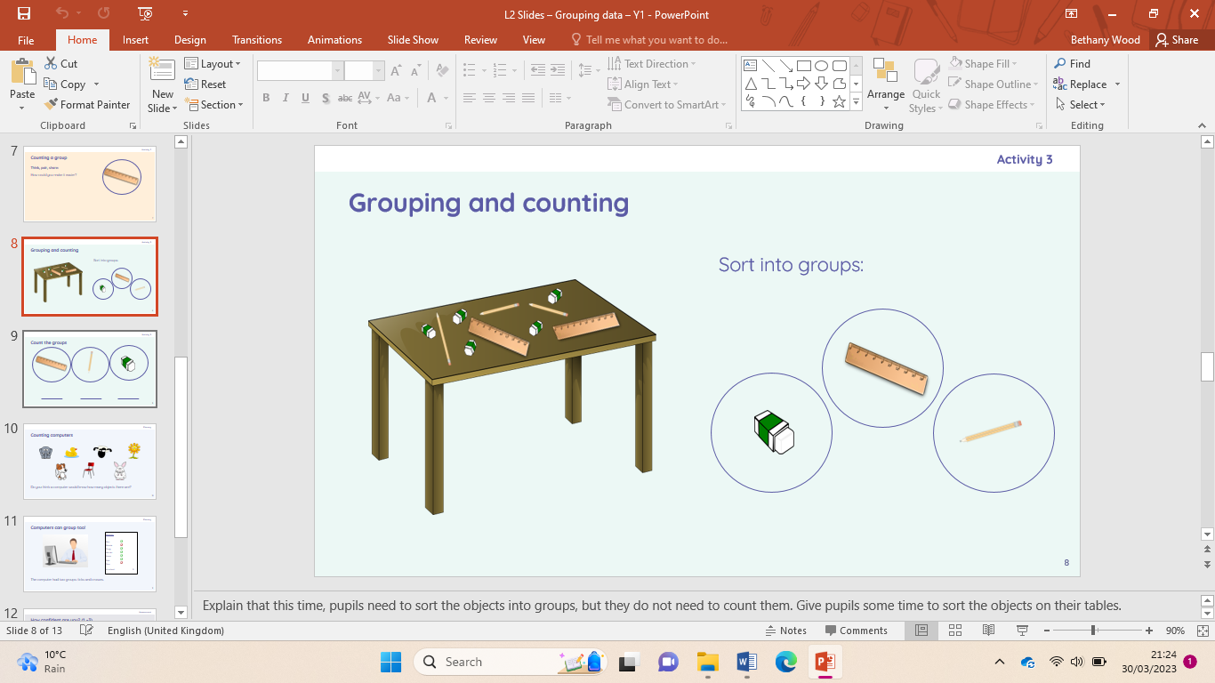

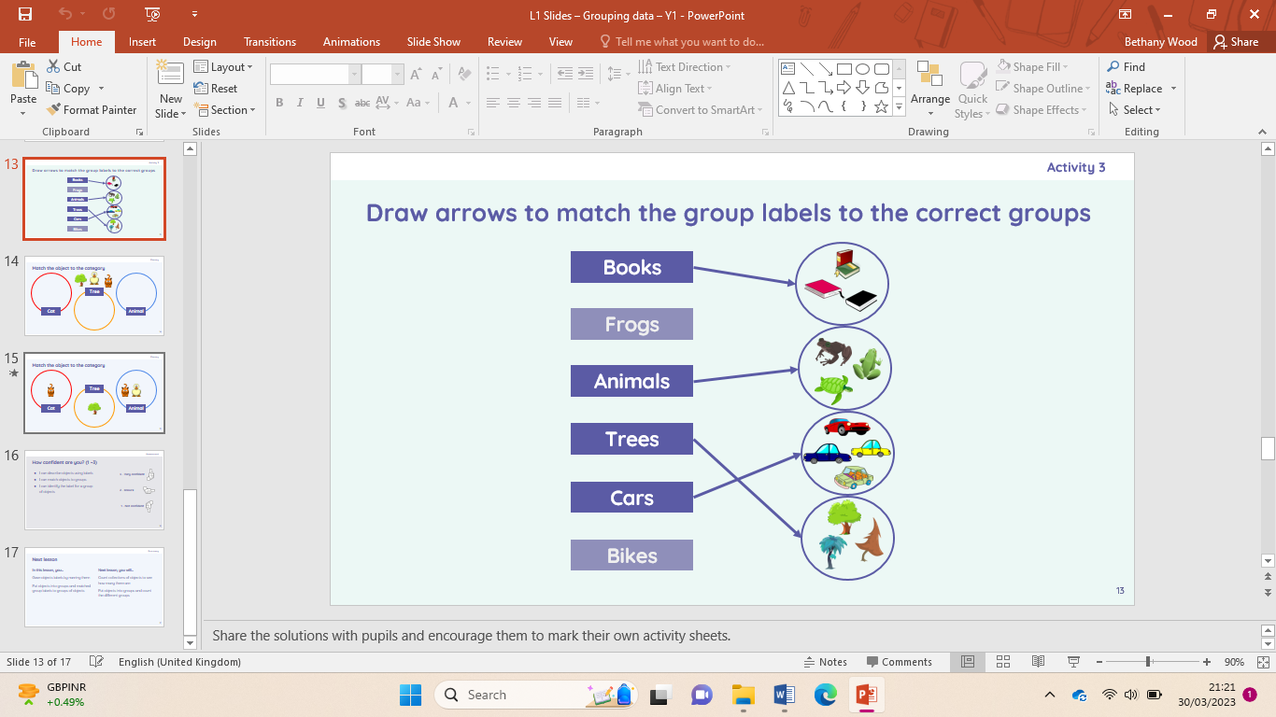

I can describe objects using labels and match objects to groups

I can describe an object and describe a property of an object

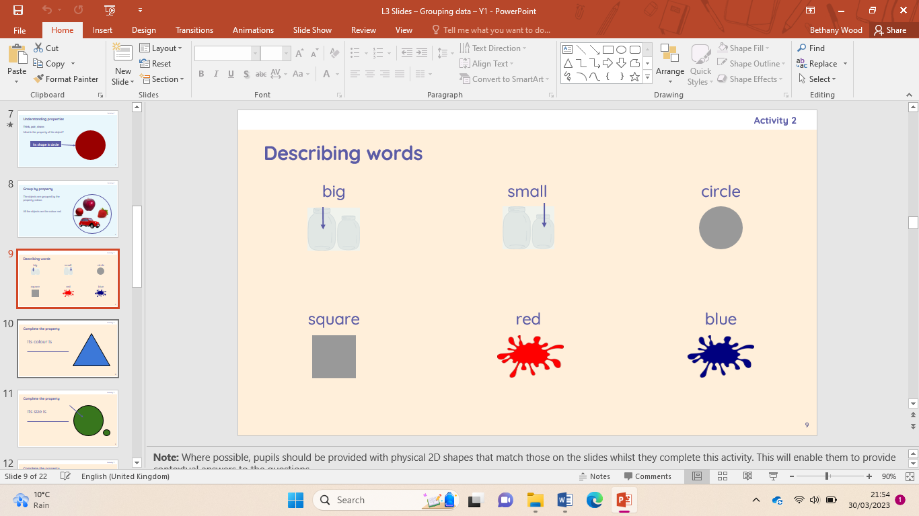

I can decide how to group objects to answer a question and compare groups of objects

I can group similar objects and group objects in more than one way

|  |
| --- |
| I can choose how to group objects and describe groups of objects |

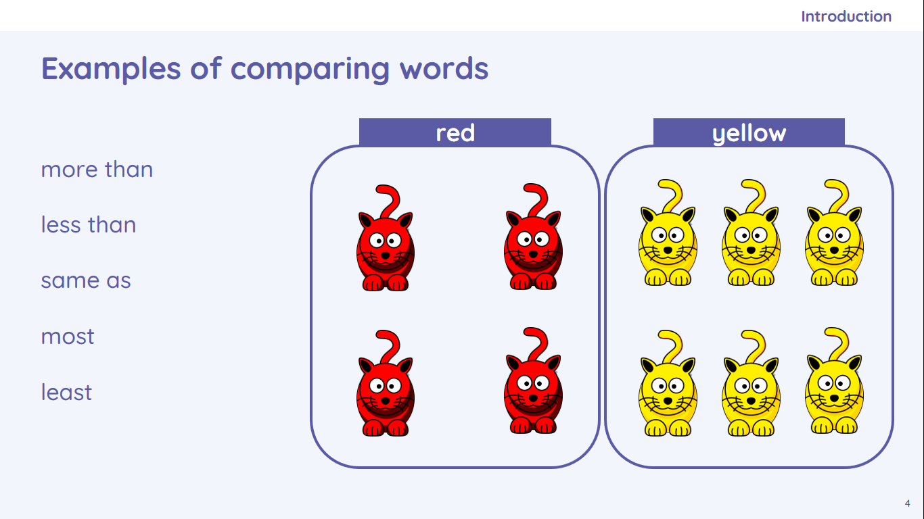

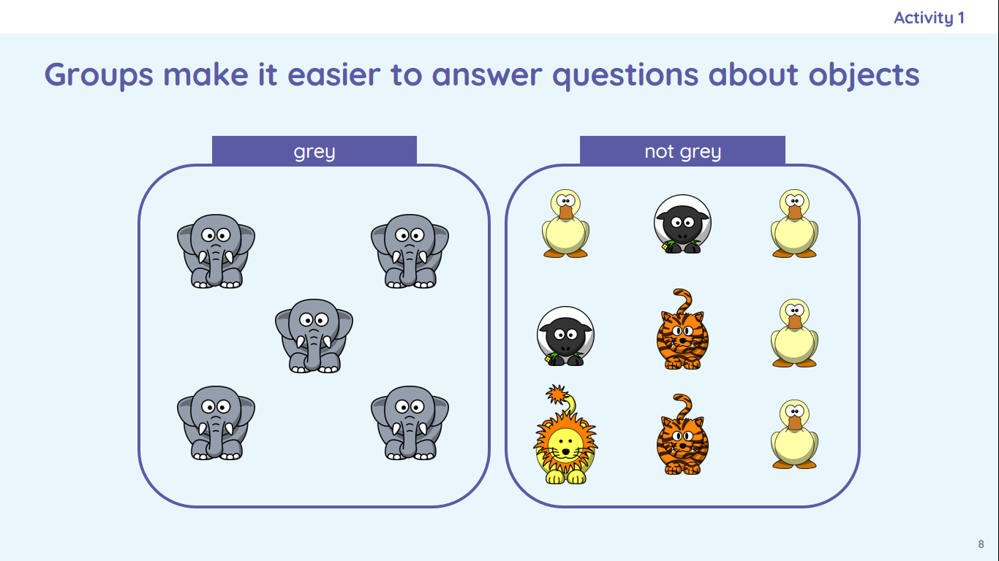

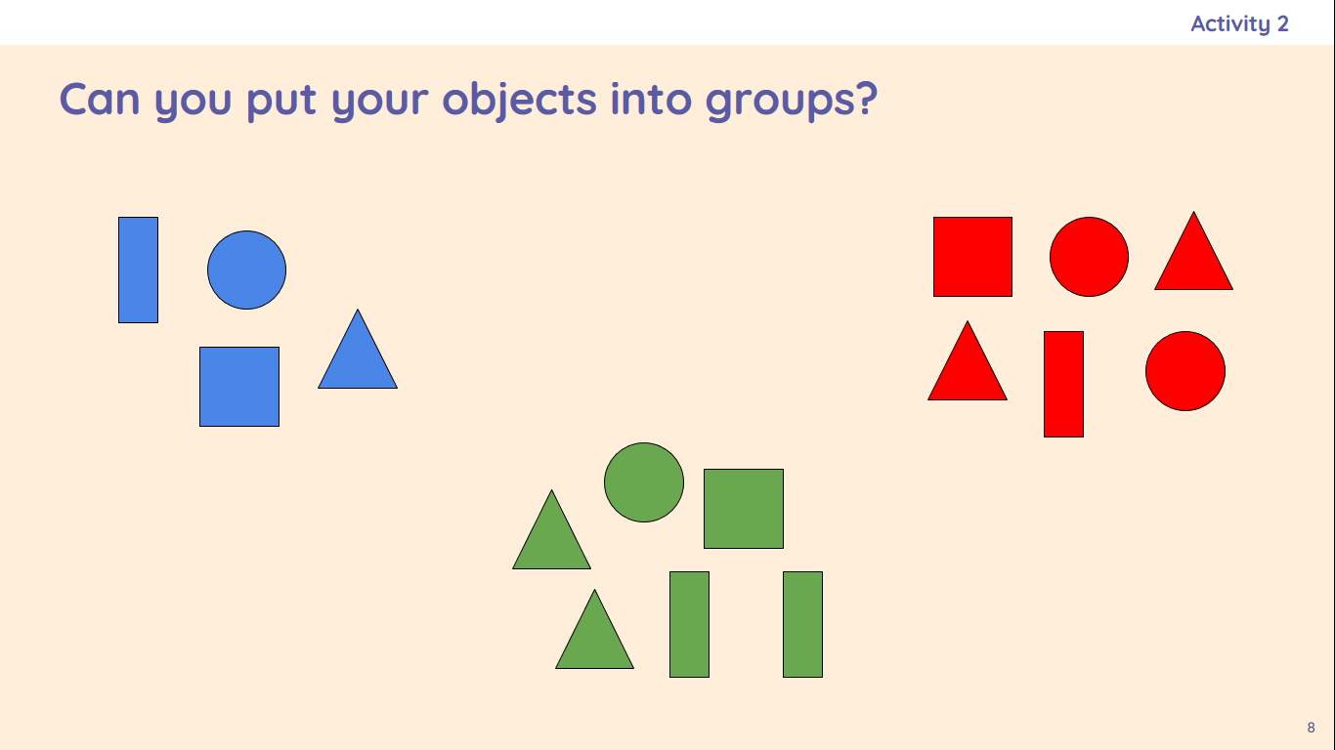

|  |
| --- |
| **Key Vocabulary** |

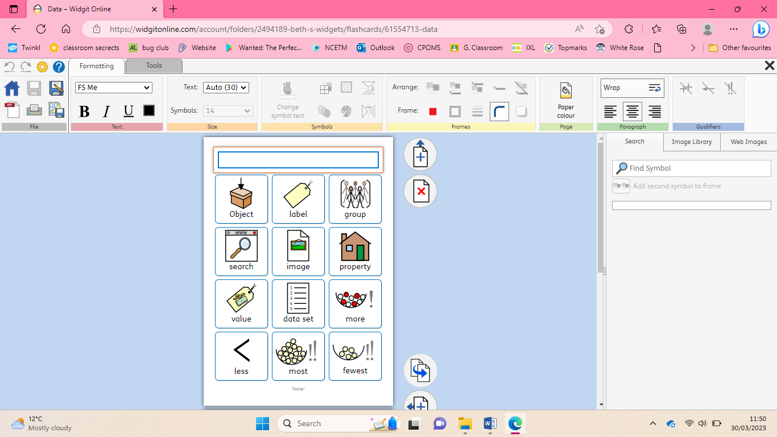

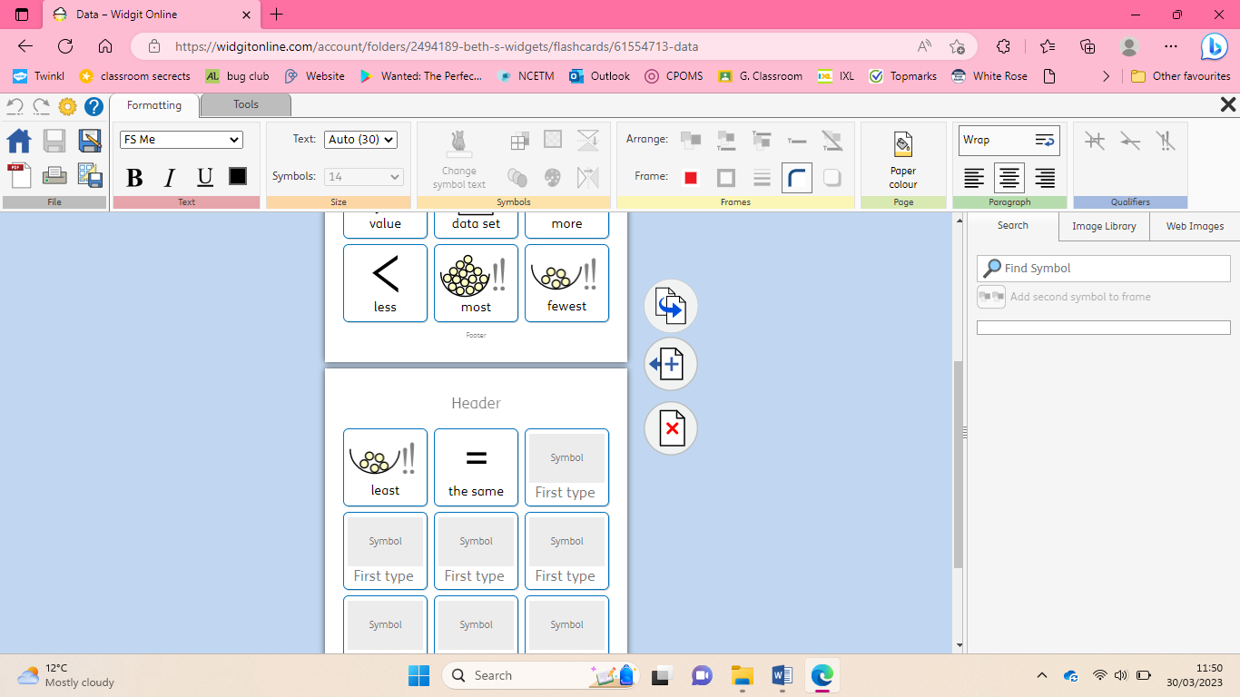

Data handling- grouping data