I can say what tool I used to change the text

I can decide if my changes have improved my writing and use ‘undo’ to remove changes

Use this part of your mouse to drag

This is the toolbar.

Double clicking by using this part of your mouse

|  |  |  |
| --- | --- | --- |
|  |  |  |
| bold | italic | underline |

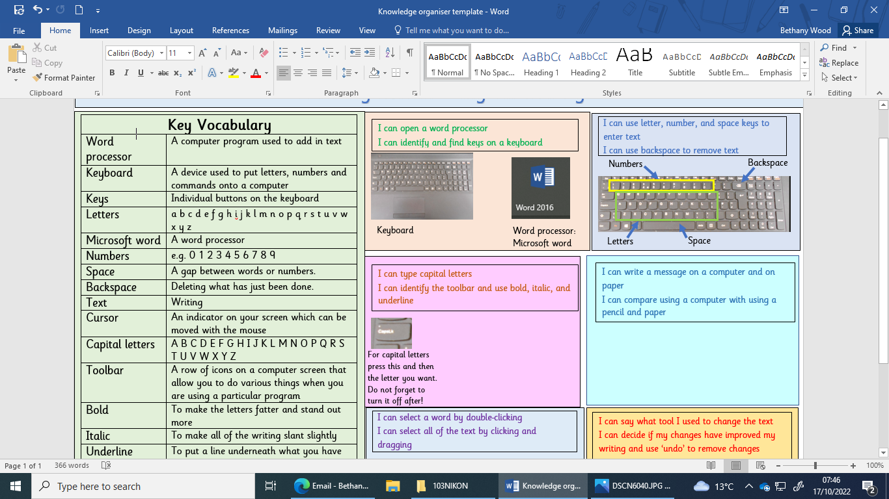

For capital letters press this and then the letter you want. Do not forget to turn it off after!

Numbers

Backspace

Space

Letters

Word processor:

Microsoft word

Keyboard

|  |  |
| --- | --- |
| **Key Vocabulary** | |
| Word processor | A computer program used to add in text |
| Keyboard | A device used to put letters, numbers and commands onto a computer |
| Keys | Individual buttons on the keyboard |
| Letters | a b c d e f g h i j k l m n o p q r s t u v w x y z |
| Microsoft word | A word processor |
| Numbers | e.g. 0 1 2 3 4 5 6 7 8 9 |
| Space | A gap between words or numbers. |
| Backspace | Deleting what has just been done. |
| Text | Writing |
| Cursor | An indicator on your screen which can be moved with the mouse |
| Capital letters | A B C D E F G H I J K L M N O P Q R S T U V W X Y Z |
| Toolbar | A row of icons on a computer screen that allow you to do various things when you are using a particular program |
| Bold | To make the letters fatter and stand out more |
| Italic | To make all of the writing slant slightly |
| Underline | To put a line underneath what you have written |
| Mouse | A handheld device used to move the cursor on the screen |
| Select | To choose something |
| Font | How the letters appear |
| Undo | To remove the last action that you have done |

I can type capital letters

I can identify the toolbar and use bold, italic, and underline

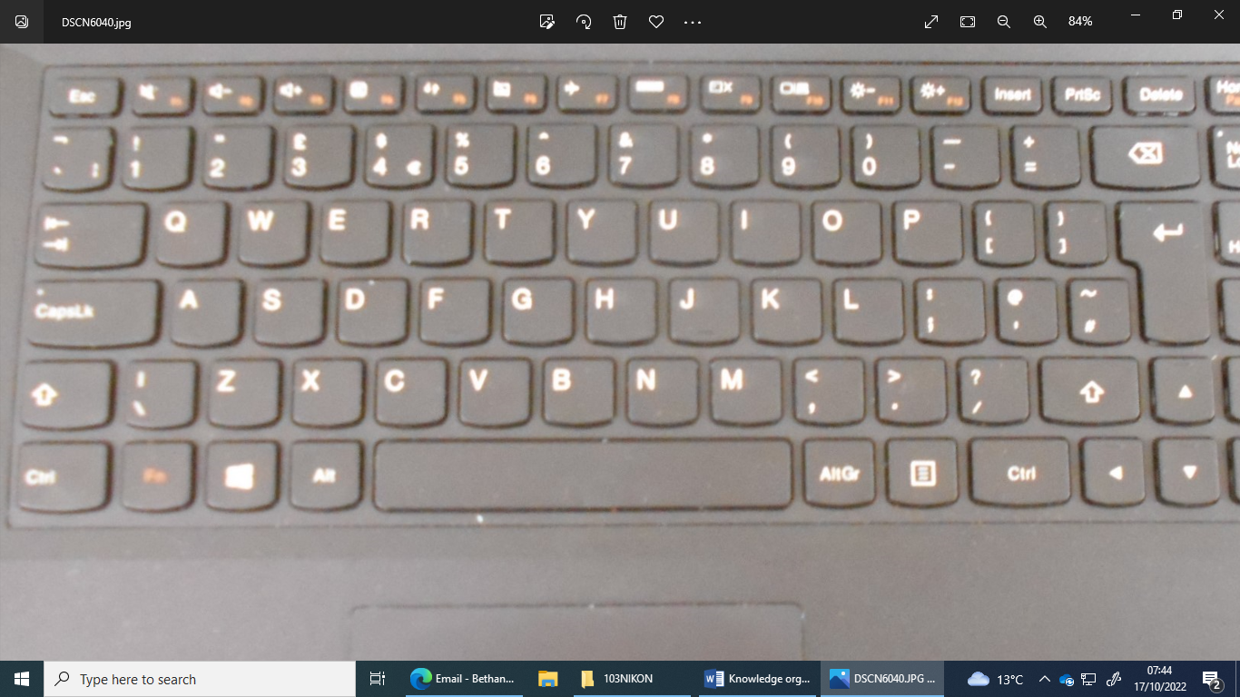

I can write a message on a computer and on paper

I can compare using a computer with using a pencil and paper

|  |
| --- |
| I can select a word by double-clicking  I can select all of the text by clicking and dragging |

 



I can choose a tool from the toolbar

This is undo: 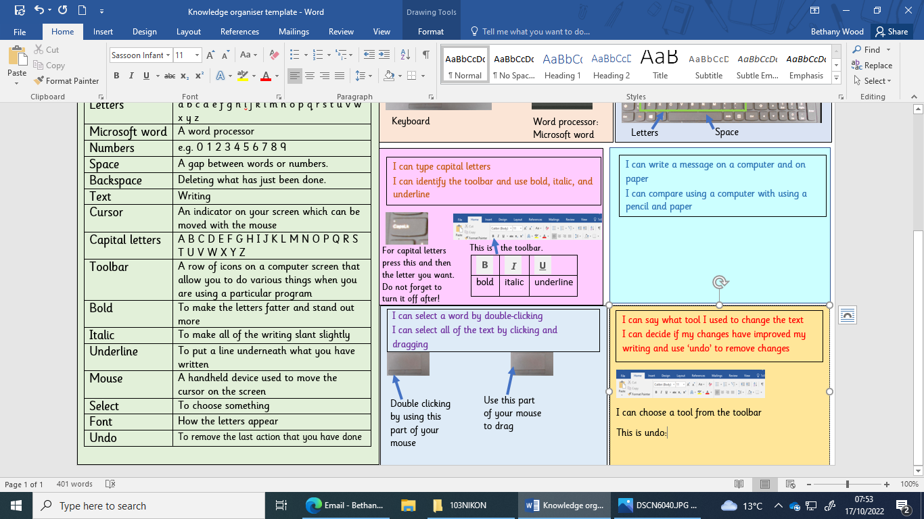

|  |
| --- |
| I can use letter, number, and space keys to enter text  I can use backspace to remove text |

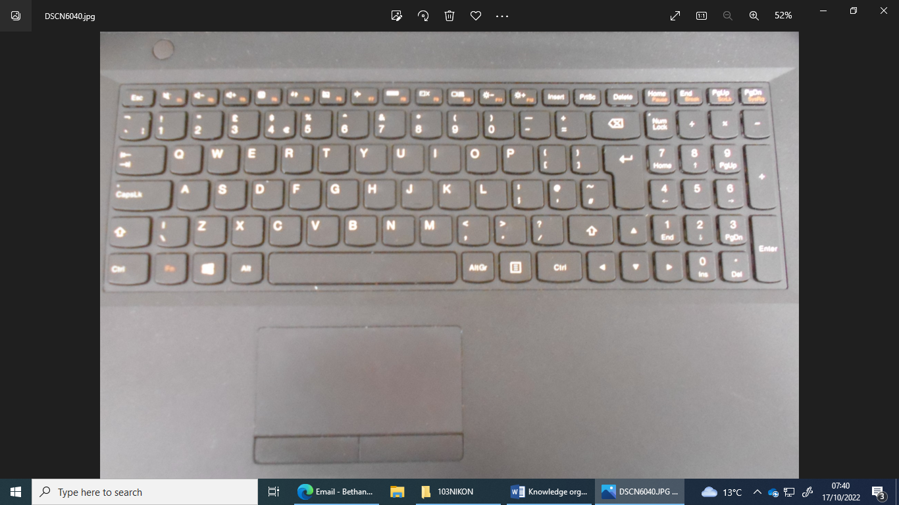

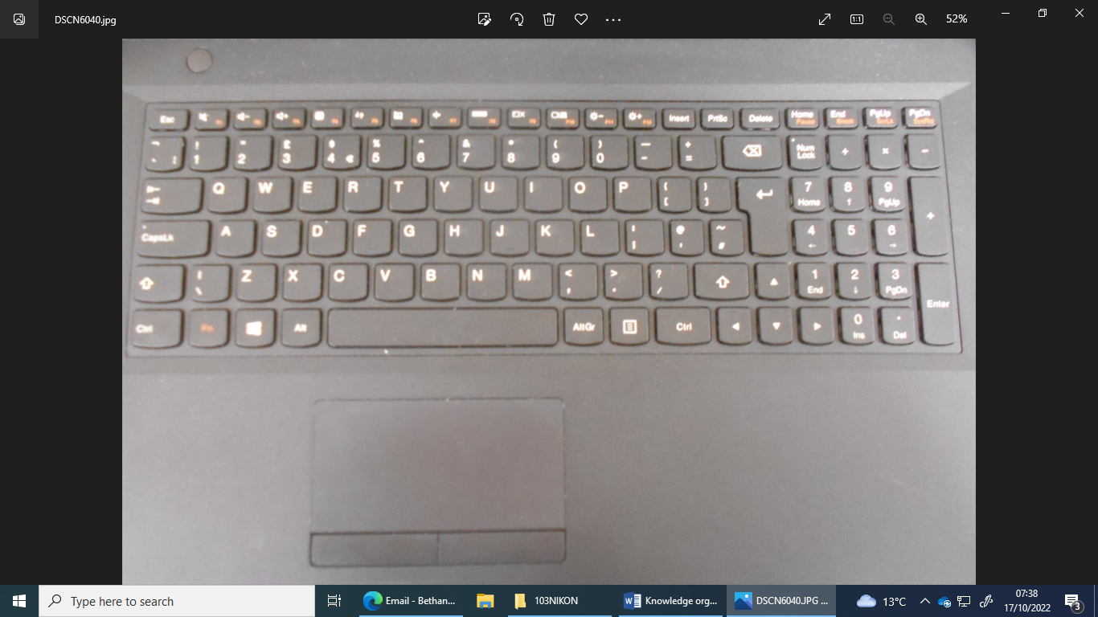 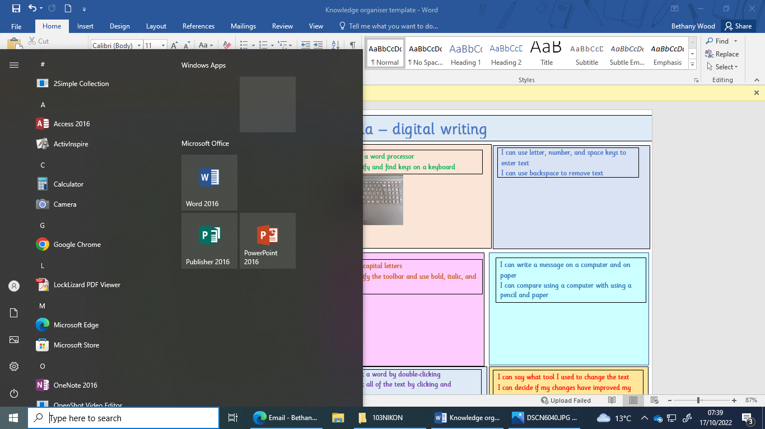

I can open a word processor

I can identify and find keys on a keyboard

Strengthening materials

Creating media – digital writing