Newsletter
March 2022

Ukraine
We are all taking deep breaths as we see and hear about this tragedy unfolding. We have quietly shared practical actions, positive actions that people are taking to help this situation and we make it clear to the children that they can speak to us if they have any worries. We are working to not add to the worry. Which is why we have not proposed any fund raising.
Attached is a document from Devon Local Authority with links on ways to talk to your child about what is happening in Ukraine.
During Lent we are inviting children to take small actions that make a difference to others around them and we are also encouraging children to be positive about what they have as a way of reassuring them during this uncertain time.
If, as a family you would like to contribute practically to the relief efforts in Ukraine by donating financially, The Round Table are collecting each Thursday in Axminster Market Square.
All major charities are directing funds through the same emergency disaster fund. The Disasters Emergency Committee (DEC), unites 15 member charities who are experts in humanitarian aid and specialists in different areas of disaster response.
The DEC launches appeals during times of monumental suffering, which is the case in Ukraine right now.
By donating to this appeal you can be reassured that vital appeal and help will reach families and communities in Ukraine and the border countries.
https://www.dec.org.uk/who-we-are
https://www.gov.uk/government/news/ukraine-what-you-can-do-to-help
https://cafod.org.uk/Give/Donate-to-Emergencies/Ukraine-Humanitarian-Appeal

Covid legislation
Current key changes to note are :
Pupils and staff identified as close contacts are NOT advised to isolate or take daily LFTs.
Only those that show symptoms should test, or advised to test, to support outbreak management.

In addition the following advice is relevant:
As with any other illness children who are unwell should not attend school whilst they are unwell.
If any illness develops into a cough, change in temperature and changes to taste and smell, the advice remains to isolate and test for Covid.
If the test is negative the pupil should return to school.
If the test is positive, follow advise to isolate.
The full guidance can be found by following the attached link.
https://www.gov.uk/government/publications/covid-19-people-with-covid-19-and-their-contacts/covid-19-people-with-covid-19-and-their-contacts

How will this change actions in school
We have begun to have whole school celebration assemblies on Fridays but are closely monitoring this.
World Book Day was the first time our whole school has been together. It was lovely to experience. This coming Friday 18th March, Comic Relief, will be a non-uniform, whole school celebration.
We will continue to keep breaks and lunchtimes as they are whilst the weather keeps us off the field. Once we are on the field we will begin to return to whole school break times.
From 1st April it is anticipated that Covid will be further downgraded. Already accessing tests is becoming difficult. Schools are no longer able to order new test kits for staff. From 1st April it will no longer be necessary to self-isolate unless you are unwell: this puts Covid alongside other illness.
We are very grateful for your continued support and sincerely look forward to returning back to fully normal.

PTFA Events – continued reminder
If you have any capacity to support PTFA events please contact the office. We are looking at the possibility of either an Easter raffle or even an Easter bingo before the end of term. Please email or speak to office admin if you think you can contribute.

Dates for the diary reminders
Wednesday 16th March - Waffle Talk Workshops for Year 6, Group 2
Thursday 17th March - St Patrick’s Day
Friday 18th March - Comic Relief (home clothes day) – please send a donation with your child.
Wednesday 23rd March - Year 5 and Year 6 trip to London Houses of Parliament debate workshops, London Eye and River Cruise.
Last week of term parent consultation sessions. These will be face to face in school events. Details to be sent to parents shortly.
Last week of term Easter Gardens – create an Easter Garden or Easter bonnet with your child and bring in to school during the last week. A lovely way to create an Easter display. Every child who contributes will receive an Easter treat.
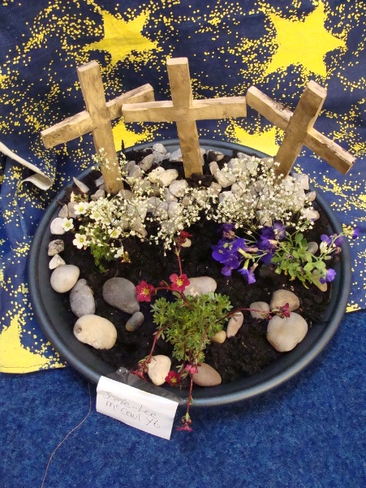

DM Coaching - Holiday Camps
We have been keen as a school to have on site provision for holiday activities. The last time we advertised a forest school activity club (pre Covid ) we had very little take up so we are hoping that you will want to support this holiday camp. It will be run by Mr Murnane and Mrs Foley. In the first instance it will be open to families across the Axminster area. The activities are very varied across the day to appeal to all children’s tastes and interests. Further information has been sent to all St Mary’s families via email.
Multi-Sport & Woodland Adventure Camp (including Movie Club) at St Mary’s Catholic Primary School, Axminster. Tuesday 12th and Tuesday 19th April 8.15am – 3.30pm(5.15pm).
East Holiday Football Camp (including Movie Club) at Stockland C of E Primary School. Monday 11th April 8.15am – 3.30pm(5.15pm).
If interested, please contact Dan Murnane directly on 07845 498057 or at dmcoaching2010@gmail.com

