* I recognise that everyone has different strengths
* I can name some of the strengths and interests someone might need to do different jobs
* I can talk about my own strengths and talents
* I know what jobs I could do which use my talents

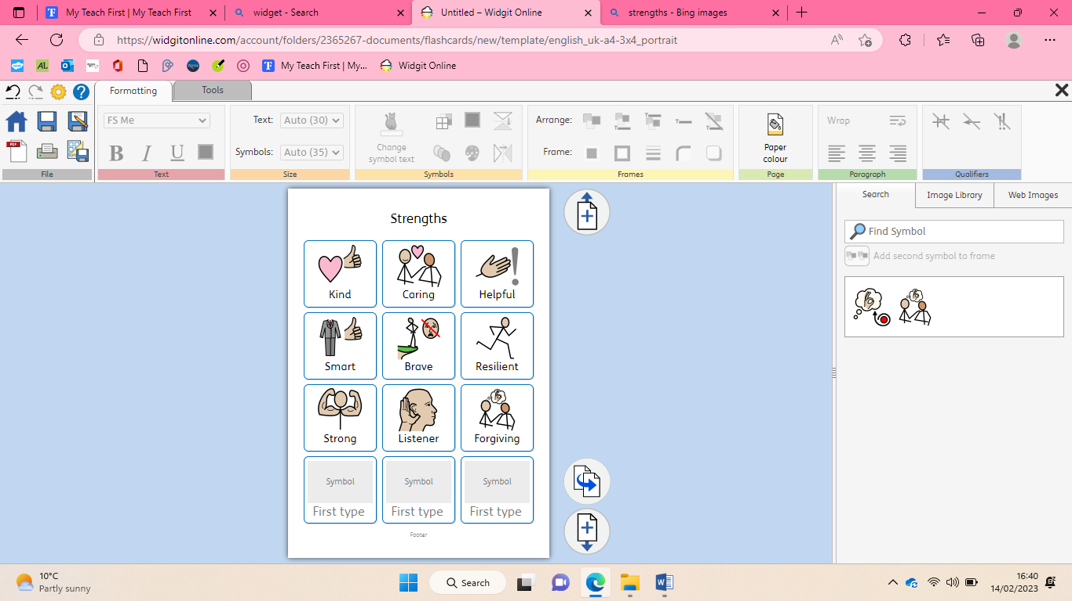

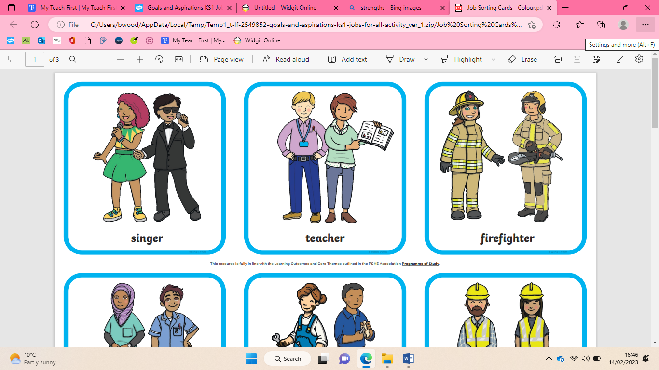 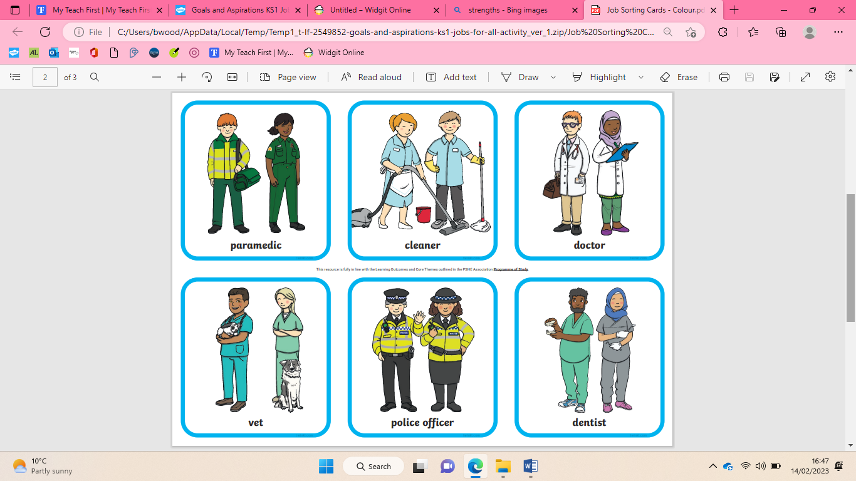 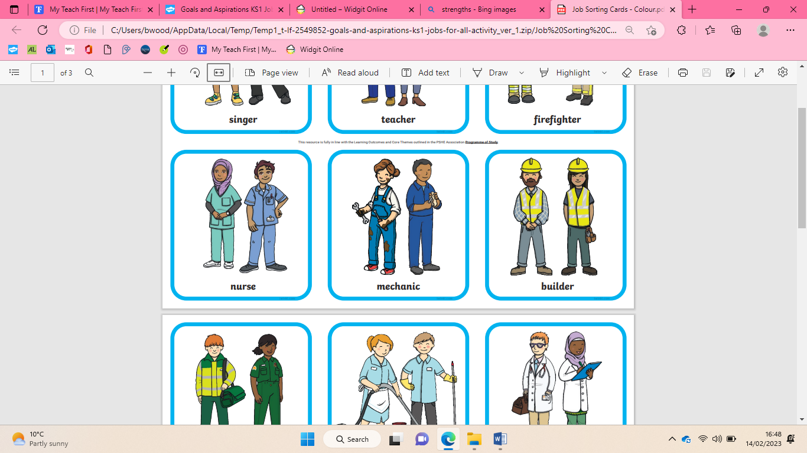

|  |
| --- |
| * I know people make different choices about how to save and spend money * I know how I can look after my money. |

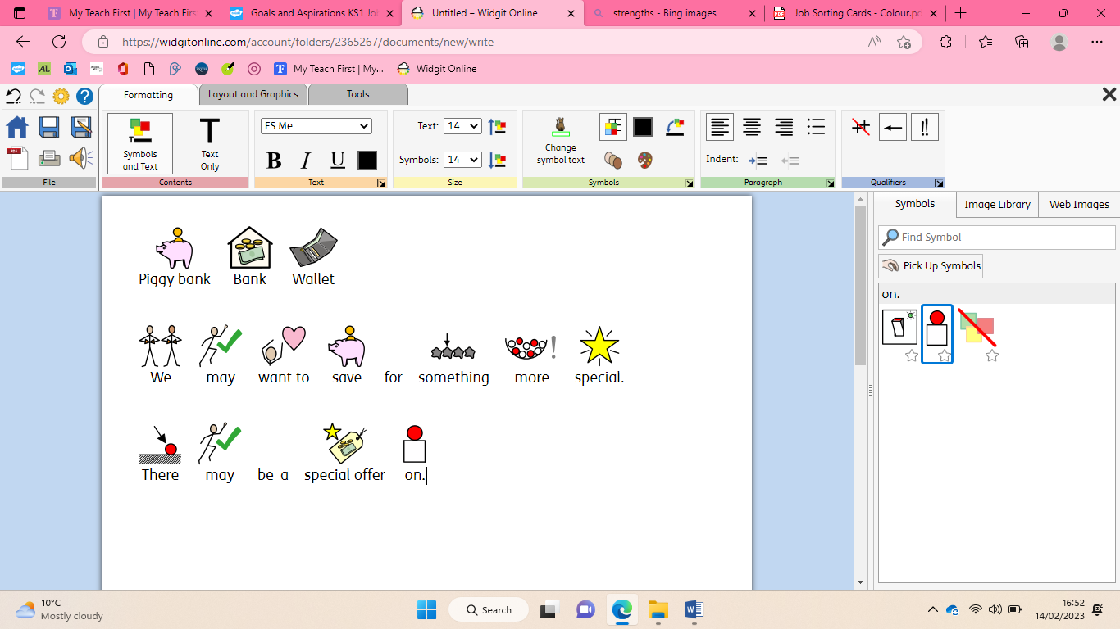

|  |
| --- |
| **Key Vocabulary** |

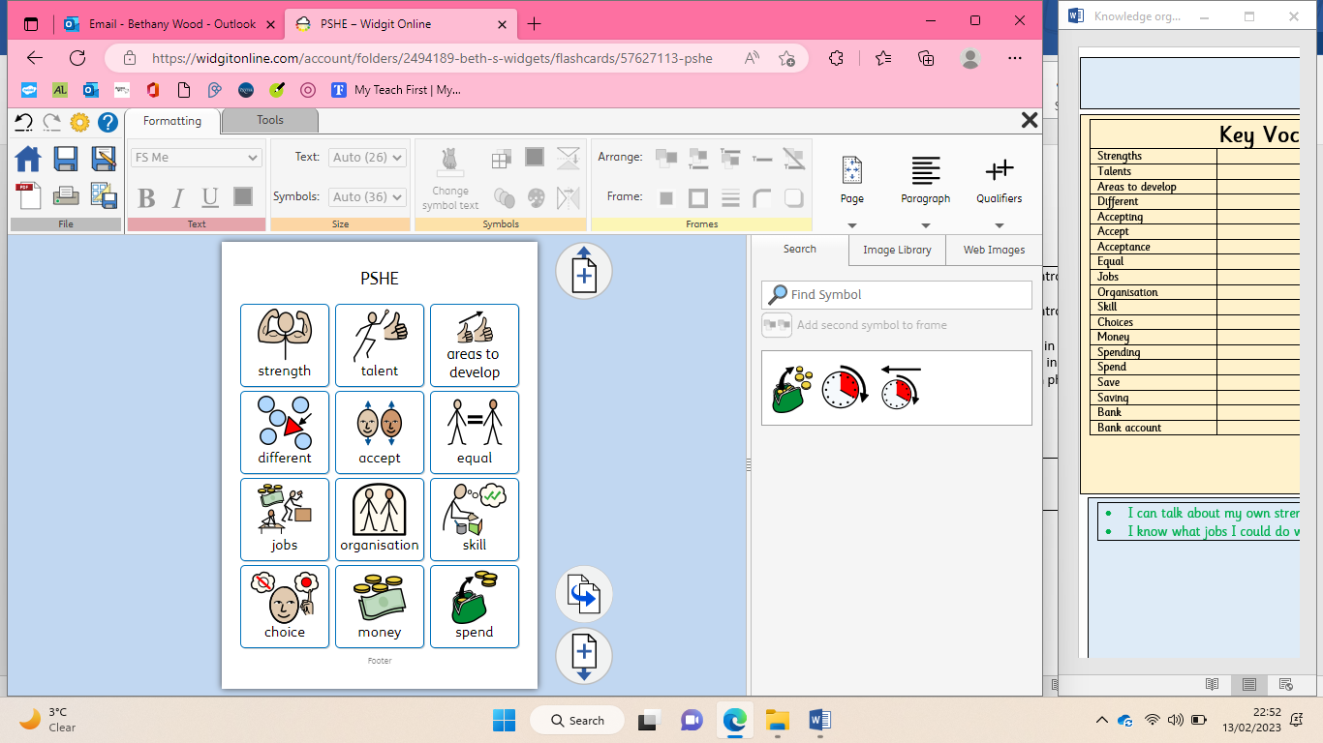

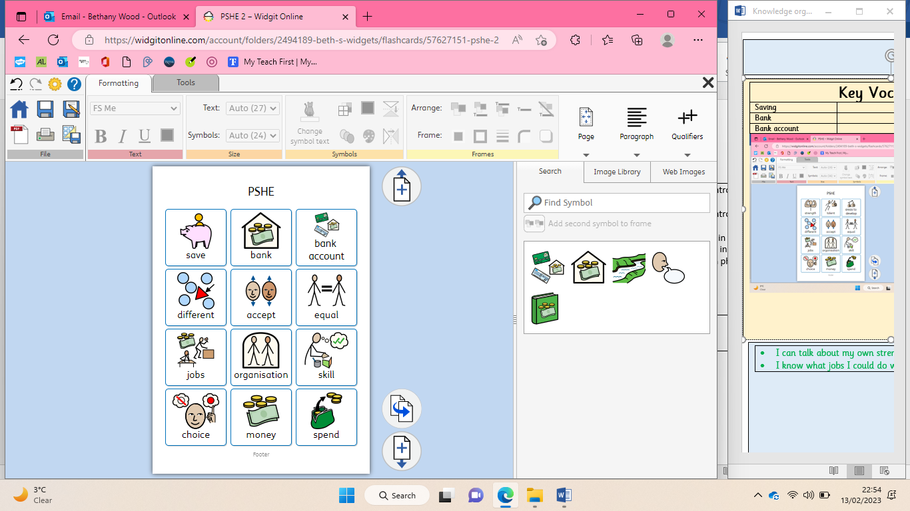

**Money and work**