Friday 26th February 2021

Dear Families of St Mary’s,

It has been lovely to see daffodils and blue sky this week. Another little sign that we are stepping forwards. People have been a bit more smiley and upbeat in anticipation.
At St Mary’s we now have so many of the children back at school. In some classes more than 2/ 3 of the children are back at some point through the week but still we are very much looking forward to having every child back.

We continue to be very grateful to everyone for the on going flexibility and support.
It will be soooooo lovely to have every child back in school.
Update on return
I did say that I would update you by today with details of the full return to school on Monday 8th March. Just one week from now.
We know that we will be required to complete a full risk assessment which has not yet been shared but we have received the full Government guidance. This makes it clear that all pupils should return so we will be working to create a return very similar to the September set up.

Children will wear full uniform. Children will be in their own hub with most children seated with access to their own resources. Throughout the day ventilation, cleaning and hand washing will support as much safe distancing as possible. Adults will wear face masks at all times in central areas and whenever they are less than 2m from the children.

Currently across the school all touch points are cleaned hourly and we will work to maintain this with the full return.

Parents will be asked to wear masks in the playground and to arrive and leave as promptly as possible, working to maintain 2m space as much as possible. All of these systems and procedures are now familiar to us all.

The document makes clear that space, ventilation and hygiene are the way forward for some time to come. Staff will continue to access twice weekly tests. Primary pupils are not going to be tested.
Track and trace systems will be in place as they have been previously. If a child shows any covid symptom’s they should take a test and remain out of school until the results are known. If the test result is negative the child can return to school. If it is positive, then they will need to self isolate along with their household.

If a member of a child’s household develops symptom’s the child should remain at home and the household should self isolate until the test results are known. Again, if the result is positive self isolation rules apply. If it is negative then the child can return to school.

If we were to have a positive case then the hub would need to self isolate. In addition, if we did have a positive case at school we would inform everyone.

In all circumtances if your child is unwell please be watchful for any covid symtptons . Please continue to monitor your child and keep us up to date with any actions you take.

School start/finish/entrance
As always, covid safelty is the priority so limiting the number of people standing and waiting in the playground is key. Parents will be asked to wear masks in the playground and to arrive and leave as promptly as possible, working to maintain 2m space as much as possible. All of these systems and procedures are now familiar to us all. We are grateful for your continued cooperation and understanding.

We will return to the drop off based on family surname so that we have a flow of children from 8.45 and we will keep children entering through current gates and doors.

Start of day
If your surname is…
A-H please arrive in the window between 8.45-8.50
J-M please arrive in the window between 8.50 -8.55
N-Z please arrive at 9am

Entry points
Robin Class-via the side door off the main entrance
Woodpecker Class-via the side door off the main entrance
Owl Class-via the new wooden gate
Kestrel Class-via the new wooden gate
Eagle Class-via the school office entrance

End of day
Robin Class-3.20-via the side door off the main entrance
Woodpecker Class-3.25-via the side door off the main entrance
Owl Class-3.25-via the new wooden gates
Kestrel Class-3.30-via the new wooden gates
Eagle Class-3.30-via the school office

School Lunches
School lunches will resume for any pupil who wishes to have a school meal. The menu that you can see on Parent Pay is what is going to be available (not the shortened version which has been offered during this lockdown phase). Going forward, our catering team have advised that we will need to pre book our meals a week in advance (we will order every Thursday for the following weeks meals). As such, it is really important that if your child requires a lunch, that it is booked at least a week in advance.

School uniform
If your child has grown out of any of their school uniform, items can be ordered online via the Honiton Sports Shop website, please see link below:

www.honiton-sports-shop.myshopify.com

Items can then be collected by their click and collect service. Staff are available in the shop on Mondays between 9am - 3pm for items to be collected. However, they have recommended ringing or messaging before travelling just in case of any change. Their telephone number is 01404 42100 or email honitonsports@gmail.com. Alternatively, you can message them via the Honiton Sports Facebook page.

As we have windows and doors open for ventilation, please may we ask that children are dressed accordingly, for your child this may mean an extra layer. Children will access learning outside if possible and will have outdoor breaks so please always send them in with a coat.

P.E
Next week we will confirm which days each class will need to come into school in their P.E kits.

Lent February 17th to Saturday 3rd April
This year Lent takes on greater relevance. A time to hope. The attached resources provide some reflection and activities to support your journey.
https://cafod.org.uk/Education/Primary-teaching-resources/Lent-resources-for-children

A Blessing of peace from lockdown 1 Children from all nations
May His face shine upon you and bring you peace.
https://www.youtube.com/watch?v=uiWZXLsdE9w

World Book Day 2021 -St Mary’s Tuesday 9th March 2021
The official date for this much celebrated day for all things books is Thursday 4th March but we thought we would all celebrate this as part of the whole school return on Tuesday 9th March. Teachers are planning to use this day as a way to support our whole school return by giving children opportunities for book talk and story telling. Children will not be in costume but we will ensure that books are the main focus of the day.
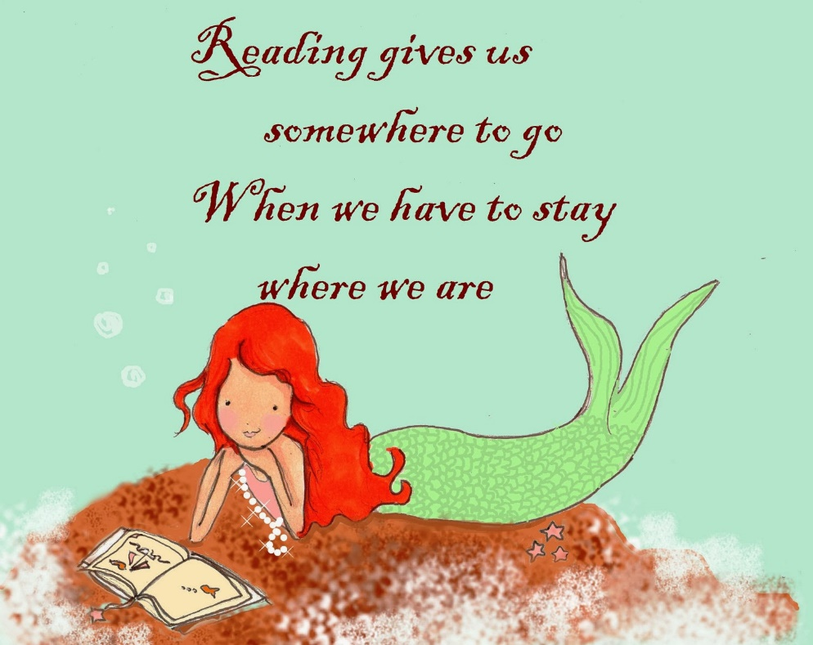

On the 4th March or anytime during next week then do take the opportunity to take some extra time to enjoy books. The World Book day site has lots of activities and ideas including daily story time events on the 3rd, 4th and 5th March. For more details follow the attached link : https://www.worldbookday.com/events/
Oak Academy have been holding lots of author events including from Jacqueline Wilson, Jeremy Strong, Konnie Huq ( of Blue Peter fame ) and Nizrana Farook and Sally Gardner. https://library.thenational.academy/

Or take some time to settle in with favourite jokes, stories or poems.
World Book Day Vouchers are being shared again this year and can be used until Sunday 28th March to buy the special £1 books or to contribute to the purchase of any book or audio or physical book. Tesco do accept these vouchers.
This year they are being sent to you as e vouchers. Please click on the below link or put it into your search browser to access your £1 book token. Children will also be sent home with a physical voucher on the 9th March.

booktoken_PrimaryUK.pdf (worldbookday.com)

Comic Relief Friday 19th March 2021
We would like to mark this day. Comic Relief fund raising makes a huge difference to so many families and organisations in the UK. It really does change lives and it would be positive to celebrate this with the children.
At the moment, as we prepare for the full return of all pupils, it is not yet fully clear what we can do on the day, so please do watch out for details in the next week.

In preparation for the day why not take part in the share a smile event. Please see attached poster which you may want to complete.

..always

