road

SC school

|  |  |
| --- | --- |
| **Key Vocabulary** | |
| Compass | A tool for finding directions |
| Road | A path for cars and other vehicles. |
| Pavement | A path where people can walk safely. |
| Zebra crossing | Part of the road which has black and white stripes indicating that cars should stop for people to cross the road. |
| Car park | An area where the public can leave their cars. |
| Houses | Buildings where people live. |
| North south east west | Compass points and directions. |
| School | A place where children go to learn. |
| Symbol | A drawing that shows a feature in a simple way |
| Plan | To think about how something will need to happen |
| Map | A drawing of a place |

|  |
| --- |
| Use symbols and labels on a map |

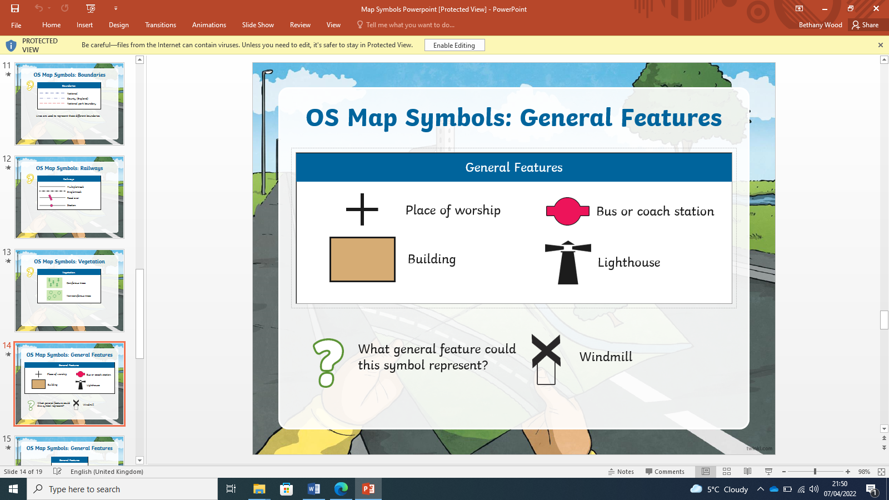 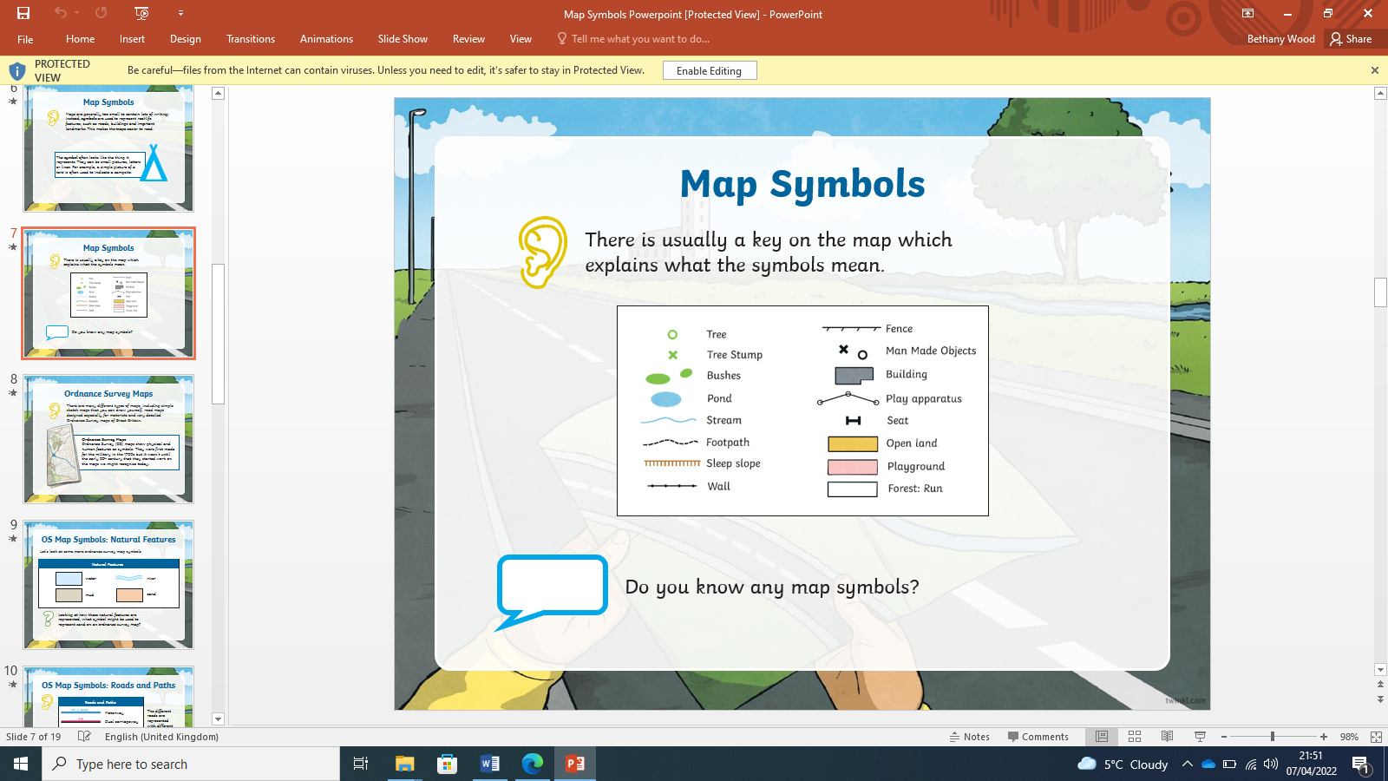 



Use directional vocabulary



|  |
| --- |
| Survey local area, use symbols |

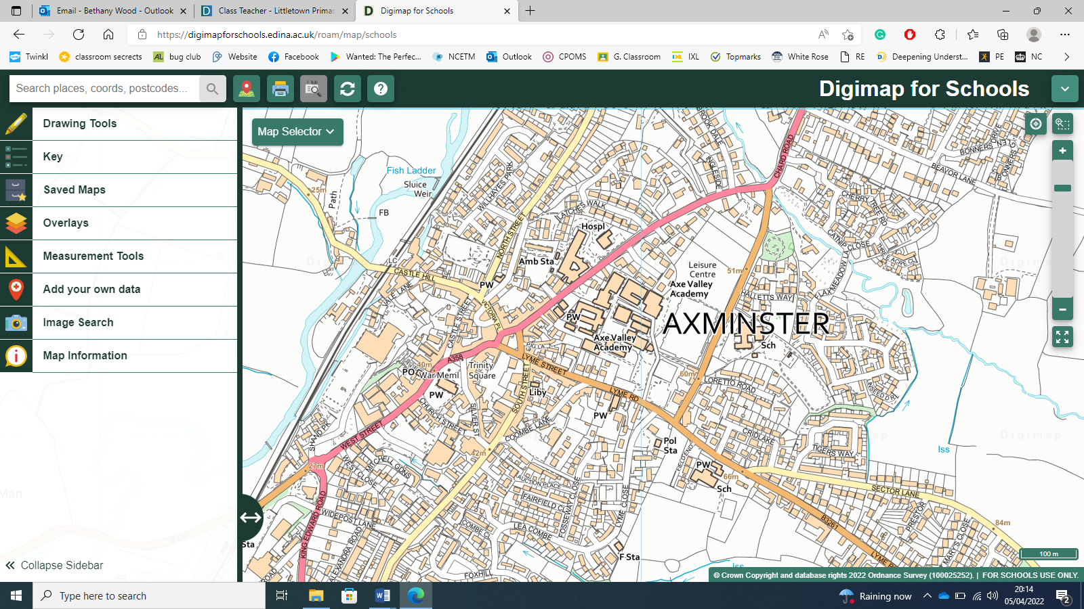

Talk about and describe locality