Patterns and pumpkins

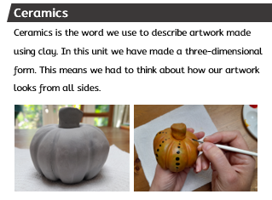

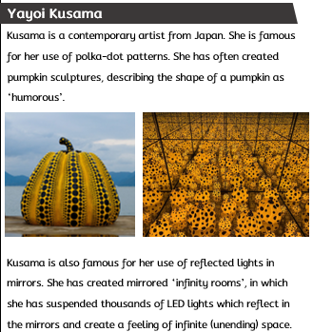

|  |
| --- |
| **Key Vocabulary** |

clay: (noun) a stiff, sticky fine-grained earth that can be moulded when wet, and is dried and baked to make bricks, pottery, and ceramics.

contemporary: (adjective) art of the present day or recent past.

form: (noun) the visible shape of something. A form has three dimensions: height, width and depth.

infinity: (noun) going on forever; never ending

pattern: (noun) a repeated decorative design.

texture: (noun) the feel of a surface.

ceramics: (noun) the art of making things out of clay.

slip: (noun) a creamy mixture of clay and water used to attach clay together or to decorate the surface of clay.