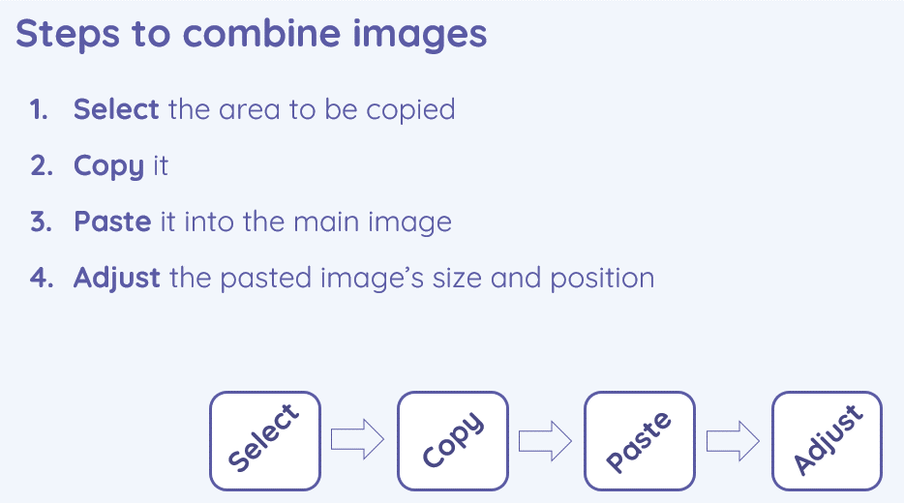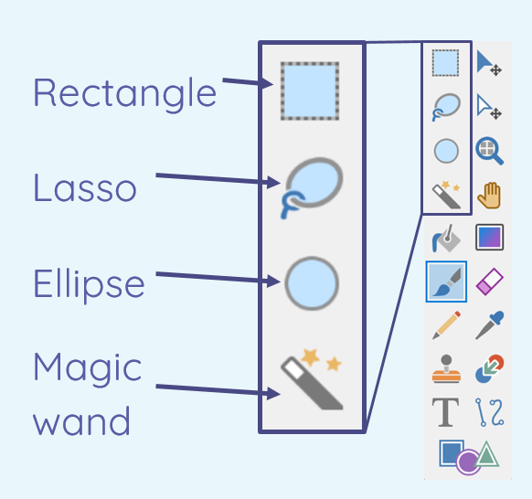
- I can give examples of positive and negative effects that retouching can have on an image
- I can choose appropriate tools to retouch an image

- I can consider the effect of adding other elements to my work
- I can compare the original image with my completed publication

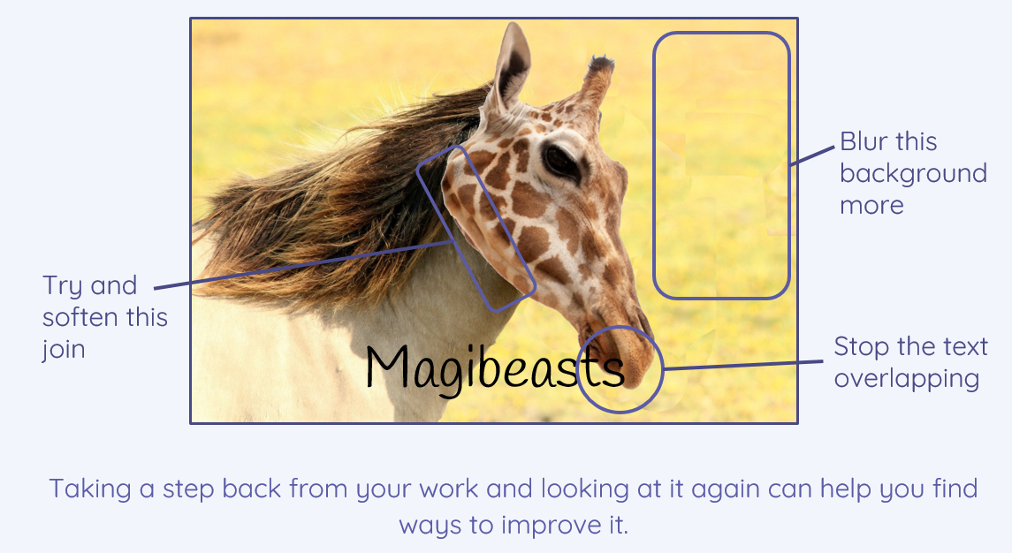
- I can sort images into ‘fake’ or ‘real’ and explain my choices
- I can combine parts of images to create new images

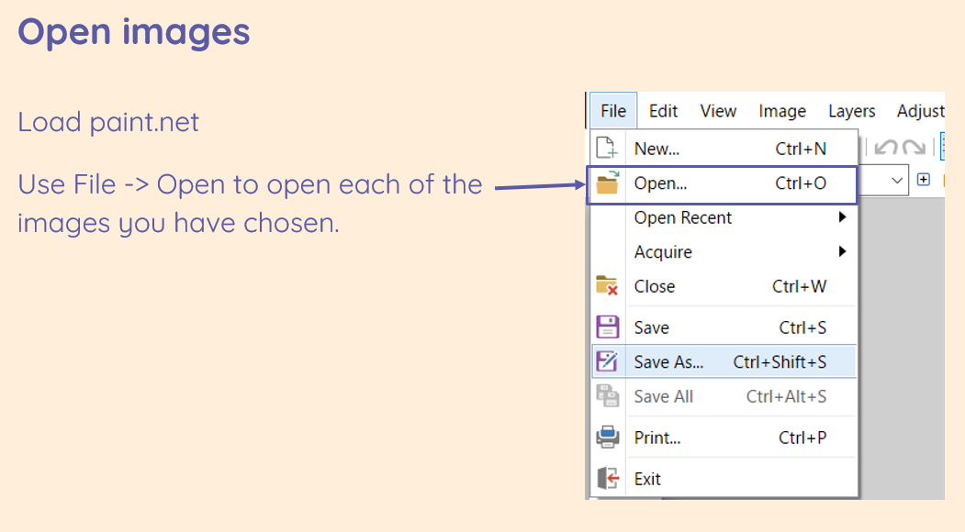
Key Vocabulary
Image- the photo
Edit- to change something to improve it
Retouch- to change something slightly
Clone- to make a copy of it
Recolour- to change the colour
Magic wand- a tool in paint.net
Adjust/ alter- to change
Sharpen- make the edges clearer
Brighten- make the picture lighter
Composite- something that is made of many parts/ elements
Cut- to remove something from somewhere
Copy- to copy something
Paste- to place the object you have cut/ copied in another place
Elements- parts
Original- the first copy
Font style- how the text looks
Border- the part around the outside
Layer- things that are put on each other
Photo editing

