I can explain how the internet allows us to view the World Wide Web
I can recognise that the World Wide Web is the part of the internet that contains websites and web pages
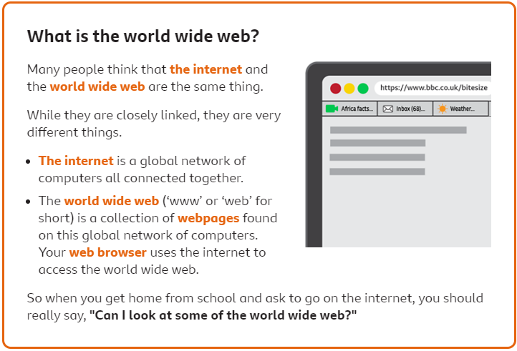
I can describe the different networked devices and how they connect
I can recognise that the World Wide Web is the part of the internet that contains websites and web pages

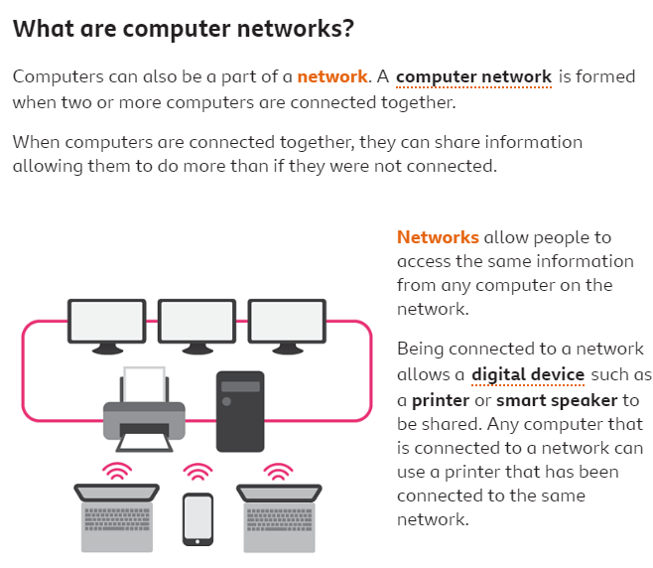

Key Vocabulary
Browser | A software used to search the world wide web.
Elements | The parts that make something up.
Internet | A network, or system, that connects millions of computers worldwide.
Network | A group or system of interconnected people or things
Network Security | Is a set of rules and configurations designed to protect the integrity, confidentiality and accessibility of computer networks and data using both software and hardware technologies.
Network Switch | A device that enables multiple devices on a network to be connected with each other.
Router | A device that passes information between two computer networks.
Server | A computer that manages the network and stores files.
Wireless access point / WAP | A device, connected to a wired network, that sends and receives wireless signals for/from devices with wifi connectivity.
Website | A collection of many web pages.
Web Address | Contains information about the location of the webpage
Web page | A document for the world wide web

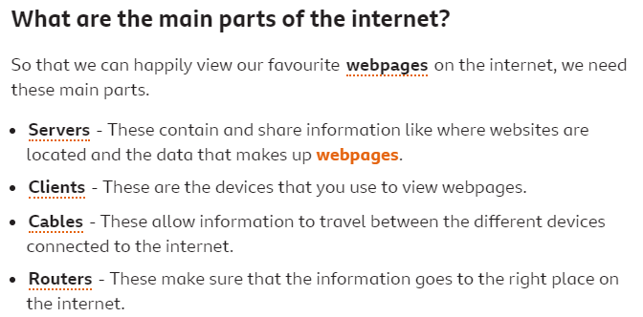

I can describe the internet as a network of networks
I can demonstrate how information is shared across the internet

Computer systems and networks – the internet

