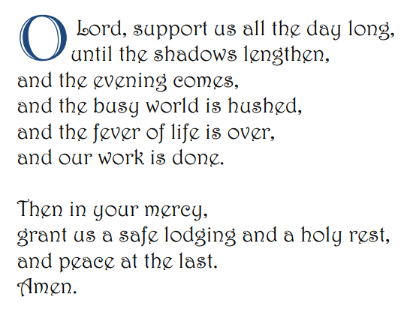

Covenant: an agreement or a promise
Virtue: a good habit that helps us to act according to God's love for us.
Faith: means that you believe God exists and He's good.
Hope: a gift from God by which we trust in Jesus Christ, that He will keep His promises and help us through difficulties on our journey.
Love: willing the good of another- reflecting God’s love for us
Forgiveness: you choose not to pay someone back when they hurt you. We should forgive because Jesus forgives us.

Creation and covenant
LO: to explore how God kept his promise to Abraham. To know the story of Abraham and Isaac and think about the meaning of the story.
Abraham came to believe in one God who was with him in his life.
The societies around Abraham didn’t believe this.
In this story, we come to understand that God does not want human sacrifices; what God wants is that people have faith in God, trust in God and try to do the right thing.
LO: to know and understand the Prayer of Cardinal Newman. To reflect on the virtues of Faith, Hope and Love.

LO: to know how faith influences the life of Jenny Garzón Saavedra and how her actions helped others
Jenny Garzón Saavedra, 28, is a youth worker in San Vicente de Caguán, in the Colombian Amazon. She works for a CAFOD partner, FUNVIPAS,, to support children and young people to improve where they live. Jenny teaches young people about their rights, such as the right to clean drinking water and a safe and healthy environment.

LO: to know the covenant God made with Abraham
Then one day this happened; (Gen 12: 1-5)
“Now the Lord said to Abram,
“Go from your country and your kindred and your father’s house to the land that I will show you. I will make of you a great nation, and I will bless you, and make your name great, so that you will be a blessing. I will bless those who bless you, and the one who curses you I will curse; and in you all the families of the earth shall be blessed.”
LO: to understand the background to Abraham’s story
The pyramids were being built.
Jobs were inherited from parents. There were many jobs they could have,
They believed in many gods who affected everyday life.
The city of Ur - Most people had jobs, labourers, craftsmen and farmers.
The Tigris and Euphrates were important rivers that flooded each year,

LO: to know how faith influences the life of Sean Deveraux and how his actions helped others
Sean was not special, nor rich or famous. He was popular at school and loved games and PE.
He was a Catholic and went on various trips organised by the church for young people. On one of those trips he met Pope John Paul.
He was able to attend a private mass with the Pope.

