|  |
| --- |
| **Key Vocabulary** |

* Group - To group things is to put similar things together.
* Common - To have something in common is to share interests or other characteristics with someone or something.
* Observable characteristic - An observable characteristic is a feature or property of a living thing that we can see or use our other senses to observe.
* Diagram - A diagram is a simplified representation of information.
* Observe - To observe is to look very closely and use other senses too.
* Classify - To classify is to sort objects into groups based on their similarities and differences
* classification key - Classification keys are diagrams which help us identify objects using yes/no questions.
* Identify - To identify something is to be able to name it correctly.
* yes/no questions - A yes/no question is a type of sentence that asks something and is answered with only yes or no.
* Structure - The parts of an animal’s body are called its structure.
* Zoologist - A zoologist is a type of scientist that studies animals.
* Botanist - A botanist is scientist who studies plants.
* Environment - The environment is the surroundings of a living thing, including other plants or animals and the conditions they live in.
* Seasons - Seasons are periods of similar weather. In the UK there are four seasons (spring, summer, autumn and winter).
* Migrate - When animals migrate, they move from one environment to another in different seasons.
* Hibernate - To hibernate, an animal goes into a deep sleep; usually in winter when food is scarce.

Using classification keys to identify animals

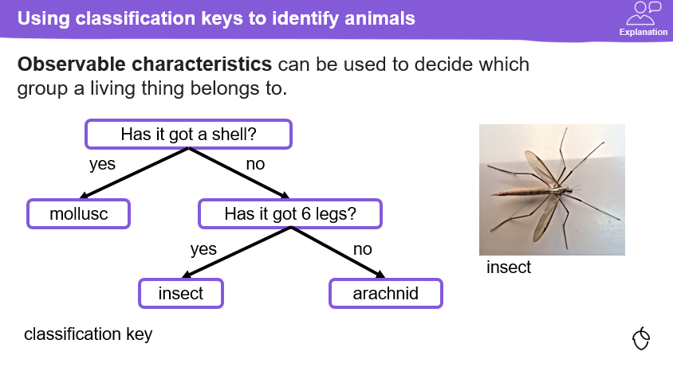

Using classification keys to identify plants

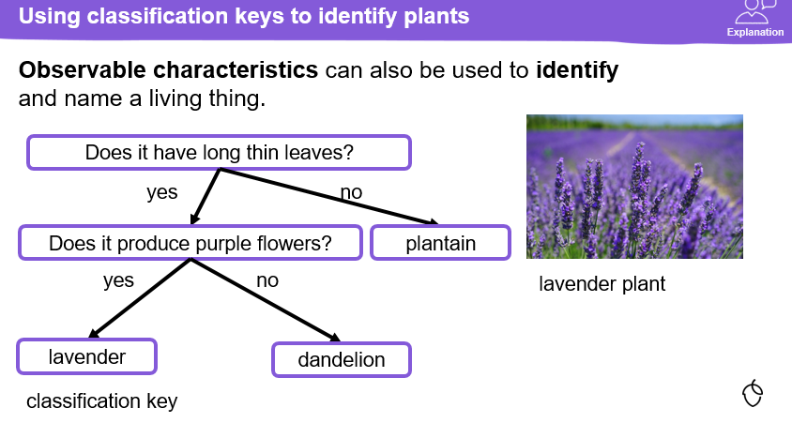

Grouping plants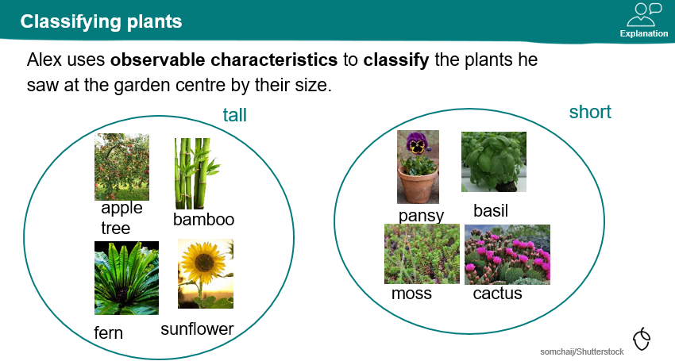

Classification keys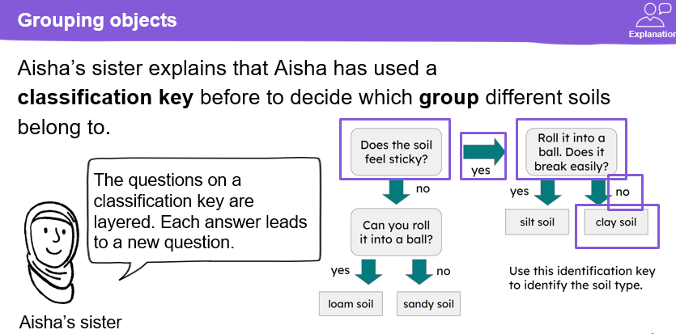

Grouping animals 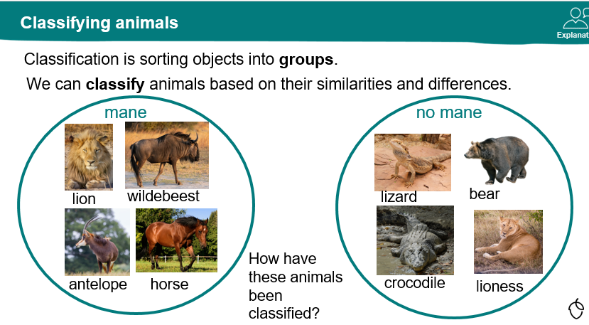

Observable characteristics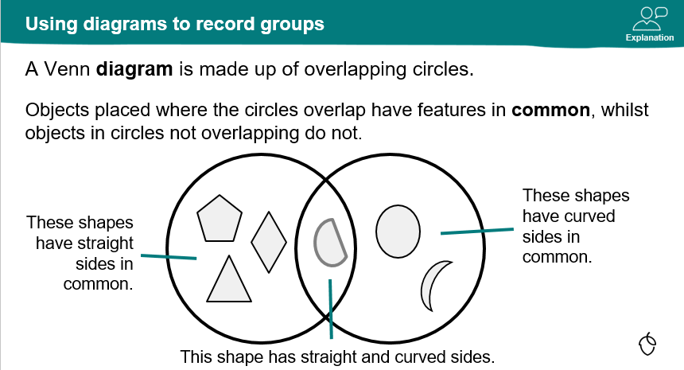

Classifying organisms