St Mary’s Catholic

Primary School

Guide to the Early Years Foundation Stage

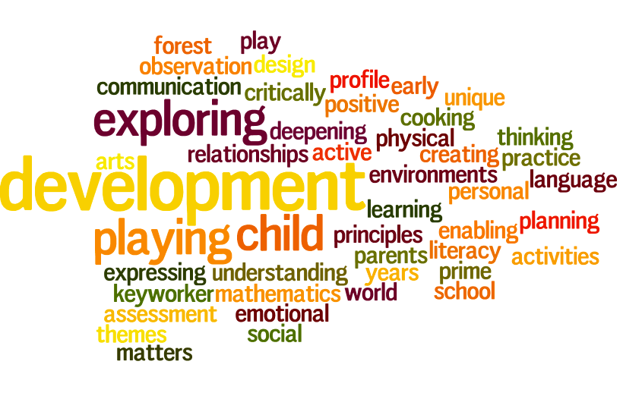



* St Mary’s Catholic Primary School
* Living, loving and learning with God
* “Every child deserves the best possible start in life and the support that enables them to fulfil their potential. Children develop quickly in the early years and a child’s experiences between birth and age five have a major impact on their future life chances. A secure, safe and happy childhood is important in its own right. Good parenting and high quality early learning together provide the foundation children need to make the most of their abilities and talents as they grow up.”
* - Statutory Framework for the Early Years Foundation Stage 2014

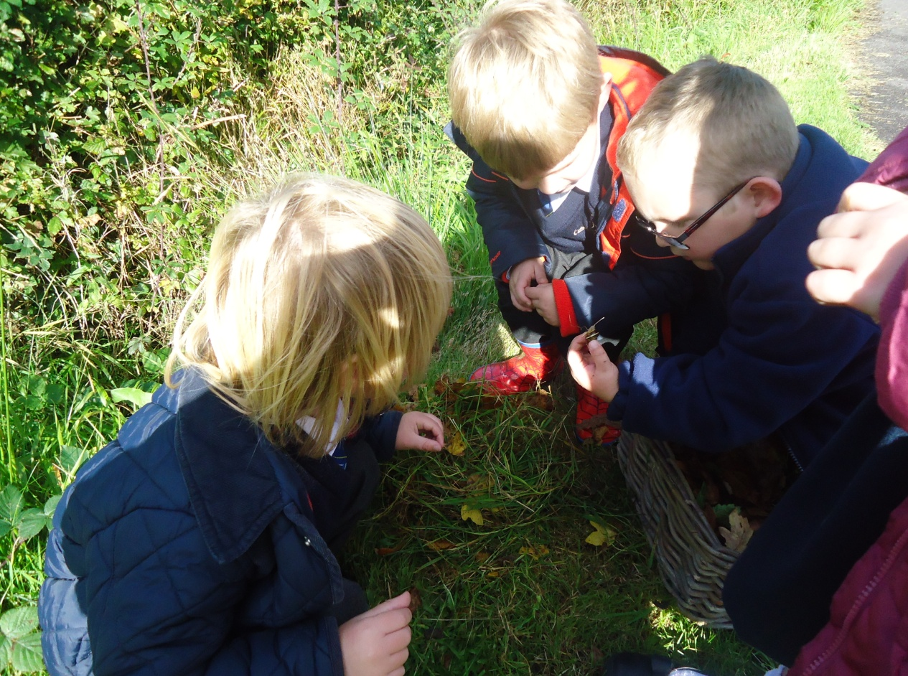

**Positive Relationships**

**Role of adults**

At St Mary’s we believe that all adults in the school make a significant contribution to the well-being and development of all children. Children learn to be strong and independent through positive relationships. They learn best when they have positive relationships with the adults caring for them. Adults in Robin class always ensure that they are sensitive and responsive to the needs, feelings and interests of all children. They encourage independence through warm and positive relationships.

***Our shared agreement at St Mary’s about the role of adults in the Early Years Foundation Stage is:***

* We seek to know and understand each individual child and their development
* We show enthusiasm and celebrate with children their interests and achievements
* We scaffold children’s learning through talk, discussing strategies and ideas, suggesting possibilities and modelling approaches
* We encourage and support children to persevere through difficulties, to take risks, to ask questions and problem-solve
* We use the language of learning to focus children on themselves as learners
* We identify and support next steps in learning
* We join in play and child-initiated activities following children’s agendas

**Adults within the class**

Reception = I would have said you have become a three adult team?? And volunteers seem a big part of your provision

In Robin class, there are two members of staff; teacher and teaching assistant working as a close team who are the main adult contact for the children in the class. This ensures there are good opportunities for children to experience consistent interactions and expectations. This helps children moving between the worlds of home and school where the environment and routine is very different. Both adults are responsible for keeping the children’s observations and Learning Journeys up to date. At some points of the day other familiar adults take over the teacher’s role for short periods of time. For example, at lunchtimes the midday meal supervisors support the children during their lunch and on the playground.

***The role of the teacher and teaching assistant is:***

* To help the child become familiar with the setting and provision within the setting
* To offer a settled relationship for the child
* To build relationships with the child’s parents
* To ensure the child’s learning and care is tailored to meet their individual needs
* To engage and support parents in guiding their child’s development at home
* To have a deep knowledge and understanding of the child
* To help families engage with more specialist support if appropriate

**Parental Involvement**

At St Mary’s we know that parents are children’s first and most enduring educators and we value being partners with them in their child’s education. We believe that children are eager learners and all adults have an important role in sustaining that eagerness. Parental involvement in education leads to better results for children in the early years and beyond.

***We ensure that parents are fully involved in their child’s education by:***

* Gathering information from parents/carers before a child starts
* Ensuring photographic evidence/children’s work is displayed around the setting for parents to see
* Giving parents/carers the opportunity to take part in educational visits and share their interests and expertise
* Talking to parents about their child before and after school and maintaining an open door policy
* Sharing children’s ‘Learning Journeys’ regularly with parents and valuing the ongoing contributions to this from parents/carers
* Using the online journal Tapestry so parents have instant access to what their children are learning in school. They can also record their child’s achievements about their child’s learning at home.
* Delivering workshops to share our practice, ethos and ideas with parents/carers

**Enabling Environments**

At St Mary’s we believe that a rich environment has an immediate effect on the quality of children’s learning and development. An enabling environment is one that is comfortable, interesting, attractive and appropriate for the children who use it. It encourages children to play and learn because they feel secure. When children feel emotionally safe they are able to explore and find out about the world around them.

The outdoor and indoor spaces are seen as one, with activities flowing freely. This free flow between the inside and the outside has a positive impact on the children’s development. In both spaces there are areas where children can be active, be quiet, be creative, imaginative and much more. We ensure that both the indoor and outdoor areas contain print (such as displays, books, labels and questions) so that children begin to understand that print conveys meaning and they develop those important early literacy skills.

**Indoors**

Indoor spaces are carefully planned so they accommodate children’s interests and needs. The spaces are used flexibly and a range of activities are provided which include challenge for all children. Where possible, resources are of the highest quality and equipment is kept in boxes, baskets or shelves labelled with print, numbers and pictures ensuring easy access for all the children to enable their play. The learning environment covers all areas of learning and particularly reflects current learning through, for example, enhancements.

**Outdoors**

We know that being outdoors has a positive impact on children’s sense of well-being and helps all children’s development. Therefore at St Mary’s we ensure that all children have constant access to the outdoors regardless of weather conditions unless it is unsafe to do so. All areas of learning are covered in the outdoor area and the current learning is reflected outdoors as well as indoors. Being outdoors offers opportunities for doing things in different ways and on different scales. It supports confidence and allows opportunities for big scale play, problem solving, creativity and risk taking. In addition, it gives children first hand experiences with weather, seasons and the natural world. The outdoor environment provides children with the freedom to explore, use their senses and to be physically active.

Many children prefer being outdoors so the learning opportunities that are available indoors are available for the children outdoors, for example, key vocabulary, writing, mathematics, role play and much more. Planning for the outdoors is of equal importance to the planning for indoors and the outdoor area is organised into learning areas where adults can follow children’s interests, respond to their ideas for developing play activities or provide a specific focus.

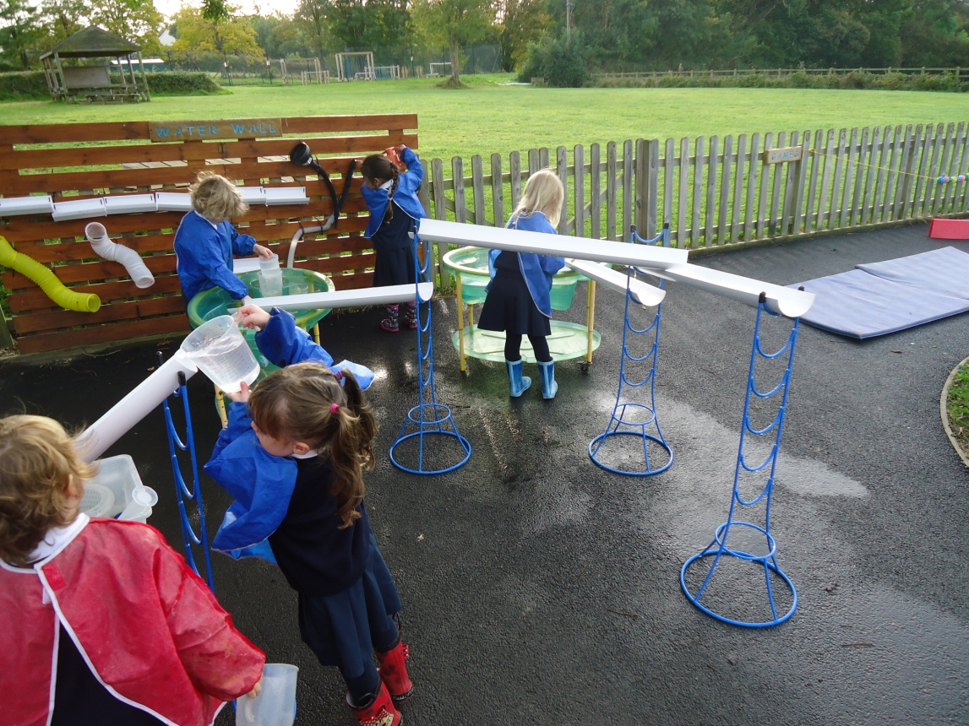

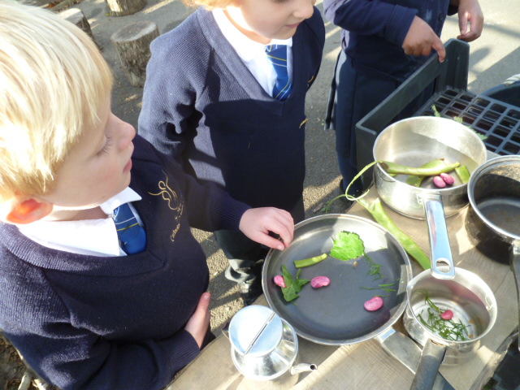

***Gardening***

At St Mary’s we believe that the benefits of gardening with young children are enormous which is why we like to grow herbs, flowers and vegetables. A 2010 study commissioned by the Royal Horticultural Society (RHS) found that children in schools that encouraged gardening became more resilient, confident, eager to learn and have healthier life styles. It also found that gardening had a positive impact on children’s literacy and numeracy development and that it led to a more active, inquisitive approach to learning and improved problem solving skills.

**Spirituality**

At St Mary’s we encourage the children to be reflective and we provide a focal point for quiet reflection inside as well as a sensory garden in our outdoor area which the children use as a quiet place to sit and reflect on what is important to them. The Gospel values of faith, hope, love and peace embody everything that we do and we encourage the children to reflect on how they can display these values in their daily lives.

**Role Play**

At St Mary’s we know that a rich, stimulating and creative learning environment is fundamental to children’s learning.

To support active engagement with different topics and texts we provide a role play area inside and encourage children to role-play outside as well. These areas are well thought out and where appropriate planned for when the topics and texts are decided on at the start of each half term.

***Role play areas:***

* Are planned to encompass a variety of types of role play. This could include domestic play, transactional play and imaginary worlds.
* Where possible, contain real objects of good quality. For example, fruit/vegetables, money and packaging for a range of products.
* Are often based on first-hand experiences from which the children can draw. For example, we would carefully consider whether to have an airport or travel agent if the majority of children have not experienced these locations.
* Are changed and enhanced to reflect the current learning.
* Have involved the children in developing the area. For example, the children choose the focus for the area and make/bring in resources for this.
* Promote opportunities for many skills. These could include, problem-solving, negotiating, mark making including writing, expressing ideas and reading.
* Contain a range of model writing/phrases/vocabulary handwritten in cursive script.

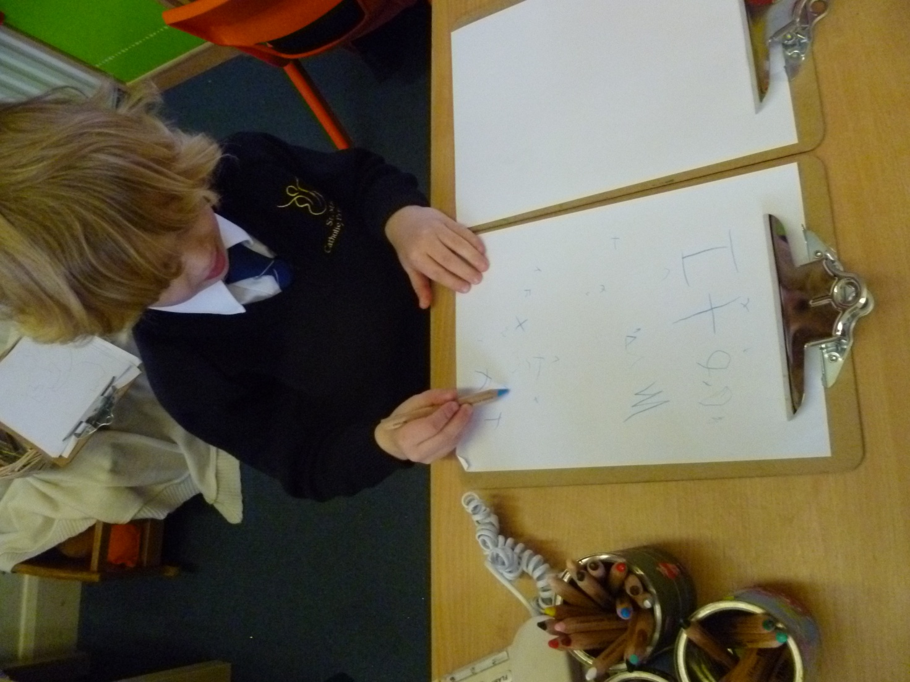

**Celebrating Children’s Learning Around the Setting**

There is no greater accolade for a child than to see his or her work around the school. At St Mary’s we aim to immerse the setting with children’s learning and achievements through the use of photographs, vocabulary, mark making/writing, book making, drawings and paintings. At our school every available space is used to celebrate children’s learning. All children’s work is valued and displayed in the setting.

In order to capitalise on children’s experiences, engagement and interests we ensure that our ‘turn around’ of photographs, book making and work is rapid. In some cases this will be the very same day, the next day or the following week. The most current learning is placed centrally for children whilst prior learning is placed in their learning journeys. This helps the children to see their progress in learning and enables them to see their learning journey over time.

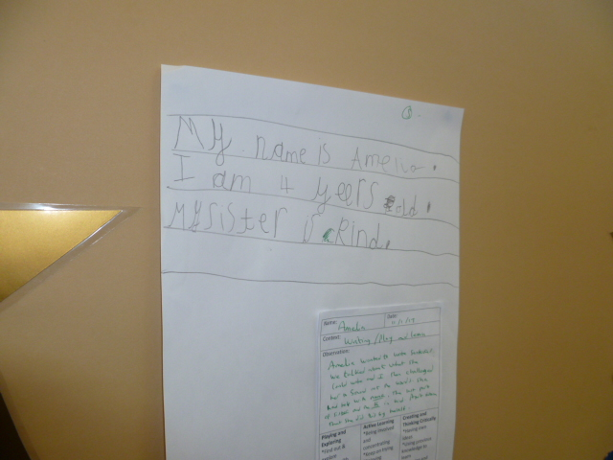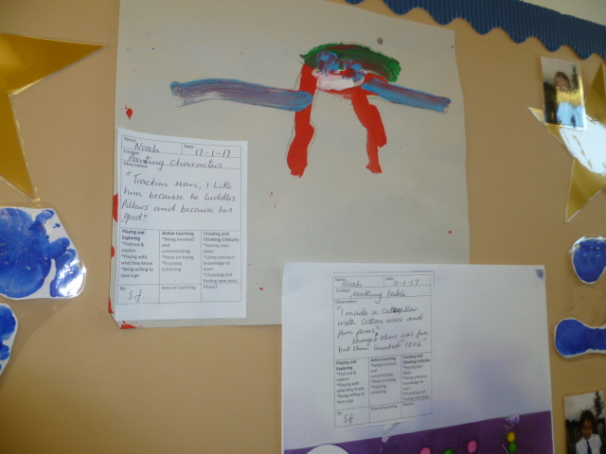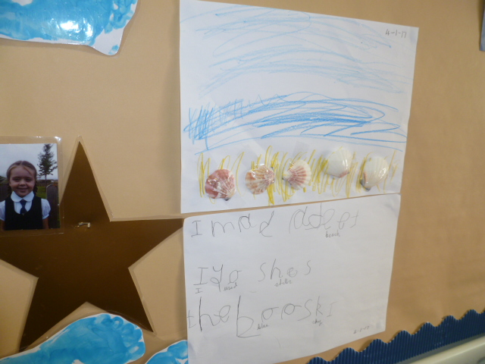

**Planning and Assessment**

At St Mary’s we believe that the quality of planning is integral to the quality of teaching and the impact on learning. When planning we are continuously striving to ensure that the needs and interests of all pupils are being met and that learning opportunities are engaging, interesting and meaningful.

***Medium Term Planning – is this accurate – what about focus on in the moment and child initiated ???***

At St Mary’s all medium terms are completed prior to the start of the new half term. This ensures that teachers have time to gather resources needed to support the children’s learning and capture their interests from the very start of the new half term. It also gives time to organise trips, visits, visitors, etc which are planned for and used to enhance and deepen learning experiences. The core text, key questions, vocabulary, images and artefacts are decided upon at this stage. In order to ensure coverage of the Statutory Framework for the Early Years Foundation Stage, medium term plans clearly identify the objectives across all areas that will be covered for the half term.

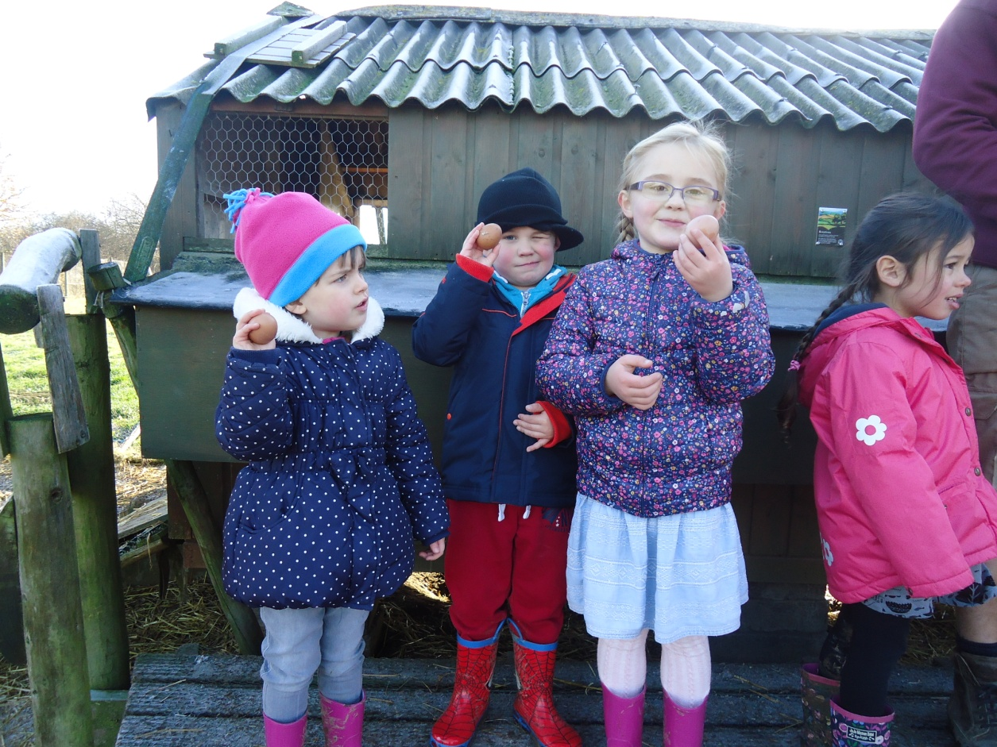

***Short Term Planning***

Short term planning is derived directly from the medium term plans and children’s interests. It breaks down the learning in more detail, particularly for literacy and mathematics and contains additional pertinent information. This includes further challenge and planned opportunities for celebrating children’s learning (See section on Celebrating Children’s Learning Around the Setting).

All planning is used flexibly and as a guide in order to also follow the children’s interests and foster their curiosity as well as providing a broad and balanced curriculum.

***Assessment***

At St Mary’s we use observations as the basis for our planning. We observe children to identify and recognise their achievements, interests and next steps for learning. Our observations then feed into our future planning as we know that this fostering of children’s interests develops a high level of motivation for the children’s learning.

When children arrive we take a baseline assessment within the first few weeks using the Development Matters statements. This ensures that we are aware of children who may be vulnerable to low achievement and put into place interventions for them to achieve well. Also, this allows us to measure the progress of each and every child. Each term we make a summative judgement about each child linked to Development Matters and we then use this data in order to raise standards.

At St Mary’s all children in the Foundation have an online ‘Learning Journey’ called Tapestry. This documents their progress throughout their time in our Foundation Stage. It includes formal and informal observations, photographs, children’s work and parental contributions. In addition, the Reception children have a writing book where their early writing skills are recorded showing progression in these skills over time. Feedback is given to the children verbally at first so they can progress in their learning.

**Unique Child**

At St Mary’s we know that every child is different and develops in individual ways. We are passionate about developing all children to be resilient, confident and self-assured. Children’s attitudes and dispositions to learning are influenced by feedback from others; we use praise and encouragement, as well as celebrations, to help the children develop a positive attitude to learning.

We know that children learn best when they are genuinely interested and engaged in their learning. Therefore, we always make sure that our provision builds on and extends children’s interests and develops their intellectual, physical, social and emotional abilities. Planning is flexible and show how all the curriculum areas can be developed in response to the children’s interests.

Independence is an important aspect of our early years practice.

Our agreed expectations for developing children’s independence are:

* We ensure our storage of resources enables the children to select and use the equipment independently during their play
* We encourage children to tidy up after themselves and to put their things away
* We always ask children to ‘have a go’ at dressing themselves before an adult helps
* We develop the children’s understanding of their own health and hygiene. For example, reminding them to wash their hands, knowing when they feel cold and independently selecting water when they are thirsty
* We give the children responsibility such as when it is tidy up time at the end of the day
* We ask the children to take responsibility for changing their reading books as well as taking letters home and handing them back to the teacher

**Learning and Development**

At St Mary’s, we follow the Statutory Framework for the Early Years Foundation Stage which is mandatory for all early years providers. This sets the standards that we meet to ensure that the children learn and develop well and are kept healthy and safe.

There are seven areas of learning and development that shape our educational programmes. All of the areas are important and inter-connected.

These are:

* Communication and Language

We give children opportunities to experience a rich language environment; to develop their confidence and skills in expressing themselves; and to speak and listen in a range of situations.

* Physical Development

We provide opportunities for young children to be active and interactive; and to develop their co-ordination, control, and movement. Children are helped to understand the importance of physical activity, and to make healthy choices in relation to food.

* Personal, Social and Emotional Development

We help children to develop a positive sense of themselves, and others; to form positive relationships and develop respect for others; to develop social skills and learn how to manage their feelings; to understand appropriate behaviour in groups; and to have confidence in their own abilities.

* Literacy

We encourage children to link sounds and letters and to begin to read and write. Children are given access to a wide range of reading materials (books, poems, and other written materials) to ignite their interest.

* Mathematics

We provide children with opportunities to develop and improve their skills in counting, understanding and using numbers, calculating simple addition and subtraction problems; and to describe shapes, spaces, and measures.

* Understanding the World

We guide children to make sense of their physical world and their community through opportunities to explore, observe and find out about people, places, technology and the environment.

* Expressive Arts and Design

We enable children to explore and play with a wide range of media and materials, as well as providing opportunities and encouragement for sharing their thoughts, ideas and feelings through a variety of activities in art, music, movement, dance, role-play, and design and technology.

We consider the needs, interests and stage of development of each child and use this information to plan challenging and enjoyable experiences for the children in all of the areas of learning and development. Examples of our rich and stimulating learning experiences include cooking, going out on trips and inviting visitors into the school.

Letters and Sounds

In Robin Class the teacher uses the ‘Letters and Sounds’ programme to teach children how the alphabet works for reading and spelling. They do this by fostering children’s speaking and listening skills as valuable in their own right and as preparatory to learning phonic knowledge and skills. This equips the children with the phonic knowledge and skills they need to become fluent readers by the end of key Stage 1.

**Playing and Exploring**

At St Mary’s we know that children need to play and explore. They learn best from first hand experiences where they have the opportunity to test their ideas, try new activities and judge risks. Playing and exploring promotes brain development and creates opportunities where both children and adults can take risks, make and learn from mistakes. Children’s competencies and confidence are developed through play and it provides time for children to explore their fears and anxieties in their play. During play children’s concepts, skills, attitudes and achievements are extended.

Our rich, enabling environments stimulate children and inspire them to engage in play. We provide motivating resources which are accessible and open-ended so they can be used, moved and combined in a variety of ways. Children are given sufficient space, time and appropriate resources within the environment, both indoors and outdoors, in order for them to play and explore. We plan, model, resource and encourage children to explore and show their interest in discovering new things.

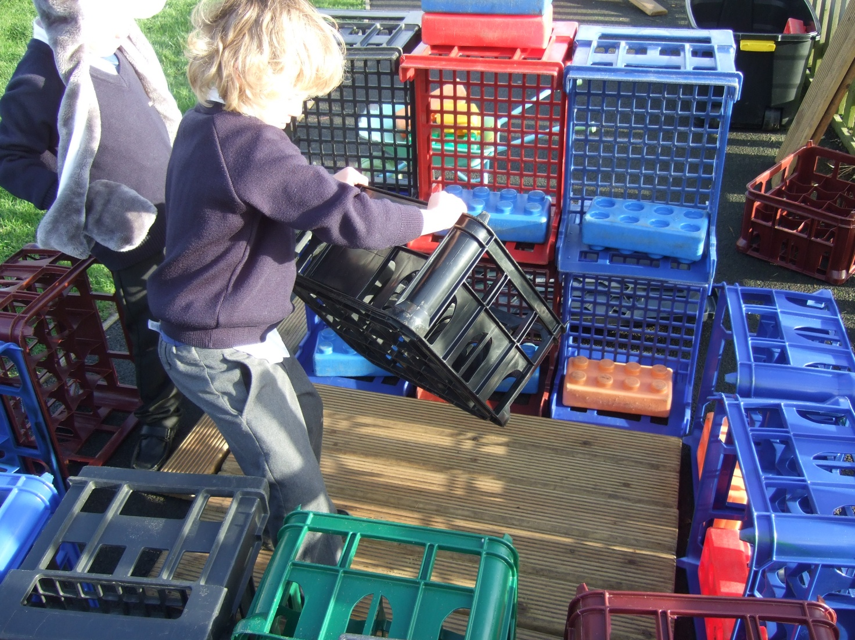

**Active Learning**

At St Mary’s we believe that learning is most effective when children are active in their learning. Children learn by actively investigating the world around them and through social activity with people. This enables them to construct ideas, set their own challenges, be creative and create a framework for thinking and learning that helps them develop as learners.

At St Mary’s, children are given the space, time and opportunities to become deeply involved in activities that interest them. Adults contribute to children’s active learning by creating the climate and conditions to promote their involvement. They support sensitively children’s chosen activities and encourage the children to talk about the processes and successes. The range of activities available enable all children to find something that sustains and engages their interest. Creating optimum conditions for active learning also involves understanding what learning looks like and creating the right context in which it can flourish. Early learning is active, interactive, messy, boisterous and often physical. Children explore their world through movement using all their senses to find out what they can do, what things are like and what they mean. They build understanding and ideas from their early sensory experiences. They seek and benefit from adult support to furnish, sustain and extend their enquiries and are delighted when their accomplishments are recognised.

We make full use of outdoor space in all weathers to extend children's learning. In our outdoor areas the children have the freedom to move, be exuberant and play on a large scale. We also have a trim trail in the school grounds which we play on to help develop physically.

**Creating and Thinking Critically**

Play is a key opportunity for children to think creatively and flexibly, solve problems and link ideas. They discover new meanings when they explore possibilities and make links and notice patterns between people, places and things.

Effective practice helps children to make connections in their learning by linking free play to adult led activities. It encourages creativity by providing opportunities for all children to link their ideas to new situations by introducing new things e.g. materials, artefacts and situations. At St Mary’s, children are given the time to talk and think. The learning environment enables children to have easy access to resources and allows them to move materials from one place to another. Adults respect children’s efforts and ideas so that the children feel safe to take a risk with a new idea. We give feedback and help children to review their own progress and learning.