St Mary’s Catholic

Primary School

Guide to the Early Years Foundation Stage

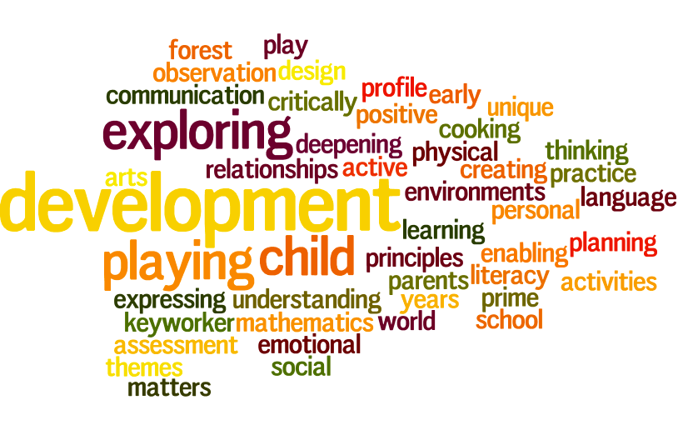



* St Mary’s Catholic Primary School
* Living, loving and learning with God
* “Every child deserves the best possible start in life and the support that enables them to fulfil their potential. Children develop quickly in the early years and a child’s experiences between birth and age five have a major impact on their future life chances. A secure, safe and happy childhood is important in its own right. Good parenting and high quality early learning together provide the foundation children need to make the most of their abilities and talents as they grow up.”
* - Statutory Framework for the Early Years Foundation Stage 2014

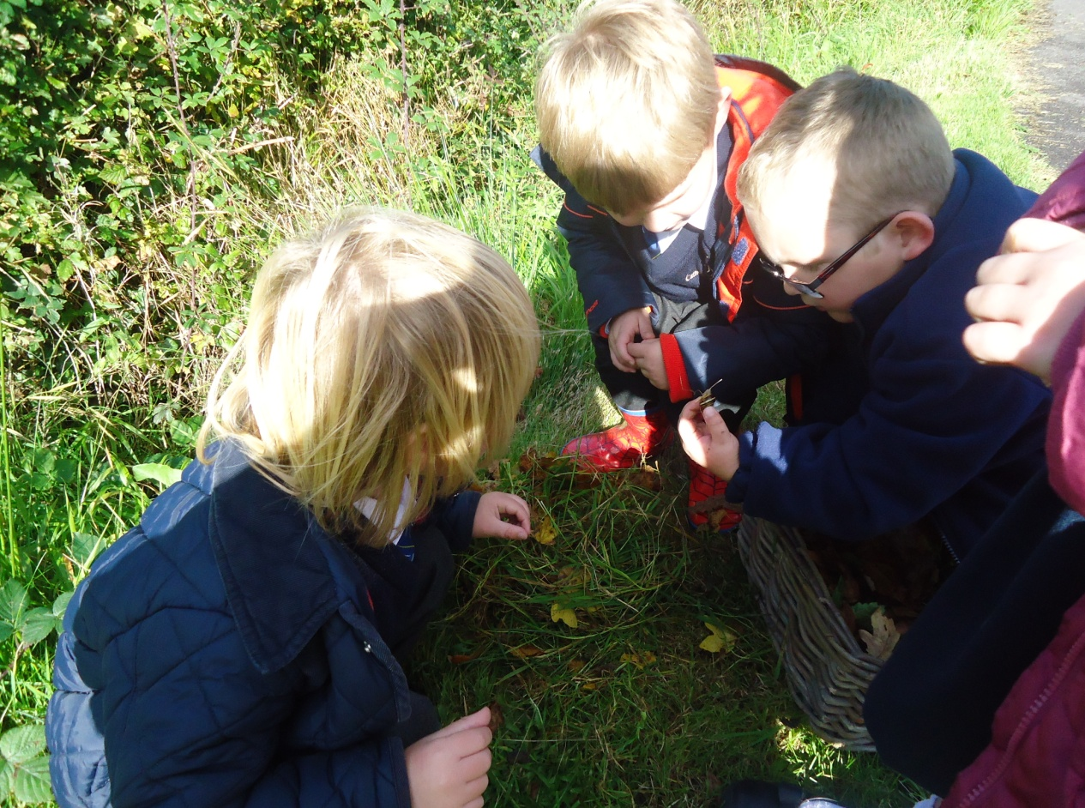

Early Years Reforms 2020 to 21

*At the time of sharing this document, the Government have been reviewing and reforming aspects of Early Years provision. This is to ensure that every setting meets the needs of all learners. Guidance from the Government is still being shared with us. It is not anticipated that the changes will affect the daily learning of pupils but it could change some of the assessment systems we use. We will update you once this is finalised.*

*At St Mary’s we put each child at the heart of our thinking. We see this as a key strength and know that we already offer the children in Robin Class a high quality start and continue to work to improve our offer to each child and family.*

**Positive Relationships**

**Role of adults**

At St Mary’s we believe that all adults in the school make a significant contribution to the well-being and development of all children. Children learn to be strong and independent through positive relationships. They learn best when they have positive relationships with the adults caring for them. Adults in Robin class always ensure that they are sensitive and responsive to the needs, feelings and interests of all children. They encourage independence through warm and positive relationships.

***Our shared agreement at St Mary’s about the role of adults in the Early Years Foundation Stage is:***

* We seek to know and understand each individual child and their development
* We show enthusiasm and celebrate with children their interests and achievements
* We scaffold children’s learning through talk, discussing strategies and ideas, suggesting possibilities and modelling approaches
* We encourage and support children to persevere through difficulties, to take risks, to ask questions and problem-solve
* We use the language of learning to focus children on themselves as learners
* We identify and support next steps in learning
* We join in play and child-initiated activities following children’s agendas

**Adults within the class**

In Robin class, there are four members of staff; Mrs Burrough and Mrs Hill work in Robin Class all week. Mrs Sakowska works every morning. In addition Mrs Slade teaches the children every Friday afternoon. In addition the children have a specialist teacher for music and once settled into school will also work with Axminster Gymnastics teachers alongside St Mary’s staff. All adults work as a close team. This ensures that there are good opportunities for children to experience consistent interactions and expectations. This helps children moving between the worlds of home and school where the environment and routine is very different. All adults are responsible for keeping the children’s observations and Learning Journeys up to date. During lunch the children work with the midday meal supervisors who support the children during their lunch.

***The role of the teacher and teaching assistant is:***

* To help the child become familiar with the setting and provision within the setting
* To offer a settled relationship for the child
* To build relationships with the child’s parents
* To ensure the child’s learning and care is tailored to meet their individual needs
* To engage and support parents in guiding their child’s development at home
* To have a deep knowledge and understanding of the child
* To help families engage with more specialist support if appropriate

**Parental Involvement**

At St Mary’s we know that parents are children’s first and most enduring educators and we value being partners with them in their child’s education. We believe that children are eager learners and all adults have an important role in sustaining that eagerness. Parental involvement in education leads to better results for children in the early years and beyond.

***We ensure that parents are fully involved in their child’s education by:***

* Gathering information from parents/carers before a child starts
* Talking to parents about their child before and after school and maintaining an open door policy
* Sharing children’s ‘Learning Journeys’ regularly with parents and valuing the ongoing contributions to this from parents/carers
* Using the online journal Tapestry so parents have instant access to what their children are learning in school. They can also record their child’s achievements about their child’s learning at home.
* Giving parents/carers the opportunity to take part in educational visits and share their interests and expertise
* Delivering workshops to share our practice, ethos and ideas with parents/carers

**Enabling Environments**

At St Mary’s we believe that a rich environment has an immediate effect on the quality of children’s learning and development. An enabling environment is one that is comfortable, interesting, attractive and appropriate for the children who use it. It encourages children to play and learn because they feel secure. When children feel emotionally safe they are able to explore and find out about the world around them.

The outdoor and indoor spaces are seen as one, with activities flowing freely. This free flow between the inside and the outside has a positive impact on the children’s development. In both spaces there are areas where children can be active, be quiet, be creative, imaginative and much more. We ensure that both the indoor and outdoor areas contain print (such as displays, books, labels and questions) so that children begin to understand that print conveys meaning and they develop those important early literacy skills.

**Indoors**

Indoor spaces are carefully planned so they accommodate children’s interests and needs. The spaces are used flexibly and a range of activities are provided which include challenge for all children. Where possible, resources are of the highest quality and equipment is kept in boxes, baskets or shelves labelled with print, numbers and pictures ensuring easy access for all the children to enable their play. The learning environment covers all areas of learning and particularly reflects current learning through, for example, enhancements.

**Outdoors**

We know that being outdoors has a positive impact on children’s sense of well-being and helps all children’s development. Therefore at St Mary’s we ensure that all children have constant access to the outdoors regardless of weather conditions unless it is unsafe to do so. All areas of learning are covered in the outdoor area and the current learning is reflected outdoors as well as indoors. Being outdoors offers opportunities for doing things in different ways and on different scales. It supports confidence and allows opportunities for big scale play, problem solving, creativity and risk taking. In addition, it gives children first hand experiences with weather, seasons and the natural world. The outdoor environment provides children with the freedom to explore, use their senses and to be physically active.

Many children prefer being outdoors so the learning opportunities that are available indoors are available for the children outdoors, for example, key vocabulary, writing, mathematics, role play and much more. Planning for the outdoors is of equal importance to the planning for indoors and the outdoor area is organised into learning areas where adults can follow children’s interests, respond to their ideas for developing play activities or provide a specific focus.

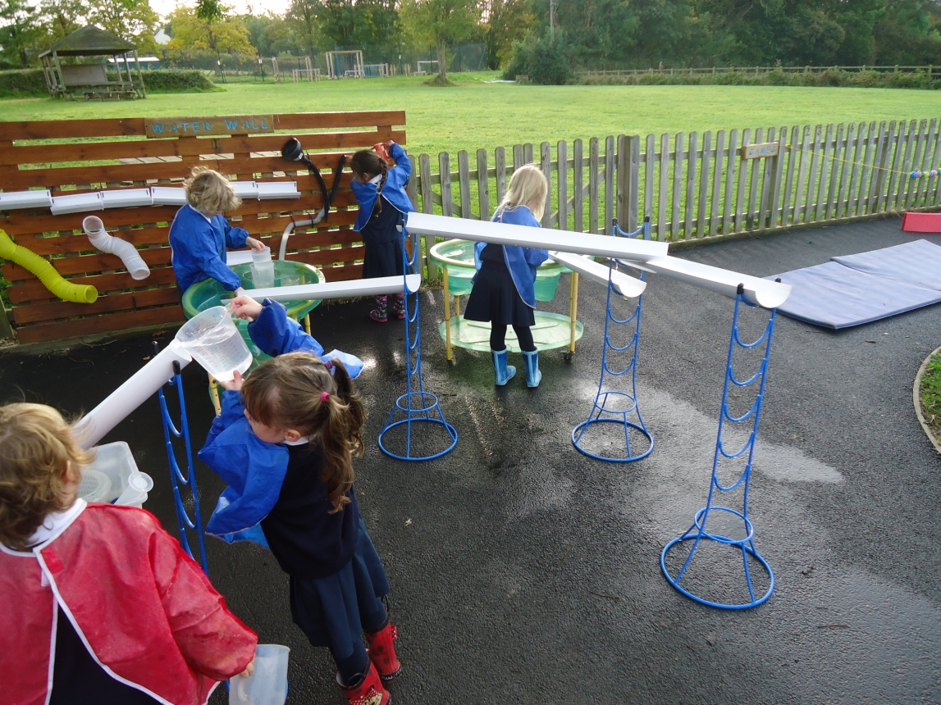

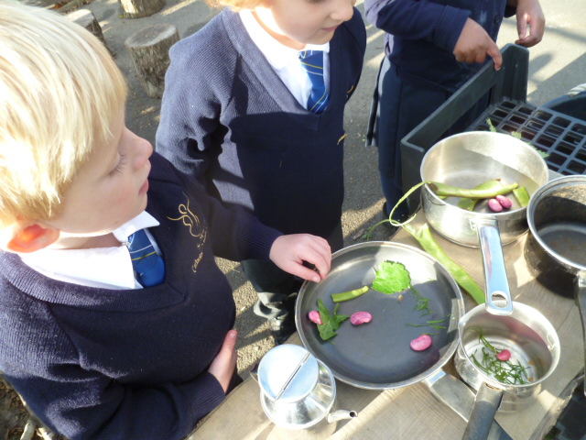

***Gardening***

At St Mary’s we believe that the benefits of gardening with young children are enormous which is why we like to grow herbs, flowers and vegetables. A 2010 study commissioned by the Royal Horticultural Society (RHS) found that children in schools that encouraged gardening became more resilient, confident, eager to learn and have healthier life styles. It also found that gardening had a positive impact on children’s literacy and numeracy development and that it led to a more active, inquisitive approach to learning and improved problem solving skills.

**Spirituality**

At St Mary’s we encourage the children to be reflective and to be open to the world and how it impacts on children’s sense of self. The Gospel values of faith, hope, love and peace embody everything that we do. Each child is cherished as an individual and we seek to help each child discover their talents and to grow to be the best they can be. Within Robin Class and across the school children are given visual reminders of the place of faith in our school life. Children are encouraged to see the good news that comes from faith traditions and to think and reflect on how we use this to shape our actions. Friendships and a caring attitude to all are developed as well as a sense that we are a community and that we work to help each other and the wider world.

**Role Play**

At St Mary’s we know that a rich, stimulating and creative learning environment is fundamental to children’s learning.

To support active engagement with different topics and texts we provide a role play area inside and encourage children to role-play outside as well. These areas are well thought out and where appropriate planned for when the topics and texts are decided on at the start of each half term. Increasingly we provide open ended resources so that the children can enjoy greater creativity.

***Role play areas:***

* Are planned to encompass a variety of types of role play. This could include domestic play, transactional play and imaginary worlds.
* Where possible, contain real objects of good quality. For example, fruit/vegetables, money and packaging for a range of products.
* Are changed and enhanced to reflect the current learning.
* Have involved the children in developing the area. For example, the children choose the focus for the area and make/bring in resources for this.
* Promote opportunities for many skills. These could include, problem-solving, negotiating, mark making including writing, expressing ideas and reading.
* Contain a range of model writing/phrases/vocabulary handwritten in cursive script.

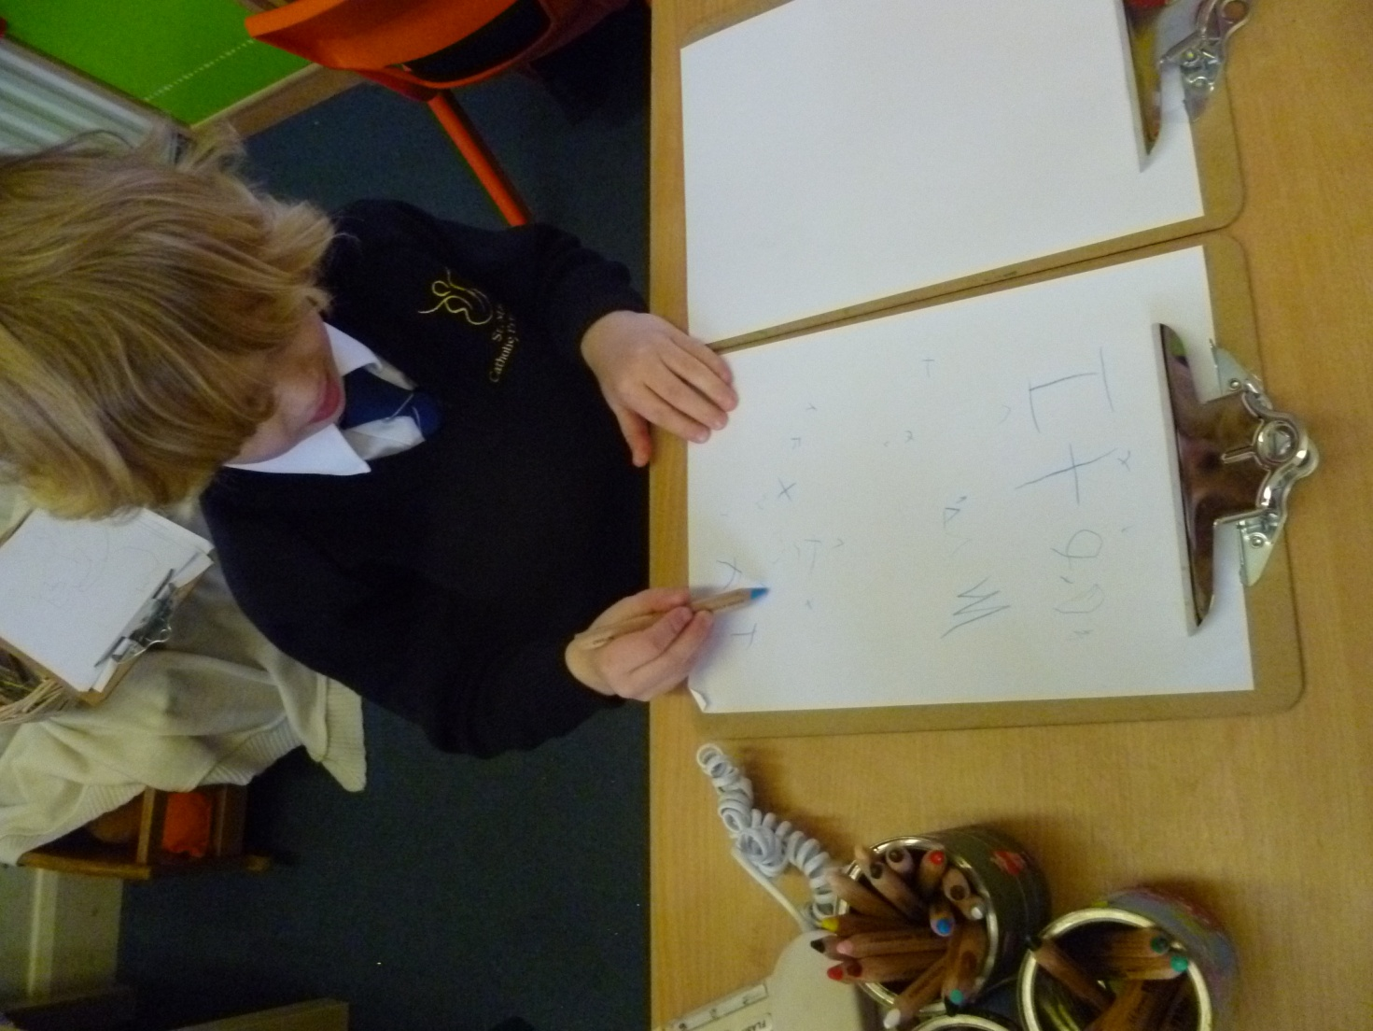

**Celebrating Children’s Learning**

The positive environment both across the school and within Robin Class ensures that children learn to celebrate and share their achievements throughout the day. Adults will explain to children what they have done well and tell them that they should feel proud of their work. Other children will be encouraged to celebrate with the child. We soon find that children are able to self praise and will identify that they are proud of their achievements. We praise the process of effort and focus alongside the skills that are used; ‘ careful letter shape, very good balancing, thank you for being so polite…..’

Helping children to identify what good learning looks like supports children’s confidence and skills.

We regularly record children’s achievements using Tapestry and can use this platform to share this with parents.

Within class we will stop and celebrate in the moment as well as sharing learning with Mrs Mannix and other staff members. Each week we choose one star for the week. Children sometimes are a little confused, particularly in the early weeks , if they are not chosen as the class star. Some want to explain that they have worked hard and done their best. To ensure that children learn to manage this we talk to them regularly about the fact that everyone is working to be a star and that everyone has completed some good learning this week but one person has stood out a bit more. This is quickly understood by the children and will become a very positive part of school life.

We do put children’s work on display in class. This is another way to share success.

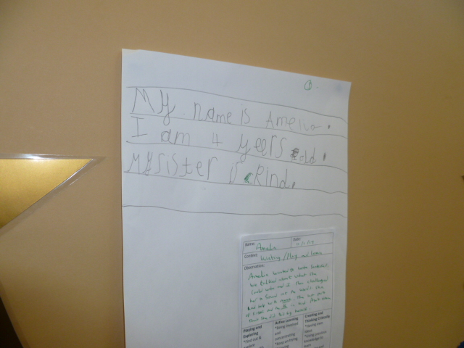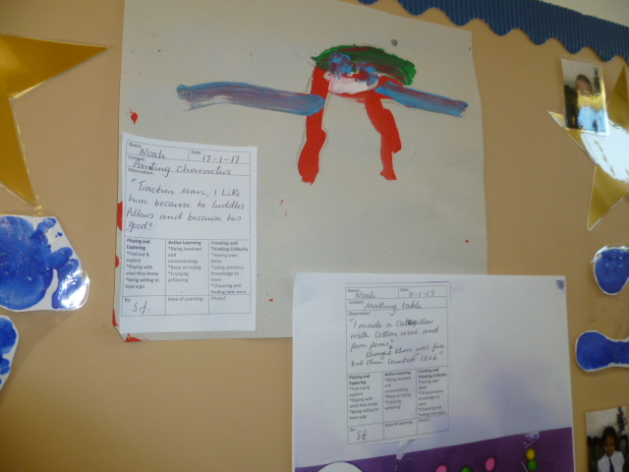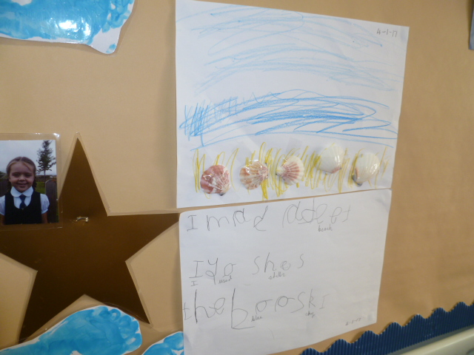

**Planning and Assessment**

At St Mary’s we believe that the quality of planning is integral to the quality of teaching and the impact on learning. When planning we are continuously striving to ensure that the needs and interests of all pupils are being met and that learning opportunities are engaging, interesting and meaningful.

At St Mary’s all medium terms are completed prior to the start of the new half term. This ensures that teachers have time to gather resources needed to support the children’s learning and capture their interests from the very start of the new half term. It also gives time to organise trips, visits, visitors, etc which are planned for and used to enhance and deepen learning experiences. The core text, key questions, vocabulary, images and artefacts are decided upon at this stage.

Within a phase of work it is important to be able to adapt to support children’s interests and learning. All planning is used flexibly and as a guide in order to also follow the children’s interests and foster their curiosity as well as providing a broad and balanced curriculum.

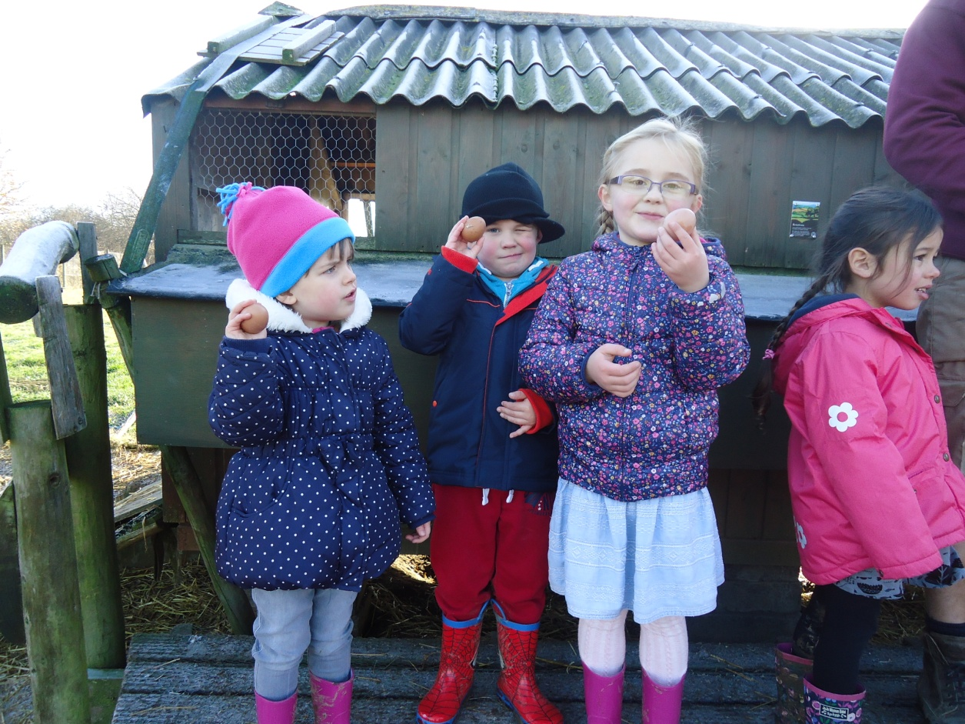

***Assessment***

At St Mary’s we use observations as the basis for our planning. We observe children to identify and recognise their achievements, interests and next steps for learning. Our observations then feed into our future planning as we know that this fostering of children’s interests develops a high level of motivation for the children’s learning.

When children arrive we take a baseline assessment within the first few weeks using the Development Matters statements. This ensures that we have a clear picture of children’s skills and areas of development. Each term we make a summative judgement about each child linked to Development Matters and we then use this data in order to raise standards.

St Mary’s all children in the Foundation have an online ‘Learning Journey’ as well as a physical book in school which records each child’s developments in mark making and drawing.

**Unique Child**

At St Mary’s we know that every child is different and develops in individual ways. We are passionate about developing all children to be resilient, confident and self-assured. Children’s attitudes and dispositions to learning are influenced by feedback from others; we use praise and encouragement, as well as celebrations, to help the children develop a positive attitude to learning.

We know that children learn best when they are genuinely interested and engaged in their learning. Therefore, we always make sure that our provision builds on and extends children’s interests and develops their intellectual, physical, social and emotional abilities. Planning is flexible and show how all the curriculum areas can be developed in response to the children’s interests.

Independence is an important aspect of our early years practice. Little people have a lot to say and can be excellent leaders and organisers. Every aspect of the working day encourages this independence. Leaving their grown ups positively and wishing them a good day as each child skips into Robin Class each morning is the first of many important steps the children will take each day and throughout their first year at St Mary’s.

**Learning and Development**

At St Mary’s, we follow the Statutory Framework for the Early Years Foundation Stage which is mandatory for all early years providers. This sets the standards that we meet to ensure that the children learn and develop well and are kept healthy and safe.

There are seven areas of learning and development that shape our educational programmes. All of the areas are important and inter-connected.

These are:

* Communication and Language

We give children opportunities to experience a rich language environment; to develop their confidence and skills in expressing themselves; and to speak and listen in a range of situations.

* Physical Development

We provide opportunities for young children to be active and interactive; and to develop their co-ordination, control, and movement. Children are helped to understand the importance of physical activity, and to make healthy choices in relation to food.

* Personal, Social and Emotional Development

We help children to develop a positive sense of themselves, and others; to form positive relationships and develop respect for others; to develop social skills and learn how to manage their feelings; to understand appropriate behaviour in groups; and to have confidence in their own abilities.

* Literacy

We encourage children to link sounds and letters and to begin to read and write. Children are given access to a wide range of reading materials (books, poems, and other written materials) to ignite their interest.

* Mathematics

We provide children with opportunities to develop and improve their skills in counting, understanding and using numbers, calculating simple addition and subtraction problems; and to describe shapes, spaces, and measures.

* Understanding the World

We guide children to make sense of their physical world and their community through opportunities to explore, observe and find out about people, places, technology and the environment.

* Expressive Arts and Design

We enable children to explore and play with a wide range of media and materials, as well as providing opportunities and encouragement for sharing their thoughts, ideas and feelings through a variety of activities in art, music, movement, dance, role-play, and design and technology.

We consider the needs, interests and stage of development of each child and use this information to plan challenging and enjoyable experiences for the children in all of the areas of learning and development. Examples of our rich and stimulating learning experiences include cooking, going out on trips and inviting visitors into the school.

Letters and Sounds

In Robin Class the teacher uses the ‘Letters and Sounds’ programme to teach children how the alphabet works for reading and spelling. They do this by fostering children’s speaking and listening skills as valuable in their own right and as preparatory to learning phonic knowledge and skills. This equips the children with the phonic knowledge and skills they need to become fluent readers by the end of key Stage 1.

**Playing and Exploring**

At St Mary’s we know that children need to play and explore. They learn best from first hand experiences where they have the opportunity to test their ideas, try new activities and judge risks. Playing and exploring promotes brain development and creates opportunities where both children and adults can take risks, make and learn from mistakes. Children’s competencies and confidence are developed through play and it provides time for children to explore their fears and anxieties in their play. During play children’s concepts, skills, attitudes and achievements are extended.

Our rich, enabling environments stimulate children and inspire them to engage in play. We provide motivating resources which are accessible and open-ended so they can be used, moved and combined in a variety of ways. Children are given sufficient space, time and appropriate resources within the environment, both indoors and outdoors, in order for them to play and explore. We plan, model, resource and encourage children to explore and show their interest in discovering new things.

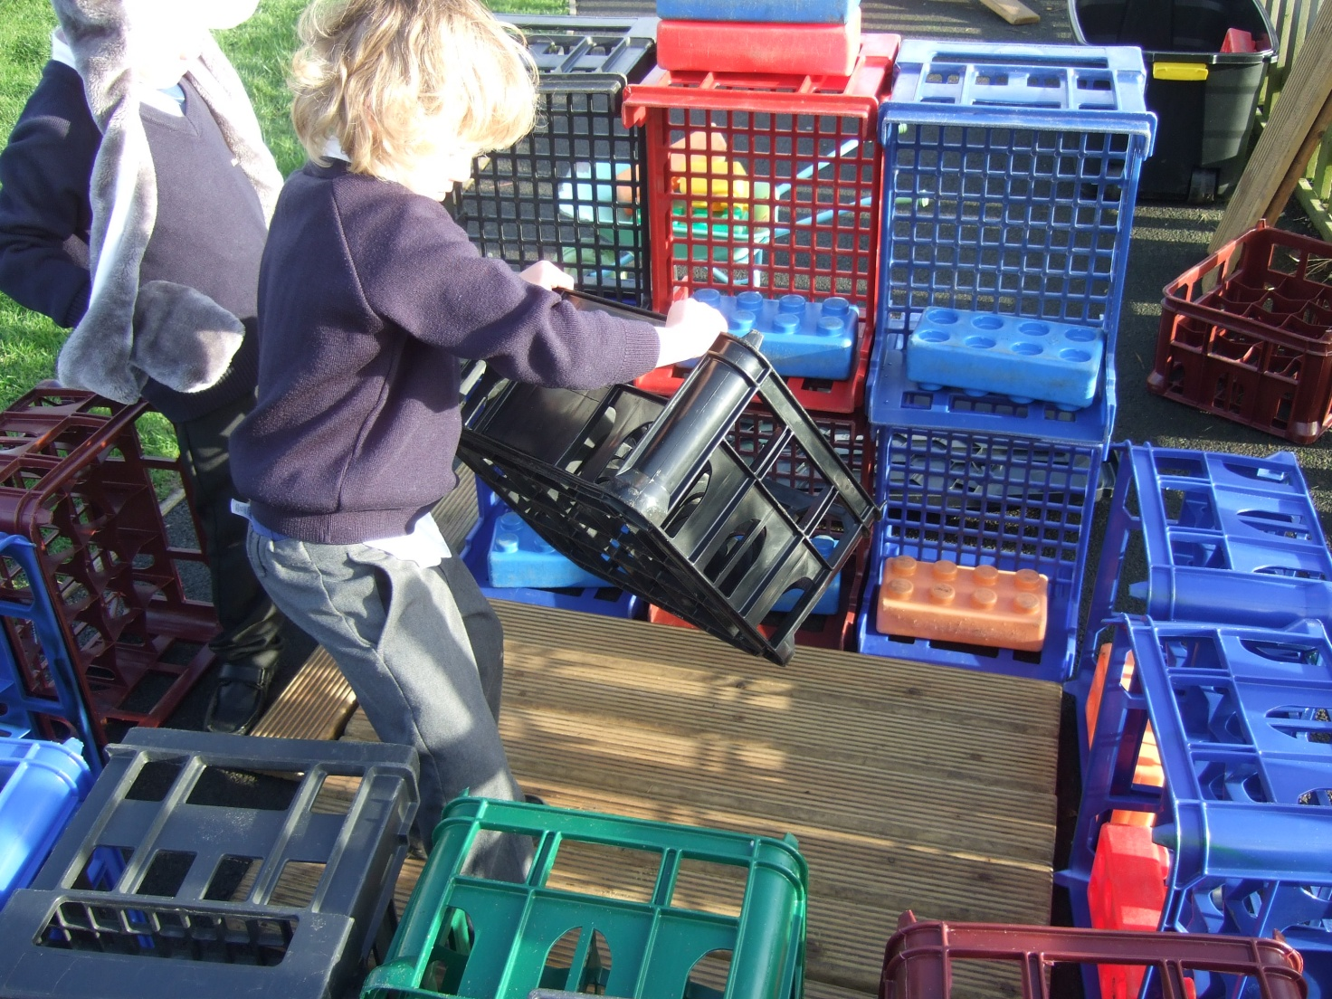

**Active Learning**

At St Mary’s we believe that learning is most effective when children are active in their learning. Children learn by actively investigating the world around them and through social activity with people. This enables them to construct ideas, set their own challenges, be creative and create a framework for thinking and learning that helps them develop as learners.

At St Mary’s, children are given the space, time and opportunities to become deeply involved in activities that interest them. Adults contribute to children’s active learning by creating the climate and conditions to promote their involvement. They support sensitively children’s chosen activities and encourage the children to talk about the processes and successes. The range of activities available enable all children to find something that sustains and engages their interest. Creating optimum conditions for active learning also involves understanding what learning looks like and creating the right context in which it can flourish. Early learning is active, interactive, messy, boisterous and often physical. Children explore their world through movement using all their senses to find out what they can do, what things are like and what they mean. They build understanding and ideas from their early sensory experiences. They seek and benefit from adult support to furnish, sustain and extend their enquiries and are delighted when their accomplishments are recognised.

We make full use of outdoor space in all weathers to extend children's learning. In our outdoor areas the children have the freedom to move, be exuberant and play on a large scale. We also have a trim trail in the school grounds which we play on to help develop physically.

**Creating and Thinking Critically**

Play is a key opportunity for children to think creatively and flexibly, solve problems and link ideas. They discover new meanings when they explore possibilities and make links and notice patterns between people, places and things.

Effective practice helps children to make connections in their learning by linking free play to adult led activities. It encourages creativity by providing opportunities for all children to link their ideas to new situations by introducing new things e.g. materials, artefacts and situations. At St Mary’s, children are given the time to talk and think. The learning environment enables children to have easy access to resources and allows them to move materials from one place to another. Adults respect children’s efforts and ideas so that the children feel safe to take a risk with a new idea. We give feedback and help children to review their own progress and learning.

St Mary’s and our parent partnership

Robin Class is the first step of learning at St Mary’s. Your continued support is critical in helping your child thrive. Please see the attached ways to support your child booklet

All children should enjoy their time in school and know that they are cared for and valued. We encourage you to know that your child is values and cared for. If you have any questions or concerns about any aspect of your child’s life at school you should know that we will always listen. You are your child’s first educator and you share a very important part of their world. When you know they are happy it is because they are.

Thank you again for choosing St Mary’s.

We look forward to a happy and successful partnership in growing your child.

With very best wishes

From all at St Mary’s.