Friday 18th September 2020
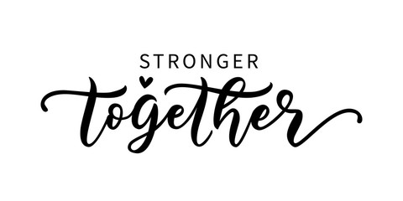
Dear Parents and Carers,

In the UK we have lived alongside the Covid 19 virus since Dec 2019 and nationally became very aware of it in February 2020. We have all worked to keep ourselves and each other safe by following national guidelines and to date at St Mary’s children, parents and staff and their families have been Covid free. You may be aware that Axminster Primary had a confirmed pupil case of Covid 19 yesterday. The school followed national protocols by closing down the affected hub for 14 days.

Having a case so close can affect anxiety levels. We all need to be gentle on ourselves and accept that it is natural to feel anxiety but allowing it to be managed well is a lesson in life and one that we at St Mary’s model positively all of the time. One of our stated aims for children is that they can be change makers. Being solution focused and positive is a life well-being attitude. Our children do seem remarkably resilient and I hope that one of the gifts of this for them will be that they are learning from us and from you that change is a normal part of life and facing it head on and looking for positives is how we cope through the difficulties and flourish.

We did have a sincere hope that come Autumn term the virus would begin to lose pace and incidents across the country and locally would continue to fall. You will all be aware that this is not the case and we all continue to work to adapt and support this situation. We must all continue to do what we can. To date I cannot fault any actions taken by our parents. Thank you. In challenging times it is a long held fact that we see either the best or the worst in people and it is humbling that you have all been so supportive of this challenge.

I can say that the children are very happy in school. Their routines are becoming established and we are working well to engage them in a wide range of learning experiences.

We all know that hygiene is a very strong protective measure. At St Mary’s we continue to work to maintain high levels of touch point cleaning throughout the day and cleaning of surfaces and resources within class bases. Alongside this, regular hand washing or anti bac throughout the day to support children’s safer movements in and out of class for entry, break times, lunch and end of day. Children remain very firmly within their class hubs. Lunchtime staff are wearing the full clear visors and within some classes some adults who have particular vulnerabilities within their own families will sometimes wear these. We are adapting and managing change as positively as possible.

If you wish to wear masks in the playground please do. Again we have some particular family vulnerabilities that have needed support and at times there may be some children wearing face masks in the school day.

We are very grateful to you for your continued vigilance. A sore throat, tonsillitis or a twisted ankle are very obviously not Covid 19. Parents are being very sensible about their actions to support the whole community at this time. Those parents with children with snuffly or runny noses know their child has a cold but are being extra vigilant and monitoring their child more closely. Colds are not Covid 19. If your child has a temperature which is 38 degrees or higher ensure that they stay home and contact 119 to seek a test. Only if a child tests positive would they need to continue to self isolate and other members of the family and those who have significant contact would need to also self isolate; this would be for 14 days. Please let us know if you are monitoring your child for a high temperature and seeking to access a test.

If we do have a confirmed case of Covid within a hub we will inform all parents in the school and we will be required to close a hub for 14 days. This is for everyone’s safety.

We do appreciate that this is not the start to the academic year that we had been hoping for, nor the start that we would want but we do have to keep trying to be vigilant, solution focused and try to remain as practical as we can.

Again I can tell you that school is a calm and happy place with many celebrations of learning success and happy friendships. Yesterday we were reviewing children’s learning across the school and it was so delightful to hear of the many ways children are engaging with their learning. We are continually looking for ways to make this year a success and we are grateful for your continued support.

Please continue to be vigilant.
Sending our very best wishes to all parents and families at this time.
Mrs Mannix

