Key Vocabulary
Unconditional
No conditions- nothing can stop it
Prophet
Someone who hears God’s words
Psalm
A song of hymn used in Christian worship
Gentile
Someone who is not a Jew
Jew
A person who believes in God but does not believe Jesus is God’s son
New Testament
The second ½ of the Bible
Parable
A story which teaches a lesson
Prodigal
Lavish, reckless, wasteful
Forgiveness
To forgive, to stop being angry
Ministry
The work of a minister
Beatitudes
Eight blessings recounted by Jesus in the Sermon on the Mount
Sermon on the Mount
Jesus taught a famous lesson- a sermon – on a mountain
We don’t have to do anything to make God love us

Titus was a Gentile (someone who is not Jewish). He converted to Christianity and helped Paul to spread the Good News of God’s love. The letter to Titus that is in the New Testament is addressed to him in Crete where Paul left him to help the church there.

Paul asks people to be peaceful and friendly. He says that the kindness and love of Jesu will save everyone.
We will learn the story of Paul and learn about how God’s love changes us.

The love and care of people

- What does it mean to be loved?
- How is love shown?
- Are there different types of love?
- Who loves us?
- Who do we love?
- We will learn what it means to love unconditionally and to be loved unconditionally.
Loving – Year 5 / 6

The Prophet, Isaiah, was inspired by God to tell people to look forward to the coming of Jesus, who would rescue them from those who threatened them. Isaiah was writing at a time when many people were having a difficult life.
Psalm 23 speaks of God as a shepherd looking after his sheep:
God will never abandon us. God looks after us just as a shepherd looks after every sheep. God loves us unconditionally.

God loves and cares for his people, even in difficult times

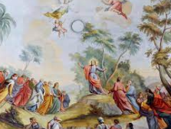

############
God never stops loving

All through the Bible, we find messages of God’s love, care and forgiveness. In John’s gospel, Jesus speaks of his Father’s love and the greatest love we can have. It is difficult to be loving all the time. There are occasions when we say or do things we regret and know they are not loving. Paul, in his letter to the Ephesians, has advice on how to deal with these kinds of situations.

Near the beginning of Jesus’ ministry, a large crowd had gathered to hear his words, to be encouraged and to learn how to shape their lives in a more loving way. This teaching is called the Sermon on the Mount because Jesus went up a hill so everyone could see and hear him. It is also called the Beatitudes - in some translations the word “blessed” is used and in other versions the word “happy” is used.
Knowing that we are loved, we can grow in love
Unconditional love

We will learn the story of the Prodigal Son. Jesus told many stories to help his friends understand difficult things. His parables still have meaning for people today.
This parable is really more about the father than the younger son. Through this story, Jesus is telling us what God our Father is like. It seems that Jesus is telling people that God loves us recklessly, extravagantly even wastefully.
Prodigal – means reckless, extravagant.
The son is prodigal in pouring away his money; the father is prodigal in pouring out his love - this is unconditional love.

We will look at these paintings and think about how they show the relationship between the father and the son. We will think about how forgiveness is shown.
Rembrandt’s Prodigal Son 1669 Guercino’s Return of The Prodigal Son 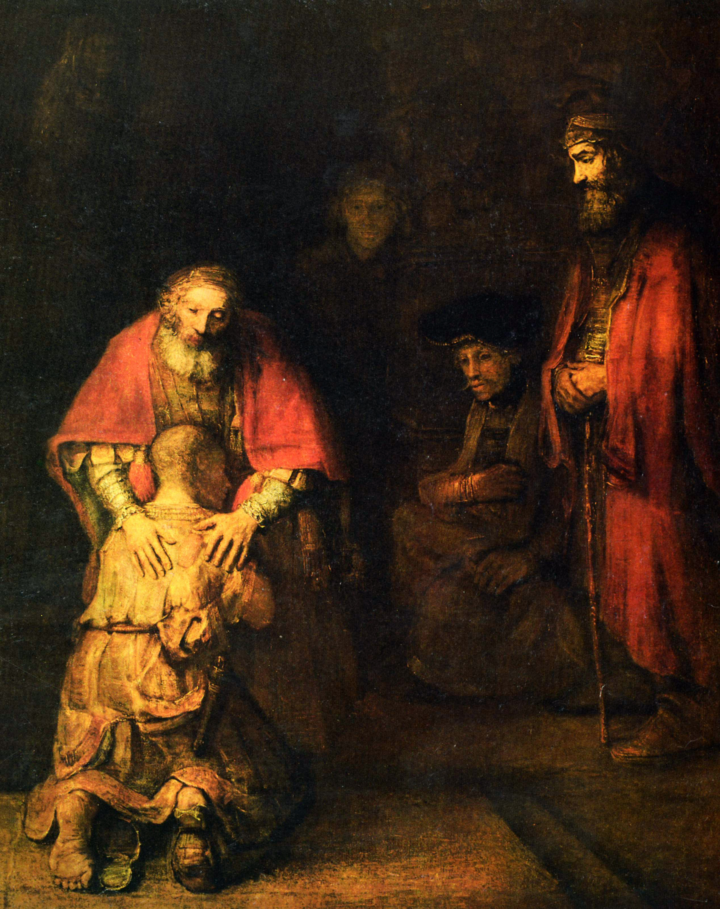 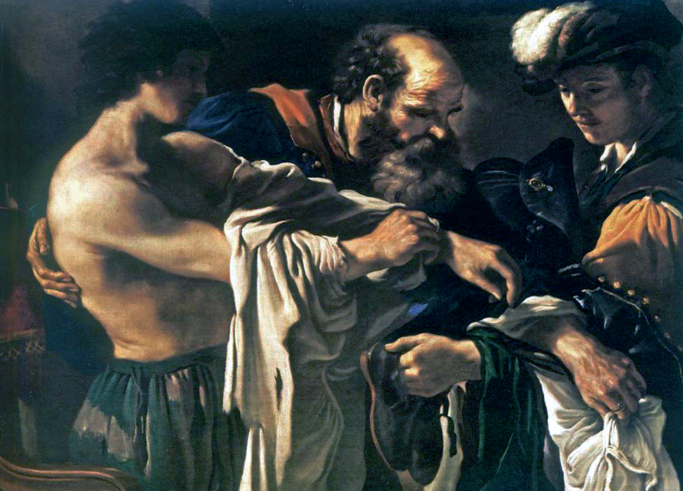
Murillio Bartolomé Esteban’s Return of The Prodigal Son.
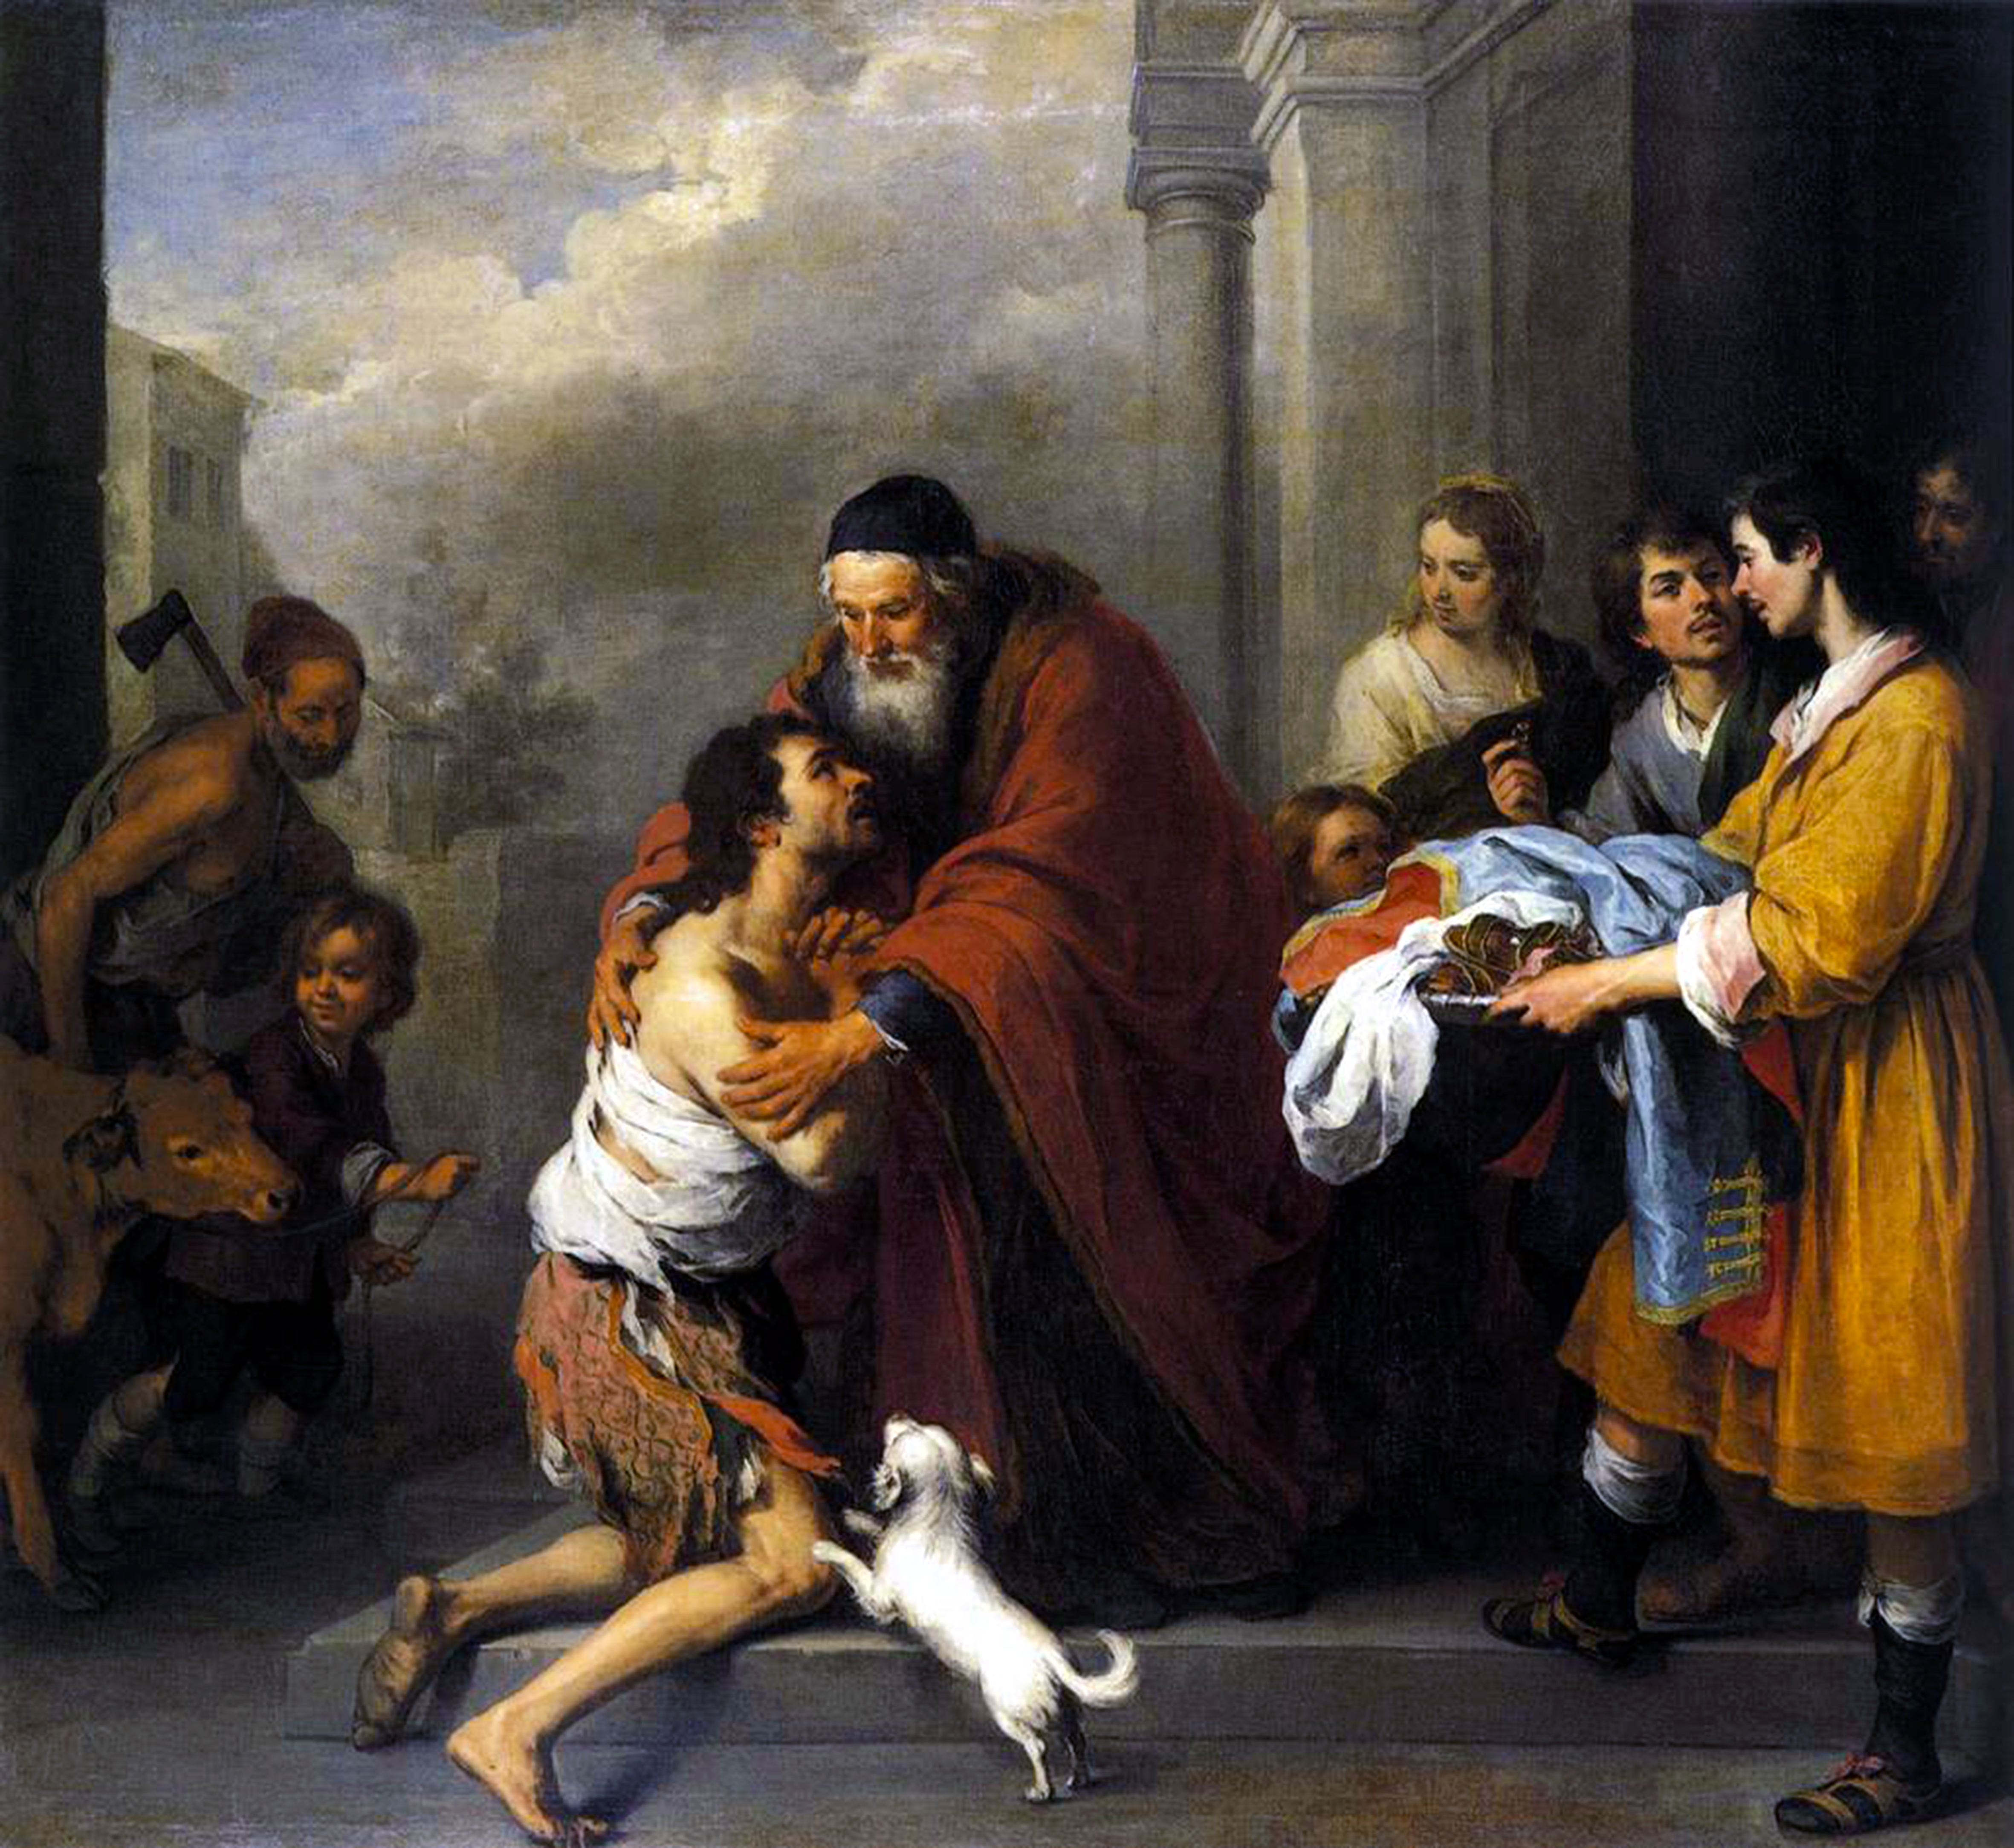

Forgiveness is an essential part of unconditional love

