St Mary’s Update Friday 1st May 2020

Dear Parents and Carers

Today marks the end of the sixth week of national lockdown. That is four weeks of school closure with the two weeks of Easter holiday. Six weeks where you have been asked to change all of your routines and to create a new normal and homework has now become school work. When we have talked with you before about our shared partnership none of us expected this but we are extremely grateful to all who are working to keep that focus on learning.

There was some possibility that Boris Johnson might have made some new announcements at his first government briefing yesterday but he didn't.  
So we now all wait together for the COBRA review next Thursday 7th May. We are told we will all be given more information about the next phase of the plan to come through the virus.  
Schools have been given no more information than you about any possible next steps. National school leaders and unions are asking important questions about what schools might do to return safely and we know that the Government are in constant review about next steps for all sectors but nothing has been discussed, agreed or finalised with schools.

**So please keep checking emails.** If you know of parents who are not accessing e mails please give them a prompt to do so. If you know they have problems accessing e mails ask them to call school or better still ask if you can e mail us to let us know. Every thing we need you to know is communicated by email.  
Most importantly please keep on with your household self isolation. Keep on working to achieve a new normal and thank you sincerely for the work you are doing to keep up your child's education.

Before lockdown we had a school full with children who enjoyed learning. They enjoyed the success of their hard work. They recognised when they had stepped up to have a go at new learning and were making progress. This is something we need to protect. Friday celebration assemblies are wonderful occasions where children celebrate with each other.

This week give yourself a star and you may wish to give your child a certificate today too.

**St Mary’s Star of the week**

To all parents of St Mary’s.

Thank you and well done for your hard work in self isolating as a household and working to find a balance through this time.

A reminder that new learning is on the school website each week along with learning links that will support you and your child.   
Robin class parents have access to Tapestry too.  
Some classes  have  been receiving copies of some of the work in the post.  
The St Mary's Axminster Facebook Group is another forum where teachers will post videos, links and features of interest. It is also a group that allows you to share your child's learning and to ask any questions that have not been answered in the emails you receive.  
  
We have one more week until we will know more and another two until the May half term holiday. It seems logical, although not certain, that we will have plans from government about returning to school next week and certainly in that three weeks. So again thank you for all you are doing for your children.

**Good News**

A reminder that life does go on with some very happy news. Kirsty in Kestrel Class has become big sister to Laura and Charlie in Robin Class is now big brother to Betsy. Both are very proud of the new arrivals. All are doing well. We send congratulations to both families and look forward to seeing you all soon.

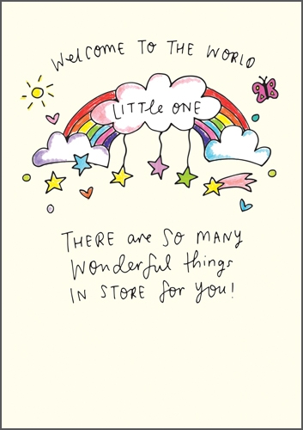

We welcome these two little ones to this strange but wonderful world. Despite its challenges, everywhere you look there are beautiful rainbows and endless stories of heroes, bravery and kindness.   This world, like before, is still full of wonder. As always we need to make the choice to notice it.  Sending all very best wishes from all at St Mary's.  
Mrs Mannix.