Dear Parents and Carers
We have come to the end of yet another term where there have been lots of changes nationally as a result of the Covid situation.
Locally Covid rates have been very high and this term for the first time we have had Covid positives in school. So far these have been single cases or occasionally two cases within a class so it is possible going forwards that we still have to have the high numbers that other schools locally have been experiencing before we get through this.
We are extremely grateful to you all for your thoughtfulness in firstly considering when and how you mix with others and also for the prompt actions you have taken when you or your children have had any possible symptoms. For 21 months we have been a very safe community so thank you.
Going forwards it is looking as though Government are very keen to do everything they can to keep all children in school.
The information below was taken from a letter sent to us yesterday from the Minister of Education. This term we have tested rather than self-isolated when we have been in close contact with a positive and this makes it clear that will continue next term :
From 14 December, a new national approach to daily testing for contacts of COVID-19 has been introduced. All adults who are fully vaccinated and children aged 5 to18 years and 6 months, identified as a contact of someone with COVID-19 – whether Omicron or not – should take an LFT test every day for 7 days instead of self-isolating. Children under five years old do not need to take part in daily testing for contacts of COVID-19 and do not need to isolate.
Once notified by Test and Trace as a close contact, all eligible staff, pupils and students are strongly recommended to take a LFT each day for 7 days and report the results through the online reporting system and to their setting. If they test negative, they can continue to attend their education setting. Outside of the education setting, they should continue to follow national guidance. This approach should also be adopted over the Christmas holiday and on return in January.

Christmas Sing
We were sad that we could not invite you in person to our Christmas events. The Kestrel and Eagle Advent Service and the Owl and Woodpecker nativity are both on our website.
Yesterday as a whole school we gathered on the playground and shared some of the songs that the children have enjoyed this term. Choir and Robin Class were able to share some of their singing for the first time this term with an audience and we heard some of the songs from the nativity and Advent service.
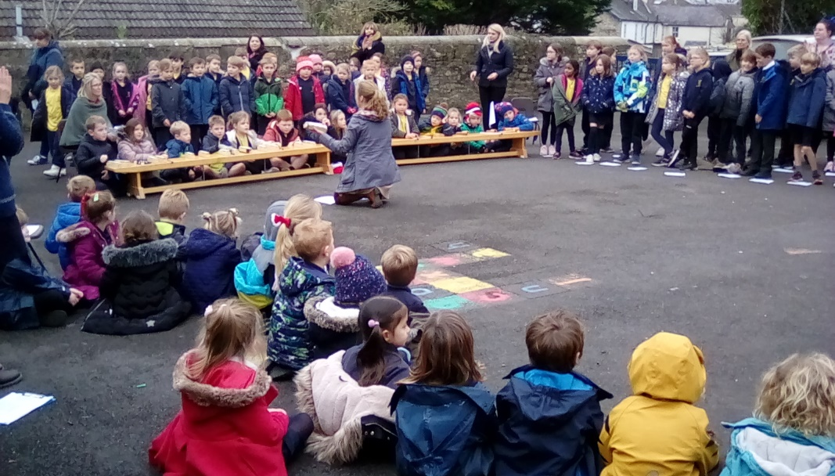
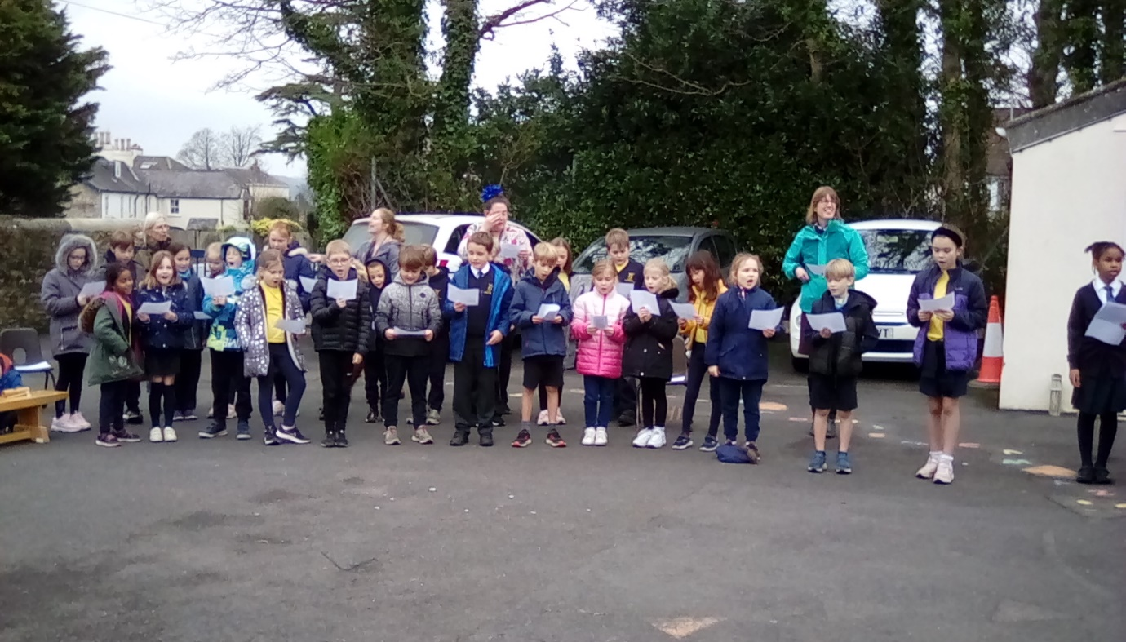
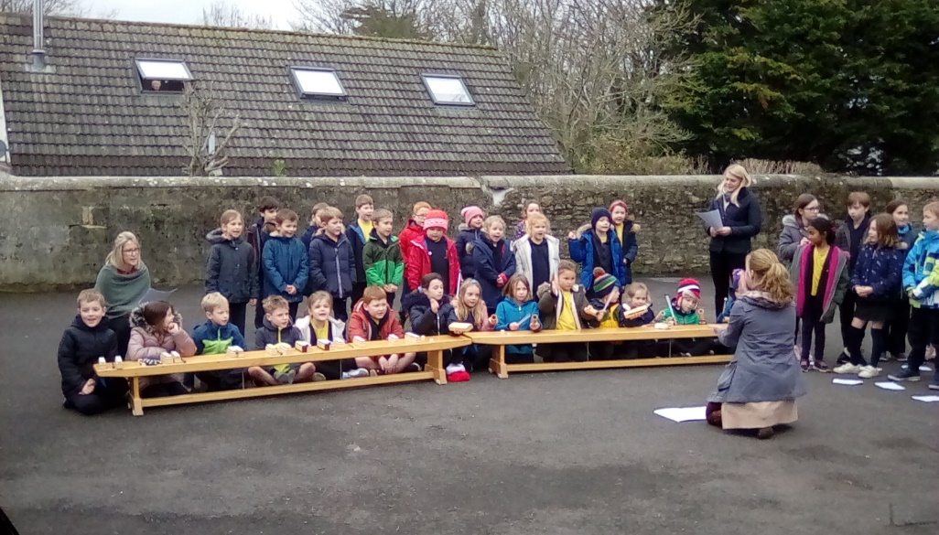

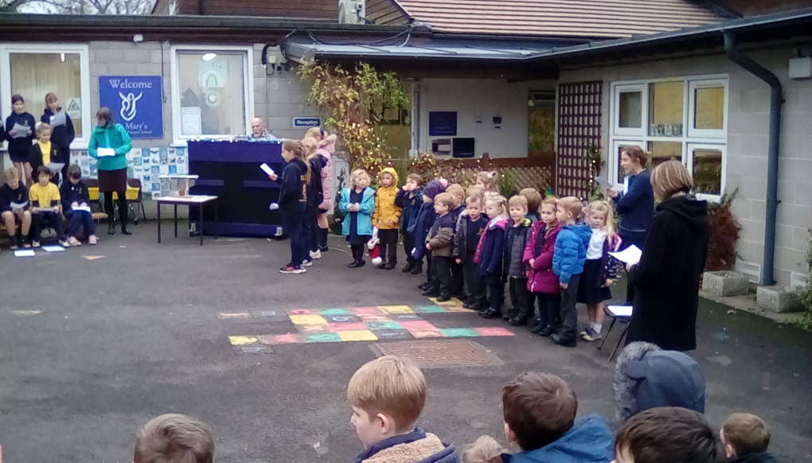

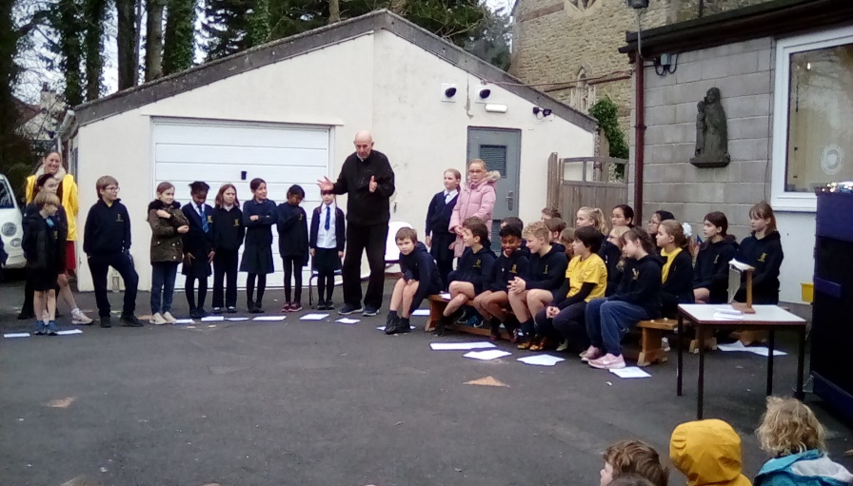

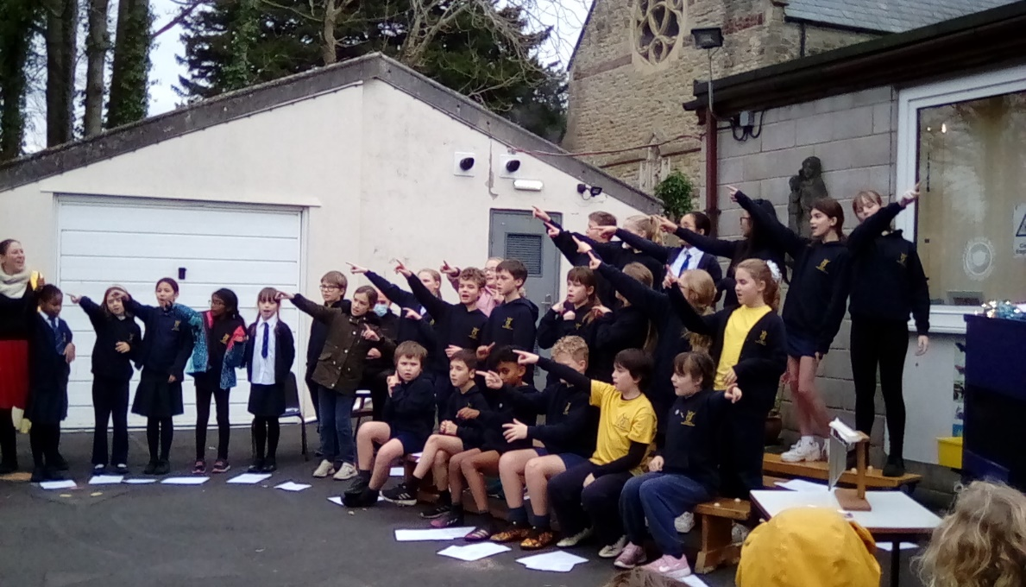

Lovely news
We are delighted to share the safe arrival of baby Matilda, baby sister to Tola. A precious early Christmas gift.

Giving this half term

Thank you for supporting our giving projects this term.
We raised the following sums:
Poppy Appeal £197.40
Children in Need £145.00
Waffle House (Advent Calendars) £55.70
Bristol Children’s Hospital ( Christmas Jumper Day ) £115. 31

School lunches
Christmas dinner Miss Taylor came in extra early on Wednesday and set up the hall with tinsel and decorations. Each table was set with seasonal paper, Christmas crackers, drawing paper and pens. Mr Jacobs played the piano and the children sang Christmas songs. At the end even our very youngest children clapped enthusiastically to celebrate the end of a really lovely event.
Why do we ask that you book lunches by the Thursday for the following week? This year Axe Valley have had some supply issues and have needed to know where and how they can adapt menus. Having a little notice of this has significantly helped them to be able to provide a continued service.
Booking your meals in advance should be more convenient for you. You can book the whole terms meals in one go if you want to. Whilst some of the supply issues are resolving it still does help the catering manager to know numbers in advance so we thank you for your continued support with this.
Why can’t we give your child a school meal if it is not booked or they don’t like what you selected for them? When children see other options at the point of service they may decide that they prefer something else on offer. We do not offer them this food as it would be wrong to overrule the choice you made as a parent. The majority of children are very happy with the food choices made so if you know your child prefers to know what they are eating each day then it might be helpful to show them the menu choices and remind them of the choices selected for them (or with them) .
Do we make children eat food ? We do encourage children to have a go at their food. Yesterday for the Christmas dinner it was surprising how many of them had at least a nibble of a sprout and decided they quite liked them. Others told us they didn’t like stuffing so we asked them to try a little with their roast potato, again some discovered that they did like stuffing. We didn’t have to encourage anyone to eat the pigs in blankets. They were a great success.
So we encourage children to eat (more than chat) so that they can finish their food during the 30 minute service time. We encourage them to eat savoury before sweet and we encourage them to eat what they can. We will encourage them to have a try of the food but we do not make them eat food they do not want to eat. We will always notice if an individual child is eating very little and will pass this concern to a class teacher to pass on to you or speak to you directly to ensure that this can be supported.

Advent Week 3
Each week in Advent has a different focus as we prepare our way to Christmas. Week 3 is the week of joy and this week there has been much joy in our school.
As we close today we all thank you for your continued interest and support and wish you and yours a very happy and peaceful Christmas time.
We look forward to the return to school on Wednesday 5th January 2022
Keep in touch
If during the holiday your child does have a PCR positive it would be appreciated if you could email this information to school using admin@stmarysaxminster.devon.sch.uk so that we can be aware of this in advance of the school return.

