**Selecting Search Results**

* We will learn how search engines select results!
* We will be able to explain why we need tools to find things online – we can filter our searches.
* We will learn about web crawlers and how they help to create a search index

**Internet Addresses**

* We will learn all about search engines!
* We will complete a web search to find specific information by choosing a search engine and typing in our search phrase
* We know how to refine our searches – how to make them clearer and more effective
* We will be comparing the search results of different search engines and thinking about which ones are the most useful for us.

|  |  |
| --- | --- |
| **Key Vocabulary** | |
| System | A set of things working together as parts of an interconnecting network |
| Connection | A relationship where a person or thing is linked or associated with something else |
| Digital | Numerical digits 0-9, joined together (e.g. 125) or individually; anything involving a computer |
| Input | The information we put in to a computer |
| Process | A series of actions or steps taken in order to reach a goal. |
| Output | The information a computer gives us |
| Protocol | Rules |
| Address | Where you want to go - websites have their own, special addresses |
| Packet | A block of data transmitted (sent) across a network. |
| Search | To look for something |
| Search Engine | This is the vehicle that takes you on your search. Different vehicles (search engines) use different routes, go at different speeds and offer you different choices of places to stop and search. Search engines include: *Google*, *Bing*, *Yahoo!,* *Swisscows* and *DuckDuckGo* |
| Refine | Make small changes to get a better result |
| Index | A method of sorting data by creating keywords or a listing of the data |
| Web Crawler | Sometimes called a spider or spiderbot and often shortened to crawler, is an [Internet bot](https://en.wikipedia.org/wiki/Internet_bot) that browses the [WWW](https://en.wikipedia.org/wiki/World_Wide_Web) and is operated by search engines to create indexes. |
| Bot | A bot -short for robot and also called an internet bot -- is a computer program that tries to mimic / simulate human activity. |
| Ranking | From highest to lowest, or lowest to highest. Websites are ranked depending on their usefulness |
| Optimisation | Making the best or most effective use of a situation or “thing” |
| Links | Weblinks join / link websites together. If you click on a weblink, it will take you to a different website. |

Computing Systems and networks – Year 5 / 6

**How Search Results are Ranked**

* We will be able to explain that search results are ordered – how many times certain words are included on their page
* We will understand how a search engine follows rules to rank relevant pages
* We will be able to suggest some of the criteria that a search engine checks to decide on the order of results

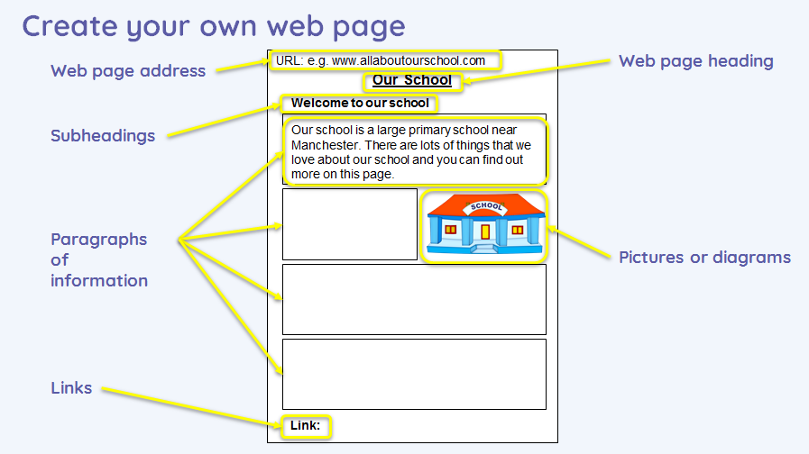

**Communicating Responsibly**

* We will be able to evaluate different methods of online communication!
* We will compare different methods of communicating on the internet – is an email more effective than a chat room? Is a zoom call better than an email? Why?
* What is ok / not ok to share with people on line? Do you share the same things with people you know and people you don’t know?
* How do we know if our online communication is private or not?
* We will all be able to explain the different ways in which people communicate – not always using a computer
* We will be able to talk about different ways of communicating over the internet (email, chat rooms, etc)
* We will be able to talk about our preferred way of communicating online

* We will know why the order of results is important, to whom and why
* Some of the ways that search results can be influenced is through advertising
* Some of the limitations of search engines are that they don’t give us exactly what we are looking for, they might be sponsored by an advertiser or they might actually be fake!
* Search engines make money by allowing advertisers to have adverts for their products – these might influence us to buy things we wouldn’t normally buy!

**How We Communicate**

**How are Searhes Influenced**