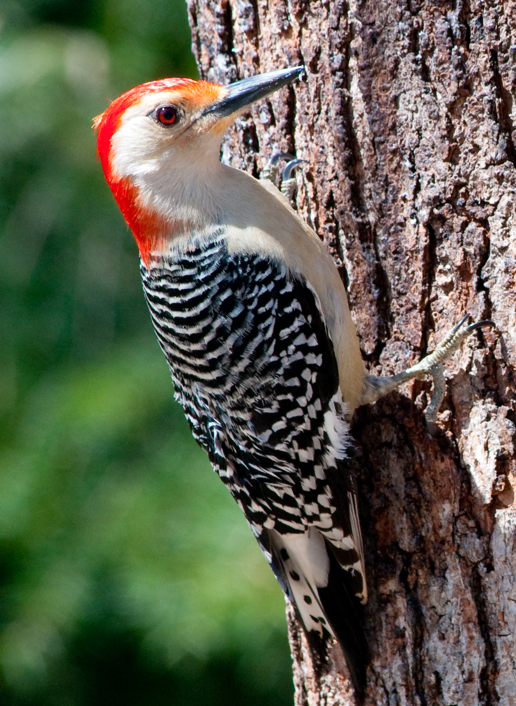

Dear Parents/ Carers of children in Woodpeckers Class,

A very warm welcome to ‘Woodpeckers Class’ and the beginning of a new academic year! Miss Wood will be the class teacher. Mrs Sakowska, our teaching assistant, supports the children’s learning in the mornings. We are very much looking forward to teaching the children. Our aim for each child is to provide a happy learning environment in which they are motivated and challenged, and develop values of respect and consideration for each other.

During this first week back, the children have been learning about and creating a list of the classroom rules and learning behaviours that we would like them to follow. In particular, we have been reinforcing listening skills, turn taking and respect. The children are earning team points for displaying any of the above positive behaviours.

Below we have outlined some information regarding the work covered in our class as well as general routines. We hope this will be of help and interest to you.

Autumn Term
This half term we will be learning about “Marvellous Me”. This will involve learning about keeping ourselves healthy, drawing self-portraits, creating models of ourselves and thinking about what makes each of us special and unique. We will also be looking at the history of Axminster. Autumn will feature a lot within our art work also.

In Maths, we will be concentrating on number, place value, calculations, shape and measure. The children will be introduced to lots of practical activities as well as a more formal introduction to written recordings. We will be ensuring that the children are able to write the numerals in the correct direction and formation.

In Science the children will be learning about ‘humans’ and naming different parts of the body and its functions. We will be learning about the five senses and how we rely on them for different tasks.

The children will have P.E. every Wednesday with Miss Rowe and Friday with Mr Munane. We hope the children will enjoy this opportunity to learn new skills. PE kits should be in school Monday mornings and stay in until Fridays. Please ensure all P.E. clothing and school clothing is labelled clearly with your child’s name.

Forest school
We will be continuing to have forest school on a Wednesday. Please provide your child with spare clothes, a coat and wellies for these sessions.

Reading
We will be sending home colour banded books and reading records. Please encourage your child to read at home as often as possible (ideally everyday), ask questions about the book to encourage them to recall parts of the story or learn new vocabulary.
We look forward to an enjoyable year and as always are extremely appreciative of parental support with your child’s learning at home i.e. listening to them read regularly, helping with homework etc – it really does make such a difference to their progress.
Playtime - Fruit
The children will continue to receive a piece of fruit at morning playtimes.

Water
We encourage the children to drink during the day at break times and therefore ask them to bring in a water bottle. Please label your child’s bottle. Thank you.

If you do have any concerns at any time about work or anything else, please do not hesitate to come and see us.
Thank you for your support

Miss Wood

