I know the roles of different people

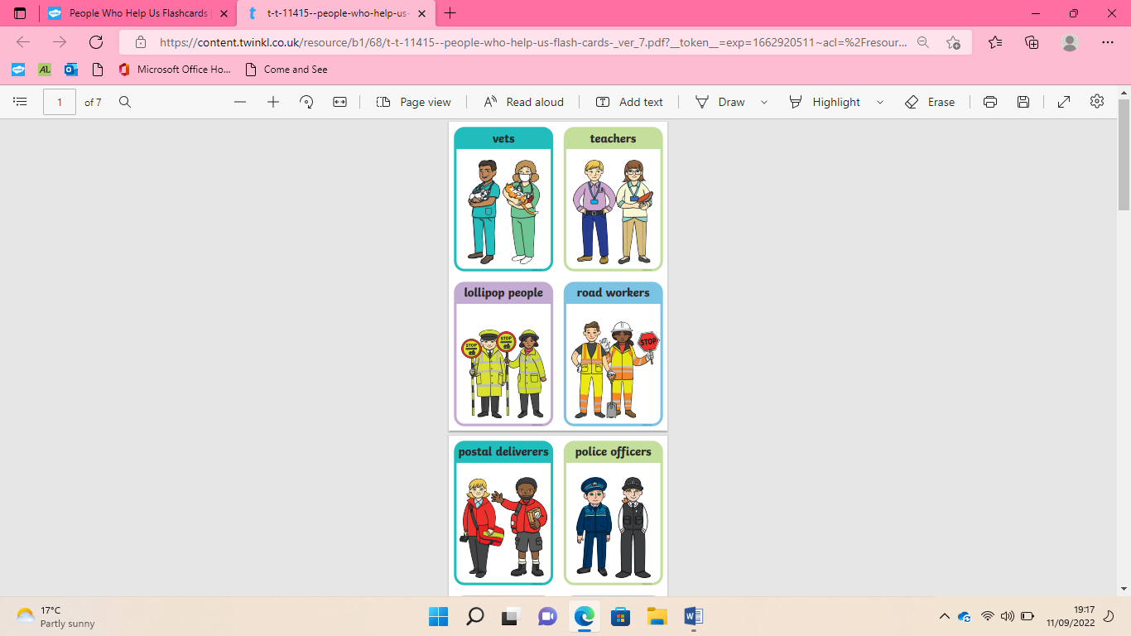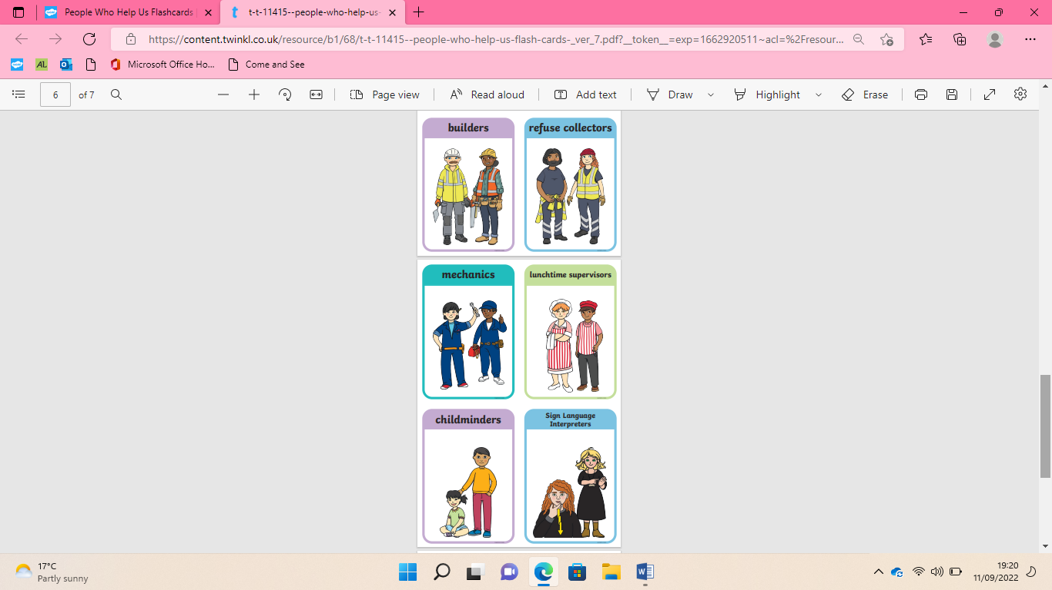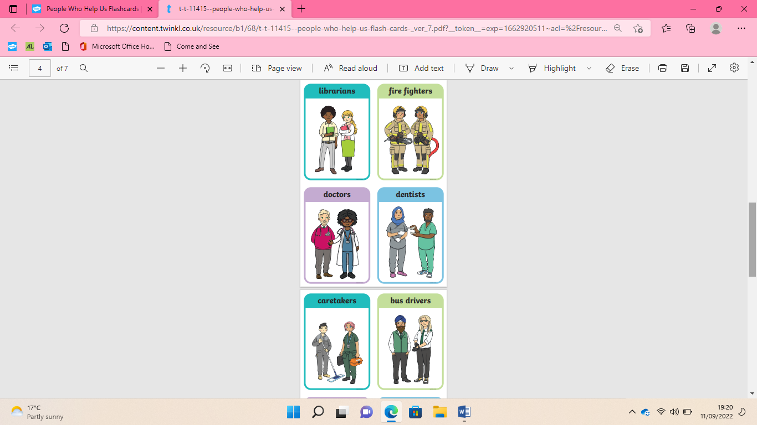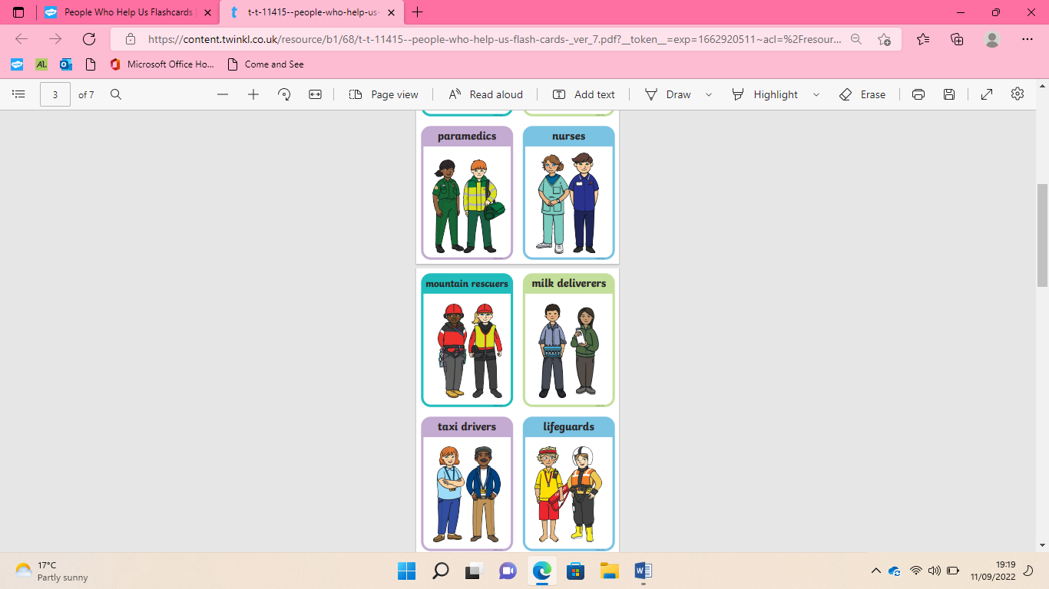

**I know how to tell an adult I’m lonely**

Speak to your thumb/ hand people.

I know some strategies for building friendships.

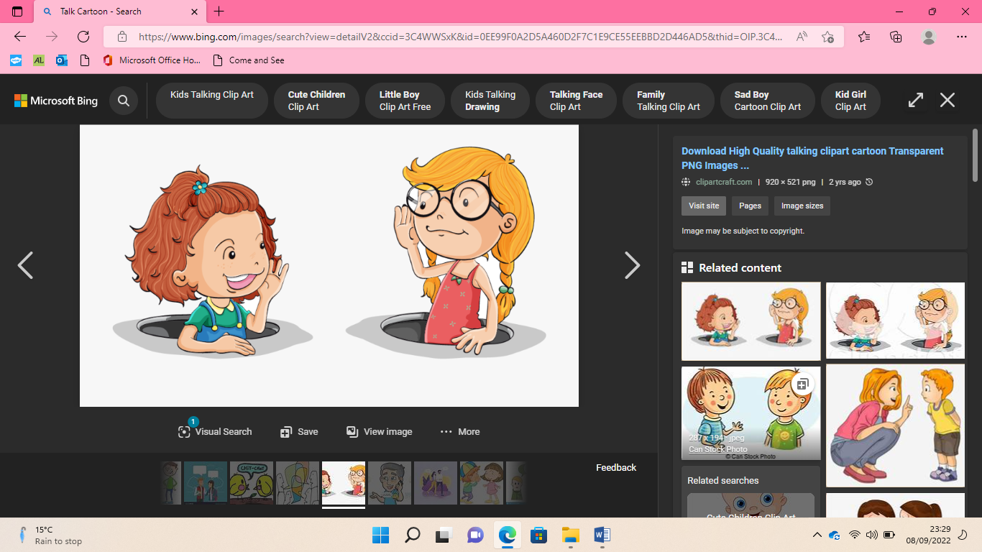

|  |  |
| --- | --- |
| **Key Vocabulary** | |
| Safe | Free from danger or harm |
| People | Human beings |
| Family | A group of individuals living under one roof |
| Care | To look after someone or something |
| Love | A strong feeling of affection |
| Safety | The state of being safe |
| Security | When something is safe or protected |
| Blended | To mix together |
| Extended | To stretch out |
| Happy | A feeling of pleasure |
| Sad | A feeling of unhappiness |
| Confused | Difficult to understand |
| Worried | Anxious or concerned about something |
| Excited | Enthusiastic and eager |
| Emergency | A serious, unexpected, and often dangerous situation requiring immediate action |
| Services | The action of helping or doing work for someone |
| Police | A service that helps to keep people safe |
| Fire Brigade | A service that helps with fires and other emergencies |
| Ambulance | A service to help injured or unwell people to hospital |
| Paramedic | A person who works on an ambulance |
| Coastguard | A service to help when there is an emergency near the coast |
| Danger | A situation or thing that could be harmful |
| Friends | Someone who you have a bond of mutual affection with |
| Lonely | Not being with anyone |
| Help | The action of helping someone to do something |



Safe hands

Different types of families

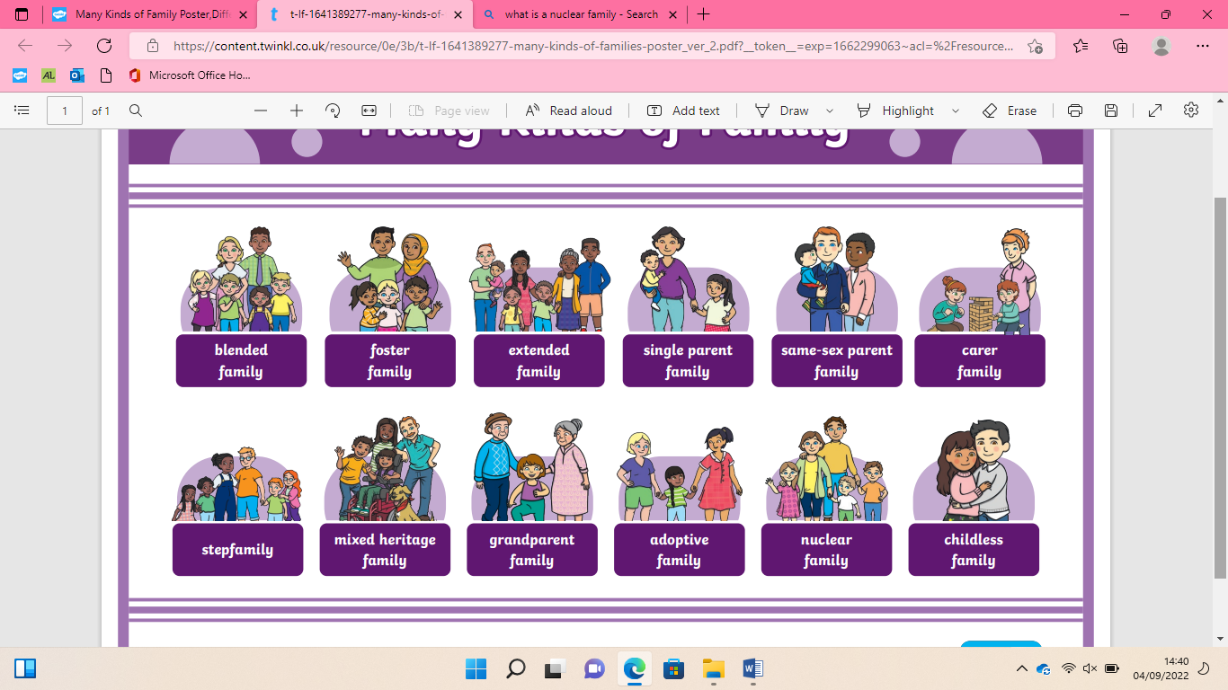

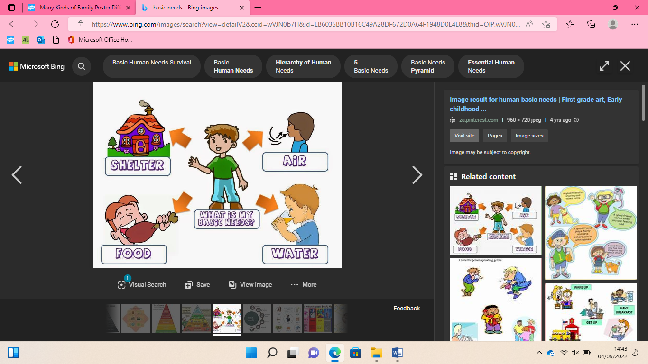

Families and friends