St Mary’s Catholic Primary School
Living, loving and learning with God
Start and end of day thank you.
We have been delighted with the way that all children have been so happy around school and the way that they have come into school each morning. Our new starters in Robins have totalled amazed us with their smiles and happy starts to each morning. Thank you to all parents who have been so supportive of the necessary changes to the start and end of day routines.
We are looking forward to Robin Class new starters being with us for the whole day from this week with end of day being 3.15.
Covid 19 restrictions
Despite the very low numbers of confirmed Covid 19 cases in East Devon we are still working to support the pandemic at a national level. Many areas of the UK faced further restrictions this week and it is clear that our individual actions are significant in supporting this on going situation. We are all being asked to consider our actions and to ensure that we do comply with the rules. Safety has to come first.
We appreciate your thoughtfulness around the changes we have been making and also the understanding you are applying when your child is unwell. There are lots of every day colds at the moment which are not Covid 19 but parents are being vigilant and very supportive in creating a safety net for everyone.
If your child is absent from school, we ask that parents or carers contact the school either by phone or email by 9am. Devon County Council monitor attendance and as such, it is important we know if your child is absent and the reason for absence. Your continued support with this is much appreciated.
We have been asked to distribute some information to parents and carers on behalf of Devon County Council, as such please find these attached.
In line with national guidance we are not currently making any plans to relax restrictions around Covid 19 protocols at St Mary’s; children will remain with their hub so that in the event of a positive result within school we can minimise the impact to others. If you could continue to support this by minimising mixed hub contact out of school that would add to our safety net.
At the same time we do want to think ahead and we do want our children to have access to the wider experience of school. We have started having single hub assemblies and talking to the children about ways that we might adapt some of our events to support Covid safety.
School parent information events, harvest festival, PTFA events….all activities that add so much to our school life will need to be adapted. We are working hard to make sense of these and will be keeping you up to date in the coming weeks. If you do have thoughts and suggestions they will be listened to so please do email school.

St Mary’s Values
As a school within the CAST Trust we share fundamental values with all of our family schools. These underpin all of our work and policies. The trust values are :
Peace, compassion, kindness and forgiveness. Integrity, courage and humility and justice.
St Mary’s school values were created in consultation with the whole school. We asked every child, staff member and governor what was important to them and this was collated with the school council. We then shared this with parents. We did collect the words together and end up with some grown up words but this did not change the meaning of the values expressed by everyone.
We now use these values every day in our lessons and around the school to share and celebrate those who model positive behaviours for friendship and for learning.

St Mary’s School Values
Forgiveness

Safe | Trust | Achievement | Resilience
Respectful  Responsible  Caring  Value each other |  | Aim high  Have a go  Curious  Self belief
Star of the Week
We are constantly celebrating the achievements of all of our children. Adults at St Mary’s work to give positive and constructive feedback to children throughout the day so that children know what they are doing well and what they can do to achieve more. We believe this gives children a clear sense of who they are and helps with their self belief. We do not encourage children to compare each other; each child is unique and each child has their own journey.
At the end of each week teachers name a child who has stood out as the star for this week. They would be announced in our celebrate assembly but die to Covid 19 we are unable to hold our assemblies so children will celebrate within their class and we plan to send out an email to all parents of our stars of the week each Friday.

Congratulations VE day success
During lockdown Eagle Class were invited to take part in a national competition to mark the VE day celebrations. The Spirit of Normandy Trust works to promote the lasting legacy of the many who fought for our freedom during World war 2. http://spiritofnormandy.org.uk/
Children were asked to design a poster that captured the spirit of VE Day.
Eagle Class Year 6 pupils who were in school entered collectively and received special congratulations for their collective entry. They each received a certificate and an individual pin badge for the quality of their research. 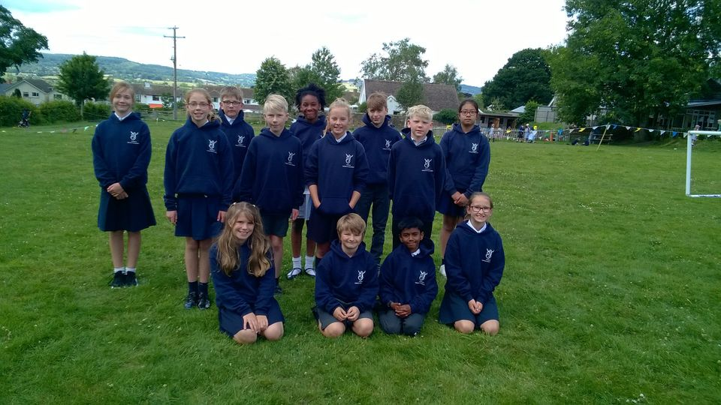

In addition some of our year 5 pupils entered from home. We are delighted to announce that Joe received a special commendation as a runner up and Giles won the overall completion. See the winning posters below. Congratulations to all.
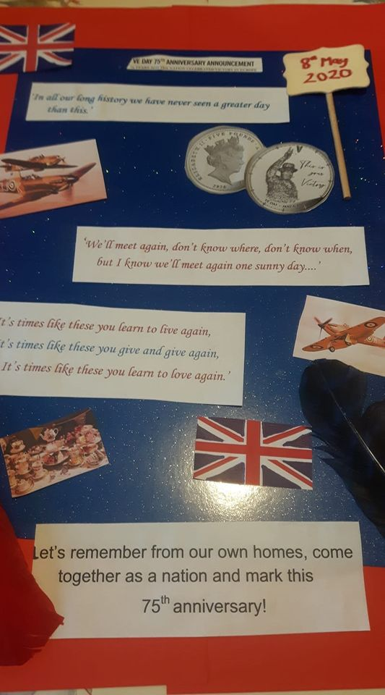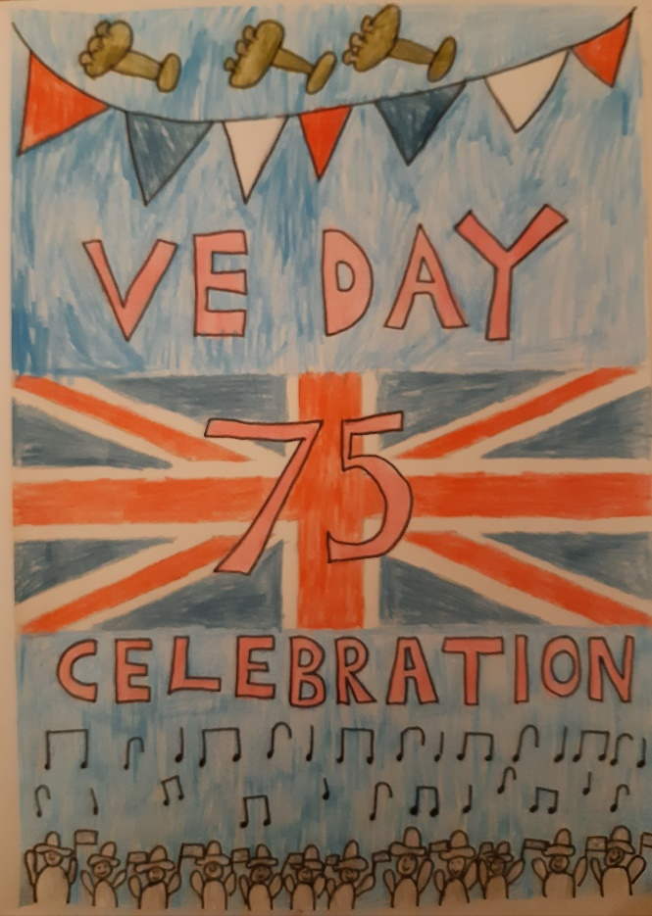
Curriculum
You may have heard about the recovery curriculum; the actions schools are taking to close any gaps that children have from the national school closures. Some schools have chosen to focus solely on reading, writing and maths on their return to school.
At St Mary’s we are working to settle the children back into school and to engage them back in to learning whilst assessing where their gaps are. We are working to provide them with a wider enriched curriculum whilst closely monitoring their core skills and looking to find ways to close gaps over time. Each class base has access to online personalised learning which will be used by teachers in class and to set homework that can help the children gain the practise experience that will allow them to do some of that catch up. We are very determined to find ways for the children to make the academic progress within the context of a stimulating wider curriculum. Some parents will have already received the class termly over view/ newsletter information and those that haven’t will be with you by no later than next Friday.

Join our team
We are looking for someone who will be able to join our lunchtime team to work with the children during their meal time. This is a very important role as the children need adults who can help practically as well as emotionally in keeping them happy and chatting during the lunch service. The closing date for this rewarding post is Monday 5th October at 9am. Please email the school office if you would like an application form and job description.
Please see our school website or Devon Jobs for more information. If you are considering this post and have some questions please don’t hesitate to call us to find out more.

Car Parking Permits for school drop off/pick up available at Pippins Community Centre

In response to the need for local parking at school drop off and pick up times, Pippins Community Centre (Stoney Lane) has made a number of parking spaces available by permit for St Mary's parents and guardians.

Parking permits are charged at £10 per term and allow parents to park in the Pippins car park at school drop off and pick up times.

(Please note that restrictions apply so that parking is prioritised for users of the Pippins centre when groups with large numbers or vulnerable members of the community are using the centre.)

If you would like to enquire, or purchase a permit, please email pippinsbookings@gmail.com.

All proceeds from parking permits are reinvested into Pippins Community Centre and/or Axminster community initiatives.

Junk modelling
In school we can always make good use of your old cardboard boxes (cereal, egg boxes ect) for junk modelling. In light of the Covid restrictions we will be keeping a plastic box for these items in the garage. If you have any thing you would like to add please leave it outside the reception under the sheltered area and we will transfer it to the box. All items will be left for 72 hours to quarantine prior to any children using them.

