Newsletter Oct 2020
Friday 23rd October 2020

Thank you
We are always extremely grateful to you for your continued support but this half term your work to adapt to the Covid practice has been really, really appreciated.
It has helped the children to adapt and to come into school each day, many with a skip in their step. All have really enjoyed being back with their friends and all are making gains in their learning.
We were sorry not to have parent meetings but hope that the mini reports sent to you have helped to give a picture of how your child has been progressing this half term. It was certainly very positive for me to speak to the teachers about all of the learning steps this half term.
Blended Learning (Google Classroom/ Tapestry / Bug Club / IXL/ Eagle Class SATSCompanion/ Times table Rockstars)
Thankfully despite all of the discussions nationally we have not been required to return to lockdown but we have still been making use of the learning platforms set up for each class group. These are helping to set practice skills in school and to provide purposeful home work tasks. In total many of our children missed 14 weeks of school so no one is pretending that this hasn’t had an impact. We are working to support children to move forward and to make up on any lost learning. Your work at home is very important.
As adults we are often more comfortable with pieces of paper and books but the children do feel very confident and safe with electronic learning. The learning platforms we have selected are all high quality and will provide engaging and valuable learning opportunities for your child. Please do consider encouraging some time each evening and at weekends and holidays. Every practice task will help.
Self isolating
Families have been very thoughtful in keeping us informed about any medical concerns and seeking appropriate advice for all illness. We have had a very small number of children who have self isolated, either because of their own symptoms or symptoms of other family members. Whilst test results are returned. To date we have not had a positive case anywhere across school.
In the majority of schools where there has been a positive case this has been a single case highlighting that these cases are brought into school from outside. Again we appreciate the steps you are taking to reduce contact outside of school. As I’ve said before we are working hard in school to take as many actions as we can to help keep us safe. Thank you on behalf of every member of our community for the actions you are taking in and out of school We have had so many aspects of school life that has meant a range of adjustments for you. We are so pleased to have reached the first half term without any incidents of Covid.
If your child becomes unwell in half term we would ask that you monitor them as you would normally do. If they are required to take a test and it comes back positive over half term please let us know via the emergency school number which is 07512 079520. You don’t need to let us know if they are taking a test only if your child has a positive result. We can then inform the rest of the associated hub. We hope this will not be necessary and that everyone with have a healthy happy half term. For your information, if we did have a child in our school who tested positive we would inform all school parents and carers.

School lunches
Parent pay has been updated with next terms menu selections. As such, if you wish your child to have a school meal please continue to book them in advance. You can book all the way up to the Christmas holidays so if you could do this it would be much appreciated. It is really important that we know how many lunches are needed each day.
Flu vaccinations
The Virgin Care Immunisation Team will be in school on Thursday 5th November to deliver the vaccinations. If you have opted to have the vaccine via the link that has previously been sent then your child will receive this their vaccine.
P.E-jogging bottoms
Now that the weather is getting more changeable please may be ask that children come in navy jogging bottoms for P.E. This will help keep them warm and also helps protect knees if a child falls over.
Secondary school application deadline 31st October-Year 6
A reminder that the deadline for your child’s secondary school application is 31st October. You should have received your application pack from the local council. If you are having any difficulties or need help with your application, please contact Devon Admissions on 0345 155 1019 and they will be happy to help.
Mrs Gill
Many of you will be aware that Mrs Gill broke her wrist last Friday. She had a very painful few days whilst she waited for the wrist to be set on Monday. Mrs Gill has not been in school this week although we have had phone and email contact and are all reassured that she is now really improved.
Mrs Bray stepped in to teach the class this week along with Mrs Hogarth and very briefly by Mrs Fudger.
We are sure you will join us in wishing Mrs Gill a relaxing half term and a speedy recovery.

Poppy Mae
Many of you will know that Poppy Mae, little sister to Jayden in Kestrel Class, was born with a complex heart condition. In the last two years we have had an annual Skip a thon for The British Heart Foundation as a thank you for the research and work they undertake; work that has already helped Poppy Mae.
We are pleased to say that finally Poppy Mae will have the next operation which has been long awaited. This will be during the October half term. We will be holding Poppy Mae and her family in our thoughts. It is hoped that very soon Poopy Mae will finally be able to join us in Robin Class.
We wish you well
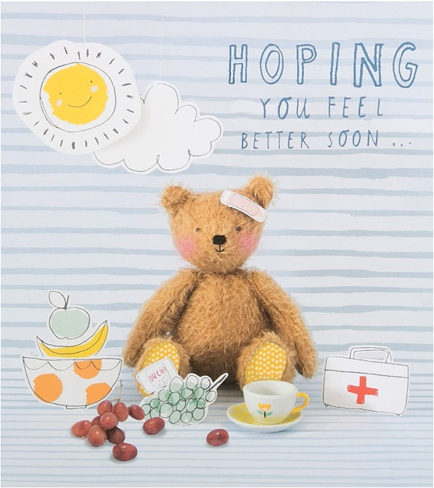

Harvest 2020
The children have been reflecting on what we can be glad about at this time and have also been watching the harvest ‘river of kindness’ grow.
We have been overwhelmed by the number of items sent in this year. We have over 200 items : 170 tins, 14 bags of rice and other items such as porridge and dried noodles. All of these items will be offered to The Axminster Food Bank to support local families facing challenge.

Please see photos taken on Tuesday and then Friday showing how your kindness has grown.
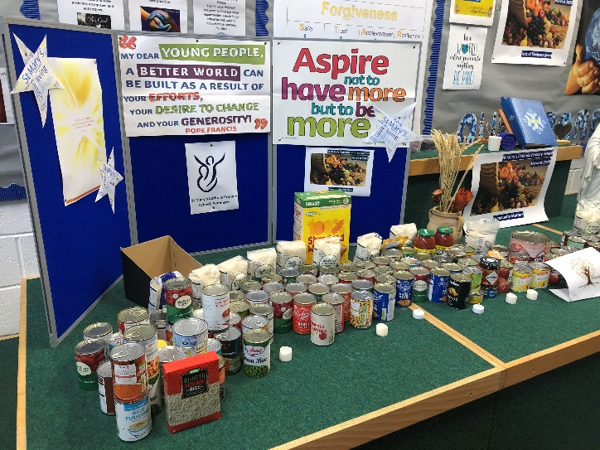

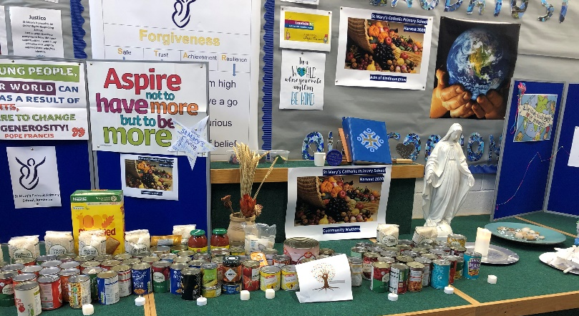

Eagle Assembly of light
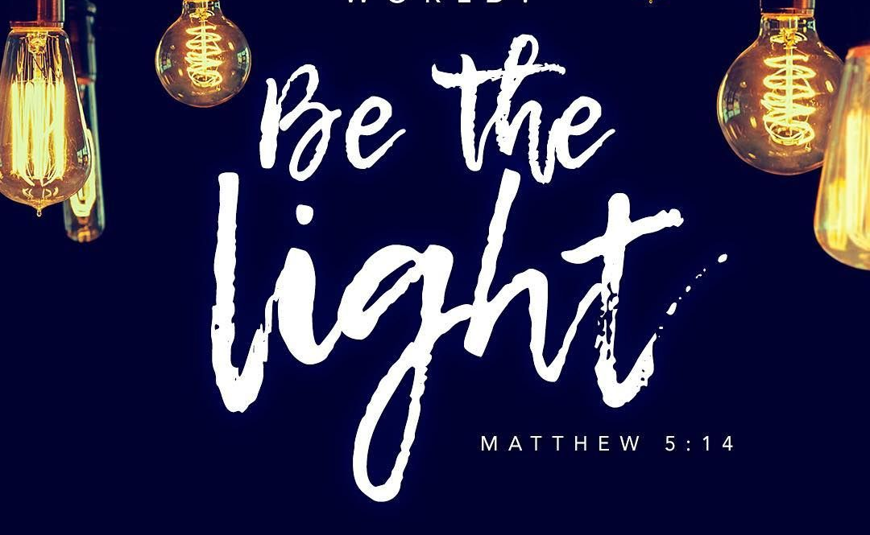
It is becoming a tradition to invite our year six pupils to light a candle and to consider how they can shine in our school. In this Covid year it is especially important that they work to use all of their skills to make a difference for themselves and for those around them.
Please see some of the photos of the children below. More can be seen on the school website.
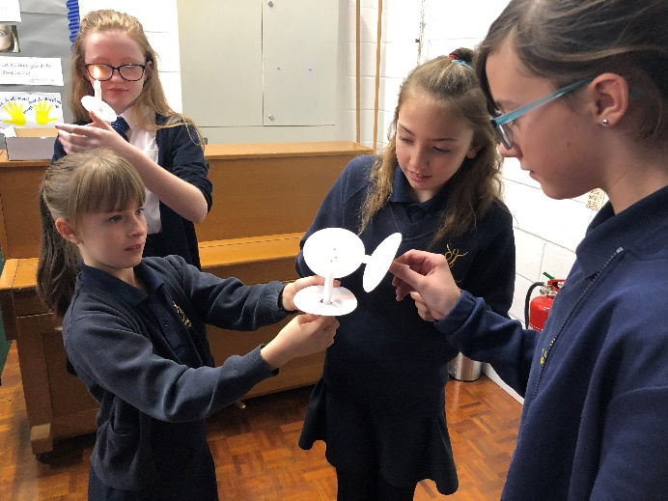 Each candle was lit form a single flame.

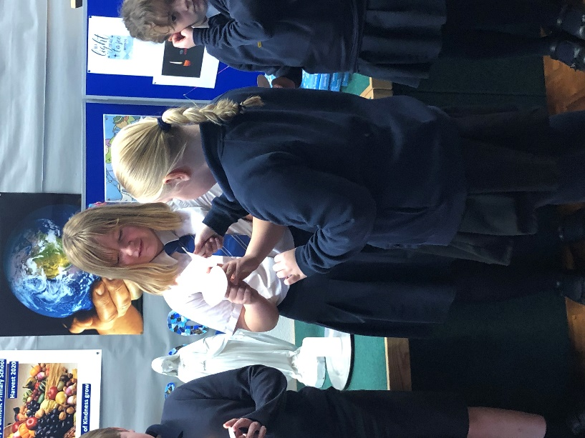

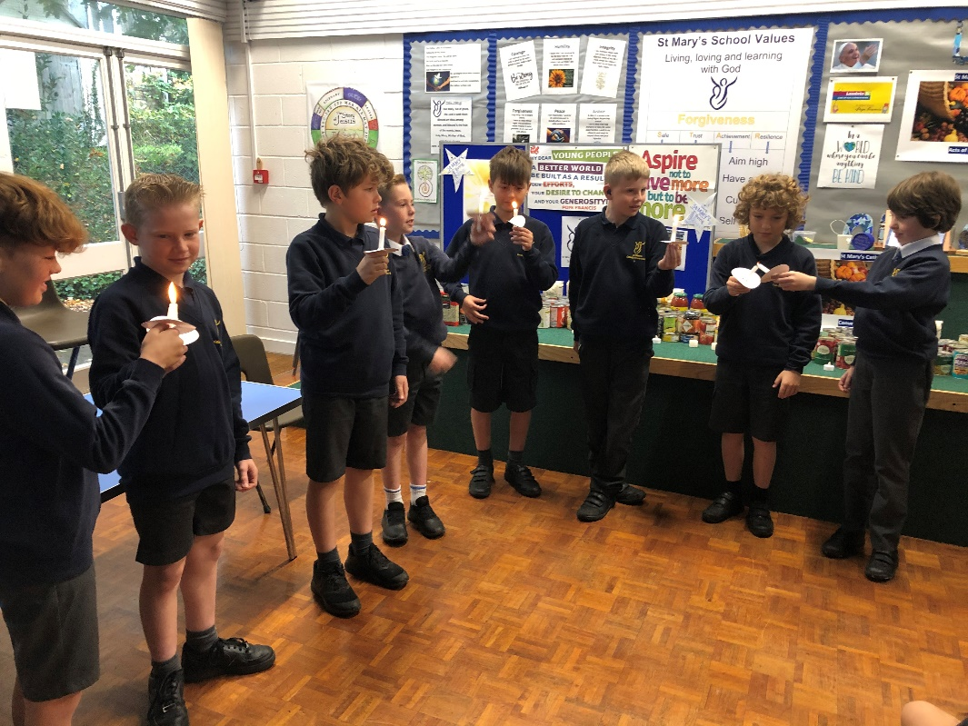
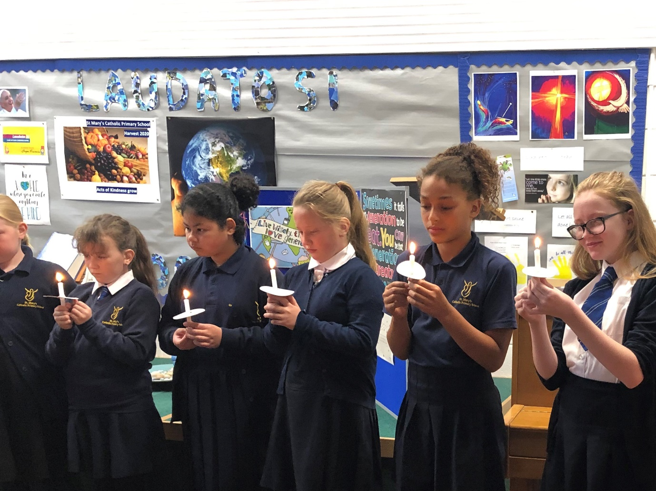

They were asked to think about what light do they bring to our school and how might they shine even more brightly.

Rights Respect Article 24
For the last two weeks all classes have been thinking about Article 24 : You have the right to the best health care possible, safe water to drink, nutritious food, a clean and safe environment, and information to help you stay well.
Below are some of Eagle Class ideas and thoughts about this right. See our website for more photos.

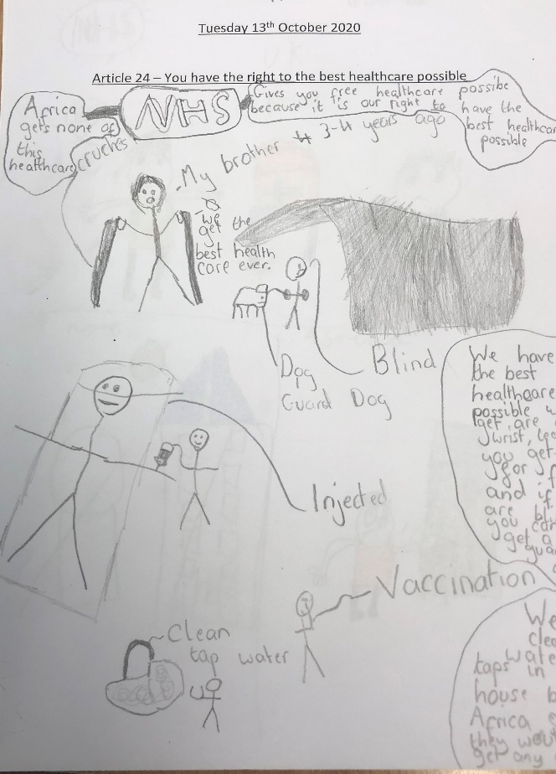

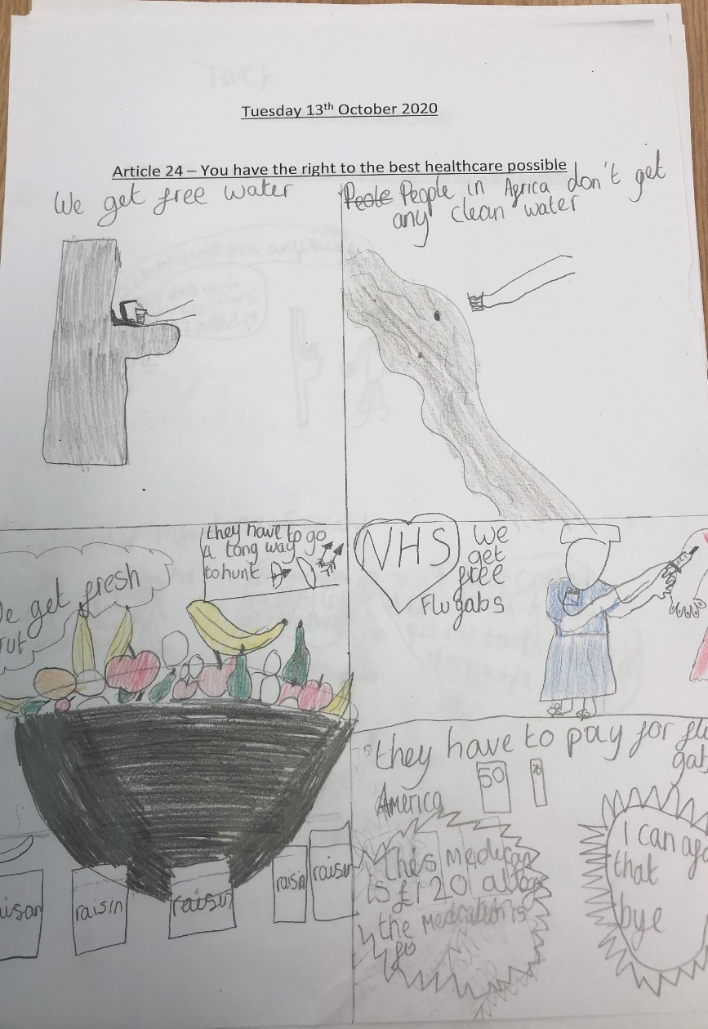

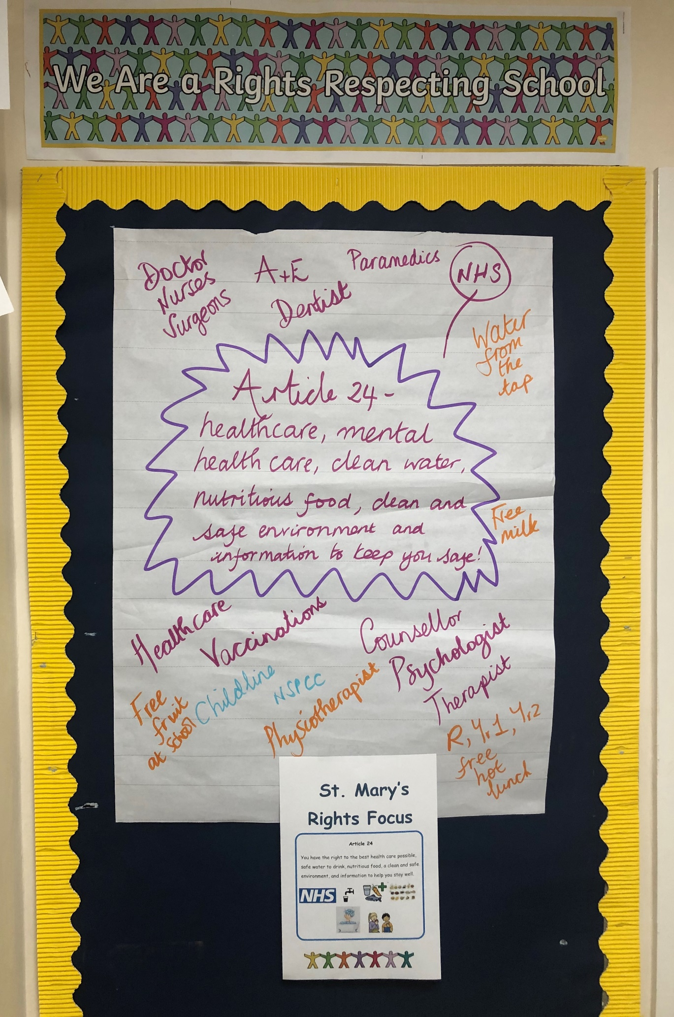

We look forward to welcoming children back to school after half term on Tuesday 3rd November (The Monday is an INSET day)

