St Mary’s Catholic Primary School
Living, loving and learning with God

Newsletter October 2020

A sincere thank you for your continued support.
Dear Parents and Carers our work to stay safe in school is greatly helped by your actions to support your children and families but also to show great consideration for the wider school community during this Covid transition phase.
Queries from parents explaining about children’s symptoms and whether being in school is the right decision, as well as parent response to our own questions, are deepening the sense of safety and the sense that at this time we are looking out for each other.
At the start of term parents were talking about sleep overs and lots of contact with other children out of school but again we are now aware that you are greatly considering these decisions and being vigilant and responsible.
It is a challenging time as everyone becomes used to this new normal but knowing we are all working together is a great strength.
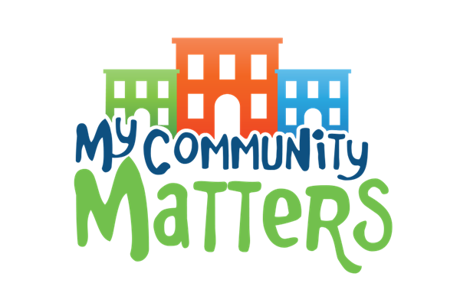

The Covid Climate
The plans we made for the September opening of St Mary’s were based on risk assessments shared by the Government in July 2020.
I had hoped that by week three of this term we would be considering ways to be able to relax some of the practice for after October half term but it will be clear to you as it is to me that this will not be happening. Cases in East Devon remain very low with 11 cases in the last week and the same number in the previous week but the national picture remains less positive.
So for now children will remain within their single hubs, we will not be introducing after school clubs as we had hoped and other aspects of whole school life going forward will not be being relaxed. We are continuing to think of ways to adapt. I include below some of the more immediate actions.
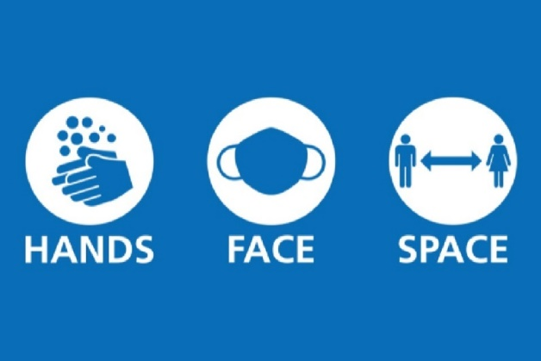

Parents Evenings
We cannot have face to face meetings with you as we would like. You have seen the way that children skip into school each morning. It is a joy to see each day and equally at the end of the day when children rush out to see you. There are lots of positives happening for the children right now.
Class learning and routines are establishing well and we continue to work to plan interesting and purposeful learning whilst working to identify and begin to close gaps in learning.
In place of parents meetings teachers plan to make a single side summary of the successes so far this term as well as some areas for development. This will be shared with you before the half term holiday.
If you have any concerns that you have not yet shared please do let your child’s class teacher know.

Harvest Festival – together we can do more -
The format we normally have for harvest will not be possible this year.
We would like to remind the children that we are very fortunate to live in a country where we can take having a daily meal for granted. We would also like to take another opportunity to show the children how our small individual actions together can achieve great things by asking for food contributions for the Axminster Foodbank.
We hope you will help your children support this. We will send further details early next week.

Home work and ‘blended’ learning
To support Covid transitions we are not currently having book bags in school and we are working to minimise home to school items.
For this reason we have been asking parents to support home work using electronic platforms.
Reading at home : Every day or at least three times a week children should be reading as they did before lockdown. Reading at home with your child does give them huge advantages for all learning. If you give them the additional practice they will learn skills more quickly but if you also hook them into reading and they enjoy reading they will have a life-long advantage over other learners.
Bug Club is the platform we have made available to all parents. It is personalised to your child. Reading on Bug Club provides us with a bank of evidence. Bug Club has texts and supporting activities that the children do enjoy. For young readers Bug Club closely maps with the phonics skills they are learning. If you would like to share and read other books from home or Axminster library then please do this as well.

Each class teacher is setting specific home work for children that will help them with what we call core learning. This may include phonics, learning tricky words, developing spelling skills and handwriting as well as times table fact learning. Teachers may also set other homework that will re inforce class learning. Teachers will make it clear what this homework is and when it needs to be completed.
This is very much as it was before lockdown. We really do value your contributions to your child’s learning. It does make a huge difference. If you have any questions or worries about this please do ask your child’s class teacher straight away.

What about the other resources/ platforms and log ins ?
Since lockdown all schools have been working to ensure that in the event of children, hubs or the whole school being out of school due to self isolation or further lockdown we would more equipped to support home learning. This is being called blended learning ; the home to school learning that happens if children can’t be in school during normal term time.
We have worked to create safe systems so that teachers can directly communicate with children and parents and to have ways to ensure that home learning is relevant and meaningful and can be teacher lead.
These systems are electronic systems. Many children are familiar with electronic platforms so it has been more about us as adults catching up with them !
We have been ensuring that the children have access to these platforms and are familiar with them by using them for class practice work and sometimes for homework.
In addition you can make use them at home at any time to provide additional learning opportunities for your child.
See below the platform and learning sites used by each class.
If you have any questions about this then please do not hesitate to ask your child’s class teacher or email admin and we will direct your enquiry.

 | How teachers communicate now | How teachers will communicate if further isolation/ lockdown | Bug Club –  a log in resource to develop reading skills and reading understanding.  TT Rockstars – times table practice | IXL  A log in resources to give children opportunities to develop skills in all areas of the curriculum | SATS Companion  A log in system to provide specific practice in reading, grammar and maths | Oak Academy  A national platform with daily lessons in all subjects
Robin Class | Face to face  email  Tapestry | Tapestry | Bug Club | Yes | No | Yes
Woodpecker Class | Face to face  Email  Google Classroom | Google Classroom | Bug Club | Yes | No | Yes
Owl Class | Face to face  Email  Google Classroom | Google Classroom | Bug Club  TT Rockstars | Yes | No | Yes
Kestrel Class | Face to face  Email  Google Classroom if isolating | Google Classroom | Bug Club  TT Rockstars | Yes | No | Yes
Eagle Class | Face to face email  SATS Companion | Google Classroom – still to be shared with all pupils/ parents | Bug Club  TT Rockstars | Yes | Yes | Yes

If your child is out of school when will they have access to school learning ?
If your child is unwell, for whatever reason, and is therefore unable to be at school we would expect that the priority would be for your child to become well enough to attend school. We would not share learning. If, as they recover, you judge they are not well enough to be in school but could access some work, then you are very welcome to access the resources above. This can give your child opportunity to practice skills.
If your child is unwell and has Covid 19 symptoms so you are required to have your child tested then we would consider that your child is unwell. We would not share class learning.
If your child tested positive so was required to stay at home for at least 8 days and then until they felt better they may feel well before the 8 days are completed. We would ask you to access some of the above learning resources to give your child opportunity to practice skills. Just as with other illness we would not share class learning.
If your child is not unwell but is required to self isolate whilst you await test results for other members of your household then we would share with you class learning and ask that your child completes tasks daily.
If your child is not unwell but school requires that your child self isolates because of a positive Covid case within their hub or that we experience further local or national lockdown then we would share with you class learning and ask that your child completes tasks daily.
Please be reassured that we are working to ensure that where children are required to access school learning from home it would be supported by a range of experiences that would mean you would not need to teach your child but would be able to take on the parent role of encouraging their engagement, focus and success with given tasks.
For now ensuring that you know that you have the log ins and can access the resources is really appreciated. Should you have any issues then please talk to your child’s teacher or email admin and your query will be directed.

We have continued to review and develop our rights respect work since returning to school.
We did think that Article 28 would make sense to children after their time away from school. Article 28 states : “Every child has the right to an educaiton. Primary education must be free. S secondary education must be available to every child. Discipline in schools must respect children’s dignity and their rights. Richer countries must help poorer countries achieve this.”
All our classes have been thinking about why education is a basic right, what they learn at school in addition to the National Curriculum, what elements of childhood they would miss by not being at being in school.
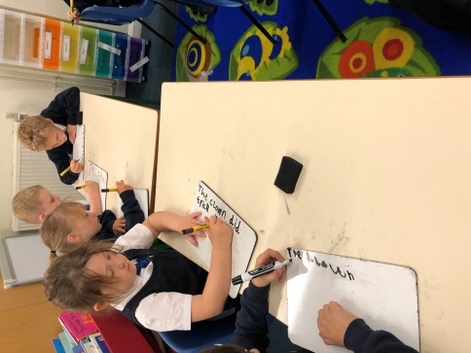
Woodpecker Class recording what they like about school and why all children should have the chance to go to school.

Car Parking
For our new parents you will realise that not having a car park for parents is a challenge. All other parents will know that this has been an on-going conversation.
No school has a car park for parents. Most schools were built when the vast majority of people walked so even staff and visitor car parking is a challenge in many schools. Even new build schools do not have car parking so we have to ensure that we move forward with this issue not backwards.
Last week parents from our school witnessed a member of the church staff being verbally challenged by someone in the church car park. The administration, cleaning and repair staff at the church all go and do a day of work and should not be treated rudely by anyone. So I was very sad to hear that it was one of our parents who had treated them in this way.
Safety : At the moment parents and children are walking through the outer car park so there is not so much traffic walking along the path; this is sensible but it does mean when cars are swinging in and out of the car park children and parents are not always safe.
I absolutely appreciate that it is not always convenient to park away from school and walk but it is something many parents do and have managed to do. Please ensure that you support this.

Radio Devon – Pledge to Talk
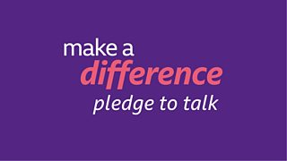

Radio Devon are running a project to make a pledge to talk to someone who you haven’t spoken to in a while or even someone you haven’t spoken to at all. This could make a huge difference to someone in your street or area who is perhaps isolated.
We will not be asking children to take part in this but it is something perhaps adults might want to take on.
Secondary school application deadline 31st October (Year 6 only)
A reminder that the deadline to apply for your child’s place at secondary school is 31st October. You should have received all the information you need from Devon County Council. If you have any difficulties or questions, please contact their customer service help line on 0345 155 1019 and they will be happy to help.

School Meals
Thank you to all everyone who is now booking all their child’s meals in advance via Parentpay. It really is helpful to us. Please continue to do this so we can make sure the numbers we order each day are accurate. There will be a new menu after half term. Mrs Newcombe will put the new menu on Parentpay before we break up so that you can book your child’s meals all the way up to the Christmas holidays.

