I can start a sequence from the same place

I can predict the outcome of a sequence involving forwards and backwards commands

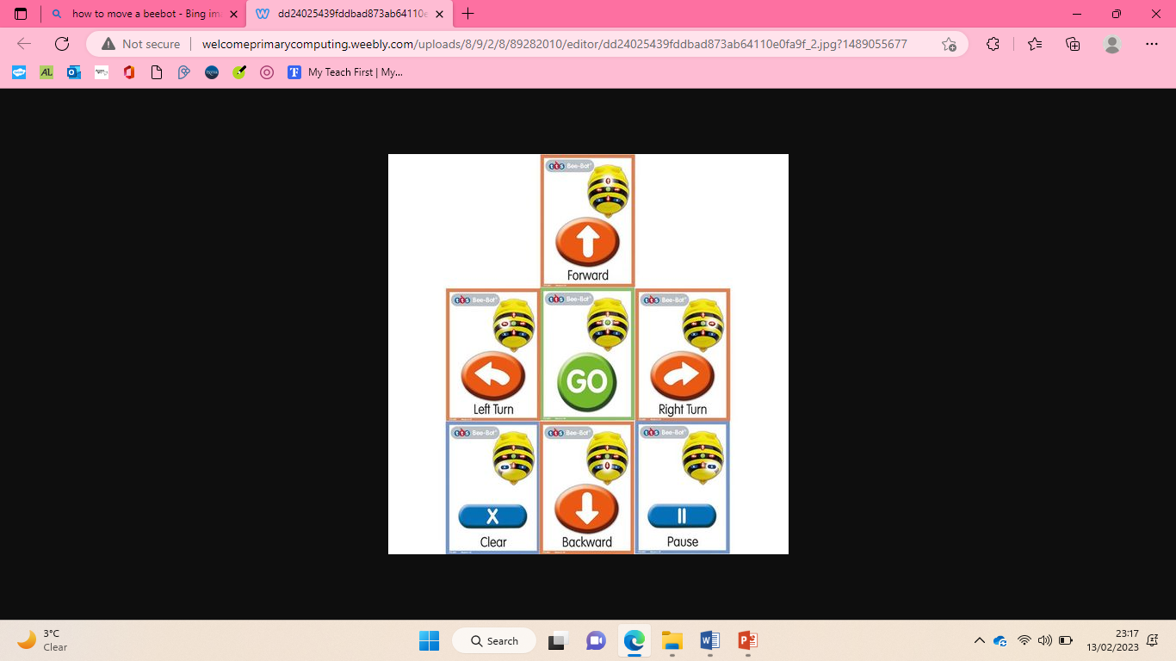

I can explain what my program should do

I can choose the order of commands in a sequence

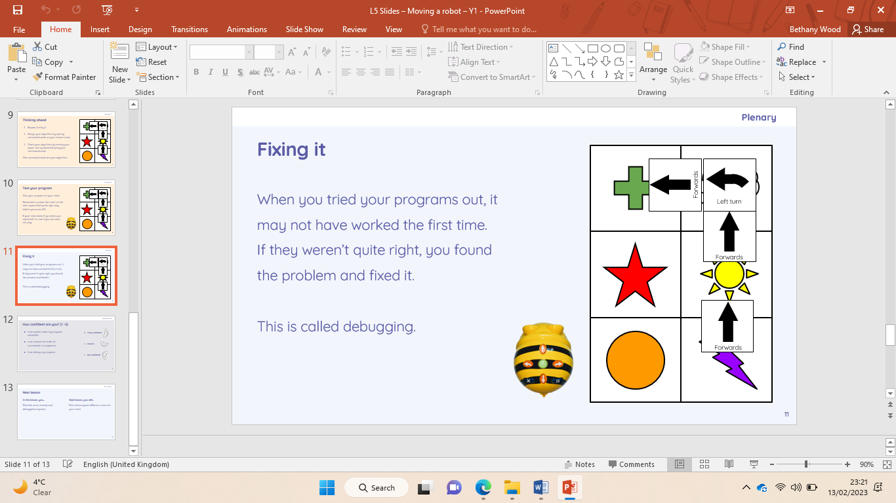

I can plan algorithms for different parts of a task

I can test and debug each part of the program

I can explain the choices I made for my mat design

I can identify different routes around my mat

|  |
| --- |
| I can create an algorithm to meet my goal  I can use my algorithm to create a program |

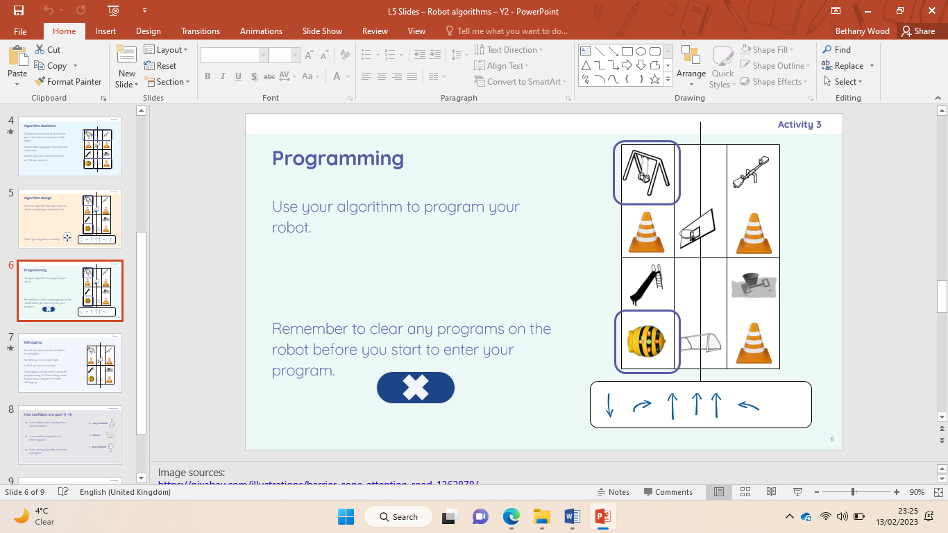

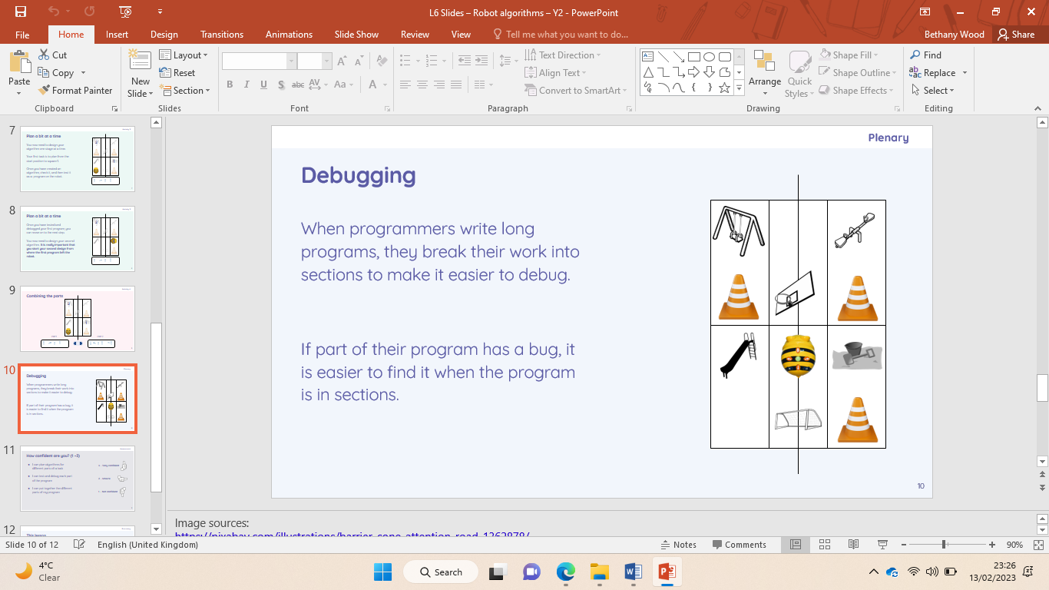

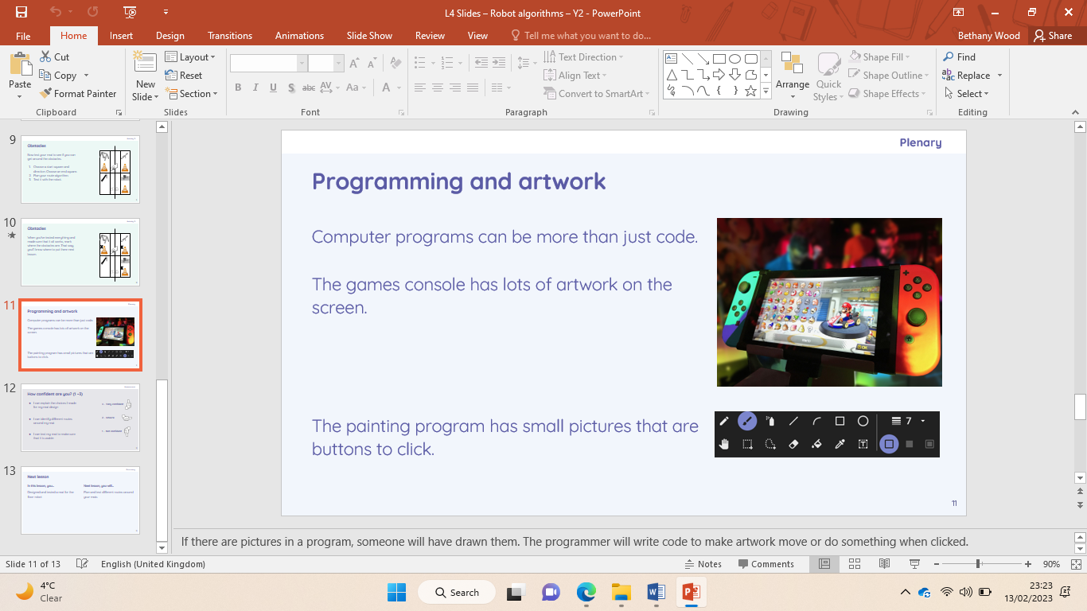

|  |
| --- |
| **Key Vocabulary** |

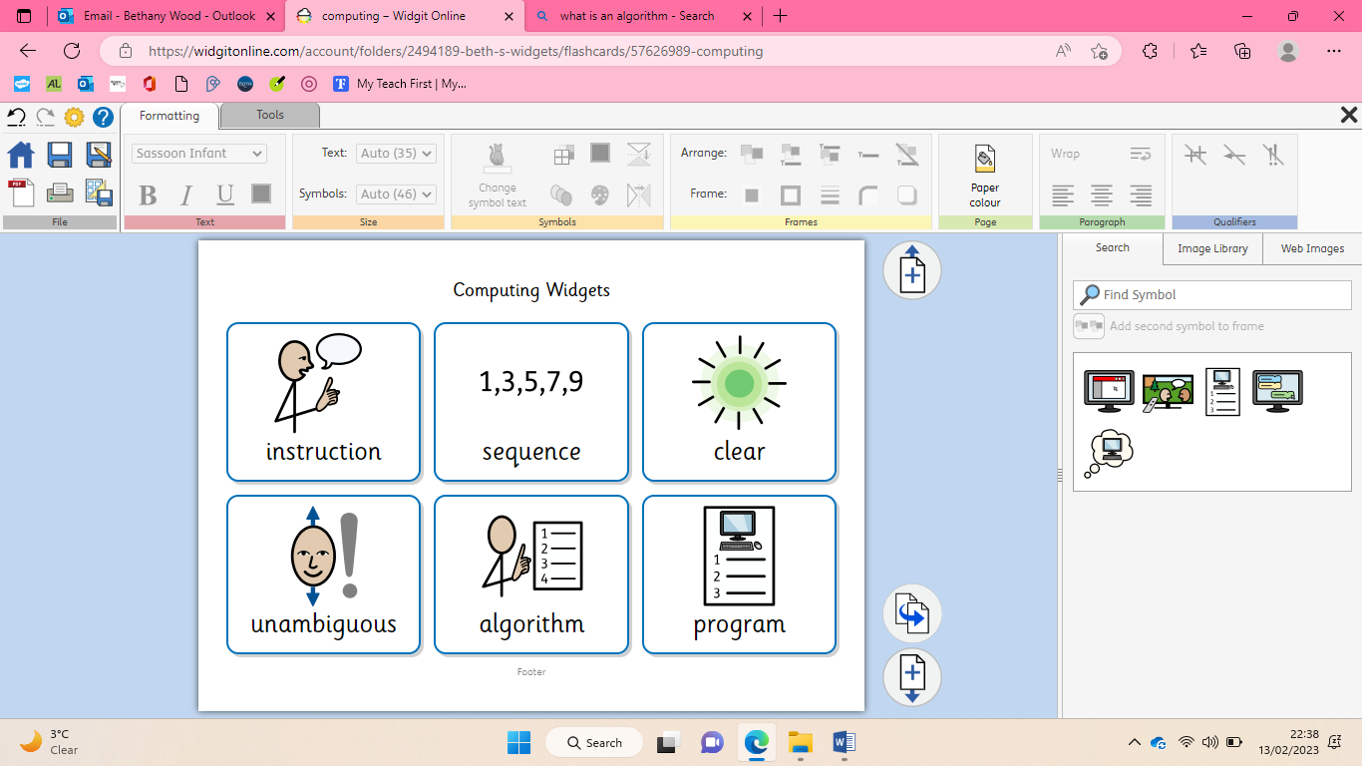

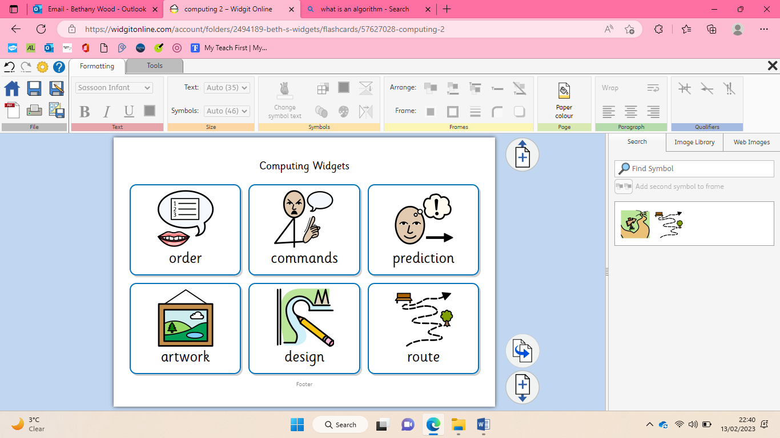 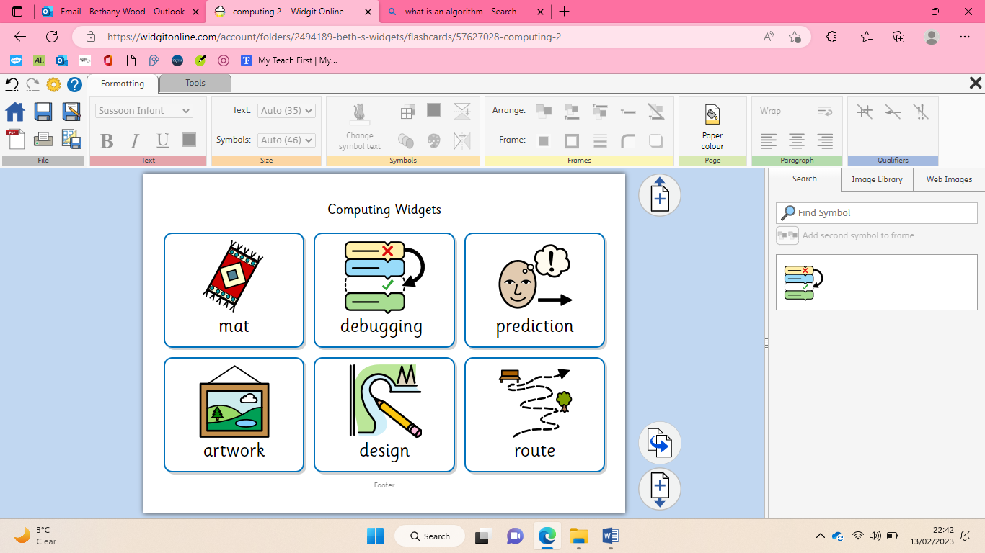

|  |
| --- |
| I can experiment with turn and move commands to move a robot  I can predict the outcome of a sequence involving up to four commands |

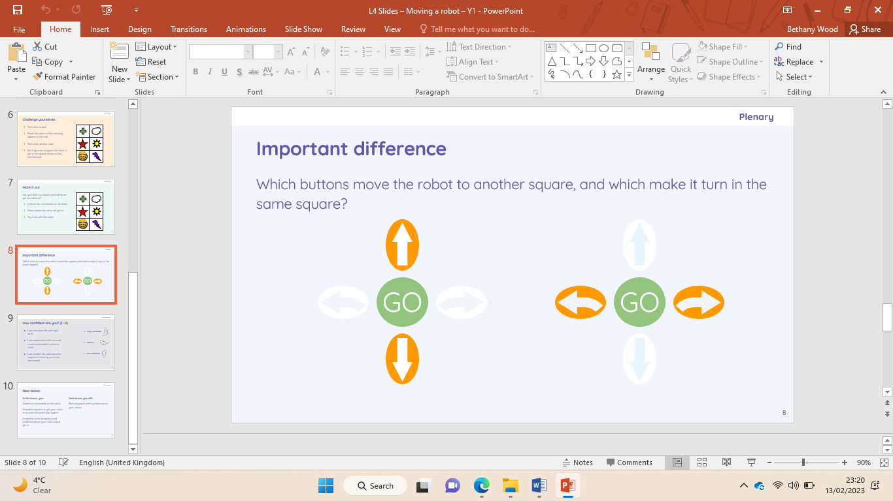

Computing- programming