St Mary’s Catholic Primary School

Living, loving and learning with God
St Mary’s Autumn Giving 2019
This year we would like to invite parents to support us in collecting for Axminster Foodbank.
Items requested include :
Tinned and dried goods: soup, beans, pasta sauces, meat, fish, fruit, custard, rice pudding, biscuits, cereals, tea, coffee and Longlife milk
Food should be brought into school on or before our Harvest service on Friday 18th October at 9.00am. All parents are welcome to attend the service.
Thank you very much in advance for your support.

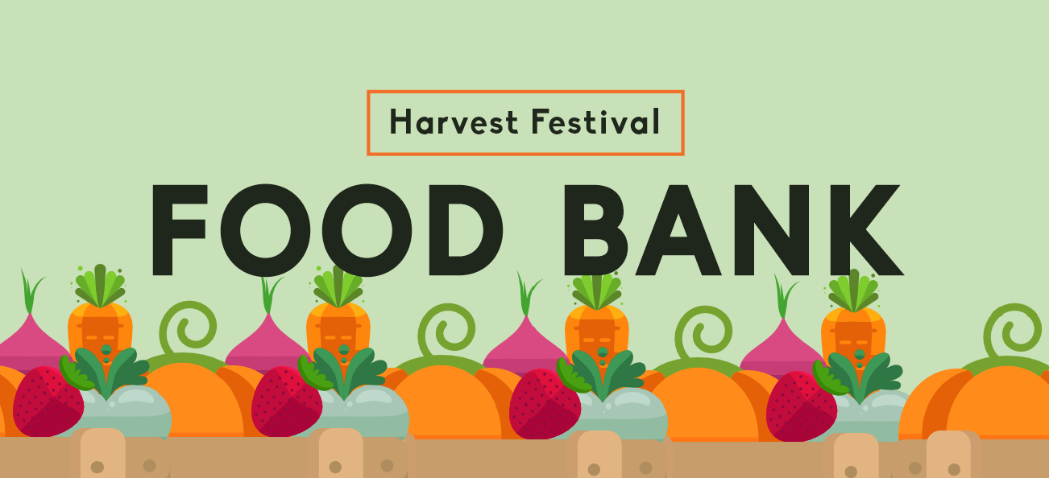

St Mary’s Catholic Primary School

Living, loving and learning with God
Autumn Giving 2019
Shoe Box Appeal
A reminder that families are invited to contribute to our Shoe Box Appeal. Please see attached leaflet for all details.
This is an event organised by The Rotary. It is coordinated at St Mary’s by Mrs Foley.
Completed shoe boxes will be given to disadvantaged children in Albania, Montenegro, Moldova and Romania.
Please see attached for full details of what can be added to each of the boxes.
We know from the boxes that were sent last year and in previous years that the children who receive them are overwhelmed, not just by the contents of the box but by the very fact that people thousands of miles away took the time to care.
Completed boxes will be from school on Friday 1st November.
Please consider filling a box with your child this half term.

St Mary’s Celebrations
October and November 2019
Health and Wellbeing Week ( 14th to 18th October )
A wide of range of events for the children to promote health and wellbeing : street dance, Thai yoga, art projects , vet talk, visit from Hayley Widger our community police office and visit from pets as therapy dog ( PAT ) for our younger pupils.
Monday 14th Street dance workshops.
Parents welcome to attend the dance celebration 3.00pm – 3.30pm
Thursday Woodpecker Class drawing and cake
1.45 to 3.15 in the hall
All welcome please let your child’s class teacher or admin know if you are attending this event
The week will end with our Harvest Service Friday 18th October @ 9.00 am
Celebrate our community giving through songs and readings shared by our children.
Dry food contributions for Axminster Food Bank
Hilary’s Lunch Wed 23rd October ( half term holiday )
St Mary’s school hall 12.00 – 2.00pm
Soup and pudding
No charge donations welcome
Come and eat, chat and play.
All welcome
PTFA events
Bags to school 6th November. Bags will be put book bags before half term.
Robin and Woodpecker cake sale Monday 14th October
Christmas Bingo. Non school uniform in return for donations of Christmas food and drinks for the bingo. 22 November.
PTFA Christmas fayre. Saturday 30th November (morning but exact
time to be confirmed)
Christmas shopping day. Friday 13th December.
The PTFA are looking for a new co-chair and treasurer. If you would like to offer your help please pop into the school office. The PTFA also need donations for the Christmas shopping day. If you have any unwanted items, such as toiletries, books or games, please drop them into the school office.
The PTFA AGM is on Thursday 17th October at 9.00am

Dance Festival 29th October to 1st November
When we return to school on Tuesday 29th October we will be welcoming Spring Dance company to work with all of our pupils throughout the week
Spring Dance is an established London based dance company who are well known for their own productions as well as for their high quality school workshops.
We are very excited to this high quality experience to the children.
You are welcome to come and see the end of week performances:
Eagle and Kestrel Dance sharing Friday 1st November @ 9.00 am
Owl, Woodpecker and Robin dance sharing Friday 1st November @ 2.45pm followed by star of the week celebrations.

https://springsdancecompany.org.uk/join-in/schools-workshops/

St Mary’s Gift Team
October 2019
We encourage every child to think of themselves as a leader and role model. During the month of September children have been voted and selected for a range of responsibilities; House Captains, buddies, mentors and school councillors.
These and other children began to ask if there were other ways that they could help around school, not necessarily in a role of responsibility, simply to make our school an even better, happier place.
By the 1st October this group had been named by the children as the gift team, with a mission to spread God’s light. This reference is one we make often, asking the children to ‘shine brightly’ through their work, friendships and behaviour. Our weekly stars shine very brightly.
As a new team at St Mary’s there are no identified benefits to those who volunteer except to spread light. There are no badges, specific responsibilities or privileges. Call me cynical but I thought perhaps 10 to 20 children from Woodpecker to Eagle might ask to join.
To date more than half of the children in our school have asked to join.
One of our pupils told me today that it had made them so happy to be a member of the gift team.
What a credit to you and the work of our community that so many children want to make a difference.

Practice Kindness.. watch it grow

