|  |
| --- |
| To notice the changes in humans from offspring to adult. |



|  |  |
| --- | --- |
| **Key Vocabulary** | |
| Amphibians | Live in water as babies and on land as they grow older. They have smooth slimy skin.  Hearing- your ears let you listen to all the things around you. Your brain is able to tell what different sounds are. |
| Fish | Live and breathe under water. They have scaly skin, find to help them swim and they breathe through gills. |
| Reptiles | They breathe air and have scales on their skin |
| Mammals | Animals that breathe air, grow hair or fur and feed on their mother’s milk as a baby. |
| Birds | Have a beak, 2 legs, feathers and wings. |
| Herbivore | Animals that only eat plants |
| Omnivore | Animals that eat both other animals and plants |
| Carnivore | Animals that eat other animals |
| Sight | Your eyes let you see all the things around you |
| Smell | You smell using your nose. Your nose can tell if things smell nice or not nice. |
| Touch | Your skin gives you the sense of touch. You can tell if something is warm, cold, smooth or rough without even looking at it. |
| Taste | Your sense of taste comes from your tongue. You can tell if something tastes bitter or sweet, you might have some tastes you like and some you don’t. |
| Hearing | Your sense of hearing comes from your ears. It is how you listen to sounds. |
| Food Chain | This shows were each living thing gets its food. |
| Prey | An animal hunted by another animal for food |
| Predator | An animal that hunts other animals for its food. |
| Camouflage | When an animal blends into its surroundings to protect itself. |
| Protection | To try and stop harm from coming to something or someone. |
| Exercise | A physical activity to keep your body fit |
| Hygiene | How clean something is (to stay healthy and stop disease and illness spreading) |
| Balanced Diet | Having the right amount of food and water that an animal needs |

To name common animals offspring

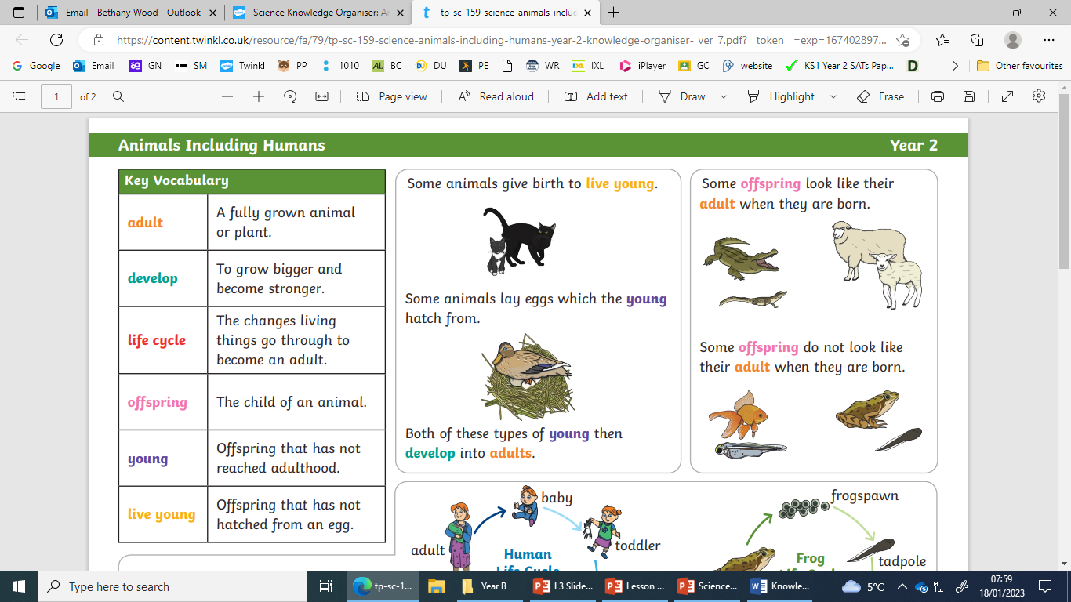

Animals including humans



Why do we exercise?

* To improve our brain health
* Reduce risk of being really poorly
* To manage our weight
* To keep our bones and muscles strong

To describe the importance for humans of exercise and hygiene.

|  |
| --- |
| To find out about and describe the basic needs of animals, including humans, for survival (water, food and air) |



To identify and name animals that are carnivores, omnivores and herbivores

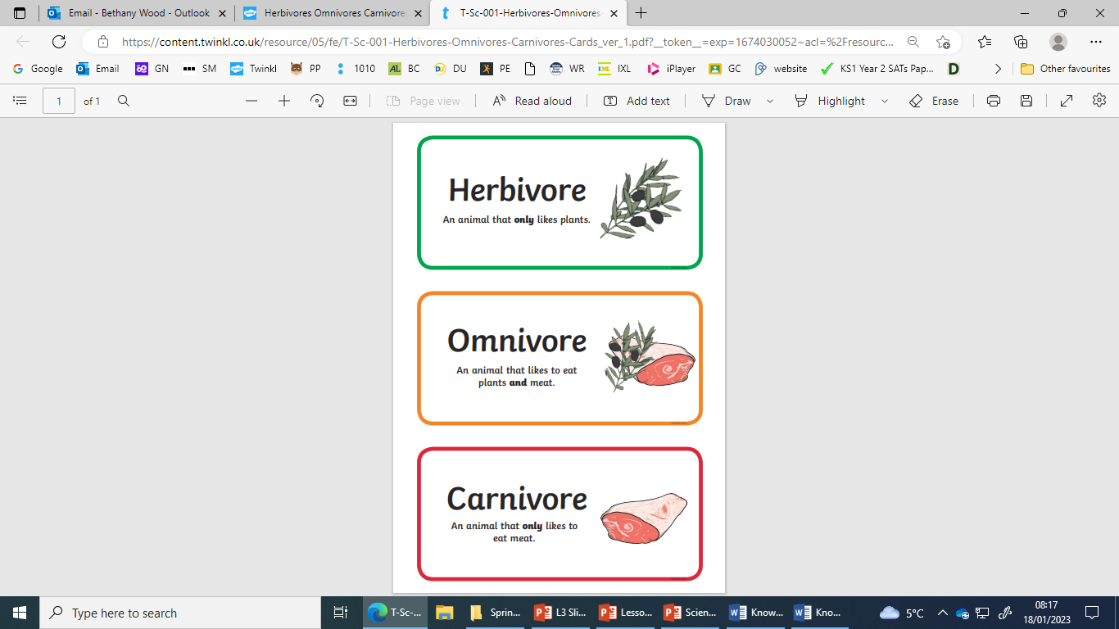

To describe the importance for humans of eating the right amounts of different types of food.

rabbits, cows, elephants, horses, sheep

bears, humans, monkeys

lions, cats, sharks, snakes, wolfs

To identify the parts of the human body associated with each sense

1. To compare the structure of common animals
2. To describe the structure of birds and animals