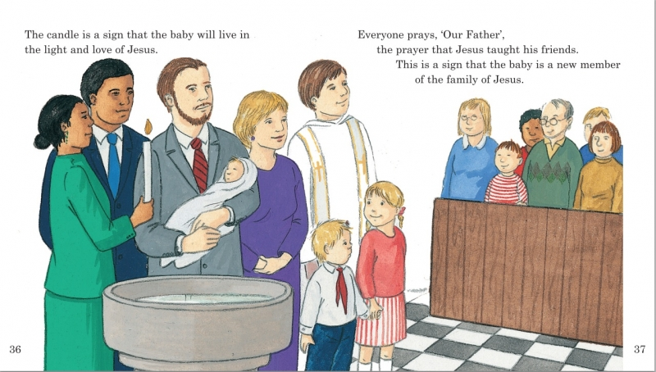

The key steps of a Baptism.

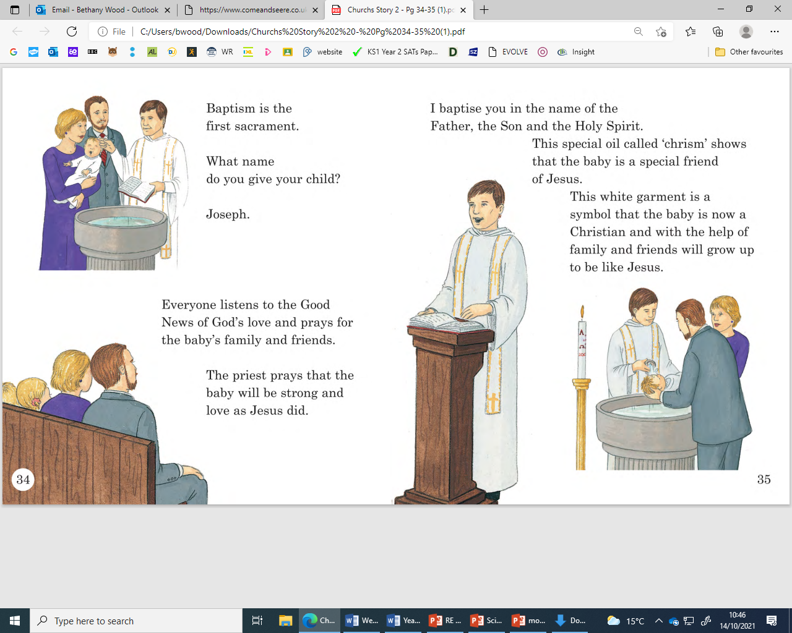

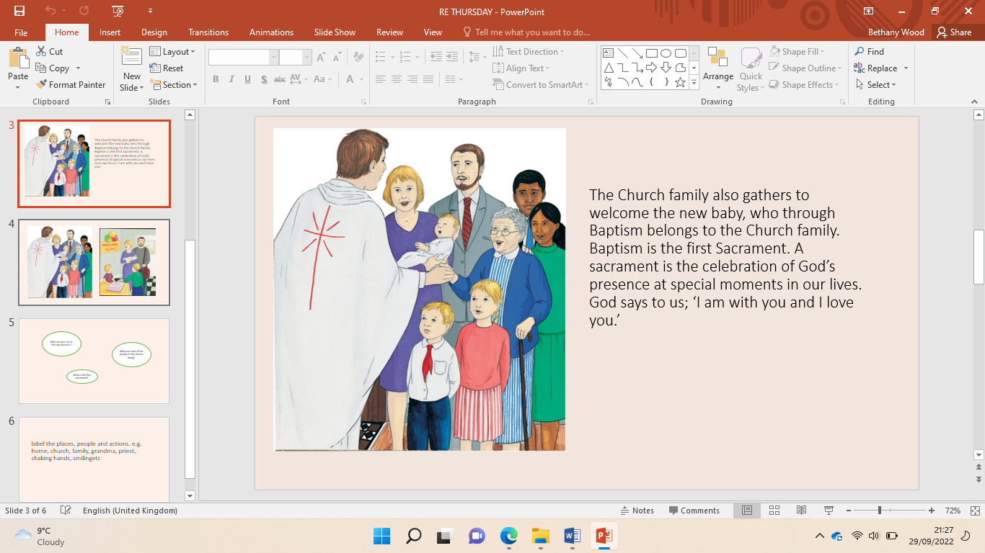

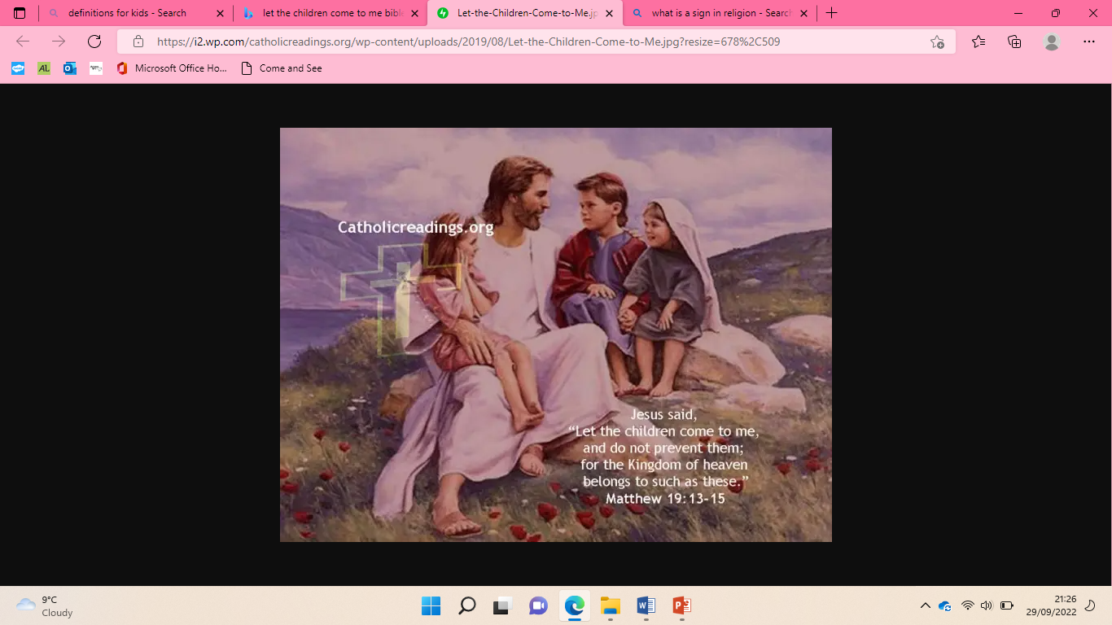

|  |  |
| --- | --- |
| **Key Vocabulary** | |
| Baptism | A sacrament where somebody is welcomed into the church family. |
| Belong | To be a part of something. |
| Font | A basin with Holy water in it used in a Baptism. |
| Godparents | A person who presents a child at baptism and promises to take responsibility for their religious education. |
| Invitation | A written or verbal request inviting someone to go somewhere or to do something |
| Sacrament | A religious ceremony or ritual |
| Sign | Something that represents something else. |
| Sign of the Cross | A movement of the hand forming a cross |
| Welcome | To be warm and friendly to thers. |

Belonging