Key Vocabulary
Judaism
The name of the religion
Jew
Someone who follows the religion of Judaism
Torah
The Holy book of the religion of Judaism
Rosh Hashanah
The celebration of the Jewish New Year
The 10 Days of Awe
For the days after Rosh Hashanah, Jews atone (say sorry) for the things they have done wrong.
Atonement
Saying sorry
Persecuted / persecution
Deliberately treating someone badly because they are different to you
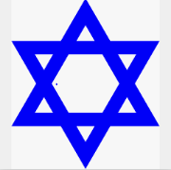

- Rosh Hashanah is the celebration of the Jewish New Year.
- After Rosh Hashanah, Jews take part in the 10 Days of Awe, where they atone for the mistakes they have made.
- Mitzvah Day is a global day where Jews from around the world get involved in hands-on global action projects.
- During Rosh Hashanah, Jews eat apples dipped in honey. The apples remind them of health and the honey reminds them of God’s sweetness.

Rosh Hashanah
Judaism – Year 5 / 6

The Star of David is the symbolism of the Jewish faith.

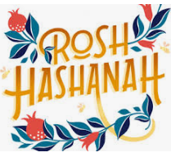

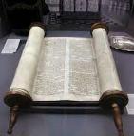
What is Judaism?

Judaism is a very old religion and dates back thousands of years – even before the first Christians.
Jewish people believe in God – the same way that Christians do – but they do not believe that Jesus is God’s son, so they don’t celebrate Christmas or Easter. They believe the Son of God would not have died in that way and they believe he is still waiting to come to Earth. They recognise Jesus as a real man who lived, just not God’s son. Jews have been persecuted for thousands of years and they are very proud of how they have overcome so many barriers.

The Torah is the holy book of the Jewish faith.

