Dear families of St Mary’s
We are enjoying the blue skies, the sounds of birds singing and daffodils brightening up our world.
We are all working hard to continue to hold the present and give children lots of positives for now and for the future.
Our Lenten Journey is about reminding each child that they are special and that they are loved. We are encouraging them to notice every positive they can.
For now we are not openly talking about the war in Ukraine as we recognise that there is much uncertainty and sadness in this.
We have started to see that the diary is filling up with visits and visitors. Some of these are being re-booked so thank you for your continued patience in keeping up with our communications and requests.
Comic Relief Thank you!
We had a slightly extended Friday Celebration to mark Comic Relief. Thank you for your support. We talked to the children about the difference we all make. Our ‘pot ‘ of money allows us to send £260 to add to the incredible £42 million raised so far this year.
Chocolate Eggs for the Easter Raffle
Thank you those parents who have contributed eggs. Raffle tickets will be sent out next week. Funds raised will be for the PTFA.
If you haven’t already then please do consider making a chocolate offering to this very worthy cause. All proceeds from the PTFA support children’s learning and well being in school.
Talk Matters – Quality talk really matters
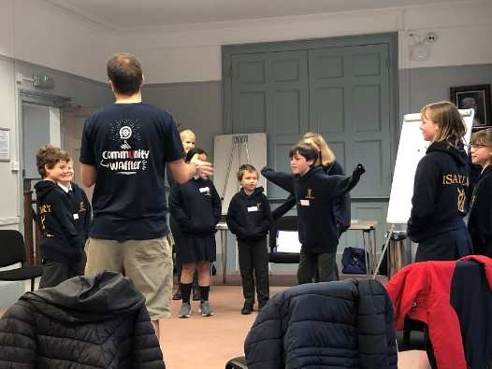
You might realise that The Waffle House is a ‘not for profit’ organisation. As well as the café staff and volunteers they have outreach workers (Matt, Simon and Sophie) who build community events. These staff are employed through national and local grants.
Our Year 6 pupils spent a half day exploring conversation and the skills to listen well and to open up a conversation. They then explored this for real with a volunteer adult before enjoying a waffle treat.
We did explain to them that this project is not about making conversation with random strangers but that in life they come across peers and older people who they will need to interact with but may not always feel able to do this with confidence.
The children clearly enjoyed the event and shared that they did feel more confident in speaking to people they may not always feel able to talk to.
Sing, sing, sing
The school choir were finally able to share their songs with family last week. It was great to have an audience.
The song list included songs we have been singing in school over the last year as well as a new favourite for the choir: Video Killed the Radio Star! This was performed as the final song in celebration of their work. Please see photos below.
Choir continues every Tuesday after school for pupils in Year 4, 5 and 6 of any ability. All are welcome to join.
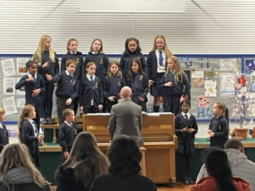
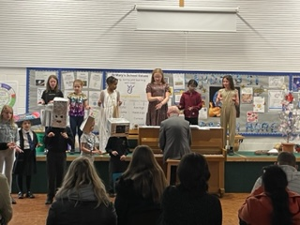
Bikeability
Due to unfortunate rainy weather on the Friday some children were unable to complete their bikeability. These children will now have a chance to complete this on the 7th April – an email will be sent to the parents of these children shortly.
Parents Consultations
Thank you to those parents who have returned slips so that times can be shared for the parent consultations.
If you have not yet returned the slip please do so at the earliest opportunity. Confirmations will be sent out shortly.
New menu
A new lunch menu will be starting week beginning 25th April. This will be available to book from the 8th April.
Please remember to continue to check your selections with your child as we are only able to give them the food you have selected each day.
A reminder that packed lunch should have a balance of healthy food.
Children in Robin Class and KS1 are offered fruit at break times. Other children should preferably have fruit or a healthy choice snack but please do not send your child with chocolate/ crisp snacks.
Dates for the diary
4th & 5th April – Parent Consultations. Confirmed time slots to be sent out next week.
6th April – Chance to Shine – Cricket day (all children to wear PE kit to school) please note this date changed from original letter sent
7th April – completion of bikeablility for those who were rained off
8th April – last day of term
25th April – first day back after half term
After School Clubs – please note after school clubs finish this term on week ending Friday 1st April.
New after school club information will be sent out next week. These clubs will start week commencing 3rd May (Monday 2nd May is a bank holiday).

